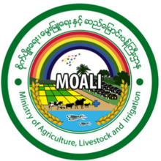



United Nations Development Programme
Country: Myanmar
PROJECT DOCUMENT

Project title:
Myanmar Rural Renewable Energy Development (RURED) Project
Country:  Myanmar | Implementing Partner:  UNDP |  | Management Arrangement:  DIM (Direct Implementation Modality)
UNDAF/Country Programme 2018-22 Outcome #2: By 2022, Myanmar becomes more resilient to climate and disaster risk with efficient environmental governance and sustainable use of natural resources
UNDP Strategic Plan 2018-21 Output 1.5.1 Solutions adopted to achieve universal access to clean, affordable and sustainable energy

UNDP Social and Environmental Screening Category:  High |  | UNDP Gender Marker: 2
Atlas Project ID (formerly Award ID): 00104187 |  | Atlas Output ID (formerly Project ID): 00105877
UNDP-GEF PIMS ID number: 5564 |  | GEF ID number: 9890
Planned start date: July 2019 |  | Planned end date: June 2024
PAC meeting date: 25 April 2019
Brief project description:

The Myanmar Rural Renewable Energy Development (RURED) Project seeks to address the twin challenges of exceptionally low electrification rate in Myanmar, as well as the unsustainably high dependence on high-emission fossil fuels in the country’s energy mix, by means of supporting improvements in the country’s rural energy infrastructure. RURED contributes to the national goals of achieving universal energy access, by supporting the off-grid electrification component of the National Electrification Plan. In doing so, RURED seeks to facilitate expansion of rural renewable energy services and productive applications in Myanmar to avoid greenhouse gas emissions. The investments in off-grid renewable energy systems during project implementation (2019-2024) will lead to cumulative (direct) GHG emissions reduction of 246 kilotons of CO₂ (over the investment’s lifetime). De-risking activities and capacity strengthening will catalyse replication in coming years. The Projects seeks to achieve this through the following Outcomes: 1) Effective implementation of enabling policies and regulations at the national and local levels for enhanced RE utilisation for rural productive uses; 2) Awareness and knowledge enhanced of government entities, market enablers and beneficiaries; 3a) Increased investments in rural renewable energy to meet household demand, social services, and productive uses of energy; and 3b) Supporting financial programme formulation. During implementation, in addition to GEF funding of USD 4,934,228, UNDP will contribute with USD 200,000, and the project will be further supported by in-kind and cash contributions to support parallel activities from government partners and other actors (MoALI/DRD, SPM, GIZ) to an amount of USD 37,750,000. Thus, the total resources available for project implementation are USD 42,884,228.

Financing Plan
GEF Trust Fund |  | USD 4,934,228
- Total Budget administered by UNDP |  | USD 4,934,228
Parallel co-financing (all other co-financing that is not cash co-financing administered by UNDP)
Department of Rural Development (DRD), Ministry of Agriculture, Livestock and Irrigation (MoALI) |  | USD 31,250,000
GIZ (Germany) |  | USD 1,500,000
PACT-Smart Power Myanmar |  | USD 5,000,000
UNDP |  | USD 200,000
- Total co-financing |  | USD 37,950,000
- Grand-Total Project Financing (1)+(2) |  | USD 42,884,228
Signatures
Signature: print name below | Agreed by Government |  | Date/Month/Year:
Signature: print name below | Agreed by Implementing Partner |  | Date/Month/Year:
Signature: print name below | Agreed by UNDP |  | Date/Month/Year:

Table of Contents

1. Table of Contents 3
List of exhibits 5
List of acronyms and abbreviations 7
2. Development Challenge 10
2.1 Introduction 10
2.2 Problem analysis and the project’s objective 16
3. Strategy 23
4. Results and Partnerships 30
4.1 Expected results 30
4.2 Partnerships 43
4.3 Risks and risks and mitigation 44
4.4 Stakeholder engagement 47
4.5 South-South and Triangular Cooperation (SSTrC) 49
4.6 Mainstreaming gender 50
4.7 Sustainability and scaling-up 51
5. Project Management 53
5.1 Cost efficiency and effectiveness 53
5.2 Project management 54
6. Project Results Framework 56
7. Monitoring and Evaluation (M&E) Plan 59
8. Governance and management arrangements 63
8.1 Roles and responsibilities of the Project’s governance mechanism 63
8.2 Project staffing and implementation 65
9. Financial planning and managemenT 68
10. Total UNDP Budget and Work Plan 70
11. Legal Context 75
12. Risk management standard clauses 75
Annexes 78
Annex A. Multi-Year Work Plan 79
Annex B. Overview of technical consultancies and subcontracts 81
Annex C. terms of reference for main project staff 84
Annex D. Gender analysis and action plan 89
D.1 Gender mainstreaming analysis 89
D.2 Gender action plan 91
Annex E. Baseline rural and renewable energy situation in myanmar 95
E.1 Electricity access and development challenge 95
E.2 Renewable energy 97
E.3 Electrification 98
E.4 Status and plans in off-grid electrification 103
E.5 Opportunities and issues in off-grid electrification and options for scaling up 110
E.6 Financing for off-grid energy 113
E.7 Stakeholders in off-grid electrification 116
E.8 Rural energy demand and PUE in the proposed Project Areas 119
E.9 Bibliography 126
Annex F. Myanmar: de-risking energy investments (DREI) 128
Annex G. GEF CORE INDICATORS and GHG emission reduction 130
G.1 Calculation of RE energy production and GHG emission avoidance 130
G.2 GEF Core indicators 133
Annex H. Stakeholder engagement plan 134
Annex I. social and environmental screening 138
Annex J. Agreements 150

List of exhibits
Exhibit 1 South-East Asia: Towards universal access in 2030 10
Exhibit 2 Myanmar electricity mix 11
Exhibit 3 Share of households with access to on-grid electricity, 2014 12
Exhibit 4 What are renewable energy mini-grid systems? 13
Exhibit 5 Theory of change – challenges, core problem and causes 16
Exhibit 6 Linkages of rural and renewable electricity with SDGs and Myanmar’s Sustainable Development Plan 21
Exhibit 7 Summary of project outcomes and outputs 22
Exhibit 8 Theory of change – objectives, outcomes and outputs 23
Exhibit 9 Areas of geographical focus of RURED 30
Exhibit 10 Integral approach to off-grid electrification 37
Exhibit 11 Mandatory GEF M&E requirements and M&E budget 61
Exhibit 12 Project governance and management structure 66
Exhibit 13 Gender-related indicators and targets (from the project Results Framework) 90
Exhibit 14 Gender and social inclusion action plan: a gender mainstreaming measurement tool 91
Exhibit 15 Gender-aspects in Theory of Change 93
Exhibit 16 Least-cost power expansion plan 95
Exhibit 17 Current situation of rural electrification 97
Exhibit 18 Township-level maps of access to energy technologies 98
Exhibit 19 Rural electrification target in Myanmar 100
Exhibit 20 Responsibilities of stakeholders in the off-grid NEP 100
Exhibit 21 National grid roll-out plan 101
Exhibit 22 Configurations of SHS offered under the off-grid NEP 103
Exhibit 23 Yearly plan for off-grid electrification, Phase 1 (2016-2021) 103
Exhibit 24 Proposed State-level regulations for off-grid electricity systems 105
Exhibit 25 Photovoltaic potential map of Myanmar 106
Exhibit 26 On-grid and off-grid electricity planning using geospatial tools 107
Exhibit 27 Renewable energy resource assessments 108
Exhibit 28 Levelised cost of energy (LCOE) for off-grid renewable energy in Myanmar 109
Exhibit 29 Comparison of tariffs and solar PV mini-grid LCOE values 110
Exhibit 30 Case study, locally governed, self-financed mini-hydro 111
Exhibit 31 Mini-grid systems installed in Myanmar 112
Exhibit 32 USAID DCA financial support products 115
Exhibit 33 Description of Dry Zone area 119
Exhibit 34 Administrative divisions, Tanintharyi 121
Exhibit 35 Mini-grid systems installed in Thanintharyi 122
Exhibit 36 Administrative divisions, Shan State 124
Exhibit 37 Mini-grid systems installed in Shan State 125
Exhibit 38 Impact of risk categories on the cost of equity for solar PV mini-grid investments in Myanmar 128
Exhibit 39 Policy and risks instruments considered 129
Exhibit 40 Characteristics and indicators of typical small hydro and solar min-grid systems 130
Exhibit 41 Baseline technology: diesel-based mini-grid system 130
Exhibit 42 Base data in estimating energy demand and solar or hydropower supply options 130
Exhibit 43 Summary of villages electrified, annual energy production and GHG emission avoidance………………131

List of acronyms and abbreviations

A-Bank Ayeyarwaddy Farmers Development Bank
ABC Anchor-Business-Community
AFD Agence Française du Développement
ATP Ability To Pay
AWP Annual Work Plan
CAPEX Capital Expenditure
CBO Community-Based Organization
CDR Combined Delivery Report
CEO Chief Executive Officer
CEO ER CEO Endorsement Request
CfP Call for Proposals
CO Country Office
CORE-KIT Community Renewable Energy – Knowledge Integration Tool
CPD Country Programme Document (UNDP)
CSO Civil Society Organisation
CTA Chief Technical Advisor
DCA USAID Development Credit Authority (DCA)
DFID Department for International Development (UK)
DIM Direct Implementation Modality
DRD Department of Rural Development
DREI De-risking Renewable Energy Development
DRI Department of Research and Innovation
DTVE Department of Technical and Vocational Education
EAO Environmental Awareness Organisation
ECD Environmental Conservation Department
EU European Union
FPIC Free Prior and Informed Consent
FSP Financial Service Provider
FSP Full-sized Project
FY Fiscal Year
GDP Gross Domestic Product
GEF Global Environment Facility
GHG Greenhouse Gas
GIZ Gesellschaft für Internationale Zusammenarbeit (German cooperation)
GOM Government of Myanmar
GRSP Governance for Resilience and Sustainability Project
GWh Gigawatt-hour (billion watt-hours)
HIVOS Humanist Organisation for Social Change (Netherlands)
HPNet Hydro Empowerment Network
HyCEM Association for Hydropower for Community Empowerment in Myanmar
IEO Independent Evaluation Office
IFC International Finance Corporation
INDC Intended Nationally Determined Contribution
IP Implementing Partner
IP Indigenous People
JICA/JICS Japan International Cooperation Agency / System
kV kilovolt
kW kilowatt
kWh kilowatt-hour
LoA Letter of Agreement
LCOE Levelised Cost Of Energy
KfW Kreditanstalt für Wiederafbau (KfW Development Bank)
LED Light-emitting Diode
LPAC Local Project Appraisal Committee
M&E Monitoring and Evaluation
MeeNet Mekong Energy and Ecology Network
MFI Micro-Finance Institution
MHP Mini/Micro Hydropower
NGO Non-Governmental Organization
MMFA Myanmar Microfinance Association
MoNREC Ministry of Natural Resources and Environmental Conservation
MTR Mid-Term Review
MNCW Myanmar National Committee for Women’s Affairs
MoALI Ministry of Agriculture, Livestock and Irrigation
MoEE Ministry of Energy and Electricity
MoNRC Ministry of Natural Resources and Environmental Conservation
MoPF Ministry of Planning and Finance
MMK Myanmar Kyat
MW Megawatt (million Watts)
NEMC National Energy Management Committee
NEP National Electrification Plan
NEP National Electrification Project (World Bank support)
OFP Operational Focal Point
O&M Operation and Maintenance
PAC Project Appraisal Committee
PIF Project Identification Form
PIR GEF Project Implementation Report
POPP Programme and Operations Policies and Procedures
PPG Project Preparation Grant
PM Project Manager
PMU Project Management Unit
ProDoc Project Document
PUE Productive Uses of Energy
PV Photovoltaic
R&D Research and Development
RE Renewable Energy
REETC Renewable Energy and Electronic Technology Centre (of DRD)
RESCO Rural Energy Service Company
REAM Renewable Energy Association of Myanmar
RET renewable energy technology
ROAR Results-Oriented Annual Reporting
RRMC Risk Reduction Management Centre
RURED Rural Renewable Energy Development Project
S/R State/Region
SDG Sustainable Development Goal
SESP Social and Environmental Screening Procedure
SHS Solar Home System
SME Small and Medium-sized Enterprise
SPM Smart Power Myanmar
SPV Special-Purpose Vehicle
tCO₂ ton of Carbon dioxide
TA Technical Assistance
TAC Technical Advisory Committee
TE Terminal Evaluation
TVET Technical Vocational Education and Training
UMFCCI Union of Myanmar Federation of Chambers of Commerce and Industry
UN United Nations
UNDP United Nations Development Programme
UNFCCC United Nations Framework Convention on Climate Change
USAID United States Agency for International Development
USD United States dollar
VEC Village Electrification Committee
VECO Village Electrification Cooperative
V(D)F Village (Development) Fund
WB World Bank
WTP Willingness To Pay

Development Challenge

Introduction

Context

Myanmar is a least developed country which continues to navigate multiple transitions: from conflict to peace, from military/autocratic rule to a democratic civilian Government and from a largely closed economy to an open market economy. These transitions are occurring in a complex development context with high concentrations of poverty in rural areas in contrast with accelerated development in urban centres; armed conflict is still occurring in some parts of the country, and frequent natural disasters pose an increasing risk. Myanmar began the transition to a parliamentary government in 2011, which resulted in the current civilian-led government taking office in 2016. This transition has been accompanied by economic reforms aimed at attracting foreign investment and reintegrating into the global economy, leading to the country’s re-engagement with global business and trade networks and international development institutions. Myanmar’s economy has been growing rapidly over the last decade, at an average rate of 8% between 2007 and 2016 and has shown recent volatility, with growth between 6% and 7% during the past few years. Myanmar’s abundant natural resources and young labour force have the potential to attract foreign investment in the energy, garment, information technology, and food and beverage sectors. The Government of Myanmar (GoM) is focusing on accelerating agricultural productivity and land reforms, modernizing and opening the financial sector, and developing transportation and electricity infrastructure. Despite these remarkable improvements, the country continues to be a least-developed country according to the OECD’s registration. In 2016, Myanmar’s GDP per capita was just USD 1161, resulting in a Human Development Index (HDI) ranking of 145 out of 188 countries with 25.6% of its population living in poverty.

In 2014, about 70% of the population had no access to energy, including 84% of rural households. The rest of the population either had no access or had to rely on unreliable or inefficient diesel systems. The Government’s reform agenda in conjunction with large investments from bilateral and multilateral development institutions and other investors have accelerated infrastructure development, including in regards to electricity generation and distribution. Myanmar has made significant progress in extending electricity access, evidenced by the country’s average electrification ratio growth from about 16% in 2006 to 26% in 2011 to 34% in 2015 to 57% in 2018. This positive development is expected to continue, with the Government’s National Electrification Plan (NEP), which has established the ambitious goal of providing electricity access to all households by the year 2030.
The NEP’s electrification targets are planned in 5 phases, starting with low-cost connections first and then moving to higher-cost connections in subsequent phases:
- Dense areas require shorter distribution lines and lower cost per connection and will be connected first. Remote communities require longer lines and higher cost and will be connected later (phases 1 to 3);
- Very remote villages (mainly in Chin, Shan, Kachin and Kayah States) have the highest cost per connection, thus are expected to be connected in the final phases (phases 4 and 5) and will be served by off-grid solutions.

Phase 1 will run from 2016-2021, with the grid extension (implemented by MoEE) supported by the World Bank with USD 310 million and government contribution of MMK 51.5 billion. The aim is to electrify 6240 villages (750,000 households; population of about 2.6 million) by extending 5130 miles of 11-33 kV lines (Soe Soe Ohn, 2016b; MoEE website 2018).
Although electrification has increased rapidly, in absolute terms Myanmar remains at one of the lowest electrification levels in South-East Asia (see Exhibit 1). The low electrification rate puts significant constraints on unlocking the productive potential of the country and ushering in regionally balanced and broad-based economic development especially impacting poverty alleviation, income generation and the overall quality of life in rural areas. The causal linkages between rural electrification rates and improved socio-economic outcomes are well established for basic services such as health and education. Thus, for instance, electricity access enables refrigerated vaccines and emergency and intensive health care particularly for women, children and the elderly and, access is an important condition for the development of the productive capacities and quality of life of the working population. In rural areas, affordable energy access is particularly relevant for production, storage, and processing of value-added agricultural commodities and fishery-based products to market, thereby supporting rural livelihoods and income generation. The pumping of clean groundwater for drinking and irrigation is vital for assuring good health and increasing agricultural productivity. The lack of access to modern energy services affects everyone but has particular adverse gender-differentiated impacts on women and children inter-alia increasing the burden of household care in view of access to well-equipped health and educational services and deprives them of economic empowerment opportunities.

Significant progress remains to be made to provide current (and rapidly growing future) electricity needs. When the NEP was released in 2014, the goal of universal electricity access in Myanmar implied that about 7.2 million households would need to be connected by 2030. The Plan’s original aim was to have 190,000 people gaining access every year mostly through centralised, grid-based solutions. This approach reflects the government’s electrification strategy, to be achieved through centralised planning and national grid extension.
Exhibit 1 South-East Asia: Towards universal access in 2030

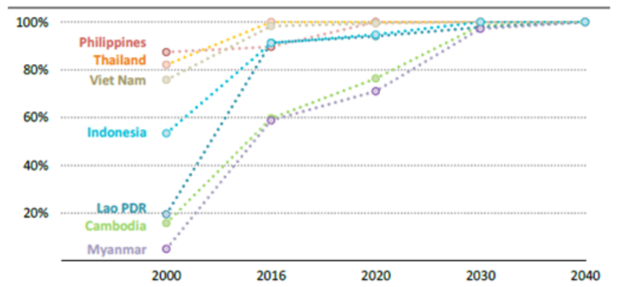
Source: South East Asia Energy Outlook 2017, International Energy Agency (2017)

Source: Eskom website (2017)

However, at current rates of infrastructure expansion, it would take 40 years or more to achieve full electrification, optimistically assuming that a national grid can reach remote coastal islands and mountainous areas. Notably, the general electrification targets hide the fact that there is a stark difference between urban and rural areas and among the various States and regions of Myanmar (see Exhibit 18 in Annex E). Four states and regions have a particularly low rural on-grid electrification rate of below 10%, namely Chin State (8%), Tanintharyi Region (7%), Rakhine State (7%) and the Ayeyarwady Region (4%). Consequently, these marked differences apparent in the referenced figures underline the need for different approaches to electrification in rural vs. urban areas, as well as between regions.

In the Myanmar grid system, electricity is generated in large fossil fuel-based (coal, gas) and large hydropower plants (see Exhibit 2 ). Although large-scale hydropower development may have carbon benefits, these benefits come with significant environmental and social risks and impacts. The construction of large dams leads to significant flooding of land in order to create a reservoir, changing river hydrology with potentially irreversible impacts on biodiversity, as well as resettlement of populations. These changes in water and land-use can lead to significant resource conflict, demonstrated in recent years in the context of Myanmar, where plans for large-scale power has led to protests over detrimental environmental effects.

The Energy Master Plan mentions that Myanmar should reduce its reliance on hydropower and natural gas in power production through greater coal use. A reason behind this strategy is to use Myanmar’s natural gas supply and hydropower for power export to Thailand and China and to reduce imports of oil products in nationally. However, replacing natural gas by coal in power production will have a negative global environmental impact due to the significantly higher GHG emissions related to coal power production, as compared to electricity produced from natural gas.
Exhibit 2 Myanmar electricity mix

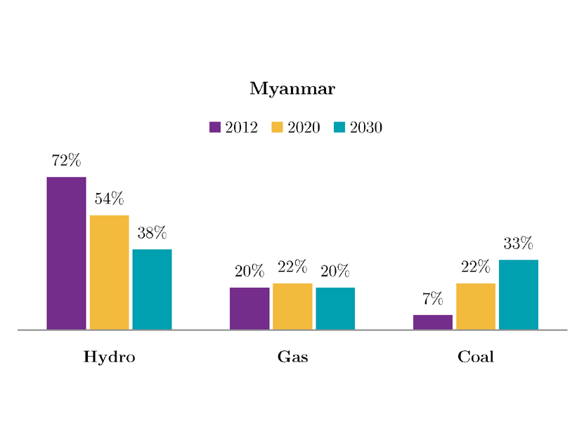
Source: International Growth Centre (IGC, 2016). Based on projections given in the Energy Master Plan

Source: Eskom website (2017)

Power plants, whether they burn coal or gas, are very large projects, and grid electrification requires extensive construction of transmission and distribution infrastructure to reach households. The topography of the land determines the cost of expanding the national grid. It can be prohibitively expensive to construct transmission and distribution infrastructure to reach households in mountainous areas (due to accessibility constraints) or to reach remote households and other end-users in sparsely populated areas, as well as on islands.

Development challenge

The low electrification rate and the tendency to choose environmentally unfriendly fuels (i.e. fossil fuels) in the country’s energy mix and for electrification are the principle development challenges the RURED project seeks to address.

Longer-term solutions

While the efforts of the Government of Myanmar in extending the national grid by means of large-scale hydropower and fossil fuel power plants are acknowledged, the RURED project is looking into other solutions for rural energy access development. Myanmar has tremendous potential to develop renewable energy beyond large-scale hydropower, such as solar power and small hydropower (see Annex E.2 for info in renewable energy resources in Myanmar). Solar home systems (SHS) seem best suited for relatively poor, small villages with low energy demand. In comparison, mini-grids can power larger residential loads and spur local economic growth through energizing larger productive use loads such as refrigeration, water pumping, saws, and agricultural processing such as rice mills or corn shelling.

Myanmar has rich hydropower potential that can make use of the four main basins of the Ayeyarwady, Chindwin, Thanlwin, and Sittaung rivers. Small hydro (mini- or micro-) can power mini-grids in locations that possess adequate free-flowing water. There is potential for many more small- and medium-sized hydropower projects in mountainous areas. These are usually run-of-the-river schemes that, compared to large hydropower projects, have relatively low negative environmental and social impacts. Since no large reservoirs are required the need for involuntary resettlement gets eliminated along with a host of related negative socio-economic impacts on the local population. Myanmar also has strong solar radiation levels, making the bio-physical condition ideal for solar generation.

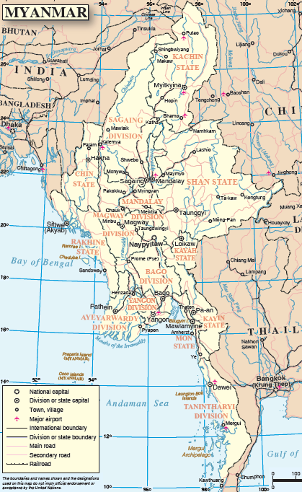
In many areas far from the existing or planned grid infrastructure, and with low population density, off-grid stand-alone and mini-grid access solutions can be more cost-effective than grid extension. For more details on the status and potential of rural and renewable energy applications, the reader is referred to Annex E.2 and E.4. In recent years the Government has come to recognise and prioritize the potential of off-grid electrification solutions, recommending that 1.3 million of the 7.2 million households targeted in the NEP have off-grid energy access by mini-grids or solar home systems.
Exhibit 3 Share of households with access to on-grid electricity, 2014

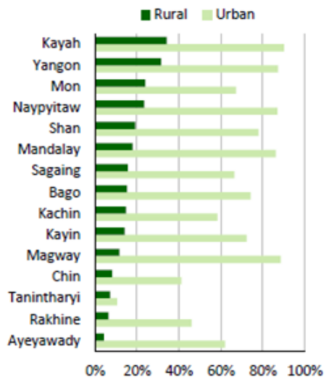

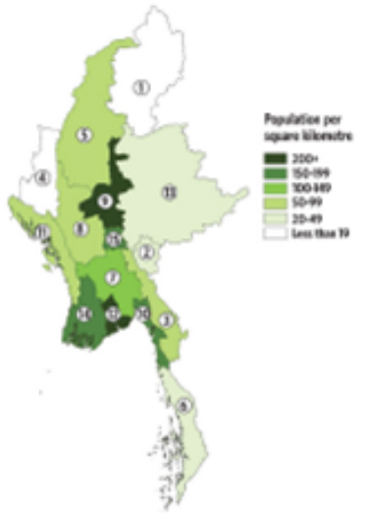

Source: Developing a renewable energy policy for Myanmar: Insights from the 2014 census, Spectrum SDKN, 2017
Myanmar map: UN Cartographic Section

State-level governments have an important role to play in energy development as under the new Electricity Law (2014) they can issue permits for small (< 10MW) power plants and for medium-sized power plants (30 MW) that are not connected to the grid. The law will effectively encourage state-level government stakeholders to take a lead in promoting power infrastructure projects, including renewable energy mini-grids. This means state level governments can also play a role in coordination on grid and off-grid electrification planning, thereby reducing investment uncertainty among renewable energy mini-grid developers.
Exhibit 4 What are renewable energy mini-grid systems?

A mini grid, also sometimes referred to as a "micro grid” or “isolated grid", can be defined as a set of electricity generators and possibly energy storage systems, interconnected to a distribution network that supplies electricity to a localized group of customers. These involve small-scale electricity generation (10 kW to 1 MW) which serves a limited number of consumers via a distribution grid that can operate in isolation from national electricity transmission networks. This power delivery architecture can be contrasted to a single customer system, such as in the case of a solar home system (SHS), but also to a centralized grid system, with mini-grids operating autonomously from the centralized grid. Mini-grids however show exceptional flexibility, as they may be designed to interconnect with the central grid, able to operate under normal conditions as part of the central grid. The mini-grid can in this case operate as a power generator (selling to the grid as an independent power producer, IPP) or as distributor (selling to its clients), or both. Furthermore, a mini-grid can be supplied by an array of energy resources and power plants, as indicated in the table below. The reliability of supply can be greater from hybrid (e.g. solar-hydro) mini-grid systems, as compared to a single technology. This not only lowers the net costs over the lifetime of a project, but also ensures availability of power when one system is not working.

 |   Micro-micro hydro |   Solar battery |   Solar-battery and diesel |   Solid biomass  gasifier |   Wind battery |   Diesel
Definition | Pico:<5kW,  Micro: <100kW  Mini: <1000kW
Main attention in RURED | Yes | Yes | Yes | No | No | No (backup only)
Investment cost mini-grid (USD/kWh) | 500-10,000 | 4,000-7,000 | 5,000-10,000 | 1,500-10,000 | 4,500-13,000 | 400-1,000
Operation and maintenance (USD/yr) | 5% | 2% | 2% | Min 10% | 5-15%
Cost (LCOE) in $ per kWh | 0.10-0.30 | 0.40-1.00 | 0.50-1.00 | 0.10-0.50 | 0.50-1.00 | 0.6-1.20
% of local technology  Local availability of parts | 40-70%  +++ | 5%  - | 5%  - | 30-95%  ++ | 20-40%  + | 5%  ++
Resource assessment | Measure water level and flow (1 year); software modelling | Worldwide databases on solar irradiation |  | Collect data on agro-residues (3 yrs). Consider seasonality | Measure wind speeds (min 1 year) | Affordability and accessibility (transport to remote areas)
Main cost driver | Head and flow;  Civil works;  Distance hydro-site and demand | Battery investment (and replacement after 7-10 yrs) | Battery cost and diesel fuel cost | Biomass price and availability  Quality gasifier and gas cleaning | Battery capacity depends on wind volatility | Fuel price and transport
The mini-grid models can be divided into four types: utility model (local or national private or state utility), private model (developer), community model, and public-private model. The community may be organized in a cooperative that can function as local utility. Various hybrid forms are also possible, in which one party owns the system and another operates. For countries where the grid system is not well developed and there is a vibrant private sector, mini-grids provide an opportunity for electrification. Economic assessments indicate that mini-grids in developing countries form potential least-cost generation options in comparison with building expensive main grid transmission system over a large distance to remote areas with relatively low electricity demand. Common challenges for the implementation of mini-grids include the lack of maintenance, the use of poor quality or untested technology and the shortage of local skills for maintenance of the mini-grid. Often tariffs are kept lower than the actual cost per kWh (levelised cost of energy), leading to a lack of sufficient funding to sustain the project over its lifetime. While the energy resource availability can be assessed, estimating the (future) demand of households, businesses and social services poses more difficulties, and mini-grid system are often either under-sized or over-sized. This is crucial in the case of renewable energy (RE) systems that require high upfront investment in the system’s capacity. The RE system design often focuses on the supply side (capacity needed in kW to meet the demand of clients) without due attention to developing this demand. The system needs to provide for peak demand (usually lighting in early hours and the evening) but with capacity sitting idle during the day with lower energy and power demand. Adding productive uses of energy (PUE), including relevant businesses, agro-processing, and workshops, will allow selling more electricity during the day while the peak load (in the evening) remains the same. This increases electricity revenues and thus improves the RE system’s viability. Supplementary programmes dealing with issues such as market access, small medium enterprise (SME) and) PUE development and working with local financing institutions contribute to energy demand stimulation and to system viability.
Source: www.energypedia.org, SKAT
It is worth noting that off-grid electrification does not fall under the responsibility of MoEE, as with other electrification efforts, but rather is supported by the Department of Rural Development (DRD) of the Ministry of Agriculture, Livestock and Irrigation (MoALI). The off-grid component of the NEP also receives financial support from the World Bank. The original budget for mini-grids in the NEP was USD 7 million, but has now been increased to USD 24 million (see Annex E.3 for more detail). By means of Call for Proposals, the DRD-NEP has invited project developers to engineer, procure, construct, and operate renewable energy mini-grids (see Annex E.4 for more information on NEP and its Call for Proposal rounds).

Exhibit The National Electrification Programme (NEP)

In 2014, the Burmese Government released its National Electrification Plan, with the ambitious goal of providing electricity access to all households by the year 2030. The plan aims to expand the national grid, under the Ministry of Electricity and Energy (MoEE) and develop off-grid electrification for remote communities by means of mini-grid and renewable energy (RE) technologies, under the Ministry of Agriculture Livestock and Irrigation (MoALI). The NEP’s electrification targets are planned in 5 phases, starting with low-cost connections first and then moving to higher-cost connections in every phase.
Grid electricity will not solve all problems. A prominent feature of the NEP is that the grid is planned on a spatial least-cost basis It is a technically efficient solution for many areas, but not for all. Areas closer to existing lines and in flatter terrain are to receive the grid sooner. Mountainous and remote regions can expect the grid to arrive much nearer to 2030, if at all. About 1.3 million of the 7.2 million households to be electrified are recommended for this ‘pre-grid electrification’ (in particular areas covered by Phases 4 and 5).
MoALI will implement the off-grid component of the NEP. The first Phase (2016-2021) will be supported by World Bank-IDA with USD 90 million in addition to the Government’s budget of about USD 75 million. The off-grid component aims at providing electricity to about 650,000 households. The Department of Rural Development (DRD) thereby publishes Calls for Proposals (CfP) to request plans for renewable energy mini-grids that would like to access financial support under the scheme. In the CfP, the DRD-NEP Project Management Office (PMO) invites project developers to engineer, procure, construct, and operate renewable energy mini-grids (or renewable-plus-diesel hybrid mini-grids) less than 1MW in a public-private partnership arrangement. During this process, DRD will provide assistance by means of construction subsidy and capacity building. The World Bank support (NEP project) will end on 30 September 2021. To date, engagement in the CfP has in general mainly been via local mini-grid developers. International developers have engaged to a lesser degree with the CfP.
The subsidy for mini-grids was 80-20% in the first year and is expected to come down to 50-50% by year 5 (in 2021) of the DRD-NEP project. Currently, the subsidy is based on 60-40%, i.e. the government supports up to 60% of the eligible cost and equity share of the remaining balance is divided by the developer and the Village Electrification Committee (VEC), in which the community has to provide at least 20% of the cost (in cash and/or in-kind).
The CfP pursues a model which requires a high level of community ownership. Project developers will be entitled to operate the mini-grids for a specified number of years (e.g. 6 to 15 years, although the exact period of operation is to be determined as part of a comprehensive business model and agreed with DRD and the respective communities) and are expected to supply 24-hour, grid-quality electricity during this time. After the developer’s period of operation, the mini-grid assets are to be transferred to the local Village Electrification Committee (VEC) for continued operation. For this reason, all mini-grids developed under the CfP shall be classified as Build, Operate, Transfer (BOT) or Build, Own, Operate, Transfer (BOOT). In addition to the capital grant support, DRD will provide capacity building and community mobilization assistance via DRD township offices. Mini-grid projects developed under the NEP must comply with the Environmental and Social Management Framework (ESMF) of the World Bank-Assisted National Electrification Project.

While off-grid-grid access solutions now have become an integral part of Myanmar’s policy, these are still referred to in the NEP as a ‘pre-electrification’ solution, i.e. filling the electricity access gap before the main grid arrives. However, with a shift in thinking around sustainable rural energy solutions, Myanmar can move towards a new paradigm in electrification. Rather than seeing off-grid electrification as a ‘temporary solution until the grid arrives’, the mini-grids can play a substantial role as a full electrification solution for off-grid power supply that later can be integrated in, rather than replaced by, the national grid system. Many of the component technologies (solar panels, inverters, batteries, turbines) are already mature. Mini-hydro generators have been in use worldwide for over a century. Solar panels are mass-produced and improvements have led to a radical price decrease. Apart from technological innovation, new business models have unfolded for decentralised electricity access projects, where investors focus on the delivery of energy services and increase the revenues stream of an energy facility. Thus, central attention is given in electrification to productive uses (such as small shops and businesses, agro-processing, workshops, irrigation, and communication) as a way to boost energy demand and sales revenues (see also Exhibit 4). At the same time, encouragement of productive energy use can increase local production and increase commerce, which has a positive overall net-positive effect on economic development. Notably, if women-owned business and productive uses favoured by women are also supported, this can also have a significant impact on gender equality outcomes and women’s empowerment.

While currently these efforts are largely dependent on public funds transfers (in Myanmar, funds from the central government supported by financing from development partners), private funding (debt and equity) should increasingly be used. Accordingly, broadening the focus of electricity access projects beyond household energy supply to include (small) businesses and productive uses can create a stronger business case for investors. The active engagement of consumers to help fund or build electricity access projects (and generate revenues) can also speed up the rate of electrification. The NEP currently has a strong emphasis on a more self-reliant electrification approach, demonstrated by the fact that while the extensions are planned to the township level, villages within the township are required to then organise and collectively finance the final stage of connection. Consequently, community members form what is referred to as Village Electrification Committees (VECs), although currently this is often done with little guidance, technical support, regulation, or financial support.

Problem analysis and the project’s objective

Core problem

The low electrification rate and the tendency to choose environmentally unfriendly fuels (i.e. fossil fuels) in the country’s energy mix and for electrification are significant development challenges in Myanmar. The core problem behind this consists of underdeveloped rural (renewable) energy infrastructure and services, while the country’s vast renewable energy resource potential remains unutilized. This puts constraints on improving the quality of life, on opportunities for rural development, and on access to social services. The core problem is caused by the persistence of a number of underlying barriers and challenges that will be further discussed in this section.

Analysis of baseline situation and barrier

As part of the project preparation (PPG phase), a team of consultants conducted an extensive analysis of the baseline situation (described in Annex E). As part of the baseline assessment, the causes (barriers and challenges) behind the core problem and its related development challenges were systematically identified. This included an analysis of risk categories, using UNDP’s De-risking Renewable Energy Investment (DREI) methodology (described in Annex F), the initial description in the Project Identification Form (PIF), updated with the input from two stakeholder workshops (in September and November 2018 respectively) and three project preparation missions undertaken by the PPG team of consultants in 2018, which facilitated further identification and analysis of the barriers and challenges.

Exhibit 5 shows a summary of the linkages between the development challenge and the core problem (on the right side) and the main and underlying causes (on the left). These can be grouped into the following categories:
- Barriers related to the policy and regulatory environment for rural and renewable energy services
- Limited capacity and awareness of market enablers and beneficiaries on rural renewable energy application
- Limited investments in rural renewable energy development and productive uses and business-technology models
- Barriers in the financial environment and financial risks

The following table presents a detailed description of the individual barriers and challenges.
Exhibit 5 Theory of change – challenges, core problem and causes

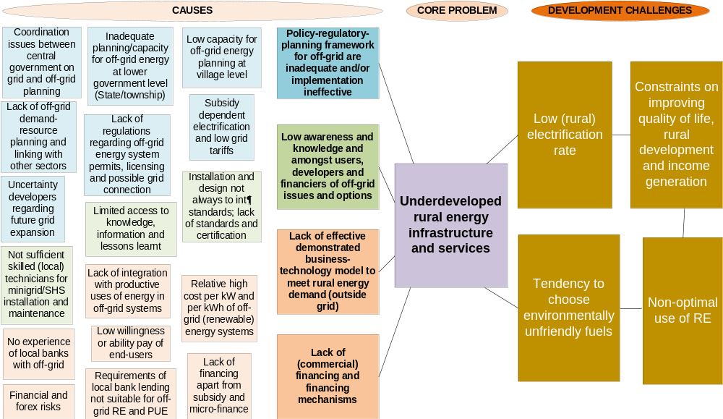

Barriers and challenges:
I. Policy-regulatory planning framework for off-grid energy systems is inadequate and/or the implementation is ineffective
- Dependence of off-grid electrification on subvention.
Subvention has helped to set up a government-enabled expansion in off-grid services. During 2012-2016 subsidies contributed to 100% of capital investment costs while in recent years this has come down to 85-90% for solar home systems (SHS) (10-15% expected to come from communities) and 60% for mini-grids (20% expected to come from developers, 20% expected to come from communities). However, in the longer run, subvention will also act as a deterrent to market growth, by: 1. making renewable energy (RE) developments that cannot access such subsidies uncompetitive, 2. Imposing a huge cost to the government’s budget. As long as the WB support for NEP continues (at least until 2022) the subsidy is likely to exist in its current form. Overtime, as renewable energy mini-grid markets mature, and the next generation of mini-grids come online, benefiting from better software, lower battery costs, higher demand and average revenue per user, and aggregation of assets, as well as lower financing costs, the levelized cost of electricity (LCOE) will lower, and policymakers can aim to phase out subsidies.

- Uncertainty regarding grid expansion and coordination issues
Under the NEP, the national grid is expanding quickly in some areas, but plans and targets for specific townships and villages tend to change over time. This uncertainty makes mini-grid developers reluctant to invest if they suspect the national grid is arriving in the near future. After the National Energy Management Committee was disbanded, the coordination between MoEE and MoALI for on- grid and off-grid electrification has not always been optimal, adding to the uncertainty issue. At subnational level, there is little coordination between electricity objectives from the national government and local development planning.

- Lack of regulatory framework for mini-grids and uncertainty on future grid connection
There is no regulatory framework for mini-grids that covers safety, quality of service, tariff regulation and provisions for what happens to the mini-grid when the main grid arrives (e.g. the grid owner abandons the system with compensation, or the owner continues distribution and/or generation). Such a framework would partly address the uncertainties developers and investors face about their investments.

- Poor availability of data and inaccuracies and inconsistencies in the available data
Project developers / rural service companies (RESCOs) have to identify their own sites, often in remote areas, and compile data on energy supply and demand. This makes the development of RE resources expensive for developers. Policy-makers at lower levels of government (State/region, townships) may lack quality and reliable data on electrification plans or available local RE resources to make informed choices. Lack of data also disfavours technologies (such as mini-hydro) that need a more extensive resource assessment. To ensure that investment in mini-grids is made in the right places, on-grid electrification maps (and off-grid plans) must be updated and made available not only to central and sub-national government stakeholders (region, township), but also to RE companies, mini-grid developers, NGOs and village decision makers. The issue may be worsened by inadequate capacity at the subnational level (skilled staff, sufficient budget) to carry out regional energy planning.

- Poor linkage of off-grid systems in the country GHG monitoring, verification and reporting to UNFCCC
There is no real standard method on how to estimate the contribution of off-grid electrification to greenhouse gas emission avoidance, and hence its potential role as a mitigation option may be underestimated in official greenhouse gas reporting

Barriers and challenges:
2. Low awareness and capacity of users, developers, and financiers of off-grid issues and options
- Lack of systematic knowledge and info gathering and dissemination
Over the past 30 years, private companies or communities have installed thousands of mini-grids without significant outside grants or funding (see Annex E). These indicate that there is basic capacity and knowledge to set up village-level minigrids and local RE companies. It forms an experience that RURED (and electrification planning in Myanmar in general) should build on. However, the knowledge behind and the results of these past experiences have not been compiled and disseminated in a coordinated and systematic way. This leads to misconceptions regarding the costs and benefits of off-grid RE systems and of local abilities and potential.

- Low technical quality of installation and poor operation and maintenance of mini-grid and stand-alone PV options will hamper its more widespread diffusion
Notably, many of the mini-grid systems installed in the past vary in quality and do not always meet today’s design criteria and international standards and/or face operation and maintenance problems. RE technologies are slowly making inroads into the market, as evidenced by the rapid increase in the use of solar products in rural areas. However, some of these are poor-quality products and this may result in low consumer and policy-makers’ confidence and may stunt future rural RE market growth. User disappointment can adversely affect the consumers’ impressions of the technology and diminish their willingness-to-pay to acquire or replace faulty systems.

- Insufficient availability of skilled technicians for solar, hydro, biomass-based RE systems
While there are several capacity building efforts (e.g. NGOs and RE companies themselves) ongoing in Myanmar, there remain gaps in capacity building support, in particular, regarding skilled technicians to install, operate and maintain village-level solar, small hydro, biomass and wind energy systems. Women are seldomly involved in the local planning, implementation, and administration of village energy systems.

- Difficulties in matching demand and supply in the off-grid system’s design
Solar home systems can be easily deployed in large numbers, with identical kits installed in each house by technicians with basic training. However, with regards to renewable energy mini-grids, villages come in different sizes and therefore require different amounts of electricity, and may have one or more renewable energy resources (hydro, wind, biomass), in addition to solar. For these reasons, mini-grids (especially micro-hydropower mini-grids) generally need to be customized for each village. The customized attention required to develop mini-grids increases set up costs per project. Clustering villages together and offering standardised power generation systems, to the degree possible, can reduce these costs.

Barriers and challenges:
III. Lack of effective demonstrated business-technology models for investment in rural renewable energy (RE) systems and productive uses of energy (PUE)
- There is a lack of awareness among RE companies, developers and village beneficiaries on the possibilities for gaining access to energy with RE, energy demand needs and links with productive uses of energy (PUE)
In both grid and off-grid electrification, the government promotes self-reliant electrification (SRE) whereby villagers mobilise funds for connection to the grid, and in the case of off-grid systems, apply for government funding (with the community and developers sharing the remaining cost of the energy access). This approach has been hampered by a lack of technical expertise, lack of skills and guidelines on governance and management of electrification committees, poor linkage with productive uses of energy (PUE) and livelihood considerations and overreliance on government subvention

- High initial cost of off-grid systems (in comparison with diesel generators); WTP and ATP
Off-grid mini-grids result in electricity costs that can vary between USD 0.20-1.20 per kWh, depending on size and technology. On the one hand, tariffs need to recover initial investment and annual operating costs. On the other hand, large numbers of households often face difficulty to pay tariffs at a level needed for the mini-grid to be financially sustainable (ability to pay, ATP), or may not want to pay a certain level (willingness to pay, WTP), e.g. not more than the national grid tariffs. Even with high levels of subvention of the off-grid energy system, tariffs are often set low to meet ATP/WTP. Where revenues do not cover the costs, mini-grids can run into financial-operational problems over time.

- The DRD-NEP scheme focuses on the realization of the mini-grid and SHS, i.e. the supply side, rather than on the utilization of the mini-grid system, leading to low energy consumption levels and reduced sales revenues, rendering the system uneconomic
As part of village-level project formulation, the demand-side should receive as much attention as the supply side. In the current DRD/Call for Proposal system, there is no incentive to design the capacity of the system in accordance with the expected demand, leading to oversized systems and low load utilization rates (see also discussion in Exhibit 4)

Barriers and challenges:
IV. Lack of (commercial) financing and financing mechanisms
- Other than small, project-based micro-finance loans, there are no dedicated financial instruments for small enterprises and off-grid development (there is a gap between micro-finance and commercial lending for large projects)
The longer-term sustainability of off-grid electrification requires less dependence on subvention and increased use of local finance for larger investments. Currently, there is a gap between the micro-finance offered by NGOs and MFIs and the commercial financing available for large infrastructure projects. Many investments in off-grid RE systems are about USD 150,000-250,000 in size. Developers of rural energy systems (and developers of larger PUE, such as milling and other agro-processing; irrigation schemes) cannot get access to commercial finance. The banking sector was opened in 1992 after being nationalized in 1962 but restrictive regulations have stunted the maturity of the financial sector.
  - Lending is geared towards the commercial/industrial sector and does not easily cater for small projects or businesses;
- Lenders’ lack of familiarity with rural energy technologies increases the perceived risk of these projects and inhibits lending to the nascent sector. Banks and financial institutions lack the necessary technical knowledge to assess off-grid projects and are, therefore, unwilling to lend to projects.
- When financing is available, interest rates are controlled by the Central Bank (8-13%), while the loans can have short tenors (of 3 to 5 years only) with very high collateral requirements (around 100%), making it nearly impossible for mini-grid developers to apply for loans

- Financing costs (the cost of equity and the cost of debt) for solar PV mini-grid projects are high in Myanmar.
Higher financing costs reflect a range of investment risks solar PV mini-grid developers/investors face in Myanmar. Four risk categories, in particular, contribute strongly to higher financing costs (see Annex F):
1) “Energy market risk” refers to power/energy market regulations and policies for mini-grids, such as the need for government regulations on integrating mini-grids to the national grid when it arrives, and a published national grid extension plan;
2) “Financing risk” refers to the lack of sufficient liquidity in the domestic banking sector and lack of availability of financing from domestic banks to mini-grid developers; and
3) “Currency risk” refers to the depreciation of local currency (MMK) versus USD, given that significant investment into the mini-grid sector has been made by foreign investors, and
4) “Sovereign risk” refers to the overall conditions of stability, peace, and sovereign credit risk.

Alignment with national priorities

This part gives an overview of the main policy documents on energy, environment, and development as related to the Project. For details on priorities in documents and policy-making institutions involved the reader is referred to Annex E and Section 4.2

Myanmar Sustainable Development Plan has been formulated by the Ministry of Planning and Finance with the objective of giving coherence to the policies and institutions necessary to achieve genuine, inclusive and transformational economic growth. It is built around a number of pillars, each with goals and proposed strategies. These can be related to the global community’s Sustainable Development Goals (as detailed in Exhibit 6).

The 2015 Myanmar Energy Master Plan was put forward by the Asian Development Bank and the Ministry of Electricity & Energy (MoEE), in order to analyse energy demand development from 2014 to 2035 along five supply expansion scenarios. The Plan feeds into a national investment strategy in energy sector infrastructure and forms the basis for a recommendation on institution building for Myanmar's future national energy planning. The plan envisions an energy generation mix of 57% hydropower, 30% coal, 8% natural gas and 5% solar and wind by 2030.

Alongside the Energy Master Plan, the Myanmar Government released its National Electrification Plan (NEP), with the ambitious goal of providing electricity access to all households by the year 2030. The plan aims to expand the national grid, under the responsibility of the MoEE, and develop off-grid electrification for remote communities by means of mini-grid and renewable energy (RE) technologies, under the Ministry of Agriculture, Livestock and Irrigation (MoALI).

The ADB supported the development of a Renewable Energy Policy in 2014 (then under the purview of the Ministry of Education). The Policy’s goal is to achieve a 27% share of renewable energy in the total installed capacity of primary energy by 2030. However, after the government’s restructuring of ministries and departments in 2016, the Policy has remained in draft form.

Myanmar formulated it’s Intended Nationally Determined Contribution (INDC) that was submitted to the Conference of Parties of the UN Framework Convention on Climate Change (UNFCCC) in 2015 (and has subsequently become Myanmar’s NDC). Regarding ‘rural electrification – renewable energy’, the INDC mentions that Myanmar “has received co-funding from a number of international development partners to develop mitigation actions in this sub-sector” and that “as a final result of the overall action, 6 million people in rural areas will have access to electricity generated by a variety of sources, at least 30 % of which will be sourced from renewables such as of mini-hydro, biomass, solar, wind and solar mini-grid technologies”.

The Environmental Conservation Department (ECD) of the Ministry of Natural Resources and Environmental Conservation (MoNREC) has formulated the Myanmar Climate Change Strategy and Master Plan 2018-2030 (MCCSMP). This document, which is pending approval, stresses that the country's rich capacity to harness its rich natural and renewable energy resources and improve energy access will determine its ability to achieve its Sustainable Development Goals (SDGs)”.

The National Environmental Policy, recently adopted by the Government of Myanmar, establishes a number of policy principles to promote sustainable development, including the following two with direct relevance for RURED: “Sustainable and renewable energy for the needs of people and for economic development in Myanmar will be secured, and utilized efficiently, through the use of existing technology and innovations in the generation, storage, supply and use of energy” and “Climate-smart approaches to development, including resilience, climate change adaptation and mitigation, and disaster reduction strategies, will be aligned to environmental protection and good natural resource management approaches in the pursuit of low-carbon, sustainable development.”

Relevance to GEF priorities

The project falls within the GEF-6 programme area “Promote the timely development, demonstration, and financing of low-carbon technologies of the Climate Change focal area’s Objective #1 “Promote innovation, technology transfer, and supportive policies and strategies”.

Relevance to the SDGs

The 17 Sustainable Development Goals (SDGs) were adopted in 2015 by the international community, including Myanmar, as part of the UN 2030 Agenda for Sustainable Development. Goal 7 specifically deals with sustainable energy, while there are various indirect linkages of sustainable energy with some of the other SDGs, including gender (Goal #5), infrastructure (Goal #7), and climate change (Goal #13). More information is provided in Exhibit 6.

Alignment with the UNDP programme in Myanmar

The Government of Myanmar (GoM) has committed to a series of policy reforms on environmental governance, climate change and disaster risk reduction (DRR), to ensure that economic growth in Myanmar is more inclusive, resilient and sustainable. The Governance for Resilience and Sustainability Project (GRSP) will support the GoM’s implementation of these policies during 2018-2022. GRSP is intended as an umbrella programme under which various UNDP-supported energy, environment, climate change, and disaster risk reduction activities in Myanmar can be linked and integrated, including the RURED Project.

This project will contribute to the following country outcome included in the Country Programme Document (CPD, 2018-2022): “By 2022, Myanmar becomes more resilient to climate and disaster risk with efficient environmental governance and sustainable use of natural resources”.

Exhibit 6 Linkages of rural and renewable electricity with SDGs and Myanmar’s Sustainable Development Plan

Sustainable Development Goals | Linkage with renewable energy and rural electrification | Myanmar Sustainable Development Plan - Strategies  (with energy-relevant linkages to the SDGs)
Sustainable energy:
7.1 Ensure universal access to affordable, reliable, and modern energy services  7.2 Increase substantially the share of renewable energy in the global energy mix |  | 5.1 Provide affordable and reliable energy to populations and industries via an appropriate energy generation mix
Other sustainable development:
1. End poverty in all its forms everywhere | Access to basic energy services is a requirement for poverty eradication | 3.5 Increase broad-based access to financial services and strengthen the financial system overall
3. Ensure healthy lives and promote well-being for all at all ages | Basic energy services are required to deliver health services | 4.2 Strengthen health services systems enabling the provision of universal health care using a path that is explicitly pro-poor
4. Ensure inclusive and equitable quality education and promote life-long learning opportunities for all | Basic energy services are required to deliver education | 4.1 Improve equitable access to high quality lifelong educational opportunities
5. Achieve gender equality and empower all women and girls | Basic energy services are required for women-led rural enterprises and activities | 3.5 Increase broad-based access to financial services and strengthen the financial system overall
6. Ensure availability and sustainable management of water and sanitation for all | Energy is needed to supply clean water to rural communities | 5.3 Enable safe and equitable access to water and sanitation in ways that ensure environmental sustainability
8. Promote sustained, inclusive and sustainable economic growth, full and productive employment and decent work for all | Productive uses of energy can make a rural energy system more viable by adding demand (and revenues) other than lighting for households. On its turn, the availability of power enables rural production (micro-businesses, agro-processing, tourism, rural manufacturing, other) | 3.2 Support job creation in industry and services, especially through developing small-and medium-sized enterprises (SMEs)  3.5 Increase broad-based access to financial services and strengthen the financial system overall
9. Build resilient infrastructure, promote inclusive and sustainable industrialization and foster innovation | Resilient infrastructure and public-private partnerships are required to ensure access to energy for all | 3.6 Build a priority infrastructure base that facilitates sustainable growth and economic diversification
10. Reduce inequality within and among countries | Access to electricity in rural areas brings potential to genuinely bring energy for all, including in remote rural areas, thus reducing inequalities | 1.2 Promote equitable and conflict-sensitive socio-economic development throughout all States and Regions
12. Ensure sustainable consumption and production patterns | Renewable energies are a key part of a future in which there is sustainable consumption. | 5.1 Ensure a clean environment together with healthy and functioning ecosystems
13. Take urgent action to combat climate change and its impacts | The carbon-intensive energy sector (based on fossil fuels) is a key driver of climate change. Renewable energy substitutes fossil fuels (zero emission) | 5.5 Improve land governance and sustainable management of resource-based industries ensuring our natural resources dividend benefits all our people
15. Protect, restore and promote sustainable use of terrestrial ecosystems, sustainably manage forests, combat desertification, and halt and reverse land degradation and halt biodiversity loss | Linking small hydro and biomass-based projects with natural resources management (e.g., watershed protection; sustainable biomass production) | 5.2 Increase climate change resilience, reduce exposure to disasters and shocks while protecting livelihoods, and facilitate a shift to a low-carbon growth pathway
Compiled from Transforming our World: the 2030 Agenda for Sustainable Development (UN, 2015), Indicators and a Monitoring Framework for the Sustainable Development Goals, Sustainable Development Solutions Network (SDSN), Myanmar Sustainable Development Plan (2018-2030)

Compiled from

Strategy

Project objective and project summary

The previous Chapter discussed the development challenge linked to the core problem of underdeveloped rural (renewable) energy infrastructure and services, a situation which is caused by the persistence of a number of main and underlying barriers and challenges). Realising this change requires a number of interventions under the project’s theory of change, as explained in this Chapter.

Responding to the identified core problem, the project’s objective is “to facilitate expansion of rural renewable energy services and productive applications in Myanmar”. The project seeks to achieve this by means of a multi-pronged barrier removal approach, focusing on solutions for policy and regulatory de-risking to address the earlier identified problem of an inadequate policy-regulatory framework for off-grid development. A full DREI analysis and market study will inform advisory services to the central government on long term sustainable support mechanisms for RE mini-grids. Since inadequate planning and capacities for off-grid energy planning at sub-national, township and village level were identified as one of the causes, policy de-risking advisory services will also be dedicated to this target group. A need for enhanced skills and capacities was identified as one of the key problems in mini-grid development, resulting in a strong focus of the project on capacity building and awareness raising. A lack of effectively demonstrated business-technology models including productive uses of energy (PUE) in RE mini-grids was identified as a key problem for realising cost-effective RE mini-grids. The project will therefore emphasize its activities on productive uses of energy when identifying and supporting the design of mini-grids. At the same time, the lack of commercial finance for mini-grids, will be addressed by project activities focusing on increased (commercial) investments and financing solutions for renewable energy mini-grids in rural areas. The project will have 3 components and 4 outcomes, one for each of the barrier removal areas, while each outcome is resulting from a number of outputs (see Exhibit 7). A detailed description of outputs and project activities is presented in Chapter 4 on Results and Partnerships.

Exhibit 7 Summary of project outcomes and outputs

Project components | Project outcomes | Project outputs
I. Policy and regulatory de-risking for improved renewable energy (RE) services and productive applications | 1. Effective implementation of supportive policies and regulations at national and local level for enhanced RE utilisation in rural productive uses | 1.1 DREI analysis conducted to support the implementation of the NEP  1.2 Advisory services provided to DRD, MoEE, ECD and to coordinate activities under NEP  1.3 Completed least-cost geospatial analysis and investment prospectus for RURED Project Areas
II. Strengthened capacity and awareness of market enablers and beneficiaries on rural renewable energy application | 2. Awareness and knowledge enhanced of government entities, market enablers and beneficiaries | 2.1 Capacity needs assessment conducted for national and local government entities, RE market actors and beneficiaries  2.2 Capacity strengthening activities designed and delivered for government entities, market actors and beneficiaries  2.3 Training on RE and off-grid systems institutionalised  2.4 Experiences and knowledge captured, lessons learnt and info disseminated  2.5 Monitoring & evaluation
III. Rural renewable energy investments | 3a. Increased investments in rural RE to meet household demand, PUE and enterprise development | 3.1 Designed and implemented off-grid RE solutions and models integrated with PUE implemented in selected villages, total installed capacity 15 MW
III. Rural renewable energy investments | 3b. Financial programmes supported | 3.2 Assessed and facilitated commercial financial support for rural RE energy projects

Theory of change

The theory of change underlying the above-described approach is that addressing one area alone will not reliably generate progress towards the project objective, and therefore a multi-pronged approach is necessary. In other words, synergies between progress in multiple areas are needed to really move the dial to a level at which substantial replication can occur, so that RE mini-grid development in combination with productive use solutions are adopted on a wider scale in Myanmar. For example, support to policy and regulation is needed to remove policy risks that increase the cost of finance for mini-grid developers. Policy makers, in turn, will benefit from capacity building to be convinced of the value of rural electrification through RE mini-grids in combination with productive use solutions. Technical training for market actors will contribute to the quality and thereby commercial and technical viability of RE mini-grids. Similarly, more financing solutions for RE mini-grids can contribute to achieving wider-spread adoption, but substantial financing will not occur without proof of viability and reliable information on the technologies. Exhibit 8 presents a diagram depicting the interaction between the project’s four main barrier removal areas, which form the basis of the project’s multi-pronged barrier removal approach.
Exhibit 8 Theory of change – objectives, outcomes and outputs

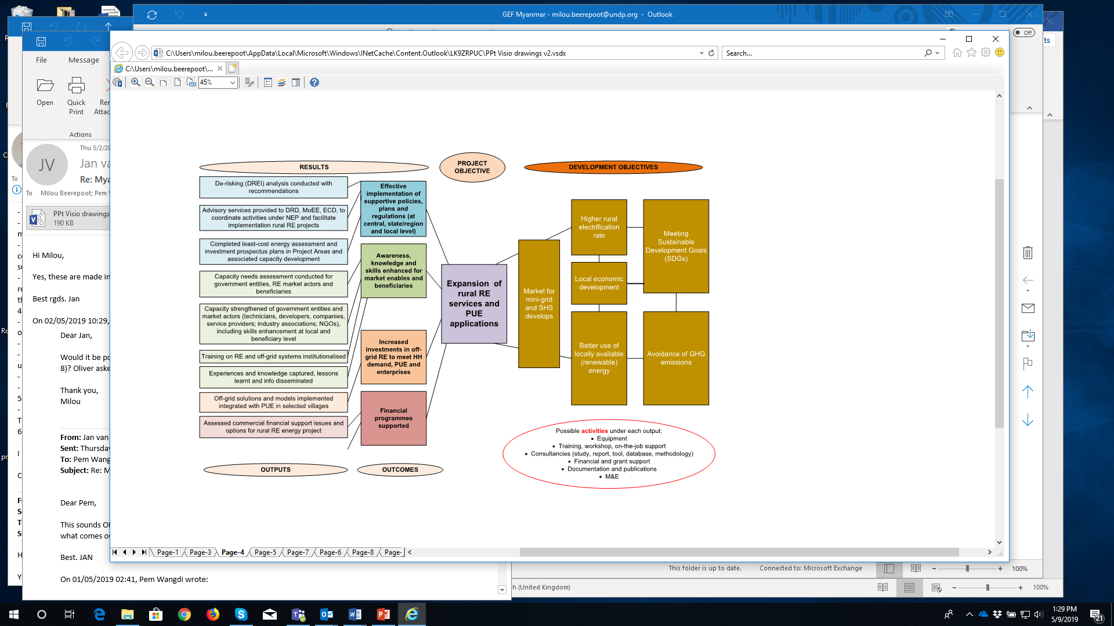
The RURED Project seeks to add on to baseline activities as undertaken by the Myanmar government and address the gaps by designing and implementing additional interventions and activities. GEF support is needed to be able to implement these additional interventions (referred to as incremental reasoning). In the baseline situation and persistence of status quo challenges and barriers, Myanmar’s electrification goals regarding universal access in 2030 will not be met (which is referred to as the baseline scenario). Addressing the underlying issues and barriers of the core problem (the underdeveloped rural energy infrastructure and services) will help the transitioning of Myanmar on the path of realizing its ambitious universal energy access target by 2030 (referred to as the alternative scenario).

The Project’s Theory of Change explains the process of change by outlining the linkages of its interventions, i.e., its outputs, direct outcomes, and impacts, with the before-mentioned main barriers to change. While Exhibit 5 in Chapter 2 showed the development challenges, core problem with main causes (and underlying barriers), Exhibit 8 shows how the project will lead to the project objective and related positive development objectives as a result of the project outcomes and underlying outputs.

The following table follows the barriers and challenges that contribute to the core problem and describes the baseline activities and the expected results (outcomes and outputs) of the RURED project. The table also shows the incremental reasoning , i.e. the additionality of the proposed project results as compared to the baseline situation (a full description of the baseline situation is provided in Annex E).

Component 1 Policy and regulatory de-risking for improved renewable energy (RE) services and productive application

Barriers and challenges:
- Dependence of off-grid electrification on subvention.
- Uncertainty regarding grid expansion
- Lack of regulatory framework for mini-grids and future grid connection
- Poor availability of data and inaccuracies and inconsistencies in the available data
- Poor linkage of off-grid systems in the country GHG monitoring, verification and reporting to UNFCCC
Baseline activities  - Asian Development Bank (ADB) Technical assistance (TA) for Off-Grid Renewable Energy Demonstration Project, Activity 2: Least-cost Energy Access and Off-grid Investment Plan: use of geospatial tools in planning in Mandalay, Sagaing and Magway region (in Myanmar’s Dry Zone area), Activity 3: Strengthen Off-Grid Planning and Business Capacity for Myanmar government institutions (project finalised)  - GIZ project “Promoting Rural Electrification in Myanmar”: Support to the government in developing a regulatory framework for mini-grids (with support from New Zealand), e.g. financial support mechanisms, ownership structures, tariff schemes, and grid interconnection at both Union level and state-level. In Phase 2 (2020-22) GIZ will work with MoEE on capacity building and more systematic use of geospatial (grid extension) planning  - Funding for NEP off-grid comes from the government, WB, KfW, GIZ, Italy, ADB, and Japan (JICS), amounts to approximately USD 150 million over 2016-2022. Italy support has focused on Chin State (about 32 million); KfW support (EUR 9 million) on Shan State). Mini-grid component Call for Proposals (CfPs) are being vetted by WB project implementation office with assistance from GIZ. WB support is USD 90 million (USD 80 million capital support for CfP and USD 10 million for TA. Support includes technical assistance in a developing project pipeline (CfP, site assessments, pre-qualification companies, business models)  - PACT-led Smart Power Myanmar (SPM) is currently conducting a nationwide assessment of the potential for decentralized energy access solutions, mini-grids in particular (not focusing on SHS) with expected findings to be shared in Q1/2019. The ‘Bridging the Energy Gap’ study published in June 2018 was conducted in 50 villages.  Planned projects:  - AFD: identification stage of rural energy (soft loans of EUR 15-25 million for biomass and RE mini-grids)  - DFID: pilot testing of solar-hybrid mini-grids using ABC model (Mandalay, Magway, Shan) with Infracapital Myanmar  - EU: Market study on rural electrification (emphasis on finance blending from ElectriFI or Asia Investment Facility)  Link with UNDP GRSP project:  Project output 1:  - Resilience and sustainability policy frameworks are strengthened - GRSP is focused on implementing the National Environmental Policy, which is directly linked to Myanmar’s Climate Change Strategy and Master Plan, references the need for innovative solutions to provide sustainable and renewable energy supplies, and advocates for mainstreaming environment and climate change considerations through all sectors. Through these linkages, GRSP and RURED will work collaboratively on the policy development components of the project. | Additionality (incremental reasoning):  Without UNDP/GEF support, the development of the rural RE energy market will happen at a much slower pace. At the national level, the GEF intervention will support:  - The use of risk analysis tools, such as DREI, and development of effective de-risking policy instruments can help to create a necessary environment for the effective implementation of NEP, planning and regulations not only at the union level but at the state level too. The DREI methodology systematically identifies public de-risking measures to target these risks, thereby lowering financing costs and resulting in lower generation costs. The modelling demonstrates how investing in public de-risking measures could create significant economic savings for solar PV mini-grid developers and help the government in achieving the investment objectives in Myanmar’s National Electrification Plan. The DREI analysis, in combination with further market analysis identifying issues such as regulatory regime, grid expansion risk, mobile money and rural cellular coverage, can contribute to advisory services to the central government on long term sustainable support mechanisms for RE mini-grids, including the gradual phase out of subsidies and need for policy that can support private sector financed mini-grid development.. A study gathering empirical data on costs of mini-grids, including modeling, will further contribute to analysis on reducing subsidies for a future scaled-up, regulatory regime creating the enabling conditions for sustainable growth of rural energy development.  - Working with DRD, MOEE and GIZ on on-grid and off-grid electrification planning and regulations; as well as work with DRD and development partners (SPM and GIZ) on business and technology delivery models for off-grid systems (and productive uses of energy) that are financially, socially and technologically sustainable; and modalities for the reduction of capital cost of RE systems and reduction of the dependence on government subsidies and support to the ‘energy access working group’ of the ‘Energy Sector Coordination Group’ to help it expand into a vehicle for the intra-ministerial cooperation and stakeholder dialogue.  - Strengthening ECD’s methodology for greenhouse gas emission calculation as part its nation GHG monitoring, verification and reporting (National Communications; INDC)  Corresponding outputs in RURED project:  1.1 DREI analysis and market study conducted to support the implementation of the NEP  1.2 Advisory services provided to DRD, MoEE, ECD and to coordinate activities under NEP, building on DREI analysis and other assessments undertaken by RURED support
At the regional/township level, GEF incremental activities include:
  - Least-cost energy access and investment planning using geospatial planning tools and software, building on the experience of the ADB, for the integrated analysis of RE resources, population, economic activity (productive uses) and social services (schools and health facilities in RURED Project’s geographical focus areas

Corresponding outputs in RURED project:
1.3 Completed least-cost geospatial analysis and investment prospectus plans in RURED Project Areas

Component 2 Strengthened capacity and awareness of market enablers and beneficiaries on rural renewable energy application
Barriers and problems:
- Lack of systematic knowledge and info gathering and dissemination
- Low technical quality of installation and poor operation and maintenance of mini-grid and stand-alone PV options will hamper its more widespread diffusion
- Insufficient availability of skilled technicians on solar, hydro, biomass-based RE systems
- Difficulties in matching demand and supply in the off-grid system’s design

Baseline activities:  - GIZ “Promoting Rural Electrification in Myanmar”: strengthening competence of private sector and community stakeholders  - IFC “Lighting Myanmar” project supporting manufacturers and distributors of solar to enter and scale in Myanmar, through market research, business development support, consumer education, and policy engagement. Also exploring support for appliance and productive use sectors  - NGOs, such as REAM and Spectrum-SDKN: information gathering on off-grid and SHS activities and dissemination to members and the public at large  - SPM: market research and knowledge sharing; creating and strengthening village energy governance structures, cooperating and delivering modules of with GIZ/DRD-facilitated training to RE developers/RESCOs  - The Renewable Energy and Electronics Research Centre of DRI organizes technical training (design, operation) on renewable energy  Link with UNDP GRSP project:  Project output 4:  Local resilience and sustainability issues are addressed through inclusive implementation (environmental action plans, training, knowledge products) – GRSP is working in a number of States and Regions, including southern Shan State, to support strategic planning responses to local environmental issues and sustainable development challenges. GRSP and RURED will collaborate on integrating the promotion of renewable energy in the project sites into the relevant broader strategic action planning for sustainability. | Additionality (incremental reasoning):  - RURED aims to enhance the ability of subnational (State/region, and township level) government to better define and respond to projects and electrification needs in their respective regions and communities in support of the subnational mandates in off-grid energy development. These have been focused on targets (number of villages and installed capacity) rather than actual village energy needs and proper design. Local actors should also be able to obtain more input from the national and local authorities, e.g. regarding future on-grid electrification and regulations.  - Despite the efforts of GIZ and some NGOs, there is still a large need to improve and add to existing RE technical training modules, which are basic and do not include a robust quality framework. Engineers and technicians with expertise in renewable energy are and will be in high demand as the implementation of RE and off-grid system increases over time. The DRI technical trainings need to be strengthened and there is a need for expanded vocational training to further improve the skills of technical personnel on RE  - Training of technicians located in the beneficiary villages will become increasingly important for operation and maintenance (O&M) as the off-grid programme expands to more and more areas. Gender-equitable Capacity building needs to be targeted and include ‘learning by doing’ opportunities shaped around developing a pipeline of rural RE projects (see output 3.1)  Corresponding outputs in RURED project:  2.1 Capacity needs assessment conducted for national, subnational and local government entities, RE market actors and beneficiaries  2.2 Capacity strengthening activities designed and delivered for government entities, market actors and beneficiaries  2.3 Training on RE and off-grid systems institutionalised  2.4 Experiences and knowledge captured, lessons learnt and info disseminated  2.5 Monitoring & evaluation

Component 3 Rural renewable energy investments

Barriers and problems:
- There is a lack of awareness among RE companies, developers and village beneficiaries on the possibilities for gaining access to energy with RE, energy demand needs and links with productive uses of energy (PUE)
- High initial cost of off-grid systems (in comparison with diesel generators); WTP and ATP
- The DRD-NEP scheme focuses on the realization of the mini-grid and SHS, i.e. the supply side, rather than on the utilization of the mini-grid system, leading to low energy consumption levels and reduced sales revenues, rendering the system uneconomic
- Other than small, project-based micro-finance loans, there are no dedicated financial instruments for small enterprises and off-grid development (there is a gap between micro-finance and commercial lending for large projects)
Baseline activities:  - PACT-Smart Power Myanmar: improvement of the process of mini-grid development through site identification and assessment, demand-side support; utilization of mini-grids development or in the pipeline; improved data collection and analysis of mini-grid operations; consumer financing: micro-finance, Village Development Funds (VDF), women’s micro-enterprise loans and Energy Impact Fund to enable households and businesses to overcome high connection fees (USD 200) to mini-grid systems and provide finance for PUE (e.g. freezers for fishing communities);  - HIVOS, HyCEM, and REAM work together to set up a framework for the advancement of ‘homegrown’ micro/mini hydropower (MHP) sector (including affordable finance, strengthening of HyCEM, and ensure the participation of MHP developers in the DRD-NEP Call for Proposals  - A-Bank and REAM intend to set up a programme to enable (commercial) financing for off-grid (decentralised) RE in Myanmar  Link with UNDP GRSP project:  Project output 2:  Increased promotion of small and large-scale green investments - GRSP is actively promoting Myanmar’s green economy potential including through identifying barriers to investment in various green industries. The RURED efforts to de-risk investment in renewable energy will be integrated with the broader investment promotion efforts under GRSP. | Additionality (incremental reasoning):  - The UNDP/GEF project is promoting a paradigm shift that moves away from the typical electrification trends using indicators that stress the supply-side achievements (so many villages, so many systems) to emphasizing demand stimulationby means of maximising the potential for productive use of energy. Productive uses of energy (PUE) are, for example, agricultural production and processing, handicrafts, local tourism, small enterprises. The use of sustainable energy to improve productivity in rural areas (which will, in turn, improve the economic viability of the renewable energy mini-grid) also leads to wider human development impacts that enable poor households to move away from poverty. Encouraging productive use of energy also offers the opportunity to promote socio-economic inclusion of IPs, as well as support women’s empowerment first by understanding which PUE may be of particular interest to these groups and then prioritising these forms of support  - In cooperation with PACT-Smart Power Myanmar, the RURED Project will build a block of village projects that will complement the current DRD-NEP CfP process by offering a business model that will integrate subsidy and non-grant finance for energy access and the simultaneous development of PUE (and social uses, clinics, schools), and aiming at reduction of equipment and development cost in project design. One way to reduce cost is by working with a group of villages rather than on a one-by-one basis, allowing a more standardised technology solutions and lower project development cost.  - Where needed, the RURED can provide grant support to enable ‘productive uses’. To support commercial debt financing to renewable energy mini-grid developers, financial support is provided to back up loan guarantee insurance (to partly cover the high collateral requirement local banks ask small business or projects)  - In the selection of villages, supply-demand assessment, design of the mini-grid and other energy solution, and formulation of finance and business plan, as well as subsequent monitoring and evaluation of the village RE systems, the RURED Project will closely work together with local authorities and Smart Power (SPM), REAM, RE associations (HyCEM, UMFCCI Solar Group) and local civil society organisations (CSOs).  - The RURED project foresees most of the selected mini-grids to be submitted under the DRD-NEP Call for Proposals to benefit from the current financial support under this mechanism. However, the project will also look for alternative financing models and where possible test the feasibility of such models.  In order to meet the 2030 electrification goals, access to financing will have to increase substantially, and private sector financing will need to be mobilised for off-grid energy access solutions, which will provide a source of demand for RETs to emerge and investments by local manufacturers/suppliers and households to be triggered. The project will:  - Make an assessment of issues, bottlenecks and potential solutions in the financing landscape in Myanmar and provide support to the development of financial mechanisms to support off-grid investments (by VECs and project developers) thereby minimising government subvention (e.g. micro-finance, credit and risk guarantee schemes; concessional loans; innovative financing);  - During project implementation, credit guarantee options and other loan facilitation schemes will be discussed with relevant organisations, such as the European Union, USAID Development Credit Authority (DCA) and AFD (Agence Française du Développement).  Corresponding outputs in RURED Project:  3.1 Designed and implemented off-grid RE solutions and models integrated with PUE implemented in selected villages, total installed capacity 15 MW  3.2 Assessed and facilitated commercial financial support for rural RE energy projects

Results and Partnerships

Expected results

This Section describes in detail the activities under each outputs of the four outcomes of the RURED project. The outcomes and outputs follow from the incremental interventions (additional to ongoing or planned baseline activities) identified and described in the previous Chapter, which explained the strategy and theory of change of the RURED project.

Component 1 Policy and regulatory de-risking for improved renewable energy (RE) services and productive application

Output | Activity
Outcome 1 Effective implementation of supportive policies and regulations at national and local level for enhanced RE utilisation in rural productive uses
1.1 DREI analysis conducted to support the implementation of the NEP | 1.1.1 DREI analysis for small-scale RE and market study conducted to support the implementation of the NEP
Main partner: MoALI-DRD; GIZ
Other partners: renewable energy companies and associations (e.g. REAM), NGOs; financial service providers (FSPs) and micro-finance institutions (MFIs)
1.2 Advisory services provided to DRD, MoEE, ECD and to coordinate activities under NEP | 1.2.1 Advisory services to ECD of MoNREC, on off-grid electrification and greenhouse gas (GHG) emission monitoring, verification and reporting  1.2.2 Advisory services to DRD (and MoEE) on National Electrification Plan (NEP), based on results and recommendations from activities 1.1.1
Main partners: MoALI-DRD; GIZ; MoEE; MoNREC-ECD
Other partners: REAM, Smart Power Myanmar (SPM)
1.3 Completed least-cost geospatial analysis and investment prospectus plans in RURED Project Areas | 1.3.1 Resource and demand assessment and investment prospectus in Shan State, Tanintharyi and/or Dry Zone.  1.3.2 Tools developed for sub-national level rural and RE off-grid planning
 | Partners: DRD; selected region/State government, townships; SPM, REAM

The following paragraphs describe the Activities that will be conducted to deliver the expected Outputs to contribute to the realization of Outcome 1. GEF support is requested to obtain the following deliverables:
- Detailed DREI study on solar and hydropower mini-grids (DREI: Derisking Renewable Energy Investment)
- Market study . following from DREI results as well as mini-grid costs development analysis.
- Improved methodology with collected energy and greenhouse gas emission data on rural electricity as input for national GHG MRV (monitoring, reporting, and verification)
- Consultancy and advisory support for DRD and the existing ‘electrification working group’ formed by development partners.
- Least-cost geospatial analysis in the geographical focus areas of the RURED project (with a prospectus of investment opportunities in mini-grid energy systems in selected villages in these geographical areas. From the PPG phase follows the suggestion of focusing on southern/eastern Shan and coastal areas of Tanintharyi as well Dry Zone areas (for the rationale of selecting these areas the reader is referred to Exhibit 9).
- Development of tools and instruments that help formulate least-cost geospatial analysis plans, carry out RE resource assessment and identify RE mini-grid investment opportunities (manual, application, and adaptation of software for energy resource, demand and geospatial planning)
Exhibit 9 Areas of geographical focus of RURED

The project has identified three States/Regions as possible locations: a) Tanintharyi, in particular the coastal areas; and b) Shan State, in particular the mountainous areas of eastern/southern Shan, c) Dry Zone. A general description of these areas can be found in the Annex E.8. The project will select two of these three States/Regions based on a set of technical criteria as listed under Output 3.1, Activity 3.1.1. The selection of the project sites will follow a conflict sensitive approach, and aim for the inclusion of marginalized groups, and follow FPIC for IP principles. Project sites will not be selected in areas where consent has not been granted. The selection of the project sites will be undertaken in the initial stages of the project inception phase.
Thus far, these areas have been lagging behind in applying for the DRD-NEP support scheme for mini-grid systems. Many islands in Tanintharyi are remote and have low likelihood of getting connected to the national grid in the foreseeable future. On the other hand, the islands do have potential for productive uses of energy (PUE) focusing on fisheries as well as tourism. Communities now depend on expensive diesel generator, which can be replaced with solar mini-grid systems with lower cost for the end-users. Another reason is that suitable potential partners already work in coastal Tanintharyi and Shan State, and the Project seeks to reinforce existing activities.
Mini/micro hydropower technology, which is very suitable in the region’s mountainous areas, has been under-represented in the DRD-NEP Call for Proposals possibly because the region has benefited more from DRD-NEP’s support for individual solar home systems. There is good potential to have solar PV and mini/micro hydropower (and hybrid RE) mini-grids installed and integrated with PUE. Shan State already has several thousands of mini/micro hydropower units (below 1 MW) but several are characterized by low technical quality, while in some cases poor operation and maintenance has led to malfunctioning of systems. Nonetheless, the experience of grassroots (hydropower) mini-grid practitioners provides a strong foundation upon which off-grid electrification can be expanded further with RURED support.
Coastal Tanintharyi, Southern Shan, and the Dry Zone are recommended in the project preparation PPG phase, but the Project does not necessarily exclude other areas. For example, Shan government representatives (when interviewed by the PPG Team) suggested the Project could also work in eastern Shan, which has more sensitive zones. The argument from a development viewpoint is that few NGOs work in these economically disadvantaged areas and presence of the Project could encourage other organizations to follow suit. In such case, the project will ensure proper consultation with the Shan government, township authorities, indigenous people representatives, NGOs and civil society organizations before venturing into sensitive areas.
Regarding Dry Zone, REAM in partnership with A-Bank has installed about 60 solar PV solar drip irrigation systems. By having cultivated water in the dry season, this promotes health (growing of vegetables) and increase income (sales of crops). The Project will work with REAM and other partners to augment productive uses (to existing or new systems). Although Shan and Tanintharyi and Dry Zone, came out of the PPG phase, as possible project areas, the Project can work with project partners based in other regions or states.

Output 1.1 DREI analyses conducted to support the implementation of the National Electrification Plan (NEP)

Activity 1.1.1 DREI analysis for small-scale RE (in Myanmar)
This activity will involve expanding the preliminary DREI analysis performed at PPG phase to come to a complete analysis for solar mini-grids (investment risks and barriers; de-risking instruments and levelized cost estimates). This may possibly include also hydro mini-grids. The DREI analysis will systematically identify the barriers and associated risks, which can hold back private sector investment in renewable energy. It should lead to conclusions that can help assist policymakers to put in place packages of targeted public interventions to address these risks. Data for the DREI study will partly come from the market and the extended baseline assessment (activity 1.2.1). The DREI study can be seen as an extension of the baseline assessment focusing on (financial) risks and risk mitigation. A market study will follow up on the results of the DREI analysis in order to collect more baseline information on a number of specific risks to be used for advisory services in Activity 1.2.3. An analysis of mini-grid costs, cost development and modeling towards future costs will thereby support analysis of long term development and abatement of financial support for mini-grids.

Output 1.2 Advisory services provided to DRD, MoEE, ECD and to coordinate activities under NEP

Activity 1.2.1 Advisory services to ECD of MoNREC, on off-grid electrification and their greenhouse gas (GHG) emission monitoring, verification and reporting
The activity will help the Environmental Conservation Department (ECD) in the formulation of National Communication, Nationally Determined Contribution (NDC) and other climate-relevant reports by providing a methodology for the measurement and estimation of (changes) in GHG emissions from off-grid and renewable energy technologies at national and sub-national level, using data from Activity 1.2.1 and other available data on off-grid energy systems. RURED will work with ECD on the issue of PV related wastes, i.e., the environmentally friendly disposal of lead-acid/lithium batteries. The Project will also work together with ECD in natural resources management and watershed protection of the river basins (in which the mini/micro hydro activities will be based) and environmental awareness.

Activity 1.2.2 Advisory services to DRD (and MoEE) on National Electrification Plan (NEP)
While several meetings, conferences and (informal) discussions between donors, government entities and the private sector are being organised on power sector development, Myanmar presently lacks an on-going and institutionalised platform that can promote intra-ministerial coordination on on-grid extension (MoEE) and off-grid electrification (DRD of MoALI) also including the Ministry of Border Affairs, and on research and development (involving the Ministry of Education). The Project will provide advisory services (Chief Technical Advisor and short-term experts, as needed) to the ‘energy access working group’ of the ‘Energy Sector Coordination Group’ and help it expand into a vehicle for intra-ministerial cooperation and stakeholder dialogue required to develop supporting policy, regulatory measures and consensus behind an integrated on-grid and off-grid electrification planning. At a higher decision-making level, the re-establishing of the former Energy Committees (see Annex E.1) could be considered. Important issues for the ‘electrification working group’ to discuss are coordinated electrification planning as well as standards and regulations for mini-grids installation and operation and for the performance of mini-grid and solar systems (in particular for the State/Regions RURED will focus on), building on on-going work by GIZ on grid-connection of mini-grid generators.

The RURED project will work with DRD (in coordination with WB and GIZ) on assessing and developing viable business and technology delivery models for off-grid systems that are financially, socially and technologically sustainable (reducing the capital cost of RE systems and minimising government subsidies). The results and recommendations from activities 1.1.1 (DREI analysis and market analysis) in combination with evidence from the support to mini-grid design and implementation with a strong emphasis on productive use of energy (output 3.1), can contribute to the discussion on long term sustainable support mechanisms for RE mini-grids, including the gradual phase out of subsidies and the need for policy that can support private sector financed mini-grid development. These inputs will be useful to structure future DRD-NEP Call for Proposals.

Output 1.3 Completed least-cost geospatial analysis and investment prospectus for RURED Project Areas

Activity 1.3.1 Energy resource and demand assessment and investment opportunities in areas of Tanintharyi, Shan and/or Dry Zone
In the project preparation phase (PPG), the following areas were identified as the Project’s focus areas, which are: a) the coastal areas of Tanintharyi (solar PV, and mini/micro hydropower) with PUE potential in fisheries and fishing communities and tourism; b) mountainous areas of eastern/southern Shan, (solar PV and mini/micro hydropower) with PUE (e.g. agro-processing) integrated with small hydro development; and/or c) the Dry Zone areas.

In these regions, the RURED project will support least-cost energy access and investment planning using geospatial planning tools (see in Exhibit 26 and Exhibit 27 in Annex E on the use of geospatial planning and resource assessment tools and software). This assessment will link energy infrastructure planning with economic potential (productive uses) and need for social services (schools and health facilities), population and the biophysical characteristics of the region. The economic potential of various income generating avenues e.g. grain mills, garment factories, hospitals, or a business district of shops ensures sufficient demand and revenues. As part of the geospatial analysis, existing demand in communities can be identified by using (night time) satellite imagery combined with other information from visits to communities or new approaches as already developed (for example in Nigeria) using smartphone apps. Also surveys can be conducted using data collection apps, which can be useful in Myanmar given the already very high smart phone penetration rate and the presence of Village Electrification Committees who could collect data and submit this via a data-collection app. Based on this assessment the geographical focus area of RURED will be narrowed to the most promising townships from two of the three States/Region from which villages will be selected for support under Output 3.1 (following the process described in Exhibit 10)

The assessment will look, among others, at a) review of existing plans and studies, resource assessment (hydro, and/or other), b) role of private sector and CSOs, and c) map existing and proposed mini-grids (hydro, solar) using geospatial planning tools to develop off-grid and RE plans (demand, distance to the grid, economic activity and PUE; costing of RE supply options, linked with RE resource assessment). The activity will coordinate on-going or planned efforts of DRD and townships, as well as analysis done by non-government project partners, such as Smart Power Myanmar (SPM), HyCEM, and REAM.

Based on the above-mentioned assessment, the Project will identify (in close coordination with DRD and other project partners) an investment prospectus of promising clusters of villages and RE sites with an overview of costs and benefits of mini-grids linked with PUE and livelihood enhancement activities in the selected villages. Clustering villages has the advantage that this approach creates a group of mini-grids, which can lower the unit cost of energy for consumers, maximise the return on investment, and lower overhead and project development costs of RE providers and developers.

Under this activity workshops will be organised to present findings and crowd-in financing from domestic and international sources and the private sector for the development of off-grid electrification in the selected project areas. The prospectus will be used in Activity 3.1.1 as a basis for the final selection of villages that will be supported by the RURED Project.

Activity 1.3.2 Tools developed for sub-national level rural and RE planning (RE, off-grid)
Taking into account the experiences and results of activity 1.3.1, a toolkit (manual) will be developed for sub-national level rural and RE planning that will be accompanied by guidelines that support a) the mainstreaming of PUE and integration with other rural development strategies and policies (agriculture, natural resources, disaster mitigation); and b) practical implementation of quality standards for off-grid systems and requirements and modalities of future grid connection of mini-grid systems (compensation, operation as distributor, generator or electricity retailer).

Existing software tools will be used as much as possible such as the geospatial tool used in previous Dry Zone assessments (described in Exhibit 26 in Annex E) and other RE assessment software (CORE-KIT and Hydrostreamer, described in Exhibit 27 ). On its turn, RURED will support the further development of CORE-KIT by providing the information on areas and villages that will expand CORE-KIT’s database. In addition, local, watershed-based, energy planning (in the case of hydropower) will be coordinated with CSOs that are involved in natural resources management and watershed area protection.

Component 2 Strengthened capacity and awareness for market enablers and beneficiaries on rural renewable energy application

Output | Activity
Outcome 2 Awareness and knowledge enhanced of government entities, market enablers and beneficiaries
2.1 Capacity needs assessment conducted for national and local government entities, RE market actors and beneficiaries | 2.1.1 Capacity needs assessment national and local government entities, RE market actors and village-level entities
Main partner: DRD, State governments, DRI, REAM, SPM, DRI
Other partners: RE associations (HyCEM, UMFCCI Solar Group)
2.2 Capacity strengthening activities designed and delivered for government entities, market actors and beneficiaries | 2.2.1 Seminars/workshops for government entities and market actors on best practices and lessons learnt in off-grid RE electrification  2.2.2 Technical training designed and delivered for RE companies, energy service companies and village organizations on various aspects of rural RE electrification  2.2.3 Guidelines established for the voluntary certification of RE technology installers and rural energy service companies (RESCOs)  2.2.4 Managerial and technical skills enhancement at local level that is gender-responsive and socially inclusive)
 | Partners: REAM, SPM, DRI, DTVE and vocational training institutes, HyCEM, Solar Group
2.3 Training on RE and off-grid systems institutionalised | 2.3.1 Technical support to strengthen DRI’s Renewable Energy and Electronic Technology Centre and selected universities  2.3.2 Technical support to vocational training centres
2.3 Training on RE and off-grid systems institutionalised | Main partners: DRI and DTVE (Ministry of Education)  Other partners: GIZ, REAM, SPM; selected universities and (vocational training) institutes
2.4 Experiences and knowledge captured, lessons learnt and info disseminated | 2.4.1 Development of a platform for info and knowledge sharing
Main partners: REAM, HyCEM, HIVOS, Spektrum-SDKN
Other partners: DRD and development partners
2.5 Monitoring and evaluation | 2.5.1 Mandatory project M&E (see Chapter 7)  Main partners: DRD and Project Board memebrs

The following paragraphs describe the Activities that will be conducted to deliver the expected Outputs to contribute to the realization of Outcome 2. GEF support will be requested to obtain the following results:
- Capacity gap and needs assessment of national, subnational and local government entities, RE market actors and village-level entities with recommended action in a capacity strengthening plan (including female-headed households, women more broadly and IPs to assess if there are particularly gaps in capacity among these groups)
- Organisation and delivery of seminar and workshops and technical training with the participation of qualified international and national experts. Linked with technical training will be the introduction of an industry-based certification system of RE technology installers and rural energy service companies
- Manuals on design, installation and operation of rural RE for technicians and developers developed (in local language)
- Design and delivery of gender-responsive and socially inclusive village-level awareness and knowledge enhancement activities
- Strengthened Renewable Energy and Electronic Technology Centre (DRI) and capacity enhancement of technical and vocational training centres (DTVE)

Output 2.1 Capacity needs assessment conducted for national, subnational and local government entities, RE market actors and beneficiaries

Activity 2.1.1 Capacity needs assessment national, subnational and local government entities, RE market actors and village-level entities
The activity will map the gaps in technical, planning and managerial capacity of government entities (national, State/region, township). At the subnational level, it will focus on the RURED Project Areas (see Output 1.3) and assess capacity building needs. Similarly, the gaps and capacity need of market actors (developers, energy service companies, NGOs/CSOs, technicians/installers) will be assessed with particular attention to the design, installation, operation, planning and finance of off-grid RE systems. Last but not least, the capacity needs of beneficiaries will be analysed (village electrification committees, cooperatives), with efforts in the planning phase to ensure that the capacity assessments take into account the differences between various segments of the populations, including female-headed households, gendered differences in technical capacity and end-use, as well as the needs to IPs in those communities. The activity will build on the extended baseline analysis of Output 1.1 (activity 1.1.1). The activity will be implemented in cooperation with DRD, Ministry of Education, the ‘energy access working group’ of the ‘Energy Sector Coordination Group’, SPM, and private sector organisations (HyCEM, REAM). The activity will result in a detailed capacity building plan for the Outputs 2.2 and 2.3. To encourage institutionalisation, the plan will identify partner organisations that will take a lead in organising capacity building activities, depending on topics, scope and expected target group. Partner organizations will include locally relevant women’s NGOs and representative organizations for IPs (CSOs in Tanintharyi, Shan and Dry Zone respectively).

Output 2.2 Capacity strengthening activities designed and delivered for government entities and market actors

Activity 2.2.1 Seminar/workshops for government entities and market actors on best practices and lessons learnt in off-grid RE electrification
The activity will support awareness building and knowledge dissemination events on best practices in the integration of PUE and livelihood considerations in site selection, mini-grid design and costing, financial/economic analysis and appropriate business models including financing options. Apart from information dissemination, the events will create an opportunity for project developers to discuss issues in rural electrification with government officials and will serve as a feedback mechanism for the government counterparts to play their role as an enabler. Apart from subject-specific workshops, there will be at least one Round-Table Event with government, donors, local banks, and civil society, for advocacy and developing solutions to key challenges. The activity will be implemented in cooperation with DRD, Ministry of Education, the aforementioned ‘energy access working group’, SPM, and private sector organisations (HyCEM, REAM). Depending on the topic, a partner organisation can take charge (this will be defined in the capacity strengthening plan of Activity 2.1.1)

Activity 2.2.2 Technical training designed and delivered for RE companies, energy service companies and village organizations on various aspects of rural RE electrification
The activity will consist of tailor-made technical training for proponents of solar mini-grids and stand-alone solar PV, and mini and micro hydropower mini-grids
o RE system design and installation, including resource and least-cost geospatial analysis; supply and demand analysis; design, installation (considering the latest standards, guidelines, and regulations, see Activity 1.2.4)
o Estimation of household demand, willingness and ability to pay (WTP/ATP), payment systems (e.g. ‘pay-as-you-go’), demand stimulation and integration with the design and planning of productive uses and rural livelihood activities (e.g., agro-processing, cold storage, battery charging, ICT, small wood and metal workshops; village stores, tourism, etc.)
- Training on the formulation of feasibility studies and bankable proposals (to be submitted to DRD-NEP Call for Proposals, and providers of debt and grant financing)

The activity will be carried out in close coordination with DRI and vocational training centres of the Ministry of Education (based in the selected RURED Project Areas, as well as relevant RE industry associations (e.g. REAM, HyCEM)). Target groups are developers, RE companies, and service providers; industry associations and NGOs).

Activity 2.2.3 Guidelines established for the voluntary certification of RE technology installers and rural energy service companies (RESCOs)
This activity strives to establish a voluntary certification system, managed by the RE industry itself and in cooperation with DRD, to give beneficiaries a level of confidence and trust in the quality of equipment and services.

Activity 2.2.4 Managerial and technical skills enhancement at local level and awareness creation on RE systems and productive uses
The activity will seek to involve local government (e.g., township and village-level administration) and work closely with REAM, HyCEM, SPM, and local community-based organisations) and local vocational training centres. By means of on-the-job support and training at local centres, the Project will support technicians and entities (VECs, cooperatives) of the villages that have been selected under Output 3.1, in skills enhancement:
o Mini-grid and RE system governance and business models, including financing options, administration and tariff setting (revenues covering operating costs including salaries, loan payments, and repair and maintenance); the role of productive uses and demand stimulation;
o Training of local technicians for O&M of solar PV and mini-grids, mini/micro hydropower (as applicable in the target villages of the Project Area selected)
o Development of operators’ and administrators’ manuals and materials in local languages.

In the villages selected to be supported by RURED, the Project will cooperate with NGOs (SPM, REAM) and civil society organisations in creating awareness among beneficiaries (end-users of the energy systems) on the possibilities and limitations of small off-grid RE systems and the income-generation potential, i.e. linkage with productive uses of energy and micro-finance access for appliances and equipment.

Output 2.3 Training on RE and off-grid systems institutionalised

Activity 2.3.1 Technical support to strengthen DRI’s Renewable Energy and Electronic Technology Centre and universities
The Project will support the Centre in expanding its current curriculum regarding the design and delivery of training course for RE technology and mini-grid systems and by incorporating multi-disciplinary elements in the RE courses. Some funding is available for equipment for the Centre to implement the curriculums. At project implementation, the project will support the development of a business plan for REETC that details the activities and inputs needed for strengthen the REETC curriculum and improve its technical facilities. Where possible, RURED will support the Centre hosting training in the State/regions that RURED will focus on. The RURED project can also support selected university or institute in the (further) integration of (off-grid) RE in their curricula.

Activity 2.3.2 Technical support to vocational training centres
This activity entails providing technical support to incorporate RE-specific elements in technical vocational training (mechanics, electrical), for example on installation, operation, and maintenance. Training of technicians located in the beneficiary villages will become more important for operation and maintenance (O&M) as the off-grid programme expands to more areas (that are remote and cannot be easily serviced by city-based technicians). An early assessment of capacity building and training needs will also be carried out in order to ensure that delivered trainings are gender-responsive and socially inclusive.

Output 2.4 Experiences and knowledge captured, lessons learnt and info disseminated

Activity 2.4.1 Development of a platform for info and knowledge sharing
The project will work with REAM, SPM and HyCEM and others (e.g. Spektrum-SDKN) in setting up a professional website and/or pages in social media, including an online map of projects, linked with the geospatial database (Output 1.3), collection of photos/videos, blog, and case studies of representative projects, and a list of certified energy service companies (Activity 2.2.3). A joint Newsletter is also proposed (in English and local languages). The site will function as an exchange platform for project partners. With the partners, the RURED project will support the development of Case Studies and Position Papers (on linkage between electrification and PUE, on policy and financing needs, on broader SDG benefits of RE mini-grids, and on specific RE technology issues and options). To achieve a regional exchange of experiences and information, the Project will participate in the regional HPNet and MEE Net networks, and with relevant development partners (e.g. HIVOS).

Output 2.5 Mandatory monitoring and evaluation

Across all three components, the project will include monitoring and evaluation (M&E), compilation of results and lessons learned, and knowledge-sharing activities (described in detail in Section 7). UNDP will conduct a quantitative evaluation of the energy savings and GHG emissions of the off-grid energy interventions that have been installed with direct or indirect support during the project’s period of implementation. The project will specifically also analyse the social and economic impacts of the deployment of RE mini-grids by implementing the guidance of UNDP’s Discussion Paper Energy Access Projects and SDG benefits in order to assess the impact of renewable energy mini-grids on the SDG goals.

Component 3 Rural renewable energy investments

Output | Activity
Outcome 3a Increased investments in rural RE to meet household demand, PUE and enterprise development

3.1 Designed and implemented off-grid RE solutions and models integrated with PUE implemented, total installed capacity 15 MW | 3.1.1 Selection of mini-grids in villages in the Project Areas to be supported under the Project  3.1.2 Technical and financial assistance provided to selected mini-grids for the design of (bankable) electrification proposals and implementation and monitoring of off-grid RE and PUE
Main partner: SPM, REAM, HyCEM, UNFCCI Solar Group;
DRD; local entities (townships; VECs/cooperatives, CBOs), Myanmar Insurance Enterprise
Outcome 3b Financial programmes supported
3.2 Assessed and facilitated financial support programmes for rural RE | 3.2.1 Assessment of current role and capacity assessment of financial service providers and status of sustainable financing and business models for off-grid electrification  3.2.2 Seminar/workshops and South-South interactions for banking/financial institutions/micro-finance institutions on financing rural and RE and PUE  3.2.3 Facilitation and advisory services to local banks that are committed to supporting long-term projects pipelines  3.2.4 SDG Impact Measurement and Management for RE developers and for investors
 | Partners: A-Bank and other financial service providers (FSPs) and micro-finance institutions (MFIs); development partners; Myanmar Insurance Enterprise
Exhibit 10 Integral approach to off-grid electrification

The Project will be integrated in terms of its geographical focus. In order to get the most out of the scarce project budget, scattering project activities throughout the country will be avoided to maximize impact (e.g. holding a RE training session in Mandalay, organizing a general workshop on finance in Yangon, working on energy planning in Kachin, and implementing RE systems in Tanintharyi). Rather, the Project will choose one or more focus areas in Shan State, Tanintharyi Region and the Dry Zone from the onset. The selection of focus areas within the State\Region will be carried out in close discussion with DRD, development partners (World Bank, GIZ, other) and local stakeholders (REAM, SPM, HyCEM, other).
In this respect, the Project seeks to fill a number of niche areas:
- Focus on Project areas that have, for a number of reasons, not benefitted or participated significantly in the DRD-NEP support programmes (solar home systems, and, the mini-grid Call for Proposal rounds, CfP; see Annex E); In the CfP, most proposals have been submitted by project developers rather than VECs, and developers tend to focus on the low hanging fruit, that is proposals coming from more densely populated, flat, Dry Zone areas, where cost per connection may be lower and regular maintenance services can be more easily delivered, rather than in more far-flung and/or less accessible areas such as islands or mountainous areas.
- The project seeks to give equal attention to at least two types of renewable energy, other than solar PV and solar mini-grids (most DRD-NEP proposals have been solar-based), such as mini-grid systems powered by mini/micro hydropower, (of which only a few have been presented to the DRD-NEP CfP) and building on the local experience in mini/micro hydropower development (as described in Annex E).
- Progress indicators in energy development projects, often focus on the supply-side, e.g., number of villages supplied and number of RE systems installed, but there is less focus on demand-side issues (e.g., availability of social services, productive uses of energy and livelihood important; roles of women and female household heads). Rather than looking at the supply side, the Project seeks to balance demand needs and supply in the RE solution, by end-user engagement and closely integrating village electrification with opportunities for productive uses of energy (PUE). With regard to the RE solution for a village, the Project does not focus on a particular technology. For example, the RE solution could consist of a solar PV or small hydropower mini-grid system (if needed in a hybrid configuration, and where needed with diesel backup) that powers social services, business and households in the village centre, while outlying households in the Project area that are too far away from the mini-grid, could be served with solar home systems.

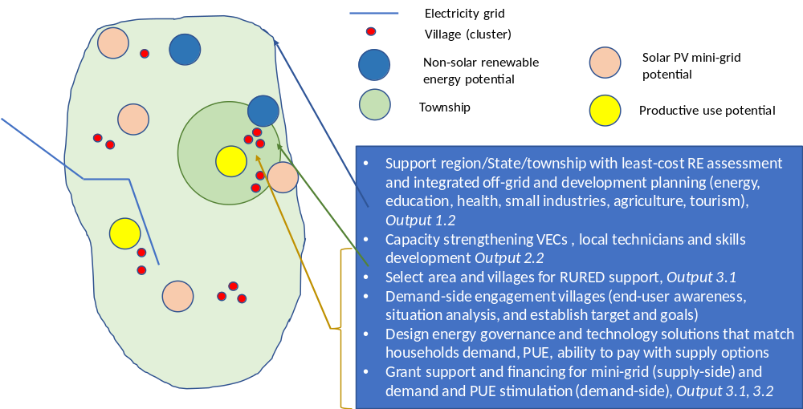

The component activities will be carried out in an integrated manner by linking the various thematic areas. For example, capacity building will address the same RE technology areas (e.g. solar PV, hydro) that will be implemented in the Project areas (and villages therein) and focus on training in project areas. The integrated approach is also illustrated by gearing the financial support of Output 3.3 towards the needs of RE companies and integrated RE and PUE development according to the situation in the selected Project areas and villages. The regulations regarding off-grid electrification (Output 3.2) can be tested on their practicability in the Project Areas

Source: Eskom website (2017)

This Component 3 of RURED will look to promote investment and commercial lending in mini-grids, supporting mini-grid business models under the current DRD-NEP Call for Proposals (CfP), as well as exploring alternative business models, which may contribute to the regulatory regimes and mechanism that may follow the CfP.

In the current setup of the CfP process, the project developer and/or VEC presents a proposal to DRD for subsidy support. Participation to date in the CfP has generally been with domestic developers with limited involvement of international developers. The agreement is signed between DRD, developer and/or the community. The developer then builds, operates and maintains the system. However, there is no incentive to reduce capital cost and avoid oversizing, while developers find it difficult to raise capital or apply for commercial loans. The programme is supply-oriented in practice with less attention given to demand development and productive uses. While the model is proven and has helped to start the mini-grid market significantly it is not financially sustainable in the longer term due to its high dependence on subsidies, which currently is 60% for mini-grids and 80% for solar home systems.

The RURED Project, together with the PACT-led Smart Power initiative (SPM), REAM and RE private sector associations, will promote an approach that is complementary to the DRD-NEP CfP process. The approach aims at:
- Being technology-neutral and finding least-cost energy supply solution;
- Better planning and more streamlined development (site selection linked with regional development and energy planning, focusing on village clusters rather than in a village-by-village approach);
- Achieving a reduction in project development costs (by clustering villages and pooling multiple projects, and standardization of equipment and mini-grid design, and reductions in financing costs) by using local technology;
- Working closely together with developers that are (local) social entrepreneurs with proven experience in mini-grid development, and renewable energy associations (such as REAM, HyCEM, Solar Group). Involvement of ‘home-grown’ developers allow easy troubleshooting and lowers cost;

A focus of RURED will be on better demand-supply matching in the RE project design to achieve a better plant capacity utilization (by stimulation demand by households and productive uses (PUE)). Enhancing productive use is central to improved mini-grid economics. The RE developers/ESCOs are encouraged to simultaneously support the development of (commercial) PUE. Approaches to be explored can consist of renewable energy developers financing productive use of equipment by leasing hardware to end-users, providing loans to mini-grid customers or renewable energy developers setting up a new business that uses energy and that can bring new services to a community (examples exist of water purifying facilities that can sell water and provide a steady stream of income). Energy demands can also be proactively managed in order to fully utilize variable renewable generation. It is vital to find productive uses that can fully utilize e.g. peak solar power generation (usually in the afternoon) as well as flexible loads, such as pumps, water purifiers, or even cold storage that can be switched on or off to follow the generation profile. Residential tariffs remain affordable through cross-subsidy with PUE tariffs. To allow PUE and essential social uses of energy (e.g. health facilities) the system provides 24/7 electricity.

The RURED project will prepare and make steps for a future where subvention for mini-grids is no longer needed and/or available and where commercial finance will need to become available for mini-grid investments. At present developers of rural energy systems (and developers of larger PUE, such as milling and other agro-processing; irrigation schemes) not getting suitable access to commercial finance may to a certain extent be caused by lenders’ lack of familiarity with rural energy technologies and a related increase in perceived risk of these projects. Banks and financial institutions also lack the necessary technical knowledge to assess off-grid projects and are, therefore, unwilling to lend to this sector. The project will therefore work with local financial institutions to increase knowledge and awareness on financing rural energy development as well as organize South-South interactions for-finance institutions on financing rural and RE and PUE. Where possible, the project will facilitate and provide advisory services to local banks that are committed to supporting long-term projects pipelines.

Output 3.1 Designed and implemented off-grid RE solutions and models integrated with PUE implemented, total installed capacity 15 MW

The RURED project will result in 15 MW of installed mini-grid capacity in 281 villages, of which 50% is powered by hydro (at 25 kW per village on average) and 50% by solar (at 80 kW per village on average). While the DRD-NEP support to the project is covering 50% of mini-grid investment, the remaining investment is expected to be contributed by the RE developers and community equity and a small share of debt finance. At the current mini-grid cost levels of an average USD 4,192 per kW, the DRD-NEP co-finance contribution to the RURED project results in finance available for 281 off-grid RE mini-grid proposals that will all will benefit from RURED’s policy support and capacity strengthening activities. A village is assumed to have 200 households on average (see Annex G for more details). At an average investment cost of the facility (generation and distribution) of USD 4,192 per kW, the total investment will be USD 61.84 million.

Out of the 281 villages, UNDP will provide additional technical and financial support to 30 villages, which can be a combination of: a) technical support in project design and feasibility assessment for communities with low technical capacities, b) additional grant support for innovative project proposals that do not receive DRD grants, for example proposals involving large PUE development or for hybridisation of system (e.g. solar-hydro combinations), and c) to pioneer in Myanmar credit insurance for off-grid RE systems that plan to make use of local debt finance.

GEF support is required to realise the following results:
- Assessments and final selection of list of mini-grids to be supported under RURED;
- Supply-demand assessments, feasibility analysis, and feasibility studies (of RE system and PUE) formulated by village entities (electrification committee; cooperative) to be presented to grant providers (e.g. DRD-NEP Call for Proposals), micro-finance and commercial finance providers
- GEF financial resources are made available as grant funding for productive use of energy applications and/or as ‘loan protection insurance’.

Activity 3.1.1 Selection of mini-grids in villages in the Project Areas to be supported under the Project
The activity involves, the selection of (clusters of) villages in the Project Areas to be supported under the Project on a rolling basis, based on Output 1.3, and guided by the project partners, REAM, HyCEM, SPM, taking into account the DRD list of villages/sites earmarked for off-grid electrification. A description of the geographical focus areas of the Project is provided in Annex E.8.

The final selection of mini-grids in villages for development support will be based on a number of criteria (to be finalised at the time of the Project Inception):
- The results of the least-cost geospatial analysis and investment prospects analysis of Activity 1.3.1
- Suggestions by central government (e.g. DRD) or local government (regional, township) during project formulation (PPG), and consultations with these entities and local stakeholders at project inception. Note that given the conflict context in Myanmar, non-state actors (such as CSOs) will also play a role in suggesting villages that may not be prioritized in government plans.
- Suggestions by project partners (Smart Power, REAM, other) and the possibility of integration with poverty alleviation, livelihood and village-level governance projects implemented by UNDP Myanmar (or development partners)
- Data provided on suitable areas/sites provided as a result of the least-cost assessment of Output 1.3, which includes considerations such as distance to the national grid (more than 10 miles and not planned to be electrified in the near future), population size, density and distribution pattern, and economic activity and opportunities for PUE (e.g. ABC, anchor load – business – customer)
- Interest and opinions expressed in local stakeholder consultations with VECs, community-based organisations, and project developers; Village demand characteristics, including willingness and ability to pay (WTP/ATP) and possible tariff structure, availability of RE resource (solar, hydropower, other); assessment of cost-effectiveness of proposed solutions.
- Conflict-sensitivity and social inclusion considerations, including FPIC processes with IP communities, and on-going changes in the operationalization of interim agreements in place as part of the National Ceasefire Agreement (NCA).
- Financing availability and the need for RURED financial and technical support (in addition to what project partners or local organisations, private sector and communities can offer)

Activity 3.1.2 Technical and financial assistance provided to selected mini-grids for the design of (bankable) electrification proposals and implementation and monitoring of off-grid RE and PUE
The RURED project will provide technical and (limited) financial assistance to the mini-grids in up to 30 villages, selected under Activity 3.1.1, on an as-needed basis. The RURED technical assistance support may consist of one or more of the following:
    - Feasibility study/business plan for off-grid energy systems in selected villages (to be submitted by VECs, VECOs and/or developers) for submission for NEP Call for Proposals rounds in 2020-2022), in accordance with Call for Proposal (CfP) guidelines and templates and/or for self-financing and/or commercial financial service providers
    - Site specific ESIA’s (Environmental and social assessment) and ESMP’s (Environmental and Social Management Plans), including analysis of linkages with watershed areas and recommendations for natural resource management (hydro), and collection/recycling of solar batteries; as needed Indigenous People’s Plan with FPIC
    - Targeted technical assistance and on-the-job training, during the installation of RE technology and associated PUE of the approved proposals, monitoring of operations and maintenance (troubleshooting), and for results reporting (in addition to capacity building of activity 2.2.4 and consumer engagement of 2.2.5)

The formulation of bankable off-grid RE business plan of selected villages (to be submitted by VECs/cooperatives and/or developers/ESCOs as part of Activity 3.1.1) will be supported by GEF funding on an as-needed basis for technical assistance (e.g. to hire independent external experts to do the feasibility assessment and design). In addition, The RURED project aims at setting up off-grid RE initiatives with the longer-term aim of reducing dependence on grants.

The (limited) GEF financial assistance is not meant to top up the already existing DRD-NEP grant support for mini-grid initiatives. RURED will rather want to act as a “broker”, linking promising off-grid proposals with finance sources for the off-grid energy system and for productive uses of energy and energy demand stimulation with local finance, such as A-Bank, and micro-finance providers. In some cases, the project can financially support village off-grid RE systems and PUE as ‘last resort’ funding for a number of cases:
- Promoting PUE. Cases where the economic viability of the mini-grid will substantially improve on the basis of adding a certain type of productive use for which insufficient initial financing is available. RURED will test and pilot different PUE options and business models, including leasing of PUE equipment to end-users. For example, a 40 kW solar mini-grid is planned to supply power to the households and small businesses; an additional 10 kW needs to be added to be able to power a larger agro-processing facility. Financing such a large expansion would be beyond the financial ability of the community. The project can consider financing part of the capacity addition so that the system can be designed with sufficient capacity needed to power the PUE.
- Hybrid technologies. Cases where an existing defunct (built in the past pre-NEP) mini-grid could be revived, e.g. by adding solar and creating a hybrid system (solar and hydropower) that due to their innovativeness may need initial support (hybridization can be interesting from a cost-effectives point of view but rarely practiced in Myanmar).
- Credit Guarantee Insurance. Cases where project proponents can be assisted to access collateral-free loans from local commercial banks, by absorbing the cost of ‘credit guarantee insurance (CGI)’ for the loan amount raised from the banks. Proponents, such as small developers or village entities, may have difficulty raising sufficient collateral for commercial loans and are considered not creditworthy by most commercial banks. Besides, bankability of many of these mini-grid assets is often questioned by commercial banks. Hence, banks typically require fixed assets over and above project assets as collateral for lending to these small developers. In order to address such barriers, the Government of Myanmar has introduced a Credit Guarantee Insurance (CGI) program wherein commercial banks can provide small loans to SMEs (of typical size MMK 20 million, about USD 13,500, can be extended to MMK 50 million, about USD 32,000) without requiring collateral. Banks can apply to Myanmar Insurance Enterprise (the state-owned entity that can provide such insurance in Myanmar) to purchase a CGI plan, which can provide cover against loan default up to 60% of the loan amount. An insurance premium of 1-3% per annum is charged by Myanmar Insurance Enterprise, which banks typically recover from the borrowers (mini-grid developers in this case). The Project will reimburse mini-grid developers the cost of CGI premium, charged by the Myanmar Insurance Enterprise. This will allow them to borrow collateral-free loans from local commercial banks and, possibly, at a higher insured loan amount.

This is summarised in the table below. Budget disbursements will depend on the demand for financing support modalities.
Modality | Budget (USD)
Additional funding to accommodate PUE | 1,060,000
Additional funding for refurbishment and hybridization of off-grid systems | 190,000
Credit guarantee insurance | 350,000
TOTAL, GEF grant support | 1,600,000

Output 3.2 Assessed and facilitated commercial financial support for rural RE energy projects

GEF funds are requested to carry out the assessment study and to organise seminar/workshops delivered by recognised (international) experts and facilitate study tours for bank senior management to selected countries in the region

Activity 3.2.1 Assessment of current role and capacity assessment of financial service providers and status of sustainable financing and business models for off-grid electrification in Myanmar
The activity will carry out an assessment of issues, options and capacity needs of the financial sector in Myanmar to provide (commercial-type) loans for off-grid electrification initiatives (service providers; financial products offered). The study will build on the results of the DREI analysis and market analysis (Activity 1.1.1). The study will provide recommendations on the financing modalities needed, e.g. credit guarantee schemes, forex risk scheme, access to overseas capital, and innovative financing, such as crowdfunding.

Activity 3.2.2 Seminar/workshops and South-South interactions for banking/financial institutions/micro-finance institutions on financing rural and RE and PUE
The activity consists of a series of training and capacity building programs to Banks, MFIs, mini-grid project developers, DRD and other government officials on financing mini-grids. The clean energy finance/mini-grid finance’ training will cover various topics, such as characteristics of financing for rural RE projects, financial modelling tools, business planning tools and exercises, customer credit appraisal tools and exercises, loan product structuring tools and exercises, etc. The activity foresees cooperation with banks in countries in the region (e.g. Sri Lanka, Nepal) that have experience in providing loans to rural RE electrification projects (see Section 4.4 South-South exchange).

Activity 3.2.3 Facilitation and advisory services to local banks that are committed to supporting long-term projects pipelines
Local banks currently face restrictions in providing commercial loans to RE project developers (see Annex E.6). The financing environment as set by the Central Bank may be allowed to loosen its restrictions in future while more local banks are showing interest to support the immediate financing needs of Myanmar’s RE entrepreneurs. RURED will provide technical assistance to partner banks to appraise projects and service project-based loans while guiding local entrepreneurs in developing documentation to effectively communicate their business models for the bank’s appraisal process, aligned with the development of technical information that is supported under activity 3.1.2. The Project will also facilitate visits by senior management of promising banks to visit the RURED-support village RE electrification proposals (activity 3.1.1) in need of financing. The goal is that a number of these projects will receive financing from local commercial banks as part of the overall finance package (of grant, equity, loans). Where possible the currents efforts, undertaken by A-Bank and REAM (described in Annex E.6), to set up commercial financing will be linked with the village-level RE projects supported by RURED in a mutually beneficial way; A-Bank will receive bankable proposals (developed with RURED support), while the A-Bank loans may fulfil the finance needs that the RURED project proposals (RE and PUE) may require. RURED may provide assistance to A-Bank (and other banks) in assessing RE/PUE loans.

Activity 3.2.4 SDG Impact Measurement and Management for RE developers and for investors
As interest grows among private sector actors to align their investment activity with the SDGs, there is a demonstrated need for approaches that can be used and relied upon to support a process of aligning with and achieving development outcomes. The project will support RE developers and where possible investors by offering tools and services to measure SDG Impact in order to help connect impact driven activity with investment and thereby enhance progress toward development goals.

Partnerships

The project forms an integral part of the broader efforts of the government to expand the electrification rate of Myanmar in line with the objectives of the National Electrification Plan (NEP). To ensure synergies and coherence of these efforts, key partners for the RURED project and how the RURED project will work with them are described below:

Project partner | How the RURED Project will work with the Partner
Department of Rural Development (DRD) of MoALI | DRD is the main Partner of the Project. DRD staff will work closely with full-time project staff and short-term experts. DRD will also take a leadership role in the Project Board in providing direction to the Project
Ministry of Electricity and Energy (MoEE) | MoEE is responsible for conventional grid extension and is a key partner in achieving a well-planned, mutually complementing, on-grid and off-grid electrification, and promoting coordination between DRD, MoEE, and utilities is one activity of RURED
ECD of MoNREC | The Project will engage ECD with the integration of avoided GHG emission from rural energy systems and area in ECD’s overall monitoring, reporting and validation system on GHG as part of the international conventions and agreements (UNFCCC National Communications; INDCs)
World Bank  GIZ | The off-grid electrification component of the National Electrification Plan (NEP) is implemented by DRD with financial and technical assistance support from World Bank and TA support from GIZ. The Project will provide further TA to DRD in a concerted effort with WB and GIZ focussing on ‘niche’ areas such the integration of PUE and demand engagement in village-level project design, and sustainable financing, as well as capacity development of government entities and private sector market actors and upgrading skills of technicians in installation, and O&M of RE.
REAM  Smart Power Myanmar (SPM)  HyCEM | The Project will work with these NGOS in Component 2 on information sharing, capturing experiences in off-grid electrification, and knowledge and dissemination, as well as capacity needs assessment and formulation of capacity building activities, and in Component 3 in the joint implementation of Output 3.1 in the selection of beneficiary villages, consumer engagement design and design and implementation of off-grid RE systems, and work together in organising the financing of the RE systems as well (micro-)finance for energy uses
DRI (REETC)  DTVE (TVET centres)  Ministry of Education | The Project will work with technology universities in mainstreaming RE and electrification elements in existing curricula, strengthening DRI’s REETC and on small RE systems, and/or organisation of vocational training for technicians (solar, hydro)
Financial service providers  Development partners | The Project will engage one (or more) local financial service providers in setting a loan programme for small RE and electrification projects. During implementation, this will be developed with the financial sector as well the need for and options of loan or loan portfolio guarantees will be explored. With respect to the latter, contacts will be made with USAID Development Credit Authority (DCA), European Union, and the French AFD (Output 3.2)
UNDP | The UNDP Country Office seeks to have its projects implemented in a more integrated way, seeking the synergies between the various thematic areas of livelihoods, governance, disaster risk reduction, environmental protection, climate change adaptation, and mitigation. In this effort, the proposed UNDP/GEF will form part of UNDP’s umbrella Governance for Resilience and Sustainability Project (GRSP) and at regional/State level will coordinate efforts with ongoing projects, such as the UNDP/GEF R2R Integrated Protected Area Land and Seascape Management in Tanintharyi and the UN-REDD+ National Programme, not only with project management itself but also with local representations and partners, including environmental awareness (EAOs) and civil society (CSOs) organisations
HPNet  MEE Net | The RURED project will cooperate with HPNET and MEE Net, for example, by jointly organising workshops and training events on mini and micro-hydropower, and facilitating exchanges with other HPNet and MEE Net countries in the region (e.g. Nepal, Sri Lanka, Indonesia).

Risks and risks and mitigation

The table includes a sample of the social and environmental risks described in Annex I (social and environmental screening). An extended risk log table is given in Annex M.
Description | Type | Impact  Probability  Significance | Mitigation Measures | Owner | Status
1. The project can potentially have adverse impacts on gender equality and/or the situation of women and girls in case the activities related to productive use of renewable energy reinforce or promote occupational gender stereotypes. | Social | I=3  P=2  Moderate | The RURED Project envisages prioritizing communities and projects that support productive uses of renewable energy and that focus on gender responsive targets, such as including women-owned RE enterprises. The professional job capacity development interventions of the project will be designed in such a way that equal opportunities exist for boys, girls, men and women, with specific targets for the number of trained and employed women in new RE-based power generation facilities. The M&E of the project activities will include tracking a number of human development indicators, and among them would be gender equity, as the number of trained and employed women in new RE-based power generation facilities.  Women’s participation in existing hydropower projects is significantly low. To promote their meaningful and active participation in the project design, implementation and monitoring and management phases, special measures should be considered (e.g. quota for VEC membership and capacity-building opportunities according to their roles at VEC). A separate series of consultations with women only will help achieve effective community consultations by giving more opportunities for women to join, as well as to voice their priorities, capacities and concerns about the implementation renewable energy. | PMU | Reducing  (due to  incorporation  of mitigation  into design and the development and implementation of the Gender Assessment and Action Plan )
2. The construction and operation of the demo low carbon technology application projects may pose potential safety risks to local communities. | Social | I=2  P=2  Low | The selection of project sites will include safety aspects (occupational and general) as one of the criteria to be considered. The project includes a quality framework including RE standards and protocols in Component 1 and capacity building and testing in Component 2, which reduce the risk of poor-quality technology. Capacity building will create high-quality technical skills in the sector. The RE technologies considered in the project are all technically mature, minimizing the risk of technical failure | PMU | Reducing  (due to  incorporation  of mitigation  into design)
3. The operation of the RE technology application demo projects may potentially cause adverse environmental impacts. Potential sources of impact include: (1) Battery waste disposal for the solar PV power generation systems is inadequately addressed  (2) Downstream impacts of small-scale hydro, including water use downstream and possible impacts on river ecology | Environ-mental | I=3  P=2  Moderate | The RE projects that will be developed and implemented will be required to adhere to the standard design practices that involve taking into account environmental impacts of RE resource preparation, utilization and the recycling of batteries while also having general design requirements and standards that have to be complied with. | PMU  DRD  ECD | Reducing  (due to  requirement  of social and  environ-  mental  assessment)
4. The construction and operation of the RE mini-grid projects may pose potential adverse impacts to habitats, cultural heritage, diversion of surface water (micro-hydro) or could be impacted by potential impacts of climate change (micro-hydro) | Social & environ-mental | I=2  P=3  Moderate | The RE projects that will be developed and implemented will be required to adhere to the standard design practices and the siting, design, development, and implementation of the demo projects will be considered in line with avoidance of any potential impact to habitats, cultural heritage or surface water. For projects such as micro/mini-hydropower facilities, the conduct of environmental impact assessments will be mandatory and should also include the potential impact of climate change affecting the output of the hydropower facilities as well as risk mitigation measures to such impact. Since no large reservoirs are required, no resettlement program is needed. Run-of-the-river schemes divert only part of the stream water away from a portion of the river to power the turbine which joins the river downstream again. However, they tend to create small, shallow pools which can cause problems such as sedimentation as well as eutrophication and can thus affect water quality.  The RURED project will take an integral approach to issues such as vulnerability (e.g., based on food security and climate-linked disasters, such as flooding and droughts) and management of natural resources in the watersheds where off-grid and on-grid hydropower projects are developed. In fact, the hydropower projects can have a positive impact by raising the awareness of proper watershed management and reforestation to secure the sustainable use of water resources. | PMU  DRD  ECD | Reducing  (due to  requirement  of social and  environ-  mental  assessment)
5. The project can potentially have adverse impacts on human rights of marginalized and indigenous people, including economic displacement | Social | I=4  P=3  High | In case mini-grid development will be located on indigenous land, FPIC (Free Prior and Informed Consent) processes will be required and documented during project implementation as a part of the limited, site-specific environmental and social impact assessments to be completed prior to any physical work beginning on the installations. For the FPIC process, extensive consultations will be conducted with local indigenous people communities. These more extensive consultations will include consultations with individual households and separate consultation meetings for women and men of the relevant clans. The FPIC processes and mutually agreed outcomes will be well documented as part of project implementation. | PMU  DRD | Reducing  (due to  requirement  of social and  environ-  mental  assessment and the process of consultation with concerned IPs through FPIC
6. Shortage of local skills for maintenance or repair of the solar mini-grid or micro-hydro.systems may lead to abandonment of systems (and dumping of used batteries) | Social | I=3  P=3  Moderate | Enhancement of local skills and training villages (maintenance, operation, administration) is an integral part of the RURED Project activities in Outcome 1, and this includeas awareness creation on environmentally sound management | PMU  DRD | Reducing  (due to  requirement  of social and  environ-  mental  assessment and local capacity building
7. Off-grid RE power systems supported by project will lack the funds to carry out repairs and purchase new parts as needed. | Operational & financial | I=3  P=3  Moderate | RURED will design management mechanisms for village off-grid RE systems and build consensus among village officials for the system, which will prioritize fee collection and saving of a portion of revenues for repairs and parts | PMU | Reducing  (due to local awareness raising and capacity building)
8. High cost of transport to remote sites will not allow regular access to project sites for project monitoring purposes. | Operational | I=2  P=2  Low | RURED will address the transport cost issue in two ways. First, the Project will have some staff (part-time) based in the State, cutting costs for visits. Second, the project will train and engage two to three local, rural villagers (technician, administrator) in the villages/sites to assist in monitoring the RE mini-grids and in guiding their operation, as a means of raising local capacity to promote sustainability. | PMU | Reducing (due to site selection and local training)
9. Unsuccessful productive use initiatives will result in lack of expected income  generation. | Financial and economic | I=4  P=2  Moderate | The project will develop coordination with the various project partners (government, private sector) to identify promising productive uses in various locations. Further, RURED will have  specific activities to design and finance productive uses, which will be selected via consultation with local communities and RE developers. Business advising will ensure that products have a good potential market and that business plans are viable. | PMU | Reducing (due to built-in linkage of village electrification with PUE in the Project, with; business plans that include both)
10. Lack of political will and coordination among government departments will result in RE standards, and off-grid regulation not being effective, and there is no good coordination between grid extension and off-grid electrification | Political | I=4  P=2  Moderate | The RURED project has specific activities to promote institutional coordination. Further, the Project will work with GIZ, DRD and MoEE on regulations for off-grid electrification, including the functioning of the mini-grid after connection (as power producer and/or distributor) | UNDP  DRD | Reducing (strong DRD support and design of coordination in the Project)
11. Lack of acceptance by the community or community authorities; the ability and/or willingness to pay by customers is lower than anticipated in this study | Economic | I=4  P=2  Moderate | Developers will accompany the establishment of mini-grid and SHS systems with good info and awareness campaign (in cooperation with local organisations) at the target site on tariffs and load limitations of mini-grid and SHS options and the importance of income-generation through productive uses. RE developers will set up the RE system jointly with village representatives and/or entities | PMU | Reducing (due to local awareness raising and capacity building)
12. High cost of energy systems, due to incorrect demand assessment leading to oversizing or under-sizing of the systems | Economic | I=3  P=3  Moderate | Achieving a reduction in project development costs (by clustering villages and pooling multiple projects, and standardization of equipment and mini-grid design, and reductions in financing costs as well as by using local technology. Better demand-supply matching in the RE project design to achieve a better plant capacity utilization (by stimulation demand by households and productive uses). | PMU | Reducing (due to feasibility assessments and business plans of mini-grid and PUE)

Stakeholder engagement

Building mutual trust and ensuring meaningful and effective engagement is facilitated by stakeholder ownership of the relevant processes. All efforts should be made to work with the relevant stakeholders to design by mutual agreement the engagement and consultation processes, including mechanisms for inclusiveness, respecting cultural sensitivities, and any required consent processes. Cultural understanding and awareness are central to meaningful stakeholder engagement.

This is particularly relevant in the context of Myanmar, one of the most ethnically diverse countries in the Asia Pacific region, with over 135 officially recognized ethnic minorities, known nationally as ethnic nationalities, as well as a diversity of other groups with distinct cultural practices and internationally recognized under the UNDRIP definition of Indigenous People’s (IPs). This ethnic and cultural diversity includes a plurality of actors, ranging from Indigenous Peoples themselves and their representatives including Ethnic Armed Organizations (EAOs), and local CSOs and NGOs, in the states and regions targeted by the project, including, but not limited to Shan (8.5 percent of Myanmar population), Karen or Kayin (7% percent of Myanmar population) Mon (2.4 percent of population), and others.

Although the Government of Myanmar is not a signatory to the ILO Convention 169, requiring Free, Prior and Informed Consent (FPIC), Myanmar is a party to the United Nations Declaration on the Rights of Indigenous Peoples (UNDRIP) and the project is subject to UNDP’s Social and Environmental Standards policy, which requires FPIC on any matters that may affect rights and interests, lands, territories, resources, and traditional livelihoods, as well as any relocation and appropriation of cultural heritage.

A human rights-based approach will, therefore, emphasize adequate consultation with stakeholders including FPIC for IPs as required, and in ensuring that benefits are distributed equitably and avoid any restriction of access to resources. The FPIC process is further outlined in the Environmental and Social Management Framework (ESMF) and associated Indigenous Peoples Planning Framework (IPPF) of the project, and will be carried out as part of the site-specific Environmental and Social Assessment (ESAs) and associated Environmental and Social Management Plans (ESMPs) from an extended Inception Phase of the project. Further information on the timing and approach of stakeholder consultations, including conflict-sensitivity and FPIC is given below.

Stakeholder consultation in project planning

The project team met with a wide array of stakeholders during project preparation, including representatives of various international organizations, local organizations and private sectors, renewable energy (RE) mini-grid developers and investors, renewable energy associations (such as REAM), private bank, multi-lateral development agencies, bilateral development agencies and international NGOs and initiatives (such as PACT, Smart Power Myanmar). Apart from two workshops (stakeholder and design workshop in September and the validation workshop in November 2018), DRD arranged for a stakeholder meeting of the project design (PPG) team and organizations currently working in the renewable energy sector (September 2018).

Two visits to Tanintharyi Region and Shan State were also undertaken in January 2019. The main objectives of these two visits were to validate and reconfirm the identification of the project areas in consultation with the relevant regional/state government officials, VECs, CSOs and community members (Tanintharyi Region and eastern/southern Shan State). The discussions provided guidance on the most appropriate RE projects and implementation activities and on gender-differentiated issues and risks. UNDP will continue to engage with these stakeholders throughout project implementation. Starting immediately during the inception period, the project’s outreach, technical assistance, and rural RE projects will be designed in direct recognition of input received from these stakeholders.

Stakeholder mapping and engagement plan

Key project stakeholders and strategies for engaging them are given below. Please also see the list of project partners in Section 4.2. Each project partner is also considered an important stakeholder of the project but is not listed again here to avoid repetition. Please also note that this stakeholder identification and engagement strategy will continue to be updated as required during project implementation.
- Private sector technical and equipment companies: Such firms will be invited to be involved in the project both as learners and as bidders for the DRD Call for Proposals and/or village electrification under Output 3.1. The project will offer training in both the mini-hydro area and the PV area. The project will be conducting work in identifying the best cost channels for sourcing quality projects and providing expected cost breakdowns for overall systems (including parts and labor). Finally, the project will work with suppliers to ensure that hydropower and PV replacement parts (especially batteries) are available in the remote sites and that means of collecting PV related waste (batteries) are also in place.
- Commercial banks: The project will invite commercial banks to attend its capacity building program for the banks on the financing of RE and off-grid technologies. The project will further reach out to the banks by approaching guarantee providers to discuss the possibility of providing guarantees for loans or loan portfolios for RE and off-grid energy projects (see Output 3.2)
- Local business persons on the islands and in villages: The project will reach out to such persons about forming a local “rural energy service company” to install and maintain village-scale RE power systems in its area on behalf of the VEC or VECO. The project will also reach out to such persons about pursuing businesses in the areas of productive use of energy. Further, the project will later contact such persons about the potential to develop replication projects and apply to the private sector financing and the credit guarantee facility offered as part of the Project.
- Engineering and consulting firms: The project will invite such firm to participate in its high-level training on (i) the design and installation hydro and or solar mini-grids and (and individual solar PV systems).
- Rural electricians: The project will identify rural technicians in each of the villages where the Project will support mini-grid or solar home system solutions. The project will provide training for such persons both through its training programs and through special certified electrician training. The project will further retain these persons to carry out project activities at the demo sites (operation and maintenance)
- Operators/ potential operators: The project will select and train a few operators from each village where there is an off-grid RE system. The operators will be paid for their part-time work, which will consist of: operating the off-grid village RE system, preparing bills and collecting payment, transferring funds to the required account, troubleshooting basic technical problems, and notifying relevant parties of more significant technical problems.
- Local villagers (households and small businesses): The project will put special emphasis on the engagement of local villagers. The project will consult extensively with local people in the demo villages regarding their interest in off-grid electrification solutions systems, their willingness to volunteer labor and land as needed. Regarding the latter, local businesses play an important role in productive uses of energy. The project will, during its early stages, conduct limited environmental and social impact assessments at each of the village demo sites as part of its social and environmental screening plan. The assessments will include an in-depth consultation with local people, including local business (shops, workshops, agro-processing, fishing, etc.). The project will put special emphasis on ensuring such groups are involved in community decision making meetings and are prioritized for opportunities with project productive use funds and if viable, opportunities for operator roles.
- Indigenous Peoples and Representatives (EAOs, CSOs and NGOs): As noted above, the in-depth consultations with local villagers will include preliminary consultations with IPs and IP representatives to determine whether project interventions, and in particular off-grid electrifications solutions are desirable. Upon initial information sharing and if consent is given to work in IP areas, the site-specific environmental and social assessment process will include iterative engagement with IPs following international best practice protocols for FPIC as required (see Annex I).
- Gender-sensitive consultations: The project will put special emphasis on the involvement of women in village community meetings with the project, ensuring that 50% of participants at such meetings are women. The project will also proactively seek the involvement of women in productive use initiatives, assuring that 50% of project funds for productive uses go to initiatives mainly involving women (see next Section 4.6 for further information on gender aspects)
- Local NGOs: The project intends to invite a number of local NGOs to the project activities. In particular, the RURED Project will partner with PACT and its initiative Smart Power Myanmar for with the implementation of village-level activities and related micro-finance activities for rural renewable energy and productive uses.

Stakeholder engagement sequencing and iterative consultations

Stakeholder engagement is an ongoing process, which requires key inputs from relevant stakeholders, not only in project planning, but also throughout project implementation, in order to ensure that projects interventions are in line with intended outcomes and field-level impacts. In addition to the consultations carried out in the planning phase of the project, stakeholder consultations will also follow the technical assessments to help determine and validate project interventions sites.

Following an initial phase of technical assessments of potential sites in Tanintharyi, Shan and Dry Zone respectively, project staff will carry out a more detailed mapping of potential local beneficiaries and stakeholders, as well as prepare communication products on detailed feasibility of pilot sites, as well as environmental and social risks to share with local stakeholders. This will allow local stakeholders to inform site-specific assessments, raise potential concerns and help to design appropriate mitigation measures. Particular attention will be paid at this stage to inclusive consultations, including participation of marginalized ethnic groups, as well as female-headed households and community members that may have access restrictions (disabled, elderly).

Free Prior and Informed Consent:

In the case that technical assessment and initial information sharing with IPs and representatives regarding the project mini-grid development, determines that project interventions may be located on indigenous land or contested territories, FPIC processes will be required and documented during project implementation as a part of the site-specific environmental and social impact assessments to be completed prior to any physical work beginning on the installations.

For the FPIC process, extensive consultations, building on initial consultations during the PPG process, will be conducted with local indigenous communities. These more extensive consultations will include consultations with individual households and separate consultation meetings for women and men of the relevant IPs. The FPIC processes and mutually agreed outcomes will be well documented as part of project implementation. The procedure for carrying out consultations with IPs has been described in the ESMF.

Conflict-sensitive consultations:

UNDP is engaging in an ongoing strategic dialogue with a varied cross section of IP representation, including EAOs and CSOs, in order to find constructive solutions at the nexus of natural resource management and peace building. The project itself will also take a conflict-sensitive approach, by consulting with potential IP beneficiaries and their representation, to ensure that all project interventions that involve IPs, IP lands and territories or contested areas, are done with consent.

South-South and Triangular Cooperation (SSTrC)

Myanmar shares similar conditions with other nations that have a similar level of rural electrification, and therefore the results of the project may be highly beneficial to such nations. As such, the Project’s results will be shared with these countries. Links for the associated Project website will be shared with relevant parties in those nations (in Asia-Pacific and Africa regions) that have relatively low electrification levels. Among the available materials, information on sourcing and best cost pricing for RE parts and equipment will be highlighted to these nations, which all face similar challenges in terms of overpriced RE equipment and lack of transparency on reasonable pricing. The results of the project demos and, particularly, the local management systems developed and business models applied for the off-grid rural RE demos will also be highlighted.

Myanmar also stands to benefit from countries elsewhere in the Asian region (e.g. India, Indonesia, Nepal, Sri Lanka, or Philippines) that have struggled with achieving sustainable management and business models for electrification with grid RE systems and have found innovative solutions. RURED will participate in regional and international networks and associations. The Hydro Empowerment Network can be supported by jointly organising workshops and training events in Myanmar on mini and micro-hydropower. The project can facilitate partnering with other organizations and organize study tours to other HPNet countries in the region. The Project will facilitate exchanges of financial sector representatives (e.g. management of Myanmar banks) to countries where the commercial banking sector is actively involved in lending for off-grid RE projects, such as Nepal or Sri Lanka.

UNDP has developed the Derisking Renewable Energy Investment (DREI) methodology (see Annex F) for solar mini-grids. The DREI Team at UNDP Headquarters has expressed its interest in developing the DREI methodology further and use Myanmar as a case study. The Myanmar case can then be widely disseminated to the international audience through UNDP. On its turn, RURED can benefit from the experience of DREI application in other countries, notably in Cambodia, which is the first case where DREI has been applied in solar PV and solar mini-grids.

Mainstreaming gender

A detailed Gender Analysis and Gender Action Plan is included in Annex D. This Section summarizes the main elements of the gender action plan, outlining what the project will do to mainstream gender in individual components/outcomes.

The 2015 UNDP Gender Development Index ranks Myanmar at 145 out of 188 countries. In addition, Myanmar is ranked 83 out of 144 countries according to the Global Gender Gap Report 2017 by the World Economic Forum. The 2017 Report highlighted Myanmar country’s women are under-represented in legislating, senior official and manager roles. Female representation in Myanmar’s political atmosphere is still very low. The 2014 census data tells us that women and girls are more likely to be married early, less likely to be economically active and earn income and be less literate. Women (50.5%) are significantly less economically active than men (85 percent), are more likely to be unemployed, and make up only a quarter of ‘employers’). Women are employed mostly in the informal sector or in professional, services and sales occupations, while men are employed in occupations considered more “masculine”. Educational attainment varies most significantly by location and income levels. In urban households, 22% of women and 19% of men have completed secondary school or have higher education as compared with 4% of women and men in rural households.

The Myanmar National Committee for Women’s Affairs (MNCWA) was formed in 1996 to systematically implement activities for the advancement of women in Myanmar. Myanmar acceded to the Convention on Elimination of All Forms of Discrimination Against Women (CEDAW) in 1997 and became a member of ASEAN Women’s Affairs Committee in 2002 and ASEAN Commission on Women and Children’s rights in 2010. Overseen by MNCWA, the National Strategic Plan for Advancement of Women 2013-2022 (NSPAW) was developed in 2013 with 12 thematic areas based on the Beijing Platform for Action and on the implementation of the CEDAW. To support the implementation of NSPAW, four Technical Working Groups (TWGs), that is Violence Against Women, Mainstreaming, Participation in Politics and Economy, as well as Women, Peace and Security, to provide technical support on specific technical issues. To strengthen the mechanisms for effective gender mainstreaming, technical assistance through TWGs will be provided to all relevant other Sector Coordination Groups as well as gender-responsive budgeting will also be supporting in all sectors.

To better realize the gender mainstreaming of technical assistance projects, , the following strategies will be applied:
- To be effective and improving access to resources and services for marginalized women and girls as well as contributing to advancing gender equity and women’s economic empowerment, specific budget lines will be allocated for reducing barriers and gaps in access, opportunity, or participation in project intervention areas;
- Images and narratives in documents often unintentionally reinforce gender bias. Words and images that challenge gender stereotype and bias as well as portray gender equality will create a supportive and inclusive environment for women and girls. During the implementation of Myanmar Rural Renewable Energy Development Programme, graphics and narratives used in training, workshop, media statement, press release, even speaking points at meeting or information/ awareness session will be prepared through gender sensitivity lens;
- Disaggregated statistical data and gender-related findings on project outcomes and indicators will provide the evidence that gender issues are taken seriously and will ensure better planning and activities, enforce changes accordingly in the project design, and advocate the policy development for better addressing gender inequality;
- Positions in projects will be reserved for women to achieve equal participation of women and men in all areas of the project intervention as well as project management level.

Sustainability and scaling-up

Sustainability and scaling up have been central considerations in project design. The project adopts several central features to ensure sustainability. First, it puts a strong emphasis on the design of, consensus building on, and adoption/ implementation of a sustainable business model for off-grid RE systems. To ensure better sustainability than other off-grid projects, the RURED Project will include the following:
- End users will pay for power and payments will be responsibly managed to pay the system operator and set aside funds for future repair and replacement of parts. Local management systems (e.g. special purpose vehicle) will be set up in which the community co-owns the mini-grid with the RE developer (RESCO);
- The RURED Project will carry out several training programs to ensure there are qualified persons to install and repair off-grid RE systems. To ensure that these are not ‘once-only’ programmes, training will be implemented involving national institutions, including the Ministry of Education’s Renewable Energy and Electronic Technology Centre and the technical and vocational training centres (in particular those in Tanintharyi and Shan), and RE centres of universities. The Project will enhance the capacities of these centres so that training programmes continue after the end of RURED;
- Further, RURED emphasizes off-grid RE systems that match the (future) energy demand to achieve a better plant capacity utilization (stimulating demand by households and productive uses of energy, such as agro-processing, small businesses, and others);
- The Project will work with private sector project developers and RE companies to achieve a reduction in project development costs (by clustering villages and pooling multiple projects, and standardization of equipment and mini-grid design, and reductions in financing costs). The Project will from the onset involve private sector associations, such as REAM, HyCEM and the UMFCCI Solar Group, in capacity strengthening and awareness creation activities, and at the same time enhance the ability of these organisations to continue carrying out these activities for their members;
- There will be a strong emphasis on addressing existing gaps in policy, regulatory, and planning work (site selection linked with regional socio-economic development and energy planning);
- The Project will mobilise financing to reduce subsidy dependency, such as micro-finance for households and small businesses, while working with banks to convince these to provide commercial loans for larger investments in the energy mini-grid system and simultaneously investments in larger productive uses.

The RURED Project design promotes scaling up primarily by promoting replication of the incremental village-level off-grid energy system, directly supported by the project (Output 3.1). The RE projects will build confidence by proving the technical and financial viability of systems. The Project’s technical assistance support for sourcing and costing of such systems will further ensure that replication is attractive. Site selection for replication will be promoted through the Project’s awareness building and through its support of cooperation between DRD, local/regional government, and development partners. The Project’s support for designing financing mechanisms (Output 3.2) for the commercial /private sector, the partnership with Smart Power Myanmar (SPM) and liaison work between project proponents and both public and commercial sector funds will also stimulate replication of the off-grid systems scale-up. To ensure that knowledge generated by the project and lessons learned are incorporated into broader stakeholder initiatives, the project will make all project related documents available online via its information exchange network for the promotion and dissemination of knowledge on sustainable energy. RURED will also endeavour to share key project results with other nations.

Project Management

Cost efficiency and effectiveness

Aspects of the project’s strategy that will promote cost efficiency are as follows:
- Stimulation of replication of the project demos: The project will invest in rural RE projects in selected villages, which will be critical in providing proof of concept and proof of costing and business models (including PUE), so that others will be willing to replicate them, thus leveraging in project funds far beyond the project demos. The project will further provide technical assistance (TA) support in multiple areas to stimulate replication of the RE projects. These areas include awareness raising that encourages local people to submit proposals of suitable sites, site identification work, preparation of a State/Region-level least-cost geospatial analysis plans, and liaison work for local project proponents, NGOs, and finance sector entities to facilitate replication of the project demos.
- Work in sourcing and costing of RE equipment and design/ installation services: The project will carry out technical assistance in sourcing and costing with an aim of identifying good quality equipment at acceptable cost. The Project aims at standardization of equipment and mini-grid design, and reductions in financing costs by using local technology, and by working closely together with those developers that are (local) social entrepreneurs with proven experience in mini-grid development, and renewable energy associations (such as REAM, HyCEM, Solar Group). Involvement of ‘home-grown’ developers allow easy troubleshooting and lowers cost;
- Savings in the long run as compared to diesel generation: Over time, with the sourcing and best cost pricing work, RE will provide greater cost efficiency for local communities than would the alternative of diesel generators (as explained in Annex G)
- Leveraging of TA funds to promote investment by other parties in RE in Myanmar. The project will invest a large proportion of GEF funds in TA in the capacity, awareness, policy, institutional, and financing areas, which are relatively low in cost, to leverage funding from other sources for actual installations of RE equipment, which is relatively high in cost. The project includes activities that involve TA support to the commercial/private sector in designing RE financing mechanisms but expects other parties to provide the actual funds for the realization of these mechanisms (DRD, micro-finance, developers/investors).
- Clustering villages has an advantage of creating a group of mini-grids, which can lower the unit cost of energy for consumers, maximising the return on investment, and lowering overhead and project development costs of RE providers and developers.
- Multi-pronged barrier removal approach: The project addresses barriers in multiple areas, rather than in one single area, such as policy. Further, initiatives within each barrier removal category (e.g. capacity building and demonstration) are mutually reinforcing. Experience in the past shows that such approaches in the design of UNDP-GEF projects are effective.
- Myanmar-specific design: The project design carefully considers the specific challenges Myanmar has been facing in achieving dissemination and sustainability of its RE installations. As such, for example, it puts much emphasis on management systems for off-grid systems, the need for village-level awareness raising to familiarize villagers with the benefits and limitations for off-grid RE power systems (for example, limitations introducing heavy loads such as electric cookstoves in solar PV mini-grids), and the need to address dispersed villages differently from villages (with individual solar home systems) with a more concentrated clustering of households (served by mini-grid systems)
- Combination of productive uses/ income generation with RE: The project puts a strong emphasis on addressing the need for income generation activities and combines this with rural energy systems to ensure that installations generate revenues, in turn leading to a higher potential for sustainability.
- Extensive consultation and involvement of communities in community-scale projects: The project design calls for extensive liaison with communities and their involvement in the implementation of demos in their village. Land issues can be a problem that stymies the progress of RE installations, in particular in the case of small hydropower. The project adopts a strategy of community-scale systems which have an easier time achieving buy-in about land issues, as compared to larger systems that spread benefits over a much larger area than that of the community providing the land alone.
- Close involvement of DRD and State governments: The project design was carried out with close involvement of DRD so that main project elements reflect DRD priorities. Implementation plans call for the continued close involvement of DRD and integration of activities with the work of DRD permanent staff and that regional/township level, with that of the State Governments that will partner with the project. Further, the Project Management Team (PMT) will be supported by region/State-based staff, possibly joining, where possible, other staff of other UNDP projects in a particular State or Region.

The Project will directly support investment in renewable energy (RE) and will, therefore, lead to direct greenhouse gas emission (GHG) emission reductions. A GHG emission analysis has been conducted and is presented in Annex G. The direct GHG emissions reductions for the off-grid investments environment is about 20.5 kilo tonnes of CO₂ per year or 246 kilo tonnes over the investments’ lifetime (of 12 years). At a GEF contribution of USD 4,934,228, this implies GEF financing (abatement cost) of USD 20 per tCO₂.

In addition, the Project will undertake several activities that will stimulate market transformation, in particular, support to the enabling policy and regulatory framework under Component 1 and capacity strengthening and awareness creation of Component 3. Further, experiencing and seeing the realization of the off-grid RE systems will encourage more communities and project developer to initiate mini-grid development. Thus, there will be consequential GHG emission reductions of about 738 kilo tonnes of CO₂ after the project’s end (calculated based on a bottom-up approach, see Annex G).

Project management

The Project will have national-level activities and conduct subnational activities in the Tanintharyi Region and Shan State. Project Management will be based at the UNDP offices in Yangon and Naypyidaw. Technical teams for each output will be housed either in the same office or at key counterparts’ offices. Depending on the eventual realization of project activities at the sub-national level, Project staff may be located in local administrative buildings.

Implementation Arrangements
The Project will use the Direct Implementation Modality (DIM), where UNDP is the Implementing Partner (IP). Under DIM, UNDP will bear full responsibility and accountability to manage the project, achieve project outputs and ensure the efficient use of funds. UNDP will be accountable to the funding partners for the disbursement of funds and the achievement of the project objective and outcomes, according to the approved work plan. In particular, the IP will be responsible for the following functions:
- coordinating activities to ensure the delivery of agreed outcomes;
- certifying expenditures in line with approved budgets and work-plans;
- facilitating, monitoring and reporting on the procurement of inputs and delivery of outputs;
- approval of Terms of Reference for consultants and tender documents for sub-contracted inputs; and
- reporting to the Project Board on project delivery and impact.

Within the UNDP Myanmar Country Office, UNDP’s Sustainable and Inclusive Growth Unit will take overall responsibility for achieving the results of the project and report to the Project Board. The day-to-day management of the Project will be delegated to a Project Management Team (PMT), as detailed in Section 8.

UNDP, as the IP, may enter into an agreement with other entities, or Responsible Parties (RP) to deliver project outputs. In this case, UNDP will select RPs following due process in line with UNDP policies and procedures and sign the appropriate legal instrument with the respective RPs. UNDP will ensure technical and financial monitoring of all activities undertaken by RPs. Bi-Monthly Project Management Meetings between UNDP and RPs will provide further guidance on implementation.

Audit
DIM is the selected implementation modality for the Project. The audit of DIM projects is done through periodic internal audits of UNDP country offices or stand-alone DIM audits by the UNDP’s Office of Audit and Investigation (OAI). Consistent with the audit disclosure policy approved by the UNDP Executive Board, country office and DIM audit reports will be publicly disclosed on the UNDP website 30 days after they have been issued by OAI (http://audit-public-disclosure.undp.org/). Where Responsible Parties are used to deliver specific project outputs, depending on the type of partner and the total contract value, the UNDP policy on the Harmonized Approach to Cash Transfers (HACT) will be applied.

Equipment, Supplies and Other Property
Ownership of equipment, supplies and other property financed from the project shall be vested in UNDP. Matters relating to the transfer of ownership by the UNDP shall be determined in accordance with applicable policies and procedures of the UNDP.

Collaborative Arrangements and direct project costs of UNDP
RURED may cost-share certain implementation costs with other projects under UNDP’s current Country Programme (CPD) 2018-2022. It is foreseen as well that the projects will co-organise a significant number of training, knowledge exchange and planning activities, for the same reasons as technical staff resources are shared. All of these will greatly reinforce the integrated approach taken by the CPD. The Project’s operational means, in particular at the sub-national level where different projects will coincide, will also be pooled, where possible.

Organisational costs incurred by UNDP in terms of staff time of the project are charged to the GEF Agency Fee, which is 9.5% of the GEF budget for the project, equivalent to USD 468,752 (as indicated in the GEF CEO Endorsement Request form).

Agreement on intellectual property rights and use of logo on the project’s deliverables and disclosure of information
To accord proper acknowledgment to the GEF for providing grant funding, the GEF logo will appear together with UNDP’s logo on all promotional materials, other written materials like publications developed by the project, and project hardware. Any citation on publications regarding projects funded by the GEF will also accord proper acknowledgment to the GEF. Information will be disclosed in accordance with relevant policies notably the UNDP Disclosure Policy and the GEF policy on public involvement.

Project Closure
Project closure will be conducted as per UNDP requirements outlined in the UNDP POPP. On an exceptional basis only, a no-cost extension beyond the initial duration of the project will be sought from in-country UNDP colleagues, and then the UNDP-GEF Executive Coordinator.

Project Results Framework

This results framework is the same as the one required in the GEF CEO Endorsement template Annex A: Project Results Framework.
Outcomes are short to medium term results that the project makes a contribution towards, and that are designed to help achieve the longer-term objective. Achievement of outcomes will be influenced both by project outputs and additional factors that may be outside the direct control of the project.
This project will directly contribute to the following Sustainable Development Goal (s):
Goal 7: Ensure access to affordable, reliable, sustainable, and modern energy for all (Target 7.3: By 2030, double the global rate of improvement in energy efficiency).
Goal 13: Take urgent action to combat climate change and its impacts (Target 13.2: Integrate climate change measures into national policies, strategies and planning; and Target 13.3: Improve education, awareness-raising and human and institutional capacity on climate change mitigation)
This project will contribute to the following country outcome included in the UNDAF/Country Programme Document:
By 2022, Myanmar becomes more resilient to climate and disaster risk with efficient environmental governance and sustainable use of natural resources
This project will be linked to the following output of the UNDP Strategic 2018-21
Output 1.5.1 Solutions adopted to achieve universal access to clean, affordable and sustainable energy

 | Objective and Outcome Indicators | Baseline (2017) | Mid-term target | End of Project (EoP)  target (2021) | Data collection methods and risks/assumptions
Project Objective:  To facilitate expansion of rural renewable energy services and productive applications in Myanmar and avoid greenhouse gas emissions  . | - [GEF Core Indicator 6]  Lifetime direct GHG emissions avoided as a result of energy access projects | N/A | Mid-term target, 81,211 tCO₂ is one-third of the end-of-project target | 246,094 tCO₂ over the 12-yr lifetime of small hydro and solar mini-grids (20,508 tCO₂ per year), and corresponding energy production of 25,341 MWh per year | - Market assessments and/or project data (see Indicators 3), 10) and 11)  - Official DRD reporting  - Project progress reports  - See Annex G (for methodology and calculation assumptions)  Assumptions:  - Support from national and State governments for off-grid electrification  - DRD remains responsible for off-grid electrification  - Interest and support from beneficiary villages and from project developers  - Proposed rural RE project proposals are developed and reach operational stage
 | - [GEF Core Indicator 6]  Lifetime consequential GHG emissions avoided as a result of energy access projects | N/A | N/A | Indirect (consequential) emissions are 738,281 tCO₂ over the 12-yr lifetime of the equipment
 | - Number of households (and # of female-headed HH) provided with electricity services  [GEF Core Indicator 11: number of direct beneficiaries disaggregated by gender] | RURED: N/A  For baseline situation on off-grid RE, see Annex E | Mid-term target is 14,480 households in 70 villages target | 56,200 households in 281 villages will be connected (RE mini-grids plus SHS). At 4.4 person per HH, beneficiaries are 247,280 (50% male and 50% female).
Outcome 1  Effective implementation of supportive policies and regulations at national and local level for enhanced RE utilisation in rural productive uses | - Status of assessment and impact measurement of rural (off-grid) RE electrification | See Annex E for a description of current off-grid electrification and DRD/WB PPP model | Extended baseline assessment report | One assessment report and one end-of-project impact measurement report with recommendations for post-project actions | - Project progress and technical report reports  - Stakeholder reports and official documents  - Evaluation and monitoring reports  - Assessment report  - Assumptions:  Continuing interest by government entities, project developers, NGOs in off-grid village electrification in general and in establishing PPPs
 | - Number and status of least-cost geospatial analysis and investment plans for off-grid energy access | ADB project carried out least-cost geospatial analysis and investment plans in Magway, Mandalay, and Sagaing Regions (2015-17) | Least-cost geospatial analysis and off-grid investment plans in at least one State/Region | Least-cost geospatial analysis and off-grid investment plans for the focus area in southern Shan State and coastal zone of Tanintharyi region | - Reports with off-grid assessment and listed rural RE project investment opportunities  - Project progress reports  - State documents  Assumptions:  - State-level government have off-grid RE electrification as a priority in their planning  - Access to and availability of data and statistics (demographic, economic, energy resources)
 | - Number of staff (and % women) from national and State governments with enhanced capacity that are effective in rural RE project planning (incl. procurement, financial management, community development) | N/A | 60 staff trained (of which 40% women) in technical training (200 staff participated in workshops and seminars) of which 50% are effective | 80 staff trained (of which 40% women) in technical training (of which 40 at national and 20 for each State/Region); and  300 staff participated in workshops and seminars, of which 75% are effective in rural RE planning | - Workshop and seminar reports  - Project progress reports  - Training materials  - Post-training evaluations of officers involved in planning  Assumptions:  - Commitment by national and city government  - Willingness of staff to be trained
Outcome 2  Awareness and knowledge enhanced of market enablers (project developers, RE companies, services, NGOs) and beneficiaries | - Number of project developers, equipment providers and vendors (% females) trained that are effective in design, installation, operation and business models for rural RE | N/A | Target is 100 staff of end-of-project target, of which 50% are effective | 150 staff trained (of which 25% women) in specific topics, of which 75% are effective | - Workshop and training reports; Minutes of meeting  - Project reports  - Training materials  - After-training evaluations  Assumptions:  - Willingness of stakeholders at national, regional and village to participate in trainings and of females to participate (see also Gender assessment)  - Availability of good experts to deliver trainings and workshops
 | - Village level promotors, operators, technicians, administrators trained that are effective in relevant subjects for successful management and operation of off-grid RE systems (with % of women) | N/A | Target is 80 of end-of-project target (of which 30% women), of which 50% is effective management and operation | 120 village-level people trained  (with at least 30% being women), of ehuich 75% are effective in off-grid RE management and operation
 | - Operational status of RE and electrification training centre at a selected university or institute; and integration of (off-grid) RE in curricula of selected institutes | Individual and universities deal with RE on a theme-by-theme and occasional basis | One RE and electrification centre inaugurated with approved two-year work plan;  RE and electrification topics incorporated in curricula of at least one (vocational training) institute | One RE and electrification centre operational at selected university/institute  RE and electrification topics incorporated in curricula of at least two institutes, of which one vocational training | - Project reports; Minutes of meeting  - Proposal and business plan for RE and electrification training facility  - Reports by participating university and technological/vocational training institute  - Course materials; Handbooks  Assumptions:  - Commitment and ability of the university and institutes to organize modules on RE and electrification and to host the training facility
Outcome 3a  Increased investments in rural RE to meet household demand, PUE and enterprise development | - Number of villages and/or projects off-grid areas that have off-grid RE (mini-grid) and SHS) systems, directly supported with GEF funds  a) with proposals  b) under construction  c) in operation | N/A | 15 villages have been supported, of which 3 in operation, 6 under construction and 6 with approved proposals | 30 villages have been directly supported with project formulation TA support and GEF financial support (max 25% of investment), of which 10 in operation, 10 under construction and 10 with approved proposals Note: the 30 villages are a subset of the number of villages (supported with GEF and all co-financing) of Indicator 3 | - Reports by DRD and stakeholders and project (progress and technical)  - Individual project design reports and proposals; post-installation reports  - Reports on installed RE systems and villages electrified and village surveys  Assumptions:  - Interest and support from beneficiary villages  - Proposed rural RE project proposals get funded, are constructed, and reach operational stage  - Ability and willingness to pay for electricity connection and monthly fees  - DRD remains responsible for off-grid electrification and provides funding through rounds of Call for Proposals
 | - Number of villages and/or projects off-grid areas that have off-grid RE hydro or solar mini-grid (and SHS systems) linked with significant PUE | N/A | 25% of villages (of the 15, mentioned in Indicator 10) have off-grid systems with significant PUE | 25% of villages (of the 30, mentioned in Indicator 10) have off-grid systems with significant PUE
Outcome 3b  Financial programmes supported | - Status of loan and/or guarantee schemes to energy access and PUE projects under commercial or private sector financing | Apart from micro-finance, no commercial loans are provided for off-grid RE | At least one financial service provider (domestic banks) provide loans to project developers/RE companies for off-grid RE projects, and/or at least one guarantee scheme set up | At least three financial service providers (domestic banks) provide loans to project developers/RE companies for off-grid RE projects, and/or at least one guarantee scheme (for RE loans or loan portfolio) set up | - Individual project design reports and funding proposals (rural RE and PUE)  - Project (progress) reports  Assumptions:  Private sector investors. Micro-finance organizations, and local banks interested in lending for rural energy access projects

Monitoring and Evaluation (M&E) Plan

The project results will be monitored annually and evaluated periodically during project implementation to ensure the project effectively achieves these results. The Project Results Framework (presented in the previous Chapter 6) includes SMART indicators for each expected outcome as well as end-of-project targets. These indicators along with the key deliverables and benchmarks included in will be the main tools for assessing project implementation progress and determining whether project results are being achieved.

The project will comply with UNDP standard monitoring, reporting and evaluation procedures. Mandatory GEF-specific M&E requirements (summarized in Exhibit 11 and outlined below) will be undertaken in accordance with the GEF M&E policy and other relevant GEF policies. Also, project-level monitoring and evaluation will be undertaken in compliance with UNDP requirements as outlined in the UNDP POPP and UNDP Evaluation Policy. In addition to these mandatory UNDP and GEF M&E requirements, other M&E activities deemed necessary to support project-level adaptive management will be agreed upon during the Project Inception Workshop and will be detailed in the Inception Report. This will include the exact role of project target groups and other stakeholders in project M&E activities including the GEF Operational Focal Point and national/regional institutes assigned to undertake project monitoring. The GEF Operational Focal Point will strive to ensure consistency in the approach taken to the GEF-specific M&E requirements (notably the GEF Core Indicators) across all GEF-financed projects in the country. This could be achieved for example by using one national institute to complete the GEF Core Indicators for all GEF-financed projects in the country, including projects supported by other GEF Agencies.

The M&E plan will be reviewed and revised as necessary during the project inception workshop to ensure project stakeholders understand their roles and responsibilities vis-à-vis project monitoring and evaluation. Indicators and their means of verification may also be fine-tuned at the inception workshop. General project monitoring is the responsibility of the Project Management Unit but other project partners will have responsibilities to collect specific information to track the indicators. It is the responsibility of the Project Manager to inform UNDP of any delays or difficulties faced during implementation so that the appropriate support or corrective measures can be adopted in a timely fashion.

M&E oversight and monitoring responsibilities:
Project Manager: The Project Manager, together with the Chief Technical Advisor, CTA, see Chapter 8) is responsible for day-to-day project management and regular monitoring of project results and risks, including social and environmental risks. The Project Manager will ensure that all project staff maintains a high level of transparency, responsibility, and accountability in M&E and reporting of project results. The Project Manager will inform the Project Board, the UNDP Country Office and the UNDP-GEF RTA of any delays or difficulties as they arise during implementation so that appropriate support and corrective measures can be adopted.

The Project Manager, together with the CTA, will develop Annual Work Plans based on the multi-year work plan included in Annex A, including a month-by-month projection of activities, as well as annual output targets. The Project Manager will ensure that the standard UNDP GEF M&E requirements are fulfilled to the highest quality. This includes, but is not limited to, ensuring the results framework indicators are monitored annually in time for evidence-based reporting in the GEF Project Implementation Report (PIR), and that the monitoring of risks and the various plans/strategies developed to support project implementation (e.g. gender strategy, Knowledge Management strategy etc.) occur on a regular basis.

Project Board: The Project Board (also called Project Steering Committee, PSC) will take corrective action as needed to ensure the project achieves the desired results. The PSC will hold project reviews to assess the performance of the project and appraise the Annual Work Plan for the following year. In the project’s final year, the Project Board will hold an end-of-project review to capture lessons learned and discuss opportunities for scaling up and to highlight project results and lessons learned with relevant audiences. This final review meeting will also discuss the findings outlined in the project terminal evaluation report and the management response. Results of this review, as well as findings outlined in the project terminal evaluation report and the management response, will be presented at a closing workshop open to a broad variety of stakeholders from Myanmar and from UNDP projects elsewhere in the region.

Project Implementing Partner: The Country Office of UNDP, as the Implementing Partner, is responsible for providing all required information and data necessary for timely, comprehensive and evidence-based project reporting, including results and financial data, as necessary. The Implementing Partner will strive to ensure project-level M&E is undertaken by national institutes, and is aligned with national systems so that the data used and generated by the project supports national systems.

UNDP Country Office: The UNDP Country Office will support the Project Manager as needed, including through annual supervision missions. The annual supervision missions will take place according to the schedule outlined in the annual work plan. Supervision mission reports will be circulated to the project team and PSC within one month of the mission. The UNDP Country Office will initiate and organize key GEF M&E activities including the annual GEF PIR, the independent mid-term review and the independent terminal evaluation. The UNDP Country Office will also ensure that the standard UNDP and GEF M&E requirements are fulfilled to the highest quality. The UNDP Country Office is responsible for complying with all UNDP project-level M&E requirements as outlined in the UNDP POPP. This includes ensuring the UNDP Quality Assurance Assessment during implementation is undertaken annually; that annual targets at the output level are developed, and monitored and reported using UNDP corporate systems; the regular updating of the ATLAS risk log; and, the updating of the UNDP gender marker on an annual basis based on gender mainstreaming progress reported in the GEF PIR and the UNDP ROAR. Any quality concerns flagged during these M&E activities (e.g. annual GEF PIR quality assessment ratings) must be addressed by the UNDP Country Office and the Project Manager. The UNDP Country Office will retain all M&E records for this project for up to seven years after project financial closure to support ex-post evaluations undertaken by the UNDP Independent Evaluation Office (IEO) and/or the GEF Independent Evaluation Office (IEO).

UNDP-GEF Unit: Additional M&E and implementation quality assurance and troubleshooting support will be provided by the UNDP-GEF Regional Technical Advisor (based at the Bangkok Regional Hub, covering the Asia and Pacific region) and the UNDP GEF Directorate as needed.

Audits: The project will be audited as per UNDP Financial Regulations and Rules and applicable audit policies on Direct Implemented Projects (DIM).

Additional GEF monitoring and reporting requirements:

Inception Workshop and Report: A project inception workshop will be held within two months after the project document has been signed by all relevant parties, in order to:
a) Re-orient project stakeholders to the project strategy and discuss any changes in the overall context that influence project strategy and implementation;
b) Discuss the roles and responsibilities of the project team, including reporting and communication lines and conflict resolution mechanisms;
c) Review the results framework and finalize the indicators, means of verification and monitoring plan;
d) Discuss reporting, monitoring, and evaluation roles and responsibilities and finalize the M&E budget; identify national/regional institutes to be involved in project-level M&E; discuss the role of the GEF OFP in M&E;
e) Update and review responsibilities for monitoring the various project plans and strategies, including the risk log; SESP, Environmental and Social Management Plan and other safeguard requirements; project grievance mechanisms; the gender strategy; the knowledge management strategy, and other relevant strategies;
f) Review financial reporting procedures and mandatory requirements, and agree on the arrangements for the annual audit; and
g) Plan and schedule PSC meetings and finalize the first-year annual work plan (FY-AWP).

The Project Manager will prepare the inception report no later than one month after the inception workshop. The inception report will be cleared the UNDP Country Office and the UNDP Regional Technical Adviser and will be approved by the Project Board.

GEF Project Implementation Report (PIR): The Project Manager, UNDP Country Office, and the UNDP-GEF Regional Technical Advisor will provide objective input to the annual GEF PIR covering the reporting period July (previous year) to June (current year) for each year of project implementation. The Project Manager will ensure that the indicators included in the project results framework are monitored annually in advance of the PIR submission deadline so that progress can be reported in the PIR. Any environmental and social risks and related management plans will be monitored regularly, and progress will be reported in the PIR. The PIR submitted to the GEF will be shared with the Project Board. The UNDP Country Office will coordinate the input of the GEF Operational Focal Point and other stakeholders to the PIR as appropriate. The quality rating of the previous year’s PIR will be used to inform the preparation of the subsequent PIR.

Lessons learned and knowledge generation: Results from the project will be disseminated within and beyond the project intervention area through existing information sharing networks and forums. The project will identify and participate, as relevant and appropriate, in scientific, policy-based and/or any other networks, which may be of benefit to the project. The project will identify, analyse and share lessons learned that might be beneficial to the design and implementation of similar projects and disseminate these lessons widely. There will be continuous information exchange between this project and other projects of similar focus in the same country, region and globally.

GEF-7 Focal Area Core Indicators: A template is available that will be used to monitor global environmental benefits of RURED, at various stages during the project cycle, at PIF, at CEO ER, at mid-term review (MTR) and the terminal evaluation (TE). The baseline/CEO Endorsement GEF-7 Focal Area Indicator template is included in Annex G to this project document. The template will be updated by the Project Manager/Team, i.e. should not be filled by the evaluation consultants hired to undertake the mid-term review (MTR) or the terminal evaluation (TE), but shared with the MTR and TE consultants before the required review/evaluation missions take place. The updated GEF-7 Core Indicator template will be submitted to the GEF along with the completed Mid-term Review report and Terminal Evaluation report.

Independent Mid-term Review (MTR): An independent mid-term review process will begin after the second PIR has been submitted to the GEF, and the MTR report will be submitted to the GEF in the same year as the 3rd PIR. The MTR findings and responses outlined in the management response will be incorporated as recommendations for enhanced implementation during the final half of the project’s duration. The terms of reference, the review process and the MTR report will follow guidance prepared by the UNDP IEO (Independent Evaluation Office), available on the UNDP Evaluation Resource Center (ERC), for GEF-financed projects. As noted in this guidance, the evaluation will be ‘independent, impartial and rigorous’. The consultants that will be hired to undertake the assignment will be independent of organizations that were involved in designing, executing or advising on the project to be evaluated. The GEF Operational Focal Point and other stakeholders will be involved and consulted during the terminal evaluation process. Additional quality assurance support is available from the UNDP-GEF Directorate. The final MTR report will be available in English and will be cleared by the UNDP Country Office, and the UNDP-GEF Regional Technical Adviser, and approved by the Project Board (PSC)

Terminal Evaluation (TE): An independent terminal evaluation (TE) will take place upon completion of all major project outputs and activities. The terminal evaluation process will begin three months before operational closure of the project allowing the evaluation mission to proceed while the project team is still in place, yet ensuring the project is close enough to completion for the evaluation team to reach conclusions on key aspects such as project sustainability. The Project Manager will remain on contract until the TE report and management response have been finalized. The terms of reference, the evaluation process and the final TE report will follow the standard templates and guidance prepared by the UNDP IEO for GEF-financed projects available on the UNDP Evaluation Resource Center (ERC). As noted in this guidance, the evaluation will be ‘independent, impartial and rigorous’. The consultants that will be hired to undertake the assignment will be independent from organizations that were involved in designing, executing or advising on the project to be evaluated. The GEF Operational Focal Point and other stakeholders will be involved and consulted during the terminal evaluation process. Additional quality assurance support is available from the UNDP-GEF Directorate. The final TE report will be cleared by the UNDP Country Office and the UNDP-GEF Regional Technical Adviser, and will be approved by the Project Board. The TE report will be publicly available in English on the UNDP ERC.

The UNDP Country Office will include the planned project terminal evaluation in the UNDP Country Office evaluation plan, and will upload the final terminal evaluation report in English and the corresponding management response to the UNDP ERC. Once uploaded to the ERC, the UNDP IEO will undertake a quality assessment and validate the findings and ratings in the TE report, and rate the quality of the TE report. The UNDP IEO assessment report will be sent to the GEF IEO along with the project terminal evaluation report.

Final Report: The project’s terminal PIR along with the terminal evaluation (TE) report and corresponding management response will serve as the final project report package. The final project report package shall be discussed with the Project Board during an end-of-project review meeting to discuss lesson learned and opportunities for scaling up.
Exhibit 11 Mandatory GEF M&E requirements and M&E budget
GEF M&E requirements | Primary responsibility | Indicative costs to be charged to the Project Budget (US$) |  | Time frame
GEF M&E requirements | Primary responsibility | GEF grant | Co-financing | Time frame
Inception Workshop (IW) | UNDP CO | 7,500 | 5,000 | At inception
Inception Report | Project Manager | None | None | After IW
Standard UNDP monitoring and reporting requirements as outlined in the UNDP POPP | UNDP Country Office | None | None | Quarterly, annually
Risk management | Project Manager  Country Office | None | None | Quarterly, annually
Monitoring of indicators in project results framework | Project Manager | 20,000 (USD 4,000/year) | None | Annually before PIR
GEF Project Implementation Report (PIR) | Project Manager, UNDP CO, UNDP Hqs and UNDP GEF Team | None | None | Annually
DIM audit as per UNDP audit policies | UNDP CO | 9,600 | None | Periodically as per UNDP Audit policies
Lessons learned and knowledge generation (end-of-project report) | Project Manager | 6,500 | 10,000 | End-of-project
Monitoring of environmental and social risks; Corresponding management, stakeholder engagement and gender plans and addressing grievances as relevant (ESMP M&E) | Project Manager  UNDP CO | 6,500 | 35,000 | Continuous
Stakeholder Engagement Plan | Project Manager  UNDP Country Office | 5,000 |  | On-going (see also ESMF)
Gender Action Plan | Project Manager  UNDP Country Office  UNDP GEF team | 5,000 |  | On-going (see also ESMF)
Addressing environmental and social grievances | Project Manager  UNDP Country Office | 20,000 |  | On-going (see also ESMF)
Project Board meetings | Project Board, UNDP CO, Project Manager | None  (covered by Agency Fee | None | Twice a year
Supervision missions | UNDP Country Office | None | None | Annually
Oversight missions UNDP-GEF; GEF Secretariat learning missions/site visits | UNDP RTA | None, (covered by Agency Fee | None | Troubleshooting as needed
Monitoring of indicators in project results framework, including updating GEF Core Indicators (at MTR and TE) | Project Manager and CTA | None | None | Before MTR and TE take place
Independent Mid-term Review (MTR) and management response (in English) | UNDP Country Office  Project team  UNDP GEF team | 29,875 | 7,500 | Between 2nd and 3rd PIR
Independent Terminal Evaluation (TE) including management response (in English) | UNDP Country Office  Project team  UNDP GEF team | 29,875 | 7,500 | At least 3 months before operational closure
End-of-project workshop | UNDP Country Office | 7,500 | 5000 | Around the same time as TE
TOTAL indicative COST (excluding project team staff time, and UNDP staff and travel expenses |  | 147,350 | 70,000

Governance and management arrangements

Roles and responsibilities of the Project’s governance mechanism

The Implementing Partner for this project is UNDP and the project will be implemented following UNDP’s Direct Implementing Modality, with the Department of Rural Development (DRD) of the Ministry of Agriculture, Livelihoods, and Irrigation (MoALI), and the Environmental Conservation Department (ECD) of the Ministry of Environmental Conservation and Forestry as well as Shan State and Tanintharyi State as key partners in the project. The Implementing Partner is responsible and accountable for managing this project, including the monitoring and evaluation of project interventions, achieving project outcomes, and for the effective use of UNDP resources.

The Implementing Partner is responsible for:
- Approving and signing the multiyear workplan;
- Approving and signing the combined delivery report at the end of the year; and,
- Signing the financial report or the funding authorization and certificate of expenditures.

Exhibit 12 outlines the Project’s governance and management structures, including the different roles and responsibilities of the parties involved in governing and managing the project. The project governance structure will ensure UNDP’s accountability for programming activities, results, monitoring and management of risks, and the use of resources, while at the same time fostering national ownership and alignment with national processes. Annex C presents the Terms of Reference of the Project Board and of key Project staff positions. The different roles and responsibilities within the Project’s governance structure are described as follows:

The Project Board (also known as Project Steering Committee) is the highest authority within the Project’s governance structure. The Board is responsible for providing overall strategic direction to ensure that the project’s objectives are being met, that progress is achieved against set targets, and that risks and issues are adequately addressed through management actions. In order to ensure UNDP’s ultimate accountability, Project Board decisions should be made in accordance with standards that shall ensure management for development results, best value money, fairness, integrity, transparency and effective international competition. In case a consensus cannot be reached within the Board, final decision shall rest with the UNDP Programme Manager. Other relevant stakeholders (i.e. CSOs and Responsible Parties from the areas where the project is being implemented) may be invited to attend Project Board meetings as observers, as approved by the members, but without decision-making rights. The Board will meet twice per year but can be convened on an ad-hoc basis at the request of any of the members or of the Project Manager.
Specific responsibilities of the Project Board include:
- Provide overall guidance and direction to the project, ensuring it remains within any specified constraints;
- Address project issues as raised by the project manager;
- Provide guidance on new project risks, and agree on possible countermeasures and management actions to address specific risks;
- Agree on project manager’s tolerances as required;
- Review the project progress, and provide direction and recommendations to ensure that the agreed deliverables are produced satisfactorily according to plans;
- Appraise the annual project implementation report, including the quality assessment rating report; make recommendations for the workplan;
- Provide ad hoc direction and advice for exceptional situations when the project manager’s tolerances are exceeded; and
- Assess and decide to proceed on project changes through appropriate revisions.
It is composed of the following members:
- Co-chairs: DRD Director-General and UNDP Resident Representative
- Senior Beneficiaries: Union-level executive institutions (MONREC (ECD), and representatives of State/Region Chief Ministers that cover the locations the Project is active (Tarintharyi, Shan)
- Senior Suppliers: Smart Power Myanmar (SPM), REAM, HyCEM, GIZ and other donors/co-financiers/partners.

Co-chairs: The Executive (or Co-charis) is an individual who represents ownership of the project who will chair the Project Board. This role can be held by a representative from the Government Cooperating Agency or UNDP. The Executive is UNDP.

The Co-chairs are ultimately responsible for the project, supported by the Senior Beneficiary and Senior Supplier. The Co-chairs’ role is to ensure that the project is focused throughout its life cycle on achieving its objectives and delivering outputs that will contribute to higher level outcomes. The Co-chairs has to ensure that the project gives value for money, ensuring cost-conscious approach to the project, balancing the demands of beneficiary and supplier.

Specific Responsibilities: (as part of the above responsibilities for the Project Board)
- Ensure that there is a coherent project organisation structure and logical set of plans;
- Set tolerances in the AWP and other plans as required for the Project Manager;
- Monitor and control the progress of the project at a strategic level;
- Ensure that risks are being tracked and mitigated as effectively as possible;
- Brief relevant stakeholders about project progress;
- Organise and chair Project Board meetings.

Senior Supplier: The Senior Supplier is an individual or group representing the interests of the parties concerned which provide funding and/or technical expertise to the project (designing, developing, facilitating, procuring, implementing). The Senior Supplier’s primary function within the Board is to provide guidance regarding the technical feasibility of the project. The Senior Supplier must have the authority to commit or acquire any supplier resources which may be required. If necessary, more than one person may be required for this role. Typically, the implementing partner, UNDP and/or donor(s) would be represented under this role. Senior suppliers are Smart Power, REAM, HyCEM, GIZ and UNDP.

Specific Responsibilities (as part of the above responsibilities for the Project Board)
- Make sure that progress towards the outputs remains consistent from the supplier perspective;
- Promote and maintain focus on the expected project output(s) from the point of view of supplier management;
- Ensure that the supplier resources required for the project are made available;
- Contribute supplier opinions on Project Board decisions on whether to implement recommendations on proposed changes;
- Arbitrate on, and ensure resolution of, any supplier priority or resource conflicts.

Senior Beneficiary: The Senior Beneficiary is an individual or group of individuals representing the interests of those who will ultimately benefit from the project. The Senior Beneficiary’s primary function within the Board is to ensure the realization of project results from the perspective of project beneficiaries. The Senior Beneficiary role is held by a representative of the government or civil society. The Senior Beneficiaries are MoALI (DRD), MoNREC (ECD), MoEE and State/Region governments.

The Senior Beneficiary is responsible for validating the needs of the project recipients and for monitoring that the solution devised meets these needs within the constraints of the project. The role of the Senior Beneficiary monitors progress against targets and quality criteria. This role may require more than one person to cover all the beneficiary interests. For the sake of effectiveness, the role should not be split between too many people.

Specific Responsibilities (as part of the above responsibilities for the Project Board)
- Prioritize and contribute beneficiaries’ opinions on Project Board decisions on whether to implement recommendations on proposed changes;
- Specification of the Beneficiary’s needs is accurate, complete and unambiguous;
- Implementation of activities at all stages is monitored to ensure that they will meet the beneficiary’s needs and are progressing towards that target;
- Impact of potential changes is evaluated from the beneficiary point of view;
- Risks to the beneficiaries are frequently monitored.

Project Assurance: UNDP provides a three – tier supervision, oversight and quality assurance role – funded by the GEF agency fee – involving UNDP staff in Country Offices and at regional and headquarters levels. Project Assurance must be totally independent of the Project Management function. The quality assurance role supports the Project Board and Project Management Unit by carrying out objective and independent project oversight and monitoring functions. This role ensures appropriate project management milestones are managed and completed. The Project Board cannot delegate any of its quality assurance responsibilities to the Project Manager. This project oversight and quality assurance role is covered by the GEF Agency.

The Project falls under the UNDP Country Programme Document 2018-2022. As such, the Project will also be reviewed by the Country Programme Board, which is responsible for overseeing and guiding the overall implementation of the Country Programme. The Country Programme Board is co-chaired by UNDP and MOPF and is made-up of government counterparts and contributing donors. The Country Programme Board will be convened annually or as requested by the Chairs.

Governance role for project target groups: The Project is targeting a variety of groups, with different levels of decision-making and/or involvement (private sector, academia, NGOs and CSOs) who will take part in Project Technical Advisory Committee and S/R Committee. Local village groups and villagers will be involved in the design and planning of mini-grid systems, productive uses and organization of village management structures.

Technical Advisory Committee: Given the wide range of institutions and thematic issues covered by the Project, and to ensure more agile decision-making regarding output-level implementation, the Project governance structure is complemented by a Technical Advisory Committee (TAC). The TAC is co-chaired by DRD, as the main senior beneficiary institution (e.g. at Director or Deputy DG level) and the Project Manager. Other government institutions (State/Region) will also participate as members in the TAC, as well as, SPM, REAM, HyCEM and GIZ. The TAC cannot change the overall nature of an Output and its expected results but will prepare and approve work plans as it sees fit and approve new partnerships to implement the Project as needed. The TAC will meet on a quarterly basis.

State/Region Coordination Committee (SRCC): The Project Board may decide, when a critical amount of project activities happens in any single State or Region, to establish a S/R Coordination Committee, to guarantee the utmost level possible of coordination and integration between project activities implemented under the different outputs, in particular, Outputs 1.3 and 3.1 (e.g. selection of villages to receive Project support). The Coordination Committee will be co-led by the senior representative from the Region/State and a UNDP representative (Area Office Coordinator, or other staff). It will not have decision-making powers on AWPs and budget revisions, but make suggestions for considerations by the Project Board.

Project staffing and implementation

UNDP will create a dedicated Project Management Unit (PMU) to implement the project, under a Project Manager (PM) with the authority to run the project on a day-to-day basis on behalf of UNDP. The PMU will aid management and administration, as well as provide technical guidance and inputs. The PMU will monitor progress in the implementation of the project, assess progress in the achievement of outputs and targets and in the use of financial resources, review project activities per set quality criteria, monitor issues and risks and update these in the project issues and risks logs. Project Quarterly Progress Reports and the Annual Review Report will be prepared and submitted through the Project Manager to the UNDP Country Office for onward submission to the Project Board.

The PMU will be housed at UNDP offices in Yangon and Naypyidaw. Depending on the eventual realization of project activities at the sub-national level, Project staff (Sub-national Coordinators) may be housed in local administrative buildings.

The PMU will assist in mobilising project resources and the support of UNDP Operations (human resources, travel, finances, procurement) to carry out activities and produce outputs in line with the approved AWP, including the management and oversight of the responsible parties for the procurement of goods and services, as specified within the AWP.

UNDP will provide Direct Project Services (DPS), according to UNDP policies on GEF funded projects. DPS costs are those incurred by UNDP for the provision of services that are execution driven and can be traced in full to the delivery of project inputs. Direct Project Services are over and above the project cycle management services. They relate to operational and administrative support activities carried out by UNDP. DPS include the provision of the following estimated services: i) Payments, disbursements and other financial transactions; ii) Recruitment of staff, project personnel, and consultants; iii) Procurement of services and equipment, including disposal; iv) Organization of training activities, conferences, and workshops, including fellowships; v) Travel authorization, visa requests, ticketing, and travel arrangements; vi) Shipment, custom clearance, vehicle registration, and accreditation. As is determined by the GEF Council requirements, these service costs are assigned as Project Management Cost, identified in the project budget as Direct Project Costs. Eligible Direct Project Costs should not be charged as a flat percentage. They should be calculated on the basis of estimated actual or transaction based costs and should be charged to the direct project costs account codes: “64397- Services to Projects – CO Staff” and “74596 – Services to Projects – GOE for CO”.

The Project Manager (PM) will be a mid-career person with an engineering, social sciences and/or management background and extensive experience in (renewable) energy, both technically and regarding policy and rural development. The PM is responsible for executing project funds according to the work plans established by the Project Management Unit (PMU) and approved by the Project Board. S/he is also in charge of overall monitoring and reporting to the Board and donors. S/he will be the interface between the PMU and Technical Committee, as well as UNDP Country Office’s Operations and Programme Units. The Project Manager should ensure that the utilisation of project funds remains within the framework set by the Project Document and approved AWP, allowable deviation from time and budgets, Project Board/UNDP Country Office decisions, UNDP Rules and Regulations, and national legislation. The PM will provide direction and guidance to the PMU, and will work with the TAC and the S/R Coordination Committees (and the Subnational Coordinators) to maintain S/R-based work plans. Finally, the PM will report to the Project Board and UNDP senior management and will liaise closely with the UNDP Regional Technical Advisor (based in Bangkok).

Specific responsibilities include:
- Provide direction and guidance to project team(s)/ responsible party (ies);
- Liaise with the Project Board to assure the overall direction and integrity of the project;
- Identify and obtain any support and advice required for the management, planning and control of the project;
- Responsible for project administration;
- Plan the activities of the project and monitor progress against the project results framework and the approved annual workplan;
- Mobilize personnel, goods and services, training and micro-capital grants to initiative activities, including drafting terms of reference and work specifications, and overseeing all contractors’ work;
- Monitor events as determined in the project monitoring schedule plan/timetable, and update the plan as required;
- Manage requests for the provision of financial resources by UNDP, through advance of funds, direct payments or reimbursement using the fund authorization and certificate of expenditures;
- Monitor financial resources and accounting to ensure the accuracy and reliability of financial reports;
- Be responsible for preparing and submitting financial reports to UNDP on a quarterly basis;
- Manage and monitor the project risks initially identified and submit new risks to the project board for consideration and decision on possible actions if required; update the status of these risks by maintaining the project risks log;
- Capture lessons learned during project implementation;
- Prepare the annual workplan for the following year; and update the Atlas Project Management module if external access is made available.
- Prepare the GEF PIR and submit the final report to the Project Board;
- Based on the GEF PIR and the Project Board review, prepare the AWP for the following year.
- Ensure the mid-term review process is undertaken as per the UNDP guidance, and submit the final MTR report to the Project Board.
- Identify follow-on actions and submit them for consideration to the Project Board;
- Ensure the terminal evaluation process is undertaken as per the UNDP guidance, and submit the final TE report to the Project Board;

The PMU’s full-time personnel will be: a) the Project Manager, b) the Finance and Administrative Assistant (FAA), and c) the Chief Technical Advisor (CTA). The Chief Technical Advisor (CTA) will provide overall technical guidance on off-grid rural RE electrification (and quality assurance for the implementation of the project’s technical components. S/he will have extensive experience in renewable energy and off-grid electrification, both technically and financial-economically, as well as both demand and supply side. S/he will work over five years. The FAA will have a cross-cutting background in project administration, will support the project in all financial and administrative aspects of the project, including the handling of all procurement efforts. The PMU further consists of part-time staff, in the form of a Capacity Building Advisor (CBA) and Sub-national Coordinators, and more short-term key experts covering a) policy, PPP and regulations, b) GIS and electrification planning, c) small hydropower, d) solar PV, e) rural poverty and energy demand, f) financial, g) monitoring and evaluation.

For more detailed position descriptions of PM, CTA, Coordinators and short-term experts, the reader is referred to Annex C.

Exhibit 12 Project governance and management structure

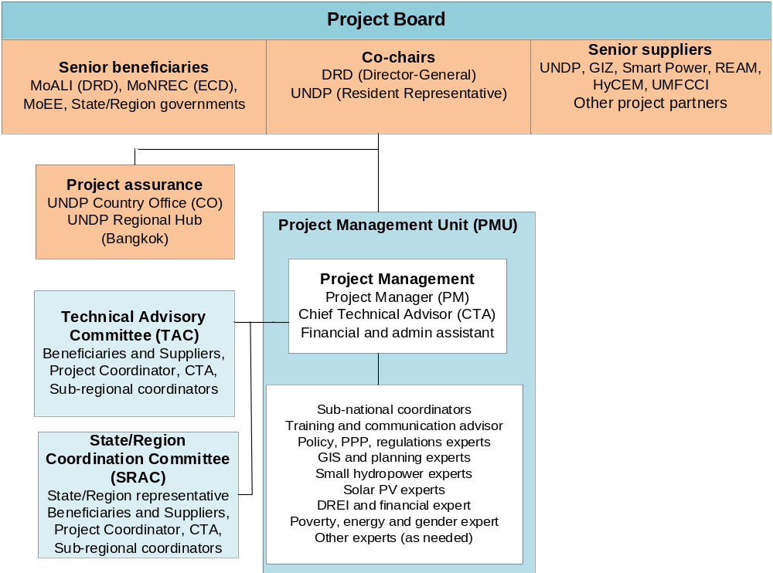

Financial planning and managemenT

The total financial resources required for effective project implementation are USD 42,884,228. This is financed through a GEF grant of USD 4,934,228 and USD37,950,000 in parallel co-financing. UNDP, as the GEF Implementing Agency, is responsible for the execution of the GEF resources and the cash co-financing transferred to UNDP.

Parallel co-financing: The actual realization of project co-financing will be monitored during the mid-term review and terminal evaluation process and will be reported to the GEF. The planned parallel co-financing will be used as follows:

Co-financing source | Co-financing type | Co-financing amount | Planned Activities/Outputs | Risks | Risk Mitigation Measures
MoALI-DRD | In-kind | 1,250,000 | Office space (for project staff and events); Support to and participation of staff in capacity building, policy and planning and support for rural RE projects (DRD Call for Proposals); participation in project management and Board | Government diverts funds and priorities to other areas. However, off-grid subsidy is planned in the budget so the risk is small | The village RE system and proposed business model realization and “seeing is  believing” phenomenon  will maintain enthusiasm  of government for the project
MoALI-DRD | Grant | 30,000,000 | Contribution (max 60% for mini-grids and mas 80% for SHS) for capital cost of off-grid energy systems (about USD 10 million a year) |  | One aim of RURED’s activities is to reduce dependency on subvention
GIZ | In-kind | 1,500,000 | GIZ supports the DRD-NEP off-grid electrification on policy and regulations, advice on Call for Proposals, and capacity development | Delays in  the progress of GIZ, RURED or SPM  activities lead  to delays in the other partner’s activities and in the timely  release of  funds | Coordination of activities RURED with SPM, GIZ, and DRD in Project Board, TAC and Sub-national working groups
Smart Power (SPM) | In-kind | 5,000,000 | In rural RE projects, work with villages and RESCOs on demand stimulation, end-user financing, capacity building, and research & knowledge sharing
UNDP | In-kind and grant | 80,000 (grant)  120,000 (in-kind) | Implementation costs of (staff) of a policy-advisory, technical, financial and implementation nature essential to deliver development results | Slow roll-out of funds | Ensuring project roll-out will ensure UNDP and GEF funds are also made available in a timely manner

Budget Revision and Tolerance: As per UNDP requirements outlined in the UNDP POPP, the project board will agree on a budget tolerance level for each plan under the overall annual work plan allowing the project manager to expend up to the tolerance level beyond the approved project budget amount for the year without requiring a revision from the Project Board. Should the following deviations occur, the Project Manager and UNDP Country Office will seek the approval of the UNDP-GEF team to ensure accurate reporting to the GEF: a) Budget re-allocations among components in the project with amounts involving 10% of the total project grant or more; b) Introduction of new budget items/or components that exceed 5% of original GEF allocation.

Any over expenditure incurred beyond the available GEF grant amount will be absorbed by non-GEF resources (e.g. UNDP TRAC or cash co-financing).

Refund to Donor: Should a refund of unspent funds to the GEF be necessary, this will be managed directly by the UNDP-GEF Unit in New York.

Project Closure: Project closure will be conducted as per UNDP requirements outlined in the UNDP POPP. On an exceptional basis only, a no-cost extension beyond the initial duration of the project will be sought from in-country UNDP colleagues and then the UNDP-GEF Executive Coordinator.

Operational completion: The project will be operationally completed when the last UNDP-financed inputs have been provided and the related activities have been completed. This includes the final clearance of the Terminal Evaluation Report (that will be available in English) and the corresponding management response, and the end-of-project review Project Board meeting. The Implementing Partner through a Project Board decision will notify the UNDP Country Office when operational closure has been completed. At this time, the relevant parties will have already agreed and confirmed in writing on the arrangements for the disposal of any equipment that is still the property of UNDP.

Transfer or disposal of assets: In consultation with the project partners, the UNDP programme manager (UNDP Resident Representative) is responsible for deciding on the transfer or other disposal of assets. Transfer or disposal of assets is recommended to be reviewed and endorsed by the project board following UNDP rules and regulations. Assets may be transferred to the government for project activities managed by a national institution at any time during the life of a project. In all cases of transfer, a transfer document must be prepared and kept on file.

Financial completion: The project will be financially closed when the following conditions have been met: a) The project is operationally completed or has been cancelled; b) The Implementing Partner has reported all financial transactions to UNDP; c) UNDP has closed the accounts for the project; d) UNDP and the Implementing Partner have certified a final Combined Delivery Report (which serves as final budget revision).

The project will be financially completed within 12 months of operational closure or after the date of cancellation. Between operational and financial closure, the implementing partner will identify and settle all financial obligations and prepare a final expenditure report. The UNDP Country Office will send the final signed closure documents including confirmation of final cumulative expenditure and unspent balance to the UNDP-GEF Unit for confirmation before the project is be financially closed in Atlas by the UNDP Country Office.

Total UNDP Budget and Work Plan

Total Budget and Work Plan
Atlas Proposal or Award ID: | 00104187 | Atlas Primary Output Project ID: | 00105877
Atlas Proposal or Award Title: | Myanmar Rural Renewable Energy Development (RURED) Project
Atlas Business Unit | UNDP Country Office - Myanmar
Atlas Primary Output Project Title | Myanmar Rural Renewable Energy Development (RURED) Project
UNDP-GEF PIMS No. | 5564
Implementing Partner | UNDP

GEF Component/Atlas Activity | Responsible Party (ATLAS Implementing Agent) | Funding ID | Donor Name | Atlas Budgetary Account Code | ATLAS Budget Description | Amount Year 1 (USD) | Amount Year 2 (USD) | Amount Year 3 (USD) | Amount Year 4 (USD) | Amount Year 5 (USD) | Total (USD) | Budget Note:
Outcome 1: Effective implementation of supportive policies and regulations at national and local level for enhanced RE utilization in rural productive uses | UNDP | 62000 | GEF | 71200 | International Consultants | 21,000 | 5,800 | 5,800 | 5,800 | 5,600 | 44,000 | 1
 |  |  |  | 71400 | Contractual Services Individual | 14,803 | 14,803 | 14,803 | 14,803 | 14,803 | 74,015 | 2a
 |  |  |  | 61300 | Salary & Post Adj Cst-IP Staff | 93,961 | 93,961 | 93,961 | 93,961 | 93,961 | 469,805 | 2b
 |  |  |  | 71300 | Local consultants | 1,000 | 4,000 | 4,000 | 2,000 |  | 11,000 | 3
 |  |  |  | 71600 | Travel | 14,000 | 10,000 | 12,000 | 12,000 | 13,000 | 61,000 | 4
 |  |  |  | 72100 | Contractual Services Companies | 32,800 | 5,000 | 30,000 | 5,000 | 30,000 | 102,800 | 5
 |  |  |  | 72200 | Equipment & Furniture | 7,500 | 7,500 | 0 | 0 | 0 | 15,000 | 6
 |  |  |  | 74200 | Audio Visual & Print Prod Costs | 1,000 | 2,000 | 2,000 | 2,000 | 2,000 | 9,000 | 7
 |  |  |  | 74500 | Miscellaneous | 1,100 | 1,000 | 1,000 | 800 | 500 | 4,400 | 8
 |  |  |  | 75700 | Training, Workshops and Conference | 10,000 | 10,000 | 10,000 | 10,000 | 10,000 | 50,000 | 9
 |  |  |  |  | Total outcome 1 | 197,164 | 154,064 | 173,564 | 146,364 | 169,864 | 841,020
Outcome 2: Awareness and knowledge enhanced of market enablers (project developers, RE companies, services, NGOs) and beneficiaries | UNDP | 62000 | GEF | 71200 | International Consultants | 12,000 | 26,000 | 26,000 | 23,000 | 14,750 | 101,750 | 10
 |  |  |  | 71400 | Contractual Services Individual | 14,802 | 14,802 | 14,802 | 14,802 | 14,802 | 74,010 | 2a
 |  |  |  | 61300 | Salary & Post Adj Cst-IP Staff | 62,641 | 62,641 | 62,641 | 62,641 | 62,641 | 313,205 | 2b
 |  |  |  | 71300 | Local consultants | 5,000 | 10,000 | 12,000 | 10,000 | 7,000 | 44,000 | 11
 |  |  |  | 71600 | Travel | 18,000 | 18,000 | 25,000 | 16,000 | 16,000 | 93,000 | 12
 |  |  |  | 72100 | Contractual Services Companies | 5,000 | 7,500 | 7,500 | 5,400 | 10,000 | 35,400 | 13
 |  |  |  | 72200 | Equipment & Furniture | 0 | 40,000 | 10,000 | 0 | 0 | 50,000 | 14
 |  |  |  | 72600 | Grants | 0 | 75,000 | 75,000 | 0 | 0 | 150,000 | 15
 |  |  |  | 74100 | Professional services | 0 | 0 | 9,600 | 0 | 0 | 9,600 | 29
 |  |  |  | 74200 | Audio Visual & Print Prod Costs | 2,000 | 3,000 | 3,000 | 3,000 | 2,500 | 13,500 | 16
 |  |  |  | 74500 | Miscellaneous | 1,000 | 1,500 | 2,000 | 1,500 | 1,000 | 7,000 | 8
 |  |  |  | 75700 | Training, Workshops and Conference | 10,000 | 44,000 | 44,000 | 25,000 | 13,000 | 136,000 | 17
 |  |  |  |  | Total outcome | 130,443 | 302,443 | 291,543 | 161,343 | 141,693 | 1,027,465
Outcome 3a: Increased investments in rural RE to meet household demand, PUE and enterprise development | UNDP | 62000 | GEF | 71200 | International Consultants | 18,000 | 23,000 | 21,000 | 36,078 | 17,422 | 115,500 | 18
 |  |  |  | 71400 | Contractual Services Individual | 14,803 | 14,803 | 14,803 | 14,803 | 14,803 | 74,015 | 2a
 |  |  |  | 61300 | Salary & Post Adj Cst-IP Staff | 62,641 | 62,641 | 62,641 | 62,641 | 62,641 | 313,205 | 2b
 |  |  |  | 71300 | Local consultants | 4,000 | 10,000 | 10,000 | 6,000 | 5,000 | 35,000 | 19
 |  |  |  | 71600 | Travel | 16,000 | 18,000 | 18,000 | 18,000 | 14,000 | 84,000 | 20
 |  |  |  | 72100 | Contractual Services Companies | 34,000 | 185,000 | 215,000 | 215,000 | 214,000 | 863,000 | 21
 |  |  |  | 72200 | Equipment and furniture | 200,000 | 200,000 | 250,000 | 250,000 | 110,000 | 1,010,000 | 22
 |  |  |  | 74200 | Audio Visual & Print Prod Costs | 1,100 | 1,100 | 1,100 | 1,000 | 800 | 5,100 | 23
 |  |  |  | 74500 | Miscellaneous | 200 | 200 | 1,000 | 922 | 878 | 3,200 | 8
 |  |  |  | 75700 | Training, Workshops and Conference | 0 | 8,000 | 8,000 | 0 | 0 | 16,000 | 24
 |  |  |  |  | Total outcome | 350,744 | 522,744 | 601,544 | 604,444 | 439,544 | 2,519,020
Outcome 3b: Financial programmes supported | UNDP | 62000 | GEF | 71200 | International Consultants | 0 | 5,750 | 4,000 | 4,000 | 0 | 13,750 | 25
 |  |  |  | 71400 | Contractual Services Individual | 14,802 | 14,802 | 14,802 | 14,802 | 14,802 | 74,010 | 2a
 |  |  |  | 61300 | Salary & Post Adj Cst-IP Staff | 31,320 | 31,320 | 31,320 | 31,320 | 31,320 | 156,600 | 2b
 |  |  |  | 71300 | Local consultants | 0 | 0 | 0 | 2,000 | 3,000 | 5,000 | 26
 |  |  |  | 71600 | Travel | 3,000 | 3,000 | 3,300 | 3,300 | 3,000 | 15,600 | 27
 |  |  |  | 72100 | Contractual Services Companies | 4,200 | 10,000 | 15,800 | 0 | 0 | 30,000 | 28
 |  |  |  | 74200 | Audio Visual & Print Prod Costs | 400 | 400 | 400 | 400 | 400 | 2,000 | 30
 |  |  |  | 74500 | Miscellaneous | 900 | 900 | 900 | 900 | 1,200 | 4,800 | 8
 |  |  |  | 75700 | Training, Workshops and Conference | 0 | 2,500 | 2,500 | 2,500 | 2,500 | 10,000 | 31
 |  |  |  |  | Total outcome | 54,622 | 68,672 | 73,022 | 59,222 | 56,222 | 311,760
Project management | UNDP | 62000 | GEF | 71400 | Contractual Services Individual | 21,393 | 21,393 | 21,393 | 21,393 | 21,393 | 106,965 | 32
 |  |  |  | 74596 | Services to Projects-GOE for CO | 14,976 | 14,976 | 14,976 | 14,976 | 14,976 | 74,880 | 33
 |  |  |  | 73100 | Rental & Maintenance-Premises | 8,000 | 8,000 | 8,000 | 9,118 | 10,000 | 43,118 | 34
 |  |  |  | 72500 | Supplies | 2,000 | 2,000 | 2,000 | 2,000 | 2,000 | 10,000 | 35
 |  |  |  |  | Total PM | 46,369 | 46,369 | 46,369 | 47,487 | 48,369 | 234,963
 |  |  |  |  | PROJECT TOTAL | 779,342 | 1,094,292 | 1,186,042 | 1,018,860 | 855,692 | 4,934,228

Summary of Funds:

 | Amount Year 1 | Amount Year 2 | Amount Year 3 | Amount Year 4 | Amount Year 5 | Total
GEF | 779,342 | 1,094,292 | 1,186,042 | 1,018,860 | 855,692 | 4,934,228
Government of Myanmar, DRD (MoALI) | 4,356,982 | 5,839,402 | 8,490,305 | 8,445,023 | 4,118,288 | 31,250,000
GIZ | 750,000 | 750,000 |  |  |  | 1,500,000
Smart Power Myanmar | 850,000 | 900,000 | 1,100,000 | 1,100,000 | 1,050,000 | 5,000,000
UNDP | 15,000 | 50,000 | 60,000 | 50,000 | 25,000 | 200,000
TOTAL | 6,751,324 | 8,633,694 | 10,836,347 | 10,613,883 | 6,048,980 | 42,884,228

Budget Notes:

1 | USD 44,000 for international consultants (8 weeks, DREI and financial Expert; 8 weeks Off-grid, PPP and regulations Expert) @USD 2750/week x 16 weeks
2a | USD 296,050 (spread across Outcome 1, Outcome 2, Outcome 3a and 3b): a) USD 196,050 for Project Manager @ 39,210/year x 5 years (SC-10, Max); and b) USD 100,000 for cost of area office staff for sub-National level coordination - @ 20,000/year x 5 years
2b | USD1,252,815 for Chief Technical Advisor @250563/year x 5 years (P4), spread across outcome 1, outcome 2, outcome 3a and outcome 3b.
3 | USD 11,000 for national consultant 8 weeks, Off-grid, policy and PPP expert and 3 weeks, Capacity building and communications advisor @ 1000/week
4 | USD 61,000 on travel (international, national) by international and local consultants and project staff (PM, CTA, coordinators)
5 | USD 102,800 for contracts: a) USD 22,800 for data gathering for market assessments (incl. GHG emissions); & b) USD 80,000 for GIS-based regional energy resource and demand assessments (in selected areas of Shan/Tanintharyi)
6 | USD 15,000 for office equipment (computers, IT), and software and measurement equipment for the least-cost geospatial analysis
7 | USD 9,000 for Audio-visual and printing for project publications, reports and for printed materials for workshops and seminars
8 | USD 19,050 - Miscellaneous costs (spread across Outcome 1, Outcome 2, Outcome 3a and 3b) for bank charge and sundries
9 | USD 50,000 for organization of seminar/workshop/training: venue, catering (workshops on policy and planning reacted to DREI and baseline/impact assessments; training for (sub)national officials on RE demand-supply and geospatial planning)
10 | USD 101,750 for: a) USD 74,250 for international consultants for training design and delivery (1 week Off-grid, 10 weeks Solar PV expert, 10 weeks Small hydropower Expert, & 6 weeks Energy, PUE and rural industries Expert) @ 2750 /week; & b) USD 27,500 for international consultant - MTR and TE, 10 weeks, @ 2750/week
11 | USD 44, 000 for: a) USD 22000 for national experts for training design and delivery (4 week Off-grid energy policy and PPP expert; 4 weeks Small hydropower Expert, 4 weeks Solar PV Expert and 6 weeks Energy, PUE, rural industries, 4 weeks Poverty, energy and gender expert) @ 1000/week; b) USD 10000 for local consultant MTR and TE (10 weeks) @ 1000/week; & c) USD 12000 for Capacity building and communications advisor (12 weeks) @ 1000/week
12 | USD 93,000 on travel (international, national) by international and local consultants and project staff (PM, CTA, coordinators)
13 | USD 35,400 for data gathering and methodology GHG emissions and monitoring of project indicators (part of M&E), knowledge capturing and info dissemination; and website design and hosting; elaboration of project publications; and for M&E: addressing environmental and social grievances; stakeholder engagement and gender action plans
14 | USD 50,000 for office equipment (computers, IT; furniture), and equipment needed for technical training on solar PV and mini/micro hydro
15 | USD 150,000 - Grant support to DRI Renewable Energy and Electronic Technology Centre to deliver RE training courses in Yangon and in the regions. Use of grant shall follow UNDP Low Value Grant Policies.
16 | USD 13,500 - Audio-visual and printing for project publications, reports and for printed materials for workshops and seminars
17 | USD 136,000 - Organization of seminar/workshop/training: venue, catering (for M&E: inception and end-of-project workshops; workshops on rural RE for government-private sector; training on installation, O&M for companies/service providers; training of local officials/village beneficiaries on planning, admin, O&M of off-grid RE system); seminar on lessons learnt)
18 | USD 115,500 for international experts (18 weeks Small Hydropower Expert, 12 weeks Solar PV Expert, 12 weeks Energy, PUE and industries Expert) @2750/week
19 | USD 35,000 for national experts 10 weeks Small hydropower Expert, 7 weeks Solar PV and 10 weeks Energy, PUE, industries Expert, plus 8 weeks Energy, poverty and gender experts to support the design and installation of the RURED-supported off-grid RE system) @ 1000/week
20 | USD 84,000 on travel (international, national) by international and local consultants and project staff (PM, CTA, coordinators)
21 | USD 863,000 for local contract for entity or entities (company, NGO; association) to support village electrification with off-grid RE and productive uses of energy, feasibility assessment and (bankable) business plan formulation and support for ESIAs and ESMPs for mini-grids as well as insurance payments for commercial lending to RE developers
22 | USD 1.01 million to support village off-grid electrification initiatives (solar PV, mini/micro-hydro and/or RE hybrid systems) by procurement of productive use equipment essential for mini-grid viability and for innovative – e.g. hybrid – RE mini-grids
23 | USD 5,100 -Audio-visual and printing for project publications, reports and for printed materials for workshops and seminars
24 | USD 16,000 - Organization of seminar/workshop/training: venue, catering (stakeholder workshops/seminar on village identification and selection; seminars on results of village electrification)
25 | USD 13,750 for international DREI and financial expert (5 weeks) @ 2750/week
26 | USD 5,000 for national financial expertise (5 weeks) @ 1000/week
27 | USD 15, 600 - Organization of seminar/workshop/training: venue, catering
28 | USD 34,200 – Contractual services company for a financial consulting or financing entity (international) to provide technical assistance and advisory services to selected local banks to enable them providing loans to the RURED-identified village off-grid RE systems
29 | USD 9,600 - DIM Audit - one audit in the project life cycle (as part of M&E)
30 | USD 2,000 -Audio-visual and printing for project publications, reports and for printed materials for workshops and seminars
31 | USD 16,000 - Organization of seminar/workshop/training: venue, catering (workshop and matchmaking event financiers/investors and developers/project proponents)
32 | USD 106,965 - cost of Project Associate @ 21393/year x 5 years (SC -Max)
33 | Direct Project Costs of $74,880 are cost recovery for administrative, operations and technical services to be provided by UNDP CO. Services include HR activities for $9,899 (project staff recruitment and HR administration), Procurement of goods and services for $4,495 (low value procurement and procurement involving CAP), Procurement of Individual Contract for $8,324, Grants for USD 7,282 and technical services USD 44,880 . Actual charge will be based on Universal Price List, Local Price List or actual costs.
34 | USD 43,118 for Rental & Maintenance-Premises, and connectivity for project staff and consultants
35 | USD 10,000 for office supplies (USD2,000/year)

Legal Context

This project document shall be the instrument referred to as such in Article 1 of the Standard Basic Assistance Agreement between the Government of Myanmar and UNDP, signed on (17 September 1987). All references in the SBAA to “Executing Agency” shall be deemed to refer to “Implementing Partner.”

This project will be implemented by UNDP (“Implementing Partner”) in accordance with its financial regulations, rules, practices, and procedures.

Any designations on maps or other references employed in this project document do not imply the expression of any opinion whatsoever on the part of UNDP concerning the legal status of any country, territory, city or area or its authorities, or concerning the delimitation of its frontiers or boundaries.

Risk management standard clauses

UNDP as the Implementing Partner will comply with the policies, procedures and practices of the United Nations Security Management System (UNSMS.)

UNDP as the Implementing Partner will undertake all reasonable efforts to ensure that none of the project funds are used to provide support to individuals or entities associated with terrorism and that the recipients of any amounts provided by UNDP hereunder do not appear on the list maintained by the Security Council Committee established pursuant to resolution 1267 (1999). The list can be accessed via http://www.un.org/sc/committees/1267/aq_sanctions_list.shtml. This provision must be included in all sub-contracts or sub-agreements entered into under this Project Document.

Social and environmental sustainability will be enhanced through the application of the UNDP Social and Environmental Standards (http://www.undp.org/ses) and related Accountability Mechanism (http://www.undp.org/secu-srm).
UNDP as the Implementing Partner will: (a) conduct project and programme-related activities in a manner consistent with the UNDP Social and Environmental Standards, (b) implement any management or mitigation plan prepared for the project or programme to comply with such standards, and (c) engage in a constructive and timely manner to address any concerns and complaints raised through the Accountability Mechanism. UNDP will seek to ensure that communities and other project stakeholders are informed of and have access to the Accountability Mechanism.

All signatories to the Project Document shall cooperate in good faith with any exercise to evaluate any programme or project-related commitments or compliance with the UNDP Social and Environmental Standards. This includes providing access to project sites, relevant personnel, information, and documentation.

UNDP as the Implementing Partner will ensure that the following obligations are binding on each responsible party, subcontractor and sub-recipient:
  - Consistent with the Article III of the SBAA, the responsibility for the safety and security of each responsible party, subcontractor and sub-recipient and its personnel and property, and of UNDP’s property in such responsible party’s, subcontractor’s and sub-recipient’s custody, rests with such responsible party, subcontractor and sub-recipient. To this end, each responsible party, subcontractor and sub-recipient shall:
    - put in place an appropriate security plan and maintain the security plan, taking into account the security situation in the country where the project is being carried;
    - assume all risks and liabilities related to such responsible party’s, subcontractor’s and sub-recipient’s security, and the full implementation of the security plan.
  - UNDP reserves the right to verify whether such a plan is in place, and to suggest modifications to the plan when necessary. Failure to maintain and implement an appropriate security plan as required hereunder shall be deemed a breach of the responsible party’s, subcontractor’s and sub-recipient’s obligations under this Project Document.
  - Each responsible party, subcontractor and sub-recipient will take appropriate steps to prevent misuse of funds, fraud or corruption, by its officials, consultants, subcontractors and sub-recipients in implementing the project or programme or using the UNDP funds. It will ensure that its financial management, anti-corruption and anti-fraud policies are in place and enforced for all funding received from or through UNDP.
  - The requirements of the following documents, then in force at the time of signature of the Project Document, apply to each responsible party, subcontractor and sub-recipient: (a) UNDP Policy on Fraud and other Corrupt Practices and (b) UNDP Office of Audit and Investigations Investigation Guidelines. Each responsible party, subcontractor and sub-recipient agrees to the requirements of the above documents, which are an integral part of this Project Document and are available online at www.undp.org.
  - In the event that an investigation is required, UNDP will conduct investigations relating to any aspect of UNDP programmes and projects. Each responsible party, subcontractor and sub-recipient will provide its full cooperation, including making available personnel, relevant documentation, and granting access to its (and its consultants’, subcontractors’ and sub-recipients’) premises, for such purposes at reasonable times and on reasonable conditions as may be required for the purpose of an investigation. Should there be a limitation in meeting this obligation, UNDP shall consult with it to find a solution.
  - Each responsible party, subcontractor and sub-recipient will promptly inform UNDP as the Implementing Partner in case of any incidence of inappropriate use of funds, or credible allegation of fraud or corruption with due confidentiality.
Where it becomes aware that a UNDP project or activity, in whole or in part, is the focus of investigation for alleged fraud/corruption, each responsible party, subcontractor and sub-recipient will inform the UNDP Resident Representative/Head of Office, who will promptly inform UNDP’s Office of Audit and Investigations (OAI). It will provide regular updates to the head of UNDP in the country and OAI of the status of, and actions relating to, such investigation.
  - UNDP will be entitled to a refund from the responsible party, subcontractor or sub-recipient of any funds provided that have been used inappropriately, including through fraud or corruption, or otherwise paid other than in accordance with the terms and conditions of the Project Document. Such amount may be deducted by UNDP from any payment due to the responsible party, subcontractor or sub-recipient under this or any other agreement.
Where such funds have not been refunded to UNDP, the responsible party, subcontractor or sub-recipient agrees that donors to UNDP (including the Government) whose funding is the source, in whole or in part, of the funds for the activities under this Project Document, may seek recourse to such responsible party, subcontractor or sub-recipient for the recovery of any funds determined by UNDP to have been used inappropriately, including through fraud or corruption, or otherwise paid other than in accordance with the terms and conditions of the Project Document.
Note: The term “Project Document” as used in this clause shall be deemed to include any relevant subsidiary agreement further to the Project Document, including those with responsible parties, subcontractors and sub-recipients.
  - Each contract issued by the responsible party, subcontractor or sub-recipient in connection with this Project Document shall include a provision representing that no fees, gratuities, rebates, gifts, commissions or other payments, other than those shown in the proposal, have been given, received, or promised in connection with the selection process or in contract execution, and that the recipient of funds from it shall cooperate with any and all investigations and post-payment audits.
  - Should UNDP refer to the relevant national authorities for appropriate legal action any alleged wrongdoing relating to the project or programme, the Government will ensure that the relevant national authorities shall actively investigate the same and take appropriate legal action against all individuals found to have participated in the wrongdoing, recover and return any recovered funds to UNDP.
  - Each responsible party, subcontractor and sub-recipient shall ensure that all of its obligations set forth under this section entitled “Risk Management” are passed on to its subcontractors and sub-recipients and that all the clauses under this section entitled “Risk Management Standard Clauses” are adequately reflected, mutatis mutandis, in all its sub-contracts or sub-agreements entered into further to this Project Document.

Annexes

- Multi-year work plan
- Overview of technical consultancies and subcontracts
- Terms of Reference for main project staff
- Gender analysis and Action Plan
- Baseline rural and renewable energy situation in Myanmar
- Myanmar: De-risking energy investment (DREI)
- GEF Core Indicators and GHG emission reduction analysis
- Stakeholder Engagement Plan
- UNDP Social and Environmental and Social Screening Template (SESP)
- Agreements: Co-financing letters
- UNDP Project Quality Assurance Report (to be completed after endorsement)
- Risk analysis and UNDP Risk Log (to be completed by UNDP Country Office)

- Multi-Year Work Plan

Output/activity per outome | Year 1 |  |  |  | Year 2 |  |  |  | Year 3 |  |  |  | Year 4 |  |  |  | Year 5
Output/activity per outome | Q1 | Q2 | Q3 | Q4 | Q1 | Q2 | Q3 | Q4 | Q1 | Q2 | Q3 | Q4 | Q1 | Q2 | Q3 | Q4 | Q1 | Q2 | Q3 | Q4
OUTCOME 1 Effective implementation of supportive policies and regulations at national and local level for enhanced RE utilisation in rural productive uses
Output 1.1 DREI analysis conducted to support the implementation of the National Electrification Plan (NEP)
1.1.1 DREI analysis (investment risks and barriers; de-risking instruments and levelized cost estimates) for small-scale RE
Output 1.2 Advisory services provided to DRD, MoEE, ECD and to coordinate activities under NEP
1.2.1 Market study (extended baseline assessment, and impacts assessment)
1.2.2 Advisory services to ECD of MoNRC, on off-grid electrification GHG MNRV
1.2.3 Advisory services to DRD (and MoEE) on National Electrification Plan (NEP)
Output 1.3 Completed least-cost geospatial analysis and investment prospectus plans in RURED Project Areas
1.3.1 Assessment of situation in at least two Project Areas
1.3.2 Toolkit developed for sub-national level rural and RE off-grid planning
1.3.3 Development of off-grid RE prospectus of most promising sites
OUTCOME 2 Awareness and knowledge enhanced of government entities, market enablers and beneficiaries
Output 2.1 Capacity needs assessment conducted for national and local government entities, RE market actors and beneficiaries
2.1.1 Capacity needs assessment of governance entities regarding off-grid and PUE planning at national and (sub)national level and of market actors
Output 2.2 Capacity strengthening activities designed and delivered for government entities, market actors and beneficiaries
2.2.1 Seminar/workshops for government entities and market actors on best practices and lessons learnt in off-grid RE electrification
2.2.2 Technical training designed and delivered for RE companies, energy service companies and village organizations on various aspects of rural RE electrification
2.2.3 Guidelines established for the voluntary certification of RE technology installers and rural energy service companies (RESCOs)
Output 2.3 Training on RE and off-grid systems institutionalised
2.3.1 Technical support to strengthen DRI’s Renewable Energy and Electronic Technology Centre and universities
2.3.2 Technical support to vocational training centres
Output 2.4 Experiences and knowledge captured, lessons learnt and info disseminated
2.4.1 Development with of a platform for info and knowledge sharing
2.4.2 Mandatory project M&E |  | 1) |  |  |  |  |  |  |  | 2) |  |  |  |  |  |  |  | 3)
OUTCOME 3a Increased investments in rural RE to meet household demand, PUE and enterprise development
Output 3.1 Designed and implemented off-grid RE solutions and models integrated with PUE implemented in selected villages, total installed capacity 15 MW
3.1.1. Selection of (cluster of) villages in the Project Areas to be supported under the Project
3.1.2 Technical and financial assistance provided to selected villages for the design of (bankable) electrification proposals and implementation and monitoring of off-grid RE and PUE
OUTCOME 3b Financial programmes supported
Output 3.2 Assessed and facilitated commercial financial support for rural RE energy projects
3.2.1 Assessment of current role and capacity assessment of financial service providers and status of sustainable financing and business models for off-grid electrification
3.2.2 Seminar/workshops and South-South interactions for banking/financial institutions/micro-finance institutions on financing rural and RE and PUE
3.2.3 Facilitation and advisory services to local banks that are committed to supporting long-term projects pipelines

Notes: 1) Inception report, 2) MTR (mid-term review), 3) TE (terminal evaluation)

- Overview of technical consultancies and subcontracts

This Annex provides an overview of short-term consultancies and subcontracts. Terms of Reference of (long-term) project staff is given in Annex C

Expertise | Inter-national | National | Description
Experts on retainer basis | (Weeks)
Capacity building and communications advisor |  | 12 | S/he will provide a baseline for skills and absorptive capacity at national/sub-national government level, village/communities and private sector (RE companies, developers) RE development, and with prospective RE. S/he will consult with relevant institutions, government officers, private sector, and local organisations on the RE and electrification knowledge gaps of these stakeholders, in close cooperation with the DREI expert.  S/he will design a capacity building programme for various groups of stakeholders, i.e. training and workshops on RE planning, design, implementation, operation and maintenance as well as financing of RE projects. The expert will work together with the technical experts (hydro, solar, financial, planning) in the elaboration of training and of appropriate training materials.
Subnational Coordinators |  | 40 | The Subnational Coordinators are based in the State/Region (S/R) and assist the Project team in elaborating S/R-based work plans, establish and maintain contacts and coordination with S/R and township authorities. They provide logistics support to activities of RURED in their respective S/R. The Coordinators advice on selection of villages and act as liaison between VECs and community organisations with the PMU. They support the technical experts on demand-supply surveys, local or S/R-based training activities, and formulation of village-level RE system business plans.
Off-grid energy policy experts | 3 | 6 | The expert review of private-public models for community-led energy access and work with GIZ (and DRD and MoEE) on sub-national design and implementation of a regulatory framework for off-grid electrification, in particular interconnection of mini-grids to the national grid, future electricity retail models (tariff setting and consumer/infrastructure subsidies) , approach to on-grid and off-grid planning and inter-ministerial coordination, ownership and business models. International expert: specialisation in Off-grid policy, PPP and regulations. National expert’s specialisation in ‘cooperatives and local governance’.
Small hydropower experts | 28 | 21 | The experts, one national, and one international, will be senior experts in designing and implementing projects of small hydropower in the civil works aspects, sourcing of pico-/ small micro-hydro equipment and parts and costing pico-/ small micro-hydro projects.  S/he reviews available hydrological studies conducted by the MOAI or other entities, conduct due diligence on resource availability, and identify a priority list of locations for the pilots; and support due diligence on all micro hydro projects, and review investment plans and engineering cost estimates. S/e expert will provide guidance and (on-site) support to VECs/communities/project partners in the design and implementation aspect of RURED’s pico-/ small micro-hydro projects. S/he will also support the project in training and the elaboration of training materials on for pico-/ small micro-hydro as well as advice on technical standards
Solar PV experts | 21 | 19 | The solar PV experts, one international and one national, will be senior experts in the PV area with extensive experience in solar home systems, and solar mini-grid systems up to a maximum of 500 kW, in the sourcing (at low cost but good quality) of PV equipment and parts, and determination of best-price comprehensive costing for PV installations  S/he will review solar irradiance surveys that are available, assess solar availability and identify a priority list of locations for solar solution-based electrification, and review investment plans and engineering cost estimates. The expert will provide support to VECs/communities/project partners in the design and implementation aspect of RURED’s solar PV projects S/he will also support the project in training and the elaboration of training materials on for solar PV mini-grid and SHS systems (including specialised software). The experts will research and provide the sourcing (at low cost but good quality) of PV equipment and parts Myanmar determination of best-price comprehensive costing for PV installations, and provide guidance on technical standards for solar energy systems
Energy demand, PUE and rural industries experts | 24 | 21 | The senior expert will provide guidance on potential energy demand in villages, in particular, the identification and elaboration of productive uses of energy at small scale (local/family shops, businesses) and larger scale (e.g. agro-processing, tourism, cold storage, etc.). This involves designing and supervising energy demand and supply surveys. S /he will also support the project in training and the elaboration of training materials on energy demand-supply matching. The expert will advise on the willingness and ability to pay in villages.
Poverty, social, energy and gender aspects |  | 11 | The expert will advise on the socio-economic profile of the households in the targeted villages, households' income and ability to pay in Project villages, use of electricity in the Project villages, as well do an assessment of the impact of electricity on changing life and the gender dimension in energy demand and supply and the role of women in operating the energy systems and developing income-generating activities. This involves designing and supervising energy demand and supply surveys (with the demand and PUE experts)
Financial and DREI experts | 12 | 6 | The expert will be responsible for providing technical inputs in relation to the financial context for RE development in Myanmar’s rural areas the development of proposed approaches for de-risking investment and the needs and demands of the RE market. The expert will work with UNDP DREI team in applying the DREI methodology to hydropower mini-grids. S/he will advise on the design and structuring of financial instruments (loans, guarantee schemes) with financial service providers. The experts will support the project in carrying out a barrier and risk review and organise training on financial issues and options.  Selection of financial partners and of beneficiaries of financial instruments. S/he will support the financial analysis of RURED’s community-led RE electrification projects
M&E experts | 8 | 8 | Experts (one international, one national) for mid-term review and final evaluation
GIS and electrification planning | Subcontract(s)  (USD 60,000) |  | The contracted company or organisations should have demonstrated expertise in energy planning, particularly energy access planning, and deep knowledge of small-scale renewable energy systems deployment for off-grid rural electrification. S/he is responsible for overall design, development, and implementation of a GIS and energy resource mapping exercise and development of least cost electrification plans.
Village electrification with off-grid RE and PUE | Subcontract(s)  (USD 780,000) |  | Local organisations or companies or association (or consortia with international companies) will be contracted to assist in the identification of initially promising villages will be achieved by a combination of (i) survey work and (ii) screening of proposals received from villages, (iii) identification of potential pico- hydro sites that may be suitable for mini/micro-hydro / PV hybrid systems. The contracted party will coordinate contacts with the project, village representatives and organisations, RE companies and developers, and (micro-)financiers.
DREI analysis | Subcontract  (USD 40,000 |  | DREI analysis of mini-grids powered by solar PVC and mini/micro hydro, according to methodology developed by UNDP – Climate Finance
PUE market assessment | Subcontract(s)  (USD 80,000) |  | Assessment of value chains in agriculture, processing, tourism and crafts regarding PUE applications, in coordination with CTA’s market assessment.
REEETC business plan | Subcontract  (USD 15,000) |  | Capacity needs assessment to provide RURED-linked hydropower and solar PV curriculums (oriented at minigrids). Development of business plan for REETC to provide such courses

- terms of reference for main project staff

Project Board

The Project Board (hereafter, PB) will be responsible for making by consensus management decisions for the project when guidance is required by the Project Manager, including recommendations for UNDP/Implementing Partner approval of project plans and revisions.

In order to ensure UNDP’s ultimate accountability, PB decisions should be made in accordance with standards that shall ensure the best value to money, fairness, integrity transparency and effective international competition. In case a consensus cannot be reached, final decision shall rest with the UNDP Programme Manager. Project reviews by this group are made at designated decision points during the running of a project, or as necessary when raised by the Project Manager. The Project Manager consults this group for decisions when tolerances (normally in terms of time and budget) have been exceeded.

The PB will review and approve project annual work plans (AWPs) and, as required, quarterly plans. The PB authorizes any major deviation from these agreed AWPs. It is the authority that signs off the completion of each AWP and authorizes the start of the next AWP. It ensures that required resources are committed and arbitrates on any conflicts within the project, or negotiates a solution to any problems between the project and external bodies. In addition, it approves the appointment and responsibilities of the Project Coordinator and any delegation of its Project Assurance responsibilities.

The proposed composition of the PB is as follows:
- Executive (co-chairs): DRD (Director General) and UNDP Resident Representative
- Senior Beneficiaries: Directors General of ECD (MoNREC), MoEP, and MOPF, and a senior representative from each of the participating Regions/States
- Senior suppliers: Smart Power Myanmar, GIZ, REAM, HyCEM, other
- The PB may permit observers, as required.

Specific responsibilities:
Defining a project
- Review and approve the Initiation Plan (if required and submitted to the LPAC).

Initiating a project
- Agree on Project Manager’s responsibilities, as well as the responsibilities of the other members of the Project Management Unit;
- Delegate any Project Assurance function as appropriate;
- Review the Progress Report for the Initiation Stage (if an Initiation Plan was required);
- Review and appraise Project Plan, AWP and Atlas reports covering activity definition, quality criteria, issue log, updated risk log and monitoring and communication plans.

Running a project
- Provide overall guidance and direction to the project, ensuring it remains within any specified constraints;
- Address project issues as raised by the Project Manager;
- Provide guidance and agree on possible countermeasures/management actions to address specific risks;
- Agree on Project Manager’s tolerances in the AWP and quarterly plans when required;
- Conduct regular meetings to review the Project Quarterly Progress Report and provide direction and recommendations to ensure that the agreed deliverables are produced satisfactorily according to plans.
- Review Combined Delivery Reports (CDR) prior to certification by the Implementing Partner;
- Appraise the Project Annual Review Report, make recommendations for the next AWP, and inform the Outcome Board (of UNDP) about the results of the review.
- Review and approve end project report, make recommendations for follow-on actions;
- Provide ad-hoc direction and advice for exception situations when the Project manager’s tolerances are exceeded;
- Assess and decide on project changes through revisions;

Closing a project
- Assure that all Project deliverables have been produced satisfactorily;
- Review and approve the Final Project Review Report, including Lessons-learned;
- Make recommendations for follow-on actions to be submitted to the Outcome Board;
- Commission project evaluation (only when required by partnership agreement)
- Notify operational completion of the project to the Outcome Board.

Terms of Reference for the Technical Advisory Committee (TAC) and State/Region Coordinating Committee (SRAC)

Two Committees will provide technical advice and inputs relating to project implementation with support from the PM. The members of the TAC and S/RAC will consist of representatives from the PMU (Manager, CTA, Sub-National Coordinators), DRD, UNDP, Smart Power, REAM, HyCEM, UMFCCI Solar Group, GIZ (represented in the PSC), State/Region representatives, and other relevant stakeholders (NGOs, private sector representatives) to be agreed by the PSC. Technical experts may be invited in to discuss specific issues. Indicative Terms of Reference are as follows. These will be reviewed by the Project Board during project inception and may be extended as necessary.

- Review planned activities and ensure that they are technically sound and that, wherever possible, there is integration and synergy between the various project components during planning and implementation; and with rural development initiatives at national and sub-national level
- Promote technical coordination and/or at regional/State between institutions, where such coordination is necessary and where opportunities for synergy and sharing of lessons exist;
- Provide technical advice and region/State-specific guidance on specific issues concerning off-grid electrification, energy demand, and productive uses; and final selection of beneficiary villages that will receive of RURED support for the design, implementation and monitoring of off-grid RE systems;
- Provide advice and guidance on the Project’s capacity building needs and training, and the implementation of stakeholder outreach (consumer awareness, knowledge, and information of municipalities);
- Share information on project progress and lessons learned with related stakeholders at the national level;
- The Committees or a subset of its members may be requested to undertake specific project-related tasks, such as preparing or reviewing analytical reports, strategies and action plans, review proposals and feasibility studies of rural RE projects, etc.;
- Other tasks as indicated by the Project Board

Terms of Reference for KEY PROJECT STAFF

Project Manager

Background
The Project Manager (PM), will be locally recruited following UNDP procedure, with input to the selection process from the Project partners. Under the supervision of the UNDP Country Office, the PM will be responsible for the overall management of the Project and day-to-day oversight, including the mobilisation of all project inputs, supervision over project staff, consultants and sub-contractors. The position will be full time for the full duration of the project, i.e. 5 years

The PM will report to the assigned UNDP Programme Manager for all of the Project’s substantive and administrative issues, from the strategic point of view of the Project. The PM will report on a periodic basis to the Board and will perform a liaison role with the government, UNDP, DRD, and other project partners, and maintain close collaboration with other donor agencies providing co-financing. The PM will work closely with the TAC.

Duties and Responsibilities
- Plan the activities of the project and monitor progress against the approved work plan.
- Supervise and coordinate the production of project outputs, as per the ProDoc in a timely and quality fashion.
- Management of the recruitment of consultants and other team members and partners for the project
- Oversight and guidance of procurement for the project
- Coordinate the recruitment and selection of project personnel, consultants and sub-contracts, including drafting terms of reference and work specifications and overseeing all contractors’ work.
- Facilitate administrative support to subcontractors and training activities supported by the Project.
- Manage requests for the provision of financial resources by UNDP through the advance of funds, direct payments, or reimbursement using the UNDP provided format.
- Oversight of the overall administration of the Project Management Unit; and monitor financial resources and accounting to ensure accuracy and reliability of financial reports, submitted on a quarterly basis.
- Prepare, revise and submit project work and financial plans, as required by the Project Board and UNDP.
- Oversee and ensure timely submission of the Inception Report, Project Implementation Report, Technical reports, quarterly financial reports, and other reports as may be required by UNDP and GEF.
- Disseminate project reports and respond to queries from concerned stakeholders.
- Report progress of the project to the Board, and ensure the fulfilment of Project Board directives.
- Ensure project’s M&E meets the requirements of the Government, the UNDP Country Office, and UNDP-GEF; develop project-specific M&E tools as necessary;
- Oversee and ensure the implementation of the project’s M&E plan, including periodic appraisal of the Project’s Theory of Change and Results Framework with reference to actual and potential project progress and results;
- Oversee/develop/coordinate the implementation of the stakeholder engagement plan;
- Oversee and guide the design of surveys/ assessments commissioned for monitoring and evaluating project results;
- Oversee the exchange and sharing of experiences and lessons learned with relevant community based integrated conservation and development projects nationally and internationally.
- Manage and monitor the project risks initially identified and submit new risks to the project board for consideration and decision on possible actions if required; update the status of these risks by maintaining the project risks log.
- Liaise with UNDP, DRD, Technical and S/R Committees, relevant government agencies, and all project partners, including donor organisations and CSOs for effective coordination of all project activities.
- Assist company, municipalities, CSOs, staff, and others with development of essential skills through training workshops and on the job training thereby increasing their institutional capabilities.
- Encourage staff, partners and consultants such that strategic, intentional and demonstrable efforts are made to actively include women in the project, including activity design and planning, budgeting, staff and consultant hiring, subcontracting, purchasing, formal community governance and advocacy, outreach to social organizations, training, participation in meetings; and access to program benefits.
- Assists and advises the Project Implementation Unit responsible for activity implementation in the target sites.
- Regular travel within Myanmar to organize and monitor project activity; possible travel outside the country for participation in directly relevant international meetings.

Required skills and expertise; Competencies
- A university degree (MSc or PhD) in management, engineering, energy, economics, marketing, or another field with direct relevance to the project
- At least 10 years of experience in managing larger projects on energy, electrification and/or rural development
- At least 5 years of demonstrable project/programme management experience.
- At least 5 years of experience working with ministries or local institutions with relevance to the project
- Strong leadership, managerial and coordination skills, with a demonstrated ability to effectively coordinate the implementation of large multi-stakeholder projects, including financial and technical aspects.
- Ability to effectively manage technical and administrative teams, work with a wide range of stakeholders across various sectors and at all levels, to develop durable partnerships with collaborating agencies.
- Ability to administer budgets, train and work effectively with counterpart staff at all levels and with all groups involved in the project.
- Ability to coordinate and supervise multiple Project Implementation Units in their implementation of technical activities in partnership with a variety of subnational stakeholder groups, including community and government.
- Strong drafting, presentation and reporting skills.
- Strong communication skills, especially in timely and accurate responses to emails.
- Strong computer skills, in particular, mastery of all applications of the MS Office package and internet search.
- Excellent command of English and local language

Chief Technical Advisor (P4 level)

This is an appointment over the duration of the project (5 years)

Job content
- Provide overall technical guidance, advice and support to local Project Manager and project team;
- Provide the interface between Project team and key specialist consultants, both domestic and international when appropriate.
- Assist the Project Manager and project team to prepare a detailed Annual Work Plan of all project activities in line with the programming and approved budget - starting and concluding them accordingly; Advise the project team on the project strategy and implementation methodology; Provide management oversight for project as required and recommend actions that focus work plans on achieving key milestones in a timely manner;
- Organisation and support to selection, assessment, proposal formulation and implementation of village mini-grid and solar home systems (and supervise short-term experts that work on these issues)
- Support developing detailed energy access plans for all states and regions of the country. This will involve designing and supervising energy demand and supply surveys, review of alternative financing models and development of possible community-led business models (and supervise short-term experts that work on these issues)
- Support the Project’s training, policy and finance work; and carry out off-grid market assessments
- Supports the independent mid-term review and terminal evaluation consultants; support management responses;
- Identifies information requirements on the market assessments (Outcome 1) and the project components concerning monitoring and evaluation;
- Facilitates annual reviews of the project and produce analytical reports from these annual reviews, including case studies, lessons learnt, other knowledge management products;
- Assists in the establishment of energy savings and greenhouse gas emission baselines and reporting
- Visit project sites as and when required to appraise project progress and validate written progress reports.
- Advises on the implementation of the project’s M&E plan, including periodic appraisal of the Project’s Theory of Change and Results Framework with reference to actual and potential project progress and results

Qualification
- At least 10 years work experience in project design and implementation, and/or monitoring and evaluation, in particular of GEF funded climate change mitigation projects
- Experience in the management, coordination or administration of development projects
- Experience in the area of renewable energy (solar PV or small hydropower) in rural context and knowledge of both technical, policy, financial-economic aspects; and productive uses of energy
- Experience in providing services as renewable energy expert in projects in developing countries
- University education in engineering, energy, physics, business or technology management or relevant field (MSc-eq.)
- Good interpersonal and communication skills
- Strong computer skills (Microsoft Office, Internet); good language skills in English (writing, speaking and reading)
- Working experience in Myanmar or the region; Knowledge of rural electrification in Myanmar is an advantage

Monitoring and evaluation

The Project Manager and CTA will share the M&E tasks of the RURED project: (a) developing and setting up the overall framework for project monitoring and evaluation (M&E), (b) prepare the monthly, quarterly and annual monitoring plan for project activities, (c) monitor and evaluate the compliance of actual progress and performance against the planned work plan and expected quality, (d) analysis of the effect of current actual performance to the project timetable and budgets, (e) prepare reports for project management including identification of problems, causes of potential bottlenecks (if any) in project implementations, (f) recommendations on how to reduce the impact of deviations vs. work plans, (g) prepare the ToRs for mid-term and final evaluation in accordance to UNDP and GEF guidelines, (h) design and implement a system to identify, analyze, and disseminate lesson learned,

Project Assistant

This is a full-time position over the duration of the project (220 weeks)

Under the guidance and supervision of the Project Manager, the Project Assistant will carry out the following tasks:
- Overall administration and financial services of the project such as processing payments, raising requisition, purchase order, projects logs, etc. using UNDP corporate software ATLAS.
- Provide information to UNDP Project web, RRMC reporting and administrative trouble shooting;
- Word processing, drafting routine letters/messages/reports, mailing; photocopying, binding and filing
- Arrange travel, itinerary preparation for project related travels,
- Assist to arrange workshops/seminar/training programs and mailing,
- Make appointments and schedule meeting,
- Assist in work-plan and budgeting, and in the development and implementation of project accounting and reporting procedures,
- Arrangement for payments to be made by the project, and conducting of bank reconciliation
- Preparation of documentation and record keeping for procurement
- Maintenance of all office equipment and keeping inventory/records of supplies and their usage and any other duties assigned by Project Manager

The Project Assistant will be recruited based on the following qualifications:
- A Bachelor’s degree or an equivalent qualification;
- At least three years of work experience preferably in a UNDP rural development project. Previous experience with UN or government projects will be a definite asset;
- Very good inter-personal skills;
- Proficiency in the use of computer software applications especially MS Word and MS Excel.
- Excellent language skills in English (writing, speaking and reading) and in local language

- Gender analysis and action plan

  - Gender mainstreaming analysis

Introduction
Key indicators, Myanmar
- Population: 52.9 million
- Average population growth: 0.9% per year
- Life expectancy: 66.4 years
- Urban population: 34.7%
- Human development index (HDI) - 0.556
- HDI rank out of 188: 145
- UN education index: 0.434
- Gender inequality index (GII): 0.374
- GII rank out of 189: 106
- GDP per capita (on PPP basis): USD 5,773
- Gini Index - 38.1
- Poverty: 30.2% *
- Foreign aid per capita: USD 22.3
Note:
* Percentage of population living on less than $3.20 a day at 2011 international prices.
Source: The World Bank, World Development Indicators 2017 | UNDP, Human Development Report 2017

According to the Global Gender Gap Report 2017, women in Myanmar are under-represented in legislator, senior official and manager roles. The Myanmar Census (2014) data tells us that women and girls are more likely to be married early, less likely to be economically active and earn income and be less literate. Educational attainment varies most significantly by location and income levels. In urban households, 22% of women and 19% of men have completed secondary school or have higher education as compared with 4% of women and men in rural households. Maternal mortality ratio is 282 per 100,000 births (which is higher than the 140 average of other South-East Asia countries). Age-specific fertility rate of 15-19 age women is 33/1000 births. Providing access to young women to education would result in delaying marriage and lower fertility rates and hence, women could participate more in the labour market. According to the result of a survey done with 430 women (45% from rural) in Kayah, Kachin and Kayin States, Yangon, Ayeyarwaddy and Mandalay Regions, 47% of women find difficulties in accessing public services and 11% find financial restrictions and transportation as major obstacles (Oxfam’s Women Budget Report August 2018).

A 2014 qualitative study conducted by the Gender Equality Network (Raising the Curtain) in Yangon and Mawlamyine found that intimate partner violence (IPV) is pervasive and patterned, with survivors experiencing multiple types of violence (physical, sexual, emotional, economic), multiple times, over a long period of time. This was also reflected in the UNFPA report of 2016 (Powerful Myths, Hidden Secrets) which was conducted across the South Eastern (SE) region of Myanmar. Sexual violence against children, particularly young girls is also another most prevalence type of gender-based violence (GBV) in the SE region. Other types of GBV such as domestic violence, cyber violence, and trafficking, and economic exploitation are also widespread throughout all three states of SE region. According to Myanmar Demographic Health Survey (2015-2016), 15% of ever-married women reported that they have experienced physical violence by their husband or partner, and 3% of Myanmar women have experienced sexual violence (since age 15). However, only 22% of women who have experienced physical or sexual violence have sought help to stop the violence, and 37% never told anyone about the violence. Annual statistics on serious crime by Myanmar Police Force showed that police have filed the rape cases as the second highest crime out of 10. However, Myanmar’s Penal Code does not properly address the different GBV cases that women have experienced these days. A new Law on Prevention and Protection of Violence Against Women (PoVAW Law) was drafted during 2014 – 2015, but submission to and approval by Parliament is still pending till date.

Gender equality: political dimension

According to the Global Gender Gap Report 2017 by the World Economic Forum, Myanmar country’s women are under-represented in legislator, senior official and manager roles. Female representation in Myanmar’s political atmosphere is still very low. By comparing 5.9 female members of parliament (MPs) during the period of 2010-2015, after the 2015 general election, the number of women MPs has increased to 14.5% of all elected MPs in the new Union Parliament, and to 13% in each of the Lower House (Amyotha Hluttaw) and Upper House (Pyithu Hluttaw) houses that make up the bicameral legislative body. At the state and region level, women MPs now constitute 12.5% of all elected MPs. Of the 29 ethnic affairs ministers elected, five were women. After the decades-long conflict, Myanmar Government signed ceasefire deals with 14 ethnic armed groups in 2013, followed by the nationwide ceasefire agreement (NCA) was signed with 10 ethnic armed organizations (EAO) out of 21 during 2015-2018. The frameworks of National Ceasefire Agreement (NCA) and Joint Monitoring Ceasefire (JMC) still lack of adequate language and attention to the specific needs of women in Myanmar’s peace. While agreeing on a 30% participation of women at different levels of the political dialogue process, the quota is not met reality. After elected in 2016, the NLD Government initiated to conduct the ‘Union Peace Conference - 21st Century Panglong’. In the first Union Peace Conference (UPC), women participation was made up only 13% and 17% in the second UPC, increased to 243 out of the total 1,112 people at the UPC as delegates, facilitators or technical assistants at the third UPC.

Gender equality demographic and economic dimensions

Women constitute 52% of Myanmar’s total population 52.9 million (according to the 2014 Census report). Of the households, 24% are female-headed (22% in rural and 28 % in urban). The average life expectancy is at 67 years but estimated at 70 years for women and 64 years for men. Women (50.5%) are significantly less economically active than men (85%), are more likely to be unemployed, and make up only a quarter of ‘employers’, and if employed, mostly in the informal sector or in professional, services and sales occupations, with men employed in occupations considered more “masculine”. Rates of labor force participation are almost equal for women (79.3%) and men (83.8%), although estimated earned income for women is about one-third that of men. A survey by DHS found that men are more likely to be employed than women, with almost all married men employed (in the 12 months previous to the survey) as compared to 71% of currently married women. Agriculture, forestry and fisheries form the backbone of Myanmar’s economy. Agriculture is accounting for 38% percent of gross domestic product (GDP), 25-30% of total export earnings and employs 70% of the labour force. The majority of workers in these three primary sectors are primarily low-income workers, but men are commonly paid more than women (Gender Situation Analysis, p52). The livestock and fisheries sectors account for more than 7% of the national GDP.

The structure and components of the national machinery responsible for gender issues

Myanmar National Committee for Women’s Affairs (MNCWA) was formed in 1996 to systematically implement activities for the advancement of women in Myanmar. Myanmar acceded to the Convention on Elimination of All Forms of Discrimination Against Women (CEDAW) in 1997, and became a member of ASEAN Women’s Affairs Committee in 2002 and ASEAN Commission on Women and Children’s rights in 2010. Overseen by MNCWA, the National Strategic Plan for Advancement of Women 2013-2022 (NSPAW) was developed in 2013 with 12 thematic areas based on the Beijing Platform for Action and on the implementation of the CEDAW. To support the implementation of NSPAW, four Technical Working Groups (TWGs), that is Violence Against Women, Mainstreaming, Participation in Politics and Economy, as well as Women, Peace and Security, to provide technical support on specific technical issues. To strengthen the mechanisms for effective gender mainstreaming, technical assistance through TWGs will be provided to all relevant other Sector Coordination Groups as well as gender-responsive budgeting will also be supporting in all sectors.

Gender issues in the proposed ‘Rural and Renewable Energy’ project

The project’s Theory of Change notes various causes that underlie the development challenge, several of which have these gender-related dimensions:
• Access to funding/lack of funding
According to Yangon Regional Government statistics, 97% of the nation’s productivity is from Small and Medium Enterprises. SMEs, however, face the challenges and obstacles to their receiving bank loan as financial support. Small micro-finance loans are available on a project-by-project basis, but not on a nation-wide basis. Empowering women and promoting participation through financial access and mainstreaming economy for income generation are integrated into the implementation of energy project in rural areas to achieve the development gains from off-grid renewable electricity.
• Female under-representation in senior level (decision-making) positions
Current challenges in Myanmar include high maternal mortality rates and unequal pay for women for similar work with men. With fewer women elected to office, women have a weaker voice and influence than men in politics. Female representation in legislator, senior official and manager roles and Myanmar’s political atmosphere is still very low even though Government is putting great efforts for the advancement of women through a national strategic framework.
• Limitation in the technology field
National rates of girls’ primary and secondary enrolment and completion rates are slightly higher than those for boys, there remain subtle educational and entrepreneurial barriers for girls. As a requirement for university entrance, girls must score higher than boys for admission to many of the institutions such as engineering schools and technology schools. It has been observed that the number of female professionals in the technology field is limited. Skills and access to technology of rural women and girls are also quite low. Skilled technicians for off-grid electrification still are in shortage. It is essential to build capacity in the energy sector with a limited quantity of female participants. Women participation and capacity building should be encouraged through various stages of the project life-cycle.

In turn, the Project seeks to be gender-responsive in the design of activities that address these causes, which will be described in the next Section D.2.

Gender and stakeholder engagement

Going forward, every effort will be made to ensure that qualified women are invited and encouraged to participate in the project activities, to equitable representation of both male and females participants is attained. A number of institutions will be consulted on gender issues at national and local levels and will include, inter alia, gender focal points at government ministries, civil society organisations working in the fields of gender and livelihood as well as research institutions and development partners working on gender issues.

  - Gender action plan

Gender will be mainstreamed on a number of components of the programme. The table in Exhibit 13 shows indicators and targets for these activities, taken directly from the project Results Framework, with gender-related aspects highlighted.

Based on the initial assessment of gender issues in the project, one gender-specific risks that may jeopardize the project has been identified. This is mentioned in the SESP (see Annex J) : the project can potentially have adverse impacts on gender equality and/or the situation of women and girls in case the activities related to the productive use of renewable energy reinforce or promote occupational gender stereotypes. As a key mitigation measure, the RURED project envisages prioritizing communities and projects that support productive uses of renewable energy, including a focus on the attainment of gender goals, including the prioritization of women-owned RE enterprises. The professional job capacity development interventions of the project will be designed in such a way that equal opportunities exist for all genders and ages, providing gender responsive trainings which account for gendered differences in capacity, determined through an initial assessment, as well as through providing training at times, and in a manner that does not increase women’s burden of work and that accounts for women’s preferences in regards to delivery. By doing this, men and women will benefit, striving to rectify any existing imbalances in technical qualifications, contributing to the improvement and promotion of gender equality. The training, capacity building, and access to finance interventions will improve the number of qualified women in Myanmar in technical areas such as the energy generation and renewables sectors. The monitoring and evaluation of the project activities will include tracking a number of human development indicators, among them would be gender equity, as the number of trained and employed women in new RE-based power generation facilities (see the Exhibit below).

Exhibit 13 Gender-related indicators and targets (from the project Results Framework)

Outcome Indicators | Comment
5) Number of staff (and % women) from national and State governments with enhanced capacity in rural RE project planning, procurement, financial management, community development, and safeguards. | Surveys and project (technical and progress) will include the number and gender of members of the household. The end-user awareness data to be collected in surveys and focus groups at the beginning and final year of the project linked with the overall market assessment (Indicator 4 of the Logframe) and with the individual project design and post-installation reports. Surveys will contain data on the gender of the respondent  Gender aspects included in campaigning and info provision Close monitoring is ensured through surveys in order to detect any gender-specific barriers cropping up so that they are addressed promptly.
6) Project developers, equipment providers and vendors (% females) trained on design, installation, operation and business models for rural RE
7) Village level promotors, operators, technicians, administrators trained on relevant subjects for successful management and operation of off-grid RE systems (with % of women)
9) Number of households (and # of female-headed HH) provided with electricity services
[GEF Core Indicator 11: number of direct beneficiaries disaggregated by gender]
Note: according to the 2014 Myanmar Population and Housing Census 23.4% of households are female-headed

Exhibit 14 Gender and social inclusion action plan: a gender mainstreaming measurement tool

Gender-related activity | Output | Indicator | Possible Output
Ensure full representation of vulnerable groups including women, and their meaningful participation in projects and programs  Strengthen women economic empowerment | Functional physical integration | Ensure women representation in all capacity building workshops and trainings, as well as at any working group or committee for project implementation and monitoring  Identify design features that impact positively on women and implement them and remove those that negatively impact the project. | A well represented governing structure that involves all groups of society is in place and participates meaningfully in the design of projects.  All bottlenecks that prevent the full and meaningful participation of women are identified and removed.
 | Social integration and sustainability | Support women and girls to voice issues and concerns about decisions and process of the project that affect their lives | Concerns of vulnerable groups, including women and girls, are addressed and their voices are integrated into all development projects and programmes through participatory approaches.
 | Economic integration and sustainability | Ensure access to loan financing by women entrepreneurs and vulnerable groups  Support women to save their time in participating in other productive activities such as education, health, and entrepreneurial activities by reducing their time and effort in doing household chores with renewable energy  Improve information and knowledge access such as operation of RE systems, financial services, market information, agricultural information and techniques and weather updates for the community (both males and females) by mobile, radio, and TV through renewable energy  Strengthen the technical capacity of women and girls for renewable energy by providing training on maintenance and repair, thus enhance their livelihood opportunity | All vulnerable groups’ needs, including women’s, are incorporated into the project cycle at all the phases of the projects to ensure economic sustainability.  Women’s participation in previous hydro-power projects is significantly low. To promote their meaningful and active participation in the project design, implementation in addition to monitoring and management phases, special measures should be considered (e.g., quota for VEC membership and capacity-building opportunities according to their roles at VEC).
Capacity building and cost-related issues disaggregated by gender | An Increased number of women receive technical training and participate in projects. The energy sector has sufficient women working in it and no longer lags behind with women representation. | Strengthen the technical capacity of women and girls for renewable energy by providing training on maintenance and repair, thus enhance their livelihood opportunity  Opportunities to empower and capacitate women including training needs are identified and tailor-made to suit projects being implemented.  Possible sources of funding for various aspects of the value chain are identified and followed through.  Ensure equitable allocation of resources for the implementation of appropriate implementation measures | At least one area where skills lack mostly among women entrepreneurs is identified and a matching training programme to address this shortage is implemented.  A set target of women entrepreneurs is assisted to secure funding for financing various aspects in the value chain.  A set and agreed to selection criteria is established and applied equally to ensure and encourage the participation of all.
Gender-responsive budget allocation to mainstream gender through the project preparation, implementation, and monitoring | An increased number of women who are more accessible to public participation, energy access, and safety | Women and girls are supported with spending some gender-responsive budget such as childcare, transportation, additional small-group meetings, translation etc to provide more access and inclusiveness to the participation of the project implementation.  Energy access for female-headed households is promoted by spending some gender budget allocation if needed accordingly  The lighting at the public area is supported to help women and girls feel safety and security for going out at night time and to prevent potential violence | A set target of women can reduce their obstacles to access public services and participation  Female-headed households with poverty and vulnerability are identified and provided support for access to electricity  Women and girls are protected and prevented from potential harm
Gender-sensitive communication | Safe and inclusive environment is created for the vulnerable groups and women to enhance their participation, to challenge gender bias and to portray gender equality | Ensure content of training materials, project documents, IEC materials including written text as well as audio and visual developed with inclusive language and appropriate illustrations without gender bias and stereotype | Significant women participation and representation are encouraged during capacity building trainings or workshops
Enable better planning and actions through disaggregated data | Disaggregated statistical data and gender-related findings on project outcomes and indicators  policy integration of gender considerations | Data are collected and tabulated separately for women and men with specific indicators measuring changes to gender equality and empowerment for adjustments to activities and implementation approaches to better outcomes of gender equality.  The case study or success story is collected as for gender-related findings at the intervention area to prove the results of gender mainstreaming | Evidence that adapts the better program accordingly, measure changes to gender equality, policy integration of gender considerations
Sensitization of project stakeholders with regards to gender equality | Effective gender mainstreaming for renewable energy project | Invest in developing competency and knowledge on gender mainstreaming for Government’s counterparts, community leaders and partner agency as well as UNDP’s project staff  Integrate gender session in each capacity-building training or workshop | Targeted and trained stakeholders are well oriented on gender issues and more confident to mainstream gender throughout the whole project circle
Monitoring on gender mainstreaming implementation | Adjustments to activities and implementation approaches and accountability to gender equality | Make sure gender balance practice applying in project staff recruitment process and hire gender-oriented staff (both male and female) for project implementation  Project staff is assigned and designated to implement and monitor the gender mainstreaming activities accordingly and their performance appraisal is evaluated by accomplishment on the assigned gender tasks.  Ensure Gender Analysis (UNDP in-house gender specialist) getting involved in the gender-mainstreaming activities as oversight, providing technical advice for implementation of the whole project circle through a gender lens.  Carry out impact assessments on how the development of energy investments contribute to gender equality and economic empowerment

Exhibit 15 Gender-aspects in Theory of Change

Goal | Outcomes | Outcome TOC | Outputs | Key Assumptions | Risks and Barriers
Promote gender inclusive energy planning and policies and designs | Energy planning and policy development is gender inclusive, participatory and responsive | If women can engage in energy planning, and policies are responsive to the needs of women and benefit them because evidence has shown that those actors with | Through effective engagement and decision making, women’s capacity to participate in energy planning and policy development is developed.  Gender-specific needs and underlying barriers are re-organized and re-assessed.  Targeted energy plans and policies drafted to support women’s access and economic empowerment in the SE sector. | Women place a strong premium on clean energy access. However, they do not have the same influence over investment decisions. | Women’s participation is not translated into gender-responsive policies; gender-responsive policies are not translated into practice; -strong interest groups favouring fossil fuel assets win over those favouring SE solutions.
Address skills shortage/ lack of information and social norms barriers that currently characterize the industry | Skill, information and social norms barriers for women SE entrepreneurs are removed, as indicated by: % distribution of tertiary graduates by sex and field of study | Women have access to required skills and information and their engagement in the SE sector is supported by enabling social norms and safe working places. | Access to technical education, training, and information for women in sustainable energy is improved.  Women’s entrepreneurial skills and knowledge is enhanced.  Increased access to decent employment in SE especially for women. | Decentralized SE technologies are the most cost-effective solutions in a growing number of developing country contexts: -the growth of SE will create the much-needed employment opportunities in existing and new sectors; addressing as it were the skilled labour shortage in the SE sector. | Investment in education does not necessarily translate into employment; high skill barriers in the energy service sector; social protection and non-discriminatory policies are not translated into practice; weak education and justice systems.
Promote the availability of finance for women entrepreneurs, WOBs and other vulnerable groups. | Financial intermediation services for WOBs (women-owned businesses) are strengthened as observed from:  % of firms identifying access to finance as a major constraint. | Women have access to affordable long-term finance and women entrepreneurs will be able to invest in the RE sector with barriers to accessing finance having been removed. | Explore traditional and innovative options to strengthen financial intermediation services for women entrepreneurs.  Capacity development of local commercial banks and MFIs.  Innovative financial solutions to meet the unique requirements of women SE entrepreneurs designed. | Women have lower levels of collateral due to discriminatory laws, which reduces their creditworthiness and ability to secure long-term funding, affordable finance etc. Women are more likely to be affected by under-developed financial sector, particularly the lack of rural bank branches. | High financing barriers in the SE sector; - required financing is not available; - discriminatory social norms regarding investor bias towards women entrepreneurs cannot be shifted in the short term.
Promote women’s productive use of climate-friendly gadgets and reduce domestic and unpaid work. | Women’s productive use of SE is promoted and time dedicated to unpaid care and domestic work is reduced. | Women have access to reliable and affordable energy services for domestic and productive uses as well as for public services. | Productive use of reliable and affordable SE in the microservice sector for women is promoted. | Productive use of efficient energy gadgets will be promoted to increase income-generating opportunities & end users’ capacity to pay for increased energy consumption services over time. | Women are not included in the design of end products which reduces the adoption rates by women; savings in time and money are not translated into higher disposable income for women due to lack of investment in other productive sectors, and income-generating activities.

- Baseline rural and renewable energy situation in myanmar

  - Electricity access and development challenge

Energy supply and demand

Myanmar has abundant energy resources, particularly hydropower and natural gas. The hydropower potential is estimated to be more than 100,000 megawatts (MW) in terms of installed capacity. The total primary energy production was 22.5 million tons of oil equivalent (Mtoe) in 2013. Biomass made up about 46%, followed by gas (43%) and others (11%)
consisting of hydropower, oil, and coal (ADB, 2016).

The total primary energy supply (TPES) is lower than the total primary energy production. Most of the produced gas is intended for export, which accounted for 79% in 2012, while the remaining 21% is utilized for domestic use. In 2015, the TPES was 20.1 Mtoe with a biomass share of 50% 10.0 Mtoe), followed by 17% (3.4 Mtoe) for hydro, 12% (2.4 mtoe) for gas, and 2% for coal (0.33 Mtoe). Myanmar has been reconnected with the world economy since its major reforms in 2011. Thus, domestic energy demand and supply have been increasing. For example, TPES increased from 11.8 MToe in 2000 to 20.1%, a 35% increase.

The power subsector

Total electricity consumption was 11,252 gigawatt-hours (GWh) in 2015, of which Yangon accounted for 44%. Electricity consumption has grown by 9.8% per year during 2000–2012. The peak load reached 2,500 MW in February 2016.The total installed capacity at mid-2016 is 4,764 MW, with 2,820 MW (59%) from hydropower, 1,824 MW (38%) from gas, and 120 MW (2.5%) from coal. Thus, Myanmar relies heavily on hydropower for its electricity generation (making up 72% of power production in 2014), yet the country has abundant hydropower resources that remain undeveloped. The country possesses over 46 GW of potential installed capacity from 92 possible hydropower projects. The Ministry of Energy and Electricity (MoEE) owns about 75% of total installed capacity and the rest owned by the private sector. The available capacity is approximately 50% of the installed capacity. Aging power plants and poor electricity transmission infrastructure cause severe power shortages, especially during the dry season when hydropower is in low supply. Of the hydropower capacity, 520 MW is reserved for export to China.

Installed capacity is expected to be expanded with new power projects adding about 11,000 MW over 2016-2030. By 2030, about 6,300 MW from 38 new hydropower plants will be added, and a first 500 MW coal plant will be added in 2023 (Soe Soe Ohn, 2016). The government tries to attract investment in hydroelectric, natural gas, and coal-fired electric capacity, to improve grid reliability, and to promote demand management. However, hydropower and coal-fired power plants are facing delays from local opposition, and gas-fired generation is dependent on the country’s future domestic gas production and potential natural gas developments (EIA, 2016). Increased attention is therefore given to solar energy, which will become more competitive as the trend of decreasing prices for solar panels will continue, and over 2500 MW of solar energy will be added (see Exhibit 16).

The country’s transmission system comprises a network of 230-kilovolt (kV), 132-kV, and 66-kV transmission lines and substations. Most of these lines lead from the northern part of the country, where most hydropower plants are, to the southern load centres, particularly the Yangon area. A 454 km long 500 kV transmission line is under implementation from
Exhibit 16 Least-cost power expansion plan

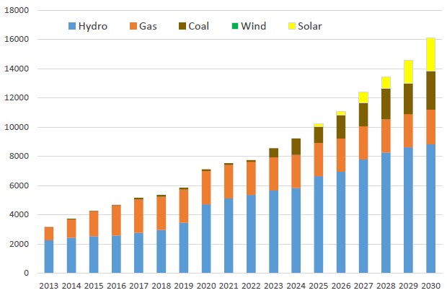
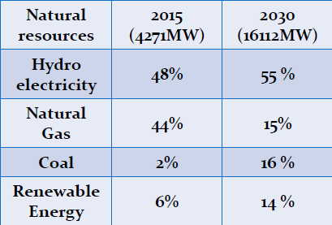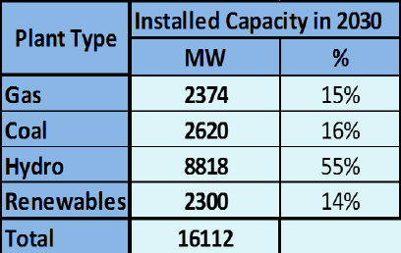
Source: MoALI-DRD; PowerPoint Dr. Soe Soe Ohn (2016)

Source: Eskom website (2017)
north to south through bilateral assistance. Technical and nontechnical losses of the combined transmission and distribution system were as high as 30% in 2003 and fell to 20% in 2013.

Institutional framework for the energy and electricity sectors

In April 2016, the government restructured its organization and reduced the number of ministries from 36 to 21, leading to a merger of a number of ministries. Ministries related to the energy sector are:
- Ministry of Energy and Electricity MoEE is the overall focal point for energy policy, coordination, and international cooperation and also the oil and gas sector, and is responsible for developing, operating, and maintaining all large hydropower and coal-fired thermal plants; for developing and maintaining the transmission and distribution systems throughout the country, and for operating gas-fired thermal plants and mini hydropower plants
- Ministry of Environmental Conservation and Forestry is responsible for forestry issues and policy (and regulates the use of biomass from forest resources for energy purposes). Its Environmental Conservation Department (ECD) is responsible for implementing environmental policy, strategy, framework, planning and action plan, including climate change issues. It has formulated the National Environmental Policy and Strategic Framework & Master Plan.
- Ministry of Industry, which has responsibility for energy efficiency and implementation of Energy Efficiency and Conservation policy and development plan
- Ministry of Agriculture, Livestock and Irrigation takes the lead in the development of biofuels, micro-hydropower (with an installed capacity of up to 10 MW), bioenergy from agricultural residues, for off-grid electrification (solar Home system, mini-grid system, etc)
- Ministry of Border Affairs, for off-grid electrification in border areas.
- Ministry of Education is responsible for the research and development of renewable energy technologies (RET) and the promotion of renewable energy, and also conduct formulation of RE policy and a specialised centre organises training courses on RE.

The Myanmar government created a National Energy Management Committee and National Energy Development Committee (NEMC/NEDC) in 2013 to facilitate cooperation and communication among energy-related ministries and organisations. However, the committees were disbanded in the ministerial restructuring that accompanied Myanmar’s transition to a new government in 2016.

On the ground, various state-economic enterprises carry out most of the work in the power sector. About 57% of the power is generated by the state company EPGE (hydropower, gas, oil, coal) and independent power producers (IPPs). The Power Transmission and Systems Control Department develops the national transmission networks and substations. EPGE is also the single buyer having the authority to purchase electricity from different energy generators through individual power purchase agreements (PPAs) and sell it to state-owned distributors. IPPs in electricity generation are becoming more common, but foreign investment still requires links with either a local company or directly with the government. The Electricity Supply Enterprise (ESE) supplies power to the bulk of the country. Electricity distribution in Yangon falls under the auspice of the Yangon Electricity Supply Corporation (YESC) and in Mandalay under the Mandalay Electricity Service Corporation.

Relevant policy, legislation and regulation

The government has prepared a set of reform programs aiming to transform the country. The framework for these reforms was laid down in the 2011–2031 National Comprehensive Development Plan. To ensure the development of the energy and electricity sectors, the NEMC prepared the National Energy Policy paper which was approved in Jan 2015. The Energy Master Plan was elaborated by IES, MMIC with support from the Asian Development Bank and published in Dec 2015. Government plans as set out in the National Energy Policy paper include sector restructuring, investment planning, pricing, and fuel subsidy review, renewable energy and energy efficiency development, promotion of private sector, increased international trade, and a National Electrification Programme (NEP) with the aims at achieving 100% electrification by 2030.

The new Electricity Law was passed in 2014 allowing private sector participation. The associated Rules and Regulations, which are to be finalized, will address details on the implementation of the law and establishment of the Energy Regulatory Commission and its duties and mandate. The National Electricity Master Plan was elaborated with Japanese support by NEWJEC, Kansai Electric Power (2014). The ADB-supported the development of a Renewable Energy Policy in 2014, but this has remained in draft form. The Policy’s goal is to achieve a 27% share of renewable energy in the total installed capacity of primary energy by 2030.

Under the new law states and regions can issue permits for small (< 10MW) power plants and for medium-sized power plants (30 MW) not connected to the grid. The new law will effectively encourage state-level government stakeholders to take a lead in promoting off-grid power infrastructure projects. Low-head hydropower technologies and cascades of smaller-scale (<10MW) dams have fewer environmental and social impacts, and are therefore likely to generate less public opposition, particularly when the electricity generated benefits local communities.

  - Renewable energy

Myanmar has rich hydropower potential that drains the four main basins of the Ayeyarwady, Chindwin, Thanlwin, and Sittaung rivers. It is estimated that there is more than 100,000 MW of installed capacity potential. Myanmar has identified about 300 large hydropower potential projects with a total installed capacity of 46,330 MW, while the current installed capacity of hydropower plants is about 3,200 MW. A total of 32 mini hydropower (with a total capacity of about 34 MW) projects have been implemented with installed capacity ranging from 50 kW to 5,000 kW to reach remote border areas in Kachin and Shan Stat. There is the potential for many more small- and medium-sized hydropower projects, each of which has a capacity of less than 10 MW, for a total potential installed capacity of approximately 250 MW (ADB, 2015). With the new Electricity Law (2014, the regional governments are permitted to approve small-scale hydro plants that power mini-grids in villages that are not connected to the grid (see next Section).

Myanmar has a strong solar radiation level. Myanmar’s maximum solar power potential is estimated at about 40,000 GWh per year. Solar energy has been introduced in some rural areas in the last decade through photovoltaic cells for charging batteries and pumping water for irrigation. The MoEE is conducting a preliminary investigation to construct solar power plants of a total of 1,460 MW with foreign direct investment in Minbu, Magway Region, Myingyan, and Mandalay Region. Solar PV is increasingly used to power off-grid villages in small mini-grid systems (see next Section), the Department of Rural Development (DRD) reported about 200 by 2017. Several households in a village already have a solar home system installed, either from the DRD programme (described in the next Section) or self-purchased.

Most of Myanmar is considered unattractive as average wind speeds are below 4 meters/second, except for coastline and mountain ranges. Site-specific wind data is limited to a few; therefore, an in-depth assessment is needed. Foreign investment proposal of about 6,540 MW have been received, but are still in concept stage and none have started any activities. Regarding biomass, about 53% of the total land area is covered with forest and has a potential annual sustainable yield of wood fuel 19.1 million cubic ton. Large amounts of waste are generated in the big cities, such as Yangon or Mandalay, with organic materials that could be used generate energy by bio-methanation. Agricultural residues and by-products (such as rice straw and husks, sesame stalks, palm leaves and animal waste) can be used to generate biogas. Five biofuel plants were constructed by various agencies between 2003 and 2010 (with a total annual production of 19.5 million gallons) but have ceased operations, hampered by financial, legal and other issues. A large number of gasifiers are in operation using rice residues as feedstock.
Exhibit 17 Current situation of rural electrification

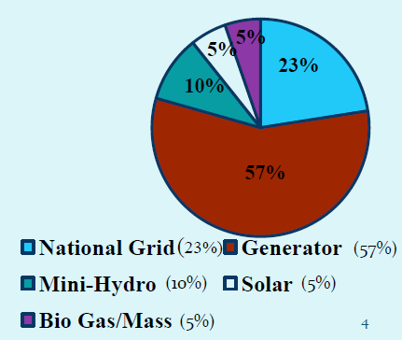
Source: MoALI-DRD; PowerPoint Dr. Soe Soe Ohn (2016)

Source: Eskom website (2017)

  - Electrification

Electrification rate

The country’s average electrification ratio has grown from about 16% in 2006 to 26% in 2011 to 34% in 2015 and 57% in 2018. Yangon City has the highest electrification ratio of approximately 78%. In comparison, the country’s rural electrification rate, at 16% in 2015-16, remains among the lowest in the world. According to World Bank ESMAP estimates, over 7.2 million households in Myanmar were off-grid as of 2015.

Exhibit 18 Township-level maps of access to energy technologies

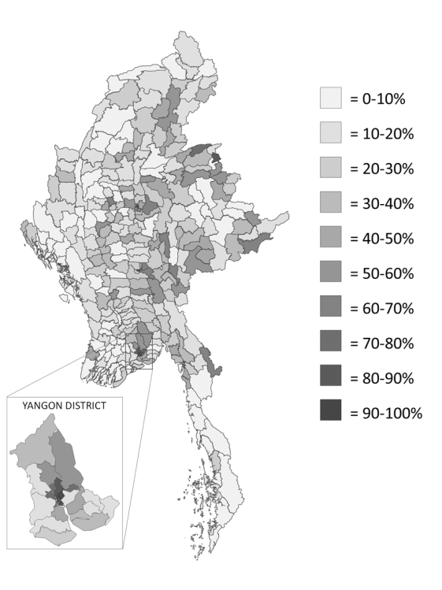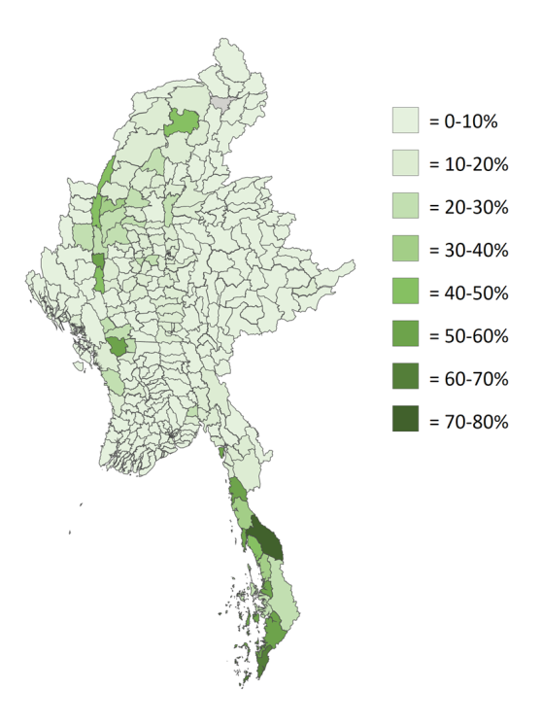
a) On-grid electricity b) Diesel generatot
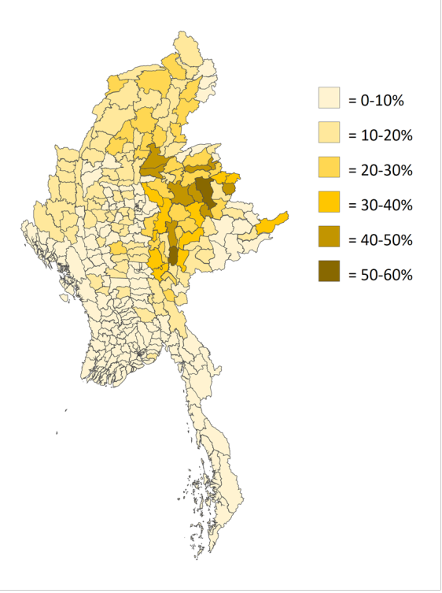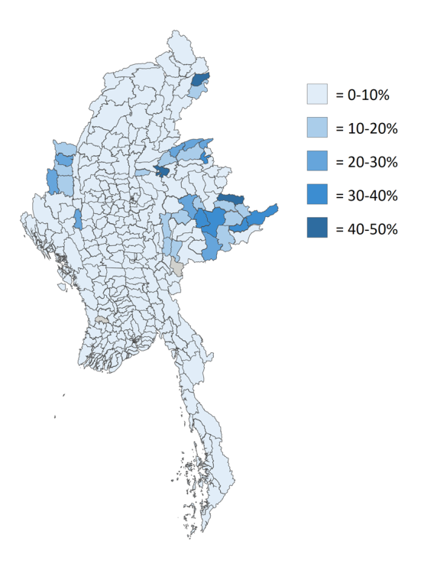
c) Solar PV d) Mini-micro hydropower
Source: Spectrum – SDKN (2017)

Out of a total of 63,899 villages in Myanmar, 20,807 villages were considered electrified as of August 2016 (villages with at least 70% of electrified households are considered ‘electrified), leaving over 43,092 villages unelectrified. Regions in the Central Dry Zone and Ayeyarwady delta region are better electrified than states in border areas; in Kayin and Tanintharyi states, electrification remains under 10%. There, most rural villages cannot tap into a steady stream of electricity, such as the grid. The NGO Spectrum SDKN has analysed the status of rural electrification, based on the 2014 Census, of which the results presented below.

However, alternatives such as diesel generators are quite common in some area, despite their high costs (see Exhibit 17). Use of private generators for lighting is very high in Tanintharyi Region and parts of Mon State (see Exhibit 18). This might be because these areas are far from the national grid and have relatively high household income levels (due to remittances from migrants worming in Thailand). The use of small solar devices is also growing. Use of solar photovoltaic (PV) systems for lighting is highest in Shan State, Kayah State, and Kachin State (see Exhibit 18). In some rural townships in Shan State, over 50% of households use solar PV for lighting. One reason is that many solar PV panels cross the border from nearby China (KWR-ERIA, 2015). In some rural areas, the use of solar PV has already overtaken the use of generators. The use of private small hydro systems for lighting was highest in Shan State, Kachin State, and Chin State, with nearly 50% of households using small hydro mini-grids or lighting in mountainous townships in Shan State and Kachin State. Gasification, powered by rice husks and other agricultural by-products, are seen as an attractive energy source in the Ayeyarwaddy Delta. It is reported there are presently 1,000 or more gasification facilities in Myanmar (KWR-ERIA, 2015).

The use of batteries is concentrated in the central dry zone and reached over 20% in rural parts of Ayeyawady Region, Magway Region, Mandalay Region, Sagaing Region, Bago Region and Yangon. This might be because the flat terrain in these areas makes distribution of batteries more economic than in more hilly parts of the country. Households that rely on batteries may be well suited for transitions to solar PV systems, since they are likely to already own low-voltage appliances and be familiar with the basic concepts of battery charging and energy management.

On average, 26% of households in rural areas and 7% of households in urban areas relied on candles for lighting in 2014. The highest usage rates were in rural townships in Rakhine State, Kayin State, Naypyitaw, Kachin State and Mon State. Candles are an expensive and often dangerous source of lighting. Switching from candles to solar PV or mini-grid systems can provide a safer, higher quality and in many cases cheaper source of lighting

Off-grid suppliers are providing household and village electricity supplies (diesel and renewables) for rural customers through retail and tenders with the government, international organizations, and NGOs. Some of these local companies and social enterprises have a long-standing presence in Myanmar, while others are relatively new and came into existence primarily to implement government tender programs. Commercially oriented off-grid service providers face risks as there are no clear standards for setting retail tariffs nor clear options for interconnection upgrades to the utility network as the grid continues to extend into new service areas. Market data and consumer information (e.g., ability and willingness to pay for electricity) were not readily available, until recently (see section E.3).

National Electrification Plan (NEP)

At present, approximately 190,000 additional households gain access to electricity every year. At this rate, it would take almost 40 years to achieve full electrification. In 2014, the Burmese Government released its National Electrification Plan, with the ambitious goal of providing electricity access to all households by the year 2030. The plan aims to expand the national grid, under the MoEE, and develop off-grid electrification for remote communities by means of mini-grid and renewable energy (RE) technologies, under the MoALi.

Such a pace of electrification will be challenging given the geographical, financial and institutional constraints. Approximately 7.2 million household connections will be required in the next 16 years to fulfill the vision of universal electrification by 2030. This means that the number of household connections needs to increase from the current 189,000 a year, to an average of 450,000 a year over the next 16 years—a more than two-fold rise. This also implies a newly added power demand of 2,636 MW.

The total cost of the grid expansion, including investments into generation, transmission and distribution, is around USD 6-10 billion over the next decade and a half (about USD 800-1600 per connection).
Exhibit 19 Rural electrification target in Myanmar

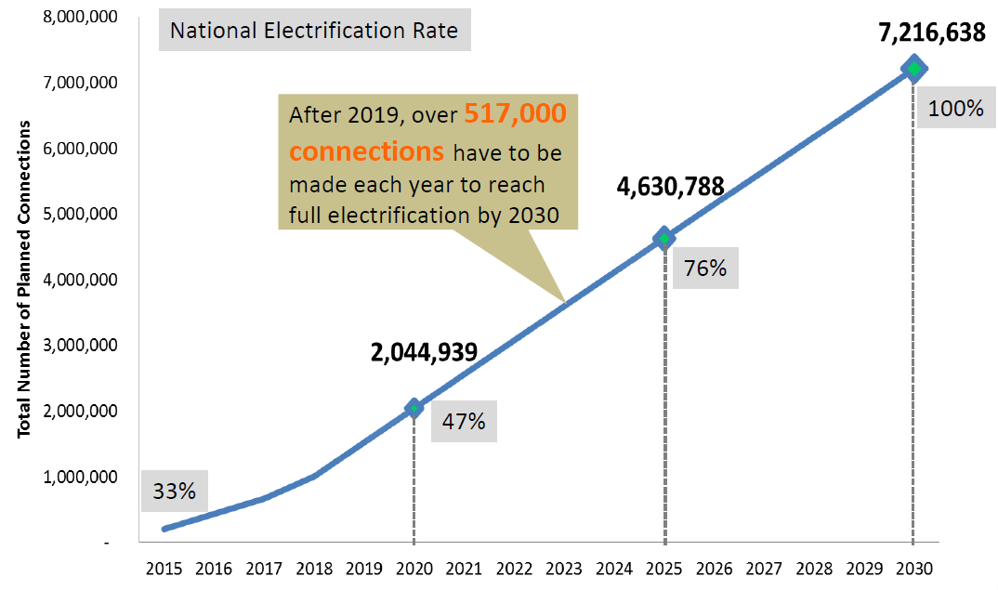
Source: MoALI-DRD; PowerPoint Dr. Soe Soe Ohn (2016)

Source: Eskom website (2017)

Financing these investments requires a financially viable power sector. It is currently not viable: the costs of production and transmission are about MMK 109 (USD 0.078) per kWh. However, the average tariff in Myanmar is only about USD 0.03 per kWh. For each unit of electricity sold to residential consumers, the government is making a loss, which is about MMK 59-74 per kWh (Doberman, 2016).

Amending tariff policy will be key for closing the funding gap which was USD 300 million (MMK 406.52 billion) in electricity subsidies over the fiscal year 2017-18 and will lose close to USD 500 million in 2018-19. The traditional argument for subsiding power consumption is that electricity is a prerequisite for almost all other aspects of development and that the poor can afford it. However, one counterargument is that the future access of the millions of unserved will depend on the funds available in the power sector to extend the generation and transmission and distribution capacity. Second, subvention is less fair than it seems. For example, a poor customer using 50 kWh per month receives a MMK 3500 subsidy, while one using 500 kWh gets MMK 30,000 worth of free electricity.
Exhibit 20 Responsibilities of stakeholders in the off-grid NEP

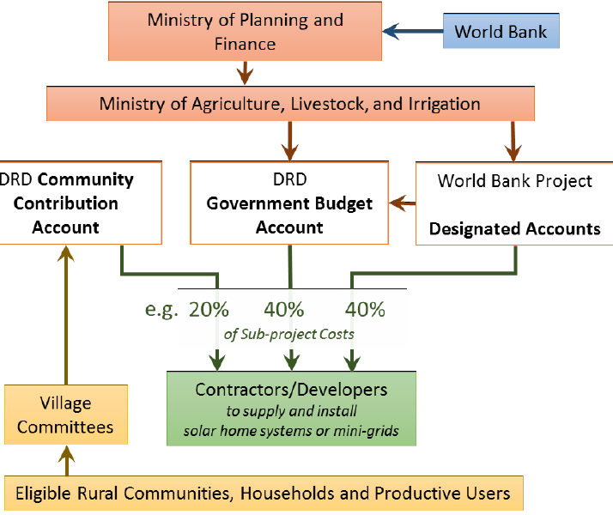
Source: ESMAP-WB, Wang (2016)

Source: Eskom website (2017)

Grid electricity will not solve all problems. A prominent feature of the NEP is that the grid is planned on a spatial least-cost basis It is a technically efficient solution for many areas, but not for all. Areas closer to existing lines and in flatter terrain are to receive the grid sooner. Mountainous and remote regions can expect the grid to arrive much nearer to 2030, if at all. The process of expansion and connection also takes many years (once the grid reaches a township, it can take anywhere between one to four years for households to complete their connections). This will leave certain areas dependent on high-cost diesel and other sources that can cost up to MMK 500 per kWh, or which provide power only a few hours a day. At the same time some of their neighbours and nearby areas, which are connected, will receive 24-hour power at the MMK 35 per kWh residential or MMK 75 per kWh industrial tariff rates. This is bound to exacerbate social tensions and promote a sense of inequity (KWR-ERIA, 2015).
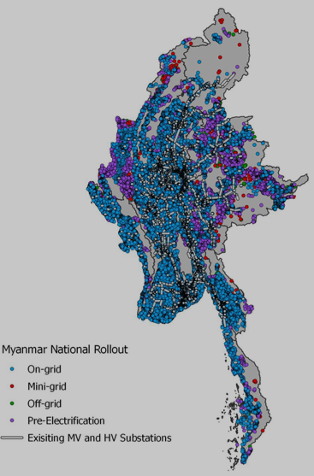
Exhibit 21 National grid roll-out plan

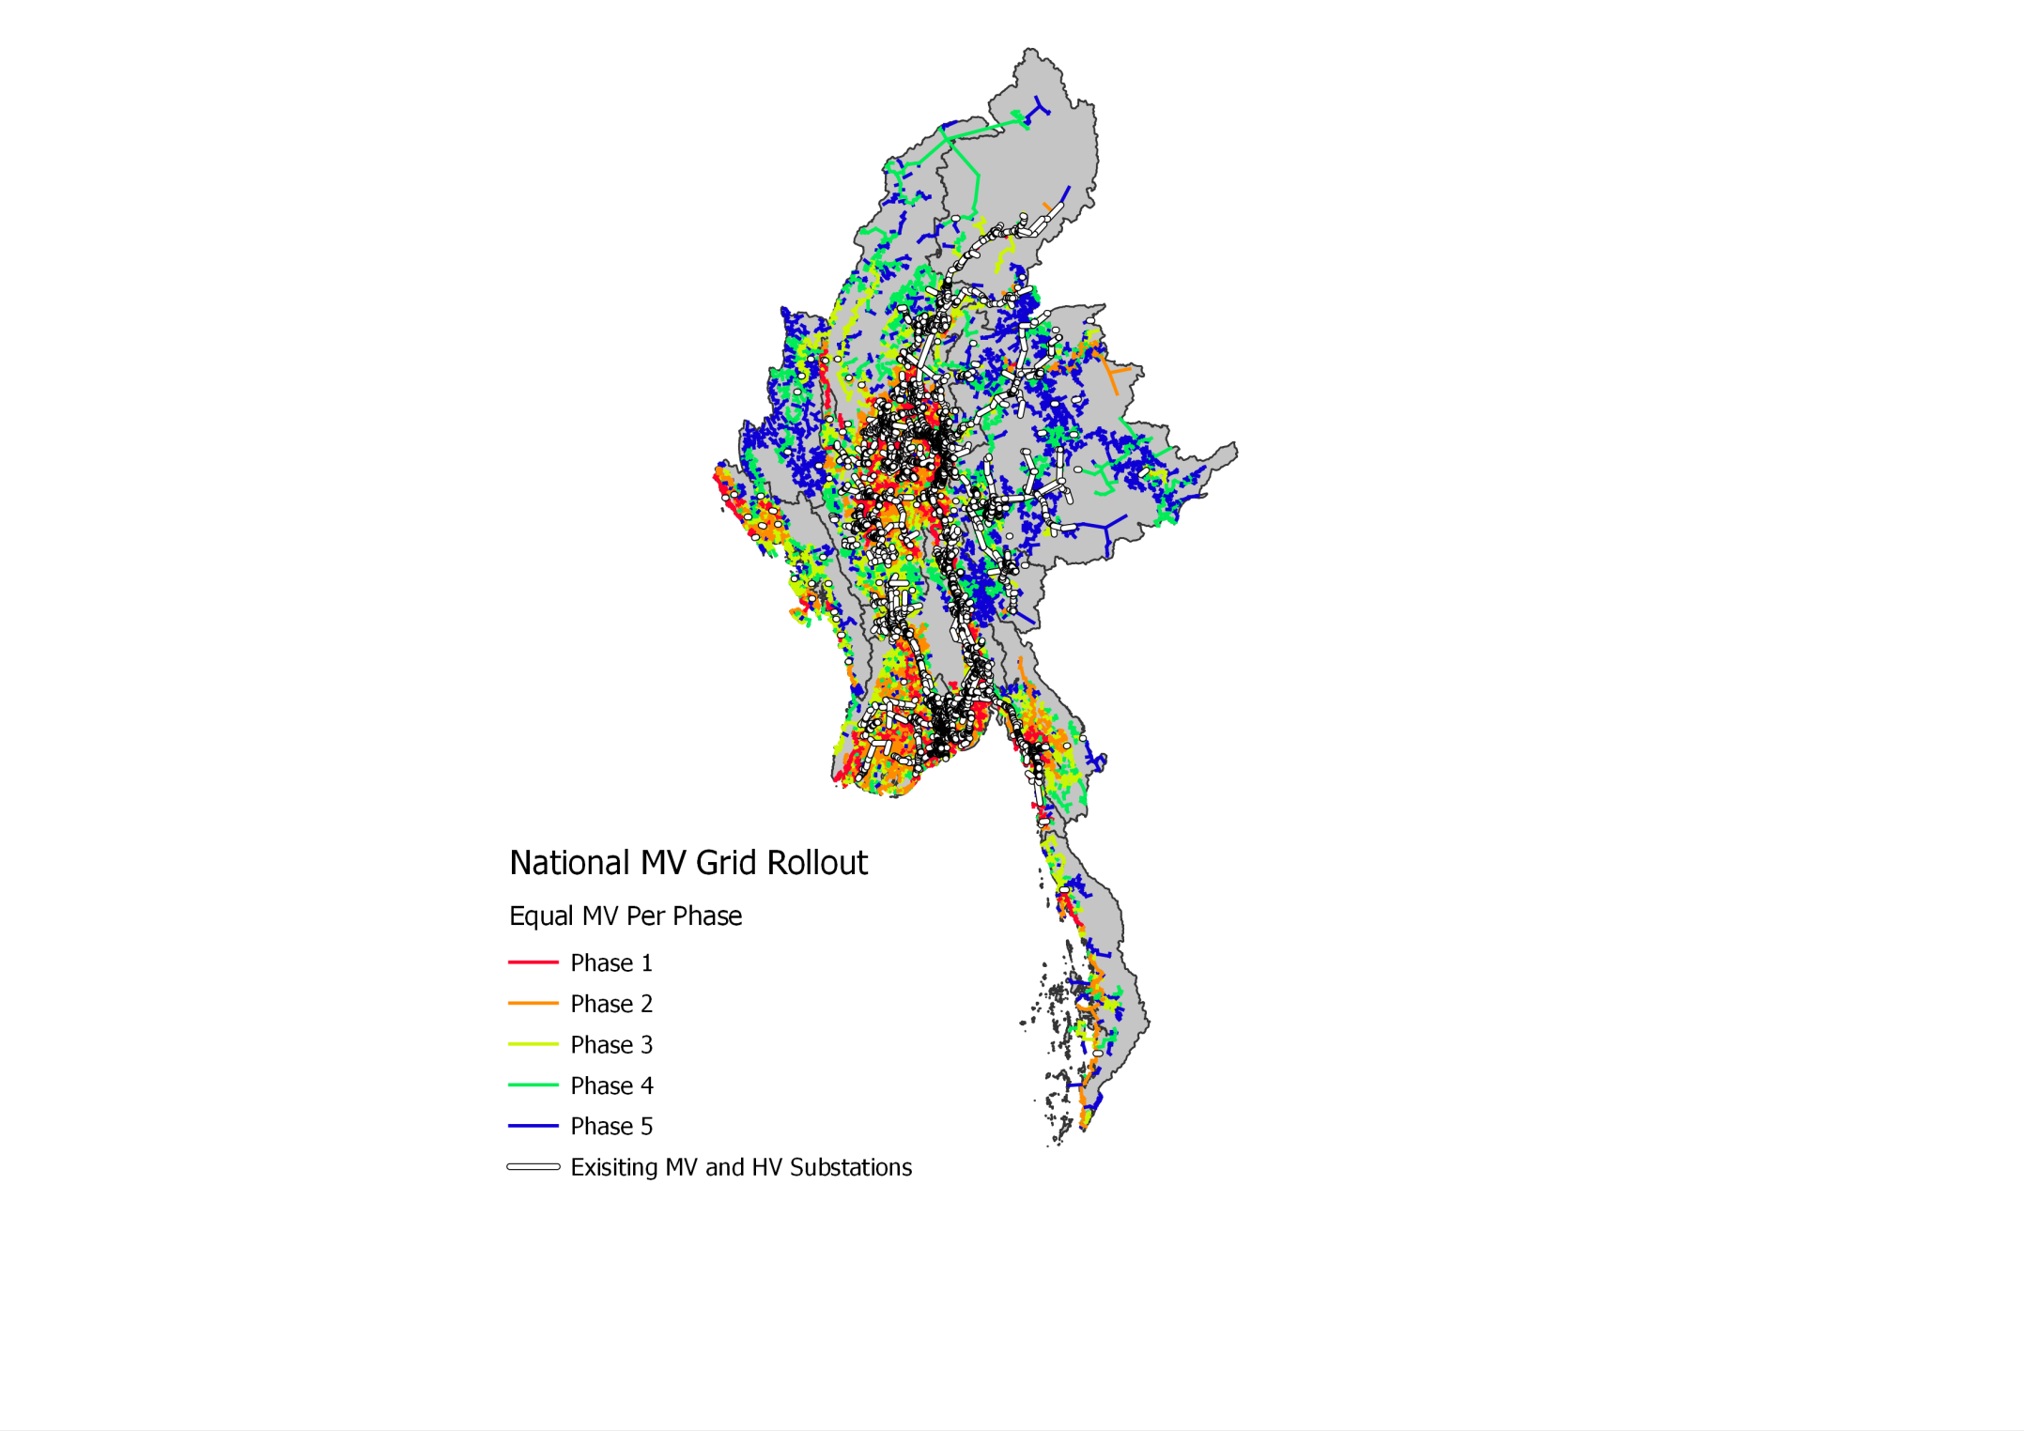

Source: MoALI-DRD; PowerPoint Dr. Soe Soe Ohn (2016a), ESMAP

There exist immediate opportunities for electrifying villages without relying on or waiting for the grid. A priority, instead of waiting, is to help develop local grids in these regions (using solar panels, micro-hydropower turbines, and traditional biomass and/or in hybrid configuration with diesel generators) must be examined (and which could later be connected to the main line when it arrives). About 1.3 million of the 7.2 million households to be electrified are recommended for this ‘pre-grid electrification’ (in particular areas covered by Phases 4 and 5). These are the purple dots in the figure on the right in Exhibit 21, especially in Shan, Chin, Kayah and Kachin States. Two promising technologies to achieve this are solar power and micro/mini-hydropower. Currently, largely as a result of charitable or non-governmental efforts, there has been an emergence of small solar devices used for basic lighting and charging of mobile phones. Another technology being used are (privately owned) diesel generators, with individuals in a village paying a fee to access its electricity.

The NEP’s electrification targets will be achieved in 5 phases, starting with low-cost and then moving to high-cost connections:
- Dense areas require shorter distribution lines and lower cost per connection and will be connected first. Remote communities require longer lines and higher cost and will be connected later (phases 1 to 3);
- Remote villages (mainly in Chin, Shan, Kachin and Kayah States) have the highest cost per connection, thus to be connected in the final phases (phases 4 and 5; see Exhibit 21) and will be served by off-grid solutions.

Phase 1 will run from 2016-2021, of which the grid extension (implemented by MoEE) is supported by the World Bank with USD 310 million and government contribution of MMK 51.5 billion. The aim is to electrify 6240 villages (750,000 households; population of about 2.6 million) by extending 5130 miles of 11-33 kV lines (Soe Soe Ohn, 2016b; MoEE website 2018).

  - Status and plans in off-grid electrification

National Electrification Plan (NEP)

MoALI will implement the off-grid component of the NEP. The first Phase (2016-2021) will be supported by World Bank-IDA with USD 90 million (of which USD 10 million for technical assistance, USD 7 million for mini-grids, USD 53 million for solar home systems, and USD for community/public institutions), in addition to the Government’s budget of about USD 75 million. The off-grid component aims at providing electricity to about 650,000 households (see Exhibit 23).

The off-grid electrification programme consists of three components:
- Solar home systems (8575 villages)
- Mini-grid systems (344 villages), powered by solar, hydro, biomass or biogas)
- Community buildings (in 5548 villages)

Village electrification committees

The NEP relies on a self-reliant electrification approach. The government will provide the grid to the township level. Villages within the township must then organise and collectively finance the final stage of connection. They must also organize the villages mini-grids and apply in Calls for Proposals (see further). Village Electrification Committees (VECs) are formed by community members. This body then works with local township electricity officials to devise a connection or mini-grid electrification plan, and crucially, to raise the funds from collective household savings. However, financial support for their functioning is very limited. Also, VECs receive with little guidance or technical support, and may not have the expertise to formulate rural energy proposals. This may explain why in the DRD-NEP Call for Proposals, most projects presented are drafted by project developers (o contractors on behalf of VECs) rather than the VECs themselves.

Solar home system program

The DRD’s off-grid program was being implemented under the government’s own budget, and with some support from a few donors, for several years prior to the approval of the World Bank-supported NEP. The DRD off-grid electrification program had electrified 416,727 households spread across 4,840 villages in Myanmar between 2012 and 2016, out of which 365,102 households were electrified with solar home systems (prior to the beginning of World Bank-DRD NEP program) with the remainder by micro-hydro, biomass and grid extension.
Exhibit 22 Configurations of SHS offered under the off-grid NEP

SHS Configuration | Capacity and service level | Total cost | Subsidy amount | Contribution from the HH
Small | 3 LED lights (3 hours per day each)  1 TV (1.2 hours per day)  1 phone charging outlet (~2.5 hours per day) | MMK 300,000  (~US$ 220) | MMK 270,000  (US$ 198)  – 90% subsidy | MMK 30,000  (US$ 22)
Medium | 4 LED lights (3.5 hours per day each)  1 TV (1.8 hours per day)  1 phone charging outlet (~2.5 hours per day) | MMK 380,000  (~US$ 280) | MMK 330,000  (US$ 243)  – 87% subsidy | MMK 50,000  (US$ 37)
Large | 5 LED lights (4 hours per day each)  1 15 W DC TV (3 hours per day)  1 phone charging outlet (~2.5 hours per day) | MMK 420,000  (~US$ 310) | MMK 340,000  (US$ 250)  – 81% subsidy | MMK 80,000  (US$ 60)
Source: ESMAP-WB (2016). Systems include battery (12 V 40 Ah, controller and 8 m of cabling

Source: Eskom website (2017)
The implementation model of the SHS component of the WB-DRD National Electrification Plan (NEP) involves procuring solar home systems from private companies (contractors) through international competitive bidding, with these contractors also responsible for installation and after-sales service. The technical specifications and quality standards of SHS are defined by World Bank and IFC Lighting Myanmar programs, and the contractors are responsible for ensuring that the SHS they install meet these standards and specifications. World Bank engaged a dedicated team for monitoring and verification of SHS installed by contractors.
The first contracts for SHS were organised in 12 lots for bidding at a value of appx USD 30 million was signed in 2016 for delivery and one-year maintenance of some 136,000 SHS and 14,000 public facilities, and installation started in January 2017. In 2016-17 the off-grid solar programme has installed 160,660 SHS with a total installed capacity of 8.9 MW A new round of international competitive bidding (ICB) was initiated for the procurement of over 140,000 SHS under the World Bank NEP in 2017-18, in addition to a further 19,000 SHS that will be procured by DRD with financial support from the German development agency KfW, thereby expecting to reach electrification of 750,000 households across Myanmar by 2018 in the various government programmes over 2012-18. The Total target 2016-2021 is 615,000 SHS in 8575 villages and mini-grids connecting 648,000 HH in 8919 villages (see Exhibit 23 ). Total cost: USD 203 million with funds coming from the Government (USD 15 million) and from donors as well as public (community) contributions.
Exhibit 23 Yearly plan for off-grid electrification, Phase 1 (2016-2021)

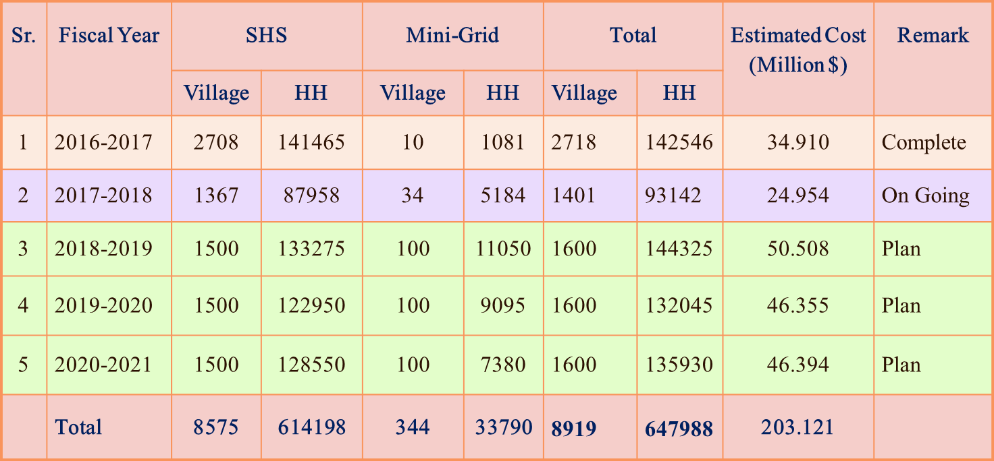
Source: MoALI-DRD; PowerPoint Dr. Soe Soe Ohn (2016a)

Source: Eskom website (2017)

Subsidies before 2016 on SHS were a full 100%. Under NEP, subsidies offered to off-grid households range between 81-90% depending on the SHS configuration opted by each household. The subsidy is to come down to 85% in year 1 and 80% on average in year 5.

Mini-grid programme

The most common mini-grid generation technology observed in Myanmar is diesel generators. The 2014 Myanmar census reports that about 178,000 households (of which 152,000 rural) used “private water mills” as the primary source of electricity, while 1,013,149 households used diesel generators (of which 836,000 rural). Solar mini-grids, either stand-alone or hybrid PV/diesel are much less common. The DRD reports some 150-200 villages by 2017; most have been heavily subsidized as pilot projects commissioned by nongovernmental organizations or DRD.

Myanmar has two major business models for mini-grids. Some mini-grids are operated by a group of farmers selected by a village’s Village Electrification Committee (VEC). In this model, the leader of each 10-household block in the village collects the monthly tariff payments. Other mini-grids are owned and operated by private entrepreneurs. Studies found that tariffs charged by the diesel-powered mini-grid operators are about MMK 1000-2000/month (USD 0.9-1.82/month) for a single light bulb connection and MMK 2500-5000 (USD 2.27-4.55/month) for a connection with lighting and TV. Equivalent tariffs per kWh are about USD 0.37-1.00. Tariffs of hydropower mini-grids are typically lower than tariffs at about MMK 200–K 860 (USD 0.18–0.78) per kWh (World Bank, 2017). Biomass gasifiers are common in the delta region, powering mini-grids as well as rice mills, irrigation pumps, sawmills, and oil pressing. Tariffs for biomass gasifier mini-grids are about MMK 400/month.

The mini-grid component of the WB-NEP has been progressing and two rounds of Call for Proposals (CfP) have been organized, supported by World Bank funding. The original budget for mini-grids in NEP (USD 7 million) has now been increased to USD 24 million (with the total budget for off-grid, mini-grids plus SHS, remaining at USD 24 million). In the CfP, the DRD-NEP Project Management Office (PMO) invites project developers to engineer, procure, construct, and operate renewable energy mini-grids (or renewable-plus-diesel hybrid mini-grids) less than 1MW in a public-private partnership arrangement. During this process, DRD will provide assistance by means of construction subsidy and capacity building. The World Bank support (NEP project) will end on 30 September 2021.

The first CfP in 2016 resulted in 26 proposals (of which 10-12 approved for feasibility and 8 have been commissioned). In the 2nd Call (2017), 82 proposals were received (with over 40 in evaluation and 16 signed and under construction by June 2018, of which 13 were solar mini-grids). Proposals are being vetted by the PMO with technical community mobilization support (via township offices) with assistance from GIZ. The PMO is identifying co-financing arrangement and improving communication and information-sharing to facilitate greater participation from the private sector for investment in hydro mini-grids.
Exhibit 24 Proposed State-level regulations for off-grid electricity systems

Under the NEP, the national grid is expanding quickly in some areas; but plans and targets for specific townships and villages tend to change over time. This uncertainty, makes mini-grid developers reluctant to invest if they suspect the national grid is arriving in the near future. After the National Energy Management Committee was disbanded, coordination between MoEE and MoALI on grid and off-grid electrification has not always been optimal, adding to the uncertainty issue.

A regulatory framework for mini-grids would partly address the uncertainties developers and investors face about their investments. One component of the GIZ support to NEP is on supporting DRD in developing a regulatory framework for mini-grids (e.g. financial support mechanisms, ownership structures, tariff schemes, grid interconnection). Small-scale energy enterprises can be isolated mini-grids (providing generation, distribution and/or power sales), small power producers (SPP), small distributors (SDN) and small electricity retailers (SER). The first elements of such off-grid regulatory framework (draft) have been proposed:
- Exclusivity (optional: providing exclusive rights to carry out project preparation activities in a designated area, for up to 12-18 months)
- Permission (simplified procedures for small companies to engage in generation, distribution and retail of up to 100 kW; full permitting procedure for capacities up to 10 MW)
- Tariffs (allowing reasonable return on investment and adjustments for inflation and changing fuel prices)
- Guarantees in the event of national grid arrival
  - Right to receive financial compensation (transfer of all assets of the mini-grid or company)
  - Linking to the grid as SPP, SDN or SER and legal right to operate (with streamlined approval < 1 MW) under a standardized small power purchase agreement (SPPA) and standardized feed-in tariff, or in case of SER, standardized small power sales agreement (SPSA)
  - Commissioning (must happen no more than 3 yrs from SPPA or SPSA signing; on verification of connection compliant with technical standards, an Interconnection Facility Certificate is issued)

Source: GIZ (2018)

The subsidy for mini-grids was 80-20% in the first year and is expected to come down to 50-50% by year 5 (in 2021) of the DRD-NEP project. Currently, the subsidy is based on 60-40%, i.e. the government supports up to 60% of the eligible cost and equity share of the remaining balance is divided by the developer and the VEC, in which the community has to provide at least 20% of the cost (in cash and/or in-kind).

A third Call for Proposals is under preparation for 2018-19 aiming at 100 new mini-grid sites. Again, it will consist of DRD-identified sites, while proposals identified by developers can now (unlike the previous rounds) be presented on a rolling basis. This may attract proposals using technology other than solar (e.g. mini/micro hydro) that have longer lead times, and for this reason, could not be presented in the first two rounds.

Project developers will be entitled to operate the mini-grids for a specified number of years (e.g. 6 to 15 years, although the exact period of operation is to be determined as part of a comprehensive business model and agreed with DRD and the respective communities) and are expected to supply 24-hour, grid-quality electricity during this time. After the developer’s period of operation, the mini-grid assets are to be transferred to the local Village Electrification Committee (VEC) for continued operation. For this reason, all mini-grids developed under the CfP shall be classified as Build, Operate, Transfer (BOT) or Build, Own, Operate, Transfer (BOOT). In addition to the capital grant support, DRD will provide capacity building and community mobilization assistance via DRD township offices. Mini-grid projects developed under the NEP must comply with the Environmental and Social Management Framework (ESMF) of the World Bank-Assisted National Electrification Project.

Renewable energy resources for mini-grids

Solar home systems (SHS) seem best suited for relatively poor villages of about 100 households or less with minimal demand. In comparison, mini-grids can power larger residential loads can spur local economic growth through energizing larger productive use loads such as refrigeration, water pumping, saws, and agricultural processing such as rice mills or corn shelling. Grid extension and micro-grid development require organization and cohesiveness, while solar home systems can be installed on an individual basis. For villages that lack leadership or the ability to organize collective payment schemes, and for which demand is low, solar home units can be an ideal solution to household electrification needs. Even in larger settings where economic factors favour mini-grids over solar home units as a primary energy source, solar home units can play a valuable auxiliary role. That is because generators and gasifiers commonly used in villages and rural settings run for only two to three hours per night to provide power over the entire micro-grid. Therefore, any individual or commercial use during other times requires auxiliary provision through platforms such as solar home systems (KWR-ERIA, 2015)

Geographic and climatic differences have a large impact on optimal off-grid electrification schemes given the need to build on regional strengths and concerns. Solar is considered optimal in areas such as the Central Dry Zone (see Exhibit 25).
Exhibit 25 Photovoltaic potential map of Myanmar

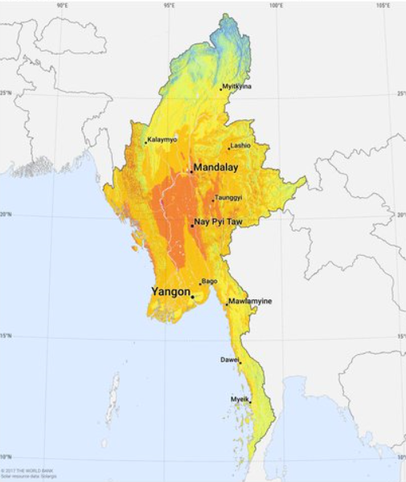
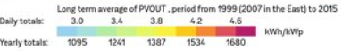
Source: World Bank-ESMAP; SOLARGIS
Micro-hydro in the mountainous locations that possess adequate free-flowing water. However, hydro is site-specific. The installation of viable facilities requires the identification of an adequate energy source. This generally requires locating the generating facility close to the point of consumption, and this can be a challenge in rural environments. Otherwise, with lengthy transmission distances, one runs into the same costs with mini-hydro that can make grid extension an expensive and technically challenging.

Gasification, powered by rice husks and other agricultural by-products, are seen as an attractive energy source in the Ayeyarwaddy Delta. It is reported there are presently 1,000 or more gasification facilities in Myanmar (KWR-ERIA, 2015). The abundant rice paddy in the Delta makes rice husk gasifiers a preferred alternative or supplement to diesel generators in this region. Although economically viable, the environmental impact of rice husk gasifiers is questionable given the lack of enforceable standards and concerns over discharge. More environmentally friendly technology is feasible but will add up to 50% onto the cost of the equipment. In addition, gasification generally requires more maintenance and care than generators that are powered by diesel alone. This makes them difficult to operate in the village and at township level. Rice mills and factories using gasification equipment and may provide excess power to neighbouring villages, but this is not always feasible and/or may be seasonally constrained.

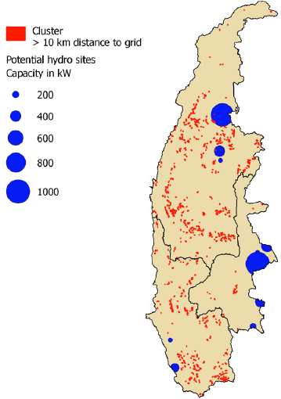
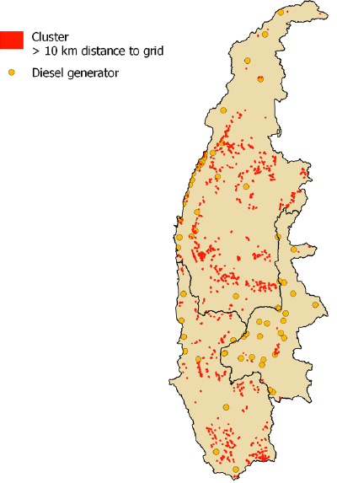
Exhibit 26 On-grid and off-grid electricity planning using geospatial tools

The Asian Development Bank (ADB) has supported the project TA 8657: Off-grid Renewable Energy Demonstration Project in Myanmar, implemented by the the Department of Rural Development (DRD) of the Ministry of Agriculture, Livestock and (MoALI. The purpose of the TA was to support the Government of Myanmar in the scale-up off-grid solutions for renewable energy (RE) systems for providing energy access in Myanmar. One component has been geospatial least-cost energy access and investment plans for the regions selected under the project, i.e., the Magway, Mandalay, and Sagaing regions. The project team conducted extensive research and rigorous data analysis to produce a geospatial and investment plan for off-grid RE in these regions, and an online geospatial web-mapping tool that provides support to project developers in identifying opportunities for developing RE mini-grids. The tool (available at http://adb-myanmar.integration.org) maps the locations of unelectrified villages and provides information on available local resources (solar, hydro, biomass and wind) and nearby infrastructure. Users can select layers to display various datasets and interactively analyze the potential for off-grid electrification.

In the three regions there are 14,822 villages. Of these, 1,807 villages (or 12%) are supplied by diesel. About 7,560 village are unelectrified. Of these, 2,926 villages (mainly in Magway and Sagaing), or 32%, are located further than 10 km from the distribution grid, and therefore should be a high priority for RE mini-grid investment, as the probability of electrification from grid extension in these areas is extremely low to non-existent (within the next 7 years). Villages were organized in clusters. This approach creates larger mini-grids, which can lower the unit cost of energy for consumers, for the same investment return. The geospatial exercise allowed for identification 508 village clusters (or 19%) clusters (each with a population of over 2500) and therefore have sufficient scale to be suitable for large scale RE off-grid mini-grid, at a total investment cost of USD 759 million, inclduing a) hydro mini-grids (investment of USD 60 million in 20 village clusters at 16 MW in total), b) biomass (at an estimated 100 locations with investment potential over USD 100 M for rice residues for gasifiers), c) biogas (investment of USD 170 million, using animal feedstock), d) wind energy (USD 73 million), and e) the remainder served by solar PV mini-grids (investment of USD 163 million), including as diesel replacement in hybrid systems (investment of USD 15 million in solar PV grids in 50 village clusters at 5 MW in total, and linked with telecom towers (about 100 clusters adjacent such towers (about USD 30 million in investment). The solar potential overall is good with an estimated potential of 8,500 MW (with an associated investment cost of USD 10 billion (at a cost of USD 0.20-0.26 per kWh).

For the investment plan, in 28 suitable sites were selected. In the end, of these 12 projects (all solar PV mini-grids at 90 kW at an average distance of 16 km to the grid) were implemented, providing a basis level of electricity services to about 1,970-2,250 households at an investment cost of USD 730,000 (with a 80% ADB contribution).

Source: ADB (2017a) and ADB (2017b)
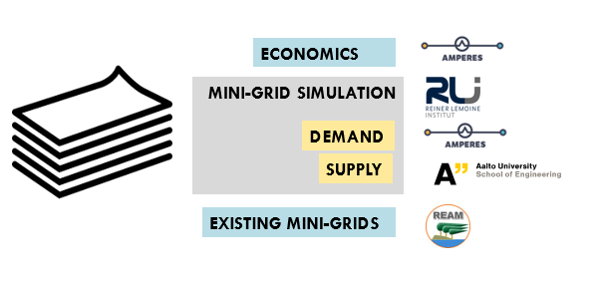
Exhibit 27 Renewable energy resource assessments

Aalto University (Finland), Rainer Lemoine Institute (RLI), Australian Mekong Partnership for Energy Resources and Energy Systems (AMPERES), and REAM work together in making estimates of the preliminary renewable energy resource potential of all villages in Myanmar.

The thesis Myanmar’s Renewable Energy Potential (Said, 2018) mapping the country’s renewable energy resources (biomass, wind, solar, hydro) at a high spatial and monthly temporal resolution as a first phase of the CORE-KIT application Community Renewable Energy - Knowledge Integration Tool). Its aim is to accurately provide a preliminary assessment of the potential energy for the purpose of identifying suitable locations for the implementation of decentralised, or off-grid, energy systems.

CORE-KIT will be an open-source web based interactive platform to map the renewable energy potential of every village within Myanmar. It will provide RE practitioners (private and CSOs) with sufficient information to understand where and how CORE mini/micro grids can be developed, to share data and information about their mini/micro grid pilots, and provide the necessary info (as indicatrioed in the figure below) to identify investment opportunities and preliminary feasibility study, with an ever increasing data base.

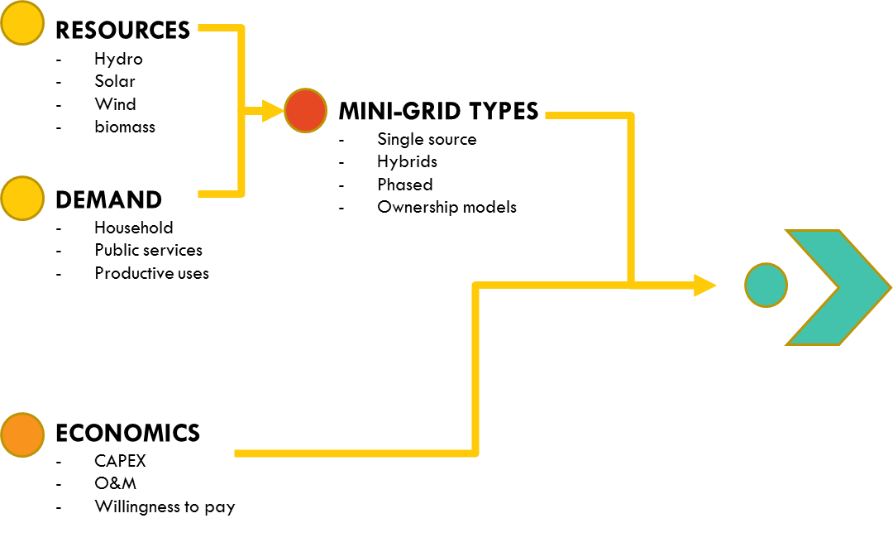

Outputs from global/regional hydrology models are readily available online, but they may not provide information at desired resolution. Hydrostreamer is a hydrology modelling package to downscale distributed runoff data products by spatial relationship between the areal unit in runoff data, and an explicitly represented river network. It has been used to model to Mekong river system and is now used to model river systems in Myanmar.

By integrating various resources assessments (solar, hydroshed and hydro-climate data) a more optimal mini-grid system design can be achieved. Currently, developers typically install a particular technology, or solar, or hydro, or biomass. However, over the year, there is 30-60% seasonal variation in solar and wind and 80-90% variation in micro hydro, which implies that in Myanmar RE hybrid solutions (solar-hydro) can often be optimal for a village. This type of integrated resource estimation with dynamic demand forecasting for villages allows extrapolating how demand will grow with access. This will improve understanding of how demand evolves of the pay-back period and should help improve the economics projections driving mini-grid decisions.

Source: Presentation CORE-KIT, HycEM Roundtable, 28 May 2018; info provided by Amperes; Said (2018)
The attractiveness of hydro and biomass in mini-grid proposals is impinged by the need for identification and assessment of a viable (and available) energy source and creates a need for up-front engineering and feasibility studies. This can be costly and time intensive and makes it difficult to utilize in a rural electrification context. Hence, we see in the two rounds of Call for Proposals in the DRD-NEP, a dominance of solar PV mini-grid proposals. Small mini-hydro and gasification projects require a basic level of maintenance that places the resource beyond the reach of (and makes it less viable for) individual towns and villages and even small groups of towns and villages. This underscores the importance of greater local-level technical training and capacity building around operation and maintenance (O&M).

  - Opportunities and issues in off-grid electrification and options for scaling up

Opportunities for off-grid electrification

Generation technologies used in mini-grids span a range of maturities from fully mature (e.g. diesel generation, mini-hydropower) to technologies that are still maturing (biomass gasification). Many of the component technologies (solar panels, inverters, diesel generators) are mature and manufactured/deployed at large scales. For example, solar panels mass-produced and used in grid-connected solar farms are perfectly suitable for mini-grids. Mini-hydro generators have been in use for over a century even if their deployment has not reached the scales found with PV or diesel. Regarding solar PV, improvements have led to a radical price decrease of solar panels, while new electricity storage options (lithium-ion batteries, flow batteries) have led to an increase in the lifetime of batteries.

Recent technology mini-grid improvements include a variety of new billing solutions incorporate “pay as you go” (PAYG) metering using money transfers on cell phones or pre-paid cards. These technologies substantially reduce expenses with bill collection that has been a challenge with rural mini-grids. Remote monitoring using cell phone networks reduces O&M costs, repair costs, and downtime by allowing problems to be diagnosed and repaired early by technicians before they result in failure.

Mini-grids have favourable costs for remote communities with households that use relatively small amounts of electricity (e.g. 700 Wh per day). The comparison of cost per unit of energy (LCOE) of off-grid renewable energy compared to the average LRMC of grid extension (for new household connections), illustrates that hydro, biomass and solar mini-grids are viable options from an economic perspective. The two key factors in determining the viability of mini-grids, in particular, are (i) distance from the grid, and (ii) scale. One way for creating economies of scale for mini-grid applications is by providing mini-grid technology on a village-by-village basis, is to cluster these in groups of villages so that mini-grid developers and operators can provide services at lower unit cost of energy (LCOE, in Exhibit 28) for the same investment return (ADB, 2017; ESAMP-WB, 2017).
Exhibit 28 Levelised cost of energy (LCOE) for off-grid renewable energy in Myanmar

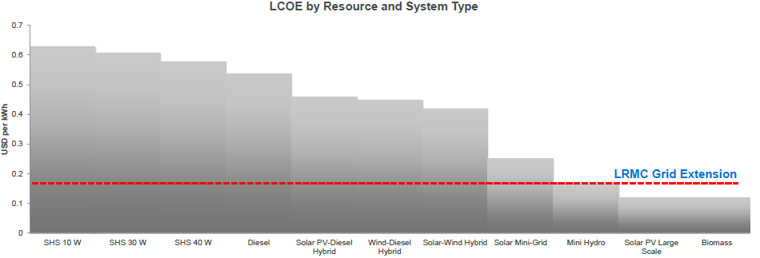
The levelized cost of energy (LCOE) is the value of lifecycle costs (e.g. in USD/kWh) of producing a unit of energy (kWh) of a specific

Source: Eskom website (2017)

This implies even that rather than a being a temporary pre-electrification solution until the grid arrives, as mentioned in the NEP, solar and mini-hydro mini-grids can play a substantial role as an electrification solution for off-grid power supply and that can later be integrated in the national grid system.

Costs of solar PV mini-grids

Exhibit 29 shows a comparison of residential tariffs on the main grid, one of the tariffs of the hybrid system microgrid, and the estimated LCOE of solar PV mini-grids. The LCOE values of microgrids powered by solar PVs and batteries in Myanmar are still high, but lower than those of diesel power sources depending on fuel price, and lower than (the real cost) of grid extension, depending on the distance to the grid.

If the LCOE of microgrids decreases to the level of the current subsidised microgrid tariff, the subsidy needs could be lowered, or even no longer be necessary. Achieving a reduction in mini-grid costs is possible by clustering villages and pooling multiple projects, and standardization of equipment and mini-grid design, and reductions in financing costs) and by using local technology.

The gap between tariffs of microgrids and the main grid is a different issue. The gap is so huge that improving it in the short term seems difficult. The main-grid tariff should be increased enough to cover power generation costs, operation and maintenance costs for existing transmission/distribution lines and power plants, and new development costs. The government plans to increase the main-grid tariff over time. For now, it means that people in urban areas can enjoy electricity from the grid at cheap prices including the subsidy and also can get diesel fuel cheaper. In contrast, people in rural areas have to pay more for diesel fuel and for electricity. So, it stands to that electricity for people in rural areas should be subsidised, hence the motivation for subsidies to CAPEX of microgrids under the ‘60/20/20’ DRD-NEP scheme.
Exhibit 29 Comparison of tariffs and solar PV mini-grid LCOE values

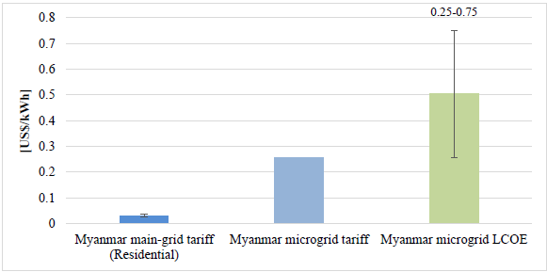

Left: Myanmar mini-grid residential tariff (2016, ADB)
Middle: average Myanmar microgrid tariff in the systems subsidised as part of ’60-20-20’ scheme
Right: estimates of levelised cost of electricity (LCOE) of solar PV mini-grid system (without subsidy)

Source: Numata et.al. (2018)

Local experience with hydropower and biomass mini-grid systems

Another way to reduce the cost of mini-grids is by working closely together with those developers that are (local) social entrepreneurs with proven experience in mini-grid development, and renewable energy associations (such as REAM, HyCEM, Solar Group). Involvement of ‘home-grown’ developers allows easy troubleshooting and lower cost. By 2017, Myanmar had about 5000-6000 mini/micro hydropower units (below 1 MW) and some 500 units biomass gasifiers for village electrification, and about 10,000 biomass gasifiers powering small-scale rice mills (D. Vaghela, 2017). Considering that the vast majority of these mini-grids were built from scratch with no government support (and no formal technology training and no international funding) under conditions of acute materials shortages, these are impressive figures. Communities and local private companies in Myanmar have developed considerable experience with biomass and hydro-based mini-grids. Much of Myanmar’s experience in mini-grid deployment and operations has been gained the hard way, through trial and error. It demonstrates the existence of social entrepreneurs who have a) engineering skills to locally manufacture cost-effective (hydropower) technology (system designer and technology manufacturer), b) entrepreneur skills to identify productive end-uses of electricity (enterprise development); c) commitment to forging local partnerships for financially viable projects with rural communities (financier), and d) community mobilizer, O&M trainer, and service provider.
Exhibit 30 Case study, locally governed, self-financed mini-hydro

This case study presents the most recent project of a leading mini-hydro developer and manufacturer in Myanmar, U Sai Htun Hla. It is an example of the type of a commercially viable, cooperative-based, and self-financed off-grid RE initiative, the RURED project tries to promote. U Sai Htun Hla has developed over 150 hydropower projects (below 1 MW) using a cooperative-based model for implementation. Some have been partially or fully supported by government or private funds, while most have been fully paid for by the community, with upfront investments from U Sai Htun Hla.

The Mae Mauk Waterfall Mini-hydro Project provides power to about 1200 households and local enterprises. Since the project needed to be self-financed, the goal for 100% electrification is being done phase-wise, in parallel to the consumers’ increasing demand and the project’s revenue available to re-invest into the project. In 2013, the project generated 50kW for less than 100 households. In 2015 the project was upgraded to generate 80kW for more than 450 households. The final phase will be to generate 400kW for households and enterprises in a total of 16-20 villages. This will cost an estimated USD 441,000.

The project is managed by Lin Yuang Chi Mini-hydro Cooperative Utility. The cooperative has a total of 100 shares, of which 50 are owned by U Sai Htun Hla and 30 owned by community members. The gap of 20 shares was raised from the connection fees paid by consumers. The monthly average revenue has increased from USD 1470 at the start of the project to USD 2500 currently, resulting from the end-uses listed below. The tariff ranges from USD 0.09-0.14 for cooperative members, USD 0.18-0.29 for all other consumers, and USD 0.59/unit for temporary users. The connection fees range from USD 135-440 for residential consumers, depending on their distance from the powerhouse. Operation and maintenance cost are about USD 900 a month. The Cooperative has a physical office, within an initial staff of 6-persons for operation and maintenance: utility manager, powerhouse operator, linesmen, meter readers, cashier, and bookkeeper.Examples of energy demand are summarised in the table below:

External enterprises | Village enterprises | Social services | Household uses
Coffee plantations, fuel pumps, poultry farm, telecom tower, technical workshop | Brick making, cash crop farming, daily goods shops, fruit processing, workshops, lime baking, silkworm breeding, tailoring, truck rental, vehicle repair | Health clinics, monasteries, public centres, schools, streetlights | Carpentry tools, corn thrasher, electric rice cookers/pans, fans,  grinders, cell phone charging, rice mills, refrigerators, televisions, water heaters,  washing machines, water pumps

Livelihood benefits include a) increased fuel affordability (clients spend 60-70% less due to diesel savings), job creation (50 people durting installation, and 8 for operations), income generation and PUE (number of external and village enterprises doubled, including women-led businesses), access to health services (24/7 electricity allows vaccine storage and minor surgeries, improved infant delivery, access to water (over 200 households use water pumps for irrigation of gardens and cash crops), reduced deforestation (electric-based cooking, replacing fuelwood) and global environmental (zero GHG emissions).
Source: Self-financed mini-hydro in Myanmar – Cooperative-based model (draft, REAM-IRENA)

Source: Numata et.al. (2018)

Exhibit 31 Mini-grid systems installed in Myanmar

Type | Number  of plants
Minihydro (0-1 MW)  Minihydro (1-10 MW)  Larger hydropower  Biomass and biogas  Wind turbines  Solar | 5840  17  18  727  25  94
Diesel  Steam / cogeneration / natural gas | 11740  14

Source: MEE Net, 2018, PowerPoint Energy Politics and Conflict, Green Energy in Shan State, by Kyi Pho

The experience of grassroots (hydropower) mini-grid practitioners provides a strong foundation upon which the NEP Off-grid component and other donor efforts should be built, helping them adapt better (more cost-effective, efficient, more robust, safe) technologies and scale up deployment (ESMAP-WB, 2017). However, the experiences of local private sector remain invisible and side-lined. One of the reasons is that international development partners work solely with the national government at the start of their programs, and the baseline studies often do not include the work of the local private sector.

  - Financing for off-grid energy

Financial sector

Myanmar's financial sector is relatively small by global and regional standards and has been historically dominated by government-owned financial institutions, although several semi-governmental, private sector banks and representative offices of a few foreign banks have become prominent in recent years as the government attempts to introduce reforms that have triggered rapid transformation and growth in the sector.

Myanmar’s banking sector is small by global and regional standards. Total assets of the banking sector as of March 2017 was just about MMK 48,834 billion (about USD 30.4 billion), amounting to about 1% of the size of the country’s GDP. Nonetheless, this represents a significant, nearly 12 times growth in comparison with March 2010 when total assets were MMK 3,853 billion (USD 3.08 billion) and amounted to just 11% of the size of the country’s GDP at that time.

Although SOBs (state-owned banks) dominated the banking sector in Myanmar for a long time, private banks have grown quickly in recent years, and they account for 55% of banking sector system assets as of March 2017, with SOBs accounting for just 36% and FBBs accounting for the remaining 9%. As of early 2018, Myanmar’s financial system now comprises 4 state-owned banks (SOBs), 24 private banks (with no government ownership), 13 foreign bank branches (FBBs). Apart from banks, insurance companies and 176 organizations with microfinance license (not including cooperatives) and a nascent capital market. The three biggest private banks are KBZ Bank, CB Bank, and A-Bank that accounted for 58% of total private bank assets, 64% of loans and 66% of deposits in Myanmar as of March 2017.

Myanmar’s financial sector is regulated by three different regulatory bodies. Banks are under the supervision of Central Bank of Myanmar (CBM), cooperatives operating in the microfinance sector are under the control of the Ministry of Cooperatives and MFIs are supervised by Financial Regulatory Department (FRD) under the Ministry of Finance.

In Myanmar’s banking sector, deposit and credit interest rates are largely controlled and capped by the Central Bank of Myanmar (CBM). Loan interest rates made by the banking sector is capped at 13% per annum including bank charges and deposit rates are capped at 8% per annum. Most loans are offered on an average tenor of 1 year and nearly all loans require collateral. Overdraft facilities, which are essentially short-term working capital loans that are rolled over every year, are the most common types of business loans offered by banks to private sector borrowers against collateral. Although the 5% spread between the deposit and lending rates is higher than in many countries in the region and across the world, banks have reported that their net interest margin is considerably less than 5%, considering regulatory requirements on loan-to-deposit ratios to be maintained at a maximum of 75%. This controlled, low-interest rate regime, in combination with a high rate of inflation, has resulted in negative real interest rates, causing low yield from savings and deposits.

Another result of interest rate caps, together with CBM’s traditional insistence on collateral requirements for all types of lending activities from banks, has been a difficult lending environment for SMEs seeking working capital, but lacking sufficient collateral. According to a World Bank survey of over 600 private sector firms between October 2016 and April 2017, access to finance was their key barrier to scaling up their business.

JICA has a two-step loan programme to provide funding to SMEs in Myanmar since 2015 wherein JICA offers low-cost wholesale funds to the government-owned Myanmar Economic Bank (MEB), which in turn provides credit lines to selected private sector banks at 4% for on-lending to SMEs at 8.5%. The six banks selected for the 2016 disbursement of this JICA program were SMIDB, MAB, A-Bank, CB Bank, MCB and KBZ Bank. JICA is planning a second disbursement in 2018.

Micro-finance sector

Although microfinance has a long history in Myanmar, most of the currently operational MFIs in the country were incorporated after the introduction of Myanmar’s Microfinance Business Law, introduced in 2011. According to recent estimates and reports from FRD and Myanmar Microfinance Association (MMFA), the microfinance sector in Myanmar has reached over 3 million borrowers with an outstanding loan portfolio of USD 436 million.

Despite the growth in licensed MFIs after the 2011 Law, UNDP-PACT’s Microfinance operation remained by far the largest microfinance operation. By 2013, it had 630,000 clients in over 6000 villages with a USD 150 million loan portfolio. In June 2014, UNDP ended the campaign and transferred its microfinance assets and fund to the PACT Global Microfinance Fund (PGMF), which today accounts for around one-third of the country’s total microfinance loan portfolio.

Myanmar Economic Bank (MEB), a large government-owned commercial bank is designated to be the provider of wholesale lending to local MFIs (mainly MFIs structured as local companies). Myanmar Microfinance Bank (MMB), a privately-held commercial bank part of the Cooperative Bank (CB Bank) Group, is also structured to act as a wholesale lending bank for local MFIs (mainly MFIs structured as local cooperative societies). Capital raising and borrowing restrictions exist for both domestic and foreign-owned MFIs in the country, and interest caps result in further restrictions on lending and deposit-taking activities of MFIs.

Access to finance for renewable energy developers

Renewable-energy systems are becoming more accessible to rural communities following the 2011 microfinance law and implemention framework, which enabled domestic and foreign investors to launch privately owned microfinance institutions (MFIs) for the first time in Myanmar. In the year following this legislation, 118 MFI licenses were issued, and overall microfinance outreach is estimated at 2.8 million micro-clients (as of 2013). Some MFIs in Myanmar, such as PACT Global Microfinance Fund, are starting to offer low-interest loan products to rural clients for purchasing solar lanterns and home lighting systems. These loans go up to approximately USD 200 and interest rates are capped annually around 24% (Ross, CSIS, 2015). Also, social enterprises have offered credit to rural customers purchasing solar lanterns and home lighting systems, with short-term loans ranging from one to four months.

Myanmar’s financial environment presents a challenge for electrification projects. The country’s banks are acknowledged as offering limited financial services that are inadequate for meeting the needs of individuals and businesses, and this has created significant barriers to local energy entrepreneurs. Today, most borrowers, including mini-grid developers, are limited to one-year loans at 13% interest rates, and they must use their homes or other immovable property as collateral. Most mini-grid developers (both domestic and foreign-funded) invest their own capital as equity for developing mini-grids in the country. Most domestic mini-grid developers choose to participate in the DRD-World Bank mini-grid financing program that offers 60% CAPEX subsidy and an additional 20% to be financed by local communities (end-consumers), leaving these developers to finance only 20% of CAPEX from their own (equity) sources. Well-funded internationally-funded mini-grid developers, such as Yoma Micropower, use equity funding raised from their investors to provide almost 100% of CAPEX as equity financing.

However, the situation is slowly improving with financial reforms. For example, more business financing is anticipated now that several foreign banks received final licenses, opened branches, and launched the first foreign bank operations in Myanmar in decades. To promote mobile banking accessible in Myanmar, Telenor is partnering with Yoma Bank, one of Myanmar’s largest private banks, for a mobile money service (pending further guidelines from the Central Bank of Myanmar). Such mobile money services would offer new opportunities for off-grid renewable energy suppliers to interface with rural customers.

As the financial sector evolves there may be increased opportunities to finance local entrepreneurs managing mini-grids for village electrification as well. However, in the meantime, demand for credit far outweighs supply. The limitations of short-term loans currently available, combined with relatively high capital costs of quality renewable energy systems, mean many potential customers still cannot afford the high-quality energy solutions designed to improve their livelihoods and reduce energy poverty (Ross, CSIS, 2015). Banks in Myanmar have had very limited exposure to lending to renewable energy sector in the country (excluding large hydropower projects), considering the fact that renewable energy projects require long-term debt of typically 7-10-year tenors and most lending in Myanmar is for one-year overdraft loans. Given the fact that most domestic mini-grid developers in Myanmar are SMEs, availability of debt financing to these developers is even more restricted.

A-Bank (Ayeyarwaddy Farmers Bank) is furthest among Myanmar bank in considering to provide loans to RE entrepreneurs for rural energy initiatives. Developers would seek loans between USD 200,000 – 3 million with a payback period of 8-10 years at the max interest rate of 13%. REAM has facilitated discussions with DFCC Bank (Sri Lanka) to provide technical assistance on how to best appraise and service project-based loans.

USAID’s Development Credit Authority (DCA) uses risk-sharing agreements to mobilize local private capital to fill this financing gap. The DCA partial credit guarantee is designed to:
- Reduce risks to generate additional lending to underserved markets and sectors
- Demonstrate the long-term commercial viability of lending in developing markets

Through DCA, more than 600 guarantees between financial institutions and USAID have made up to USD 5.5 billion in private financing available for more than 350,000 entrepreneurs around the world. More info can be found at www.USAID.gov/dca (see Exhibit 32).

USAID in Myanmar partnered with LOLC (Lanka Oryx Leasing Company) and four other micro-finance institutions (MFIs) in 2016 to issue a USD 10-million Development Credit Authority (DCA) loan portfolio guarantee to support loans to micro, small, and medium-size enterprises (MSMEs) in the agriculture sector. The guarantee has helped LOLC make larger loans and loans that were not supported by the group lending models. Using the guarantee, LOLC has been one of the first MFIs to make the maximum loan allowed by law to individual entrepreneurs, in addition to piloting new products in riskier areas.
Exhibit 32 USAID DCA financial support products

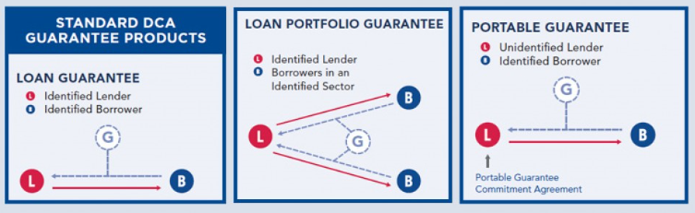
Source: USAID website

The state-owned Myanmar Insurance Enterprise introduced a Credit Guarantee Insurance (CGI) scheme for SMEs. The aim of the new insurance service has been to enable people who want loans from the banks but without collateral to have access to financial assets and lenders to reduce risks. The insurance would cover up to 60% of the loan (i.e. if debtors fail to pay, CGI reimburses 60% of the loan with the lender shouldering 40%). The premium for a loan without collateral is set at three kyats (per 100 kyat of the insured amount) for the first year, two kyats for the second year and one kyat for the third year and years thereafter. CGI is now used by businesses in both the industrial sector as well as the agricultural industry and the amount of CGI loans has been small; by Feb 2019 there had been 600 applicants (through CB Bank, SMIDB and Myanmar Economic Bank).

  - Stakeholders in off-grid electrification

Stakeholder | Description
Government
Ministry of Agriculture, Livestock, and Irrigation (MoALI) | MoALI’s Department of Rural Development (DRD) takes the lead in the development of biofuels, micro-hydropower (with installed capacity of up to 10 MW), bioenergy from agricultural residues, for off-grid electrification (solar home system, mini-grid system, etc). MoALI-DRD implements the off-grid component of the National Electrification Plan (NEP).
Ministry of Energy and Electricity (MoEE) | MoEE is the overall focal point for energy policy, coordination and international cooperation and also the oil and gas sector, and is responsible for developing, operating, and maintaining all large hydropower and coal-fired thermal plants; for developing and maintaining the transmission and distribution systems throughout the country, and for operating gas-fired thermal plants and mini hydropower plants. MoEE implements the grid extension component of the NEP.
Ministry of Natural Resources and Environmental Conservation (MoNREC) | Regulates the use of biomass from forest resources for energy purposes and is responsible for climate change issues. It has formulated the National Environmental Policy and Strategic Framework & Master Plan, and is responsible for climate change and greenhouse gas emission monitoring, reporting, and verification (MRV) as part of National Communications and NDC. The GEF operational focal point is at its Environmental Conservation Department (ECD)
Ministry of Education | Responsible for the research and development (R&D) of renewable energy technologies (RET) in universities and RE-relevant education in universities and training institutes.
Development partners
Asian Development Bank (ADB) | During 2015-2017, ADB implemented the Off-Grid Renewable Energy Demonstration Project to support the scale-up of off-grid solutions for renewable energy (RE) in Myanmar with a budget of about USD 2 million (of which about USD 500,000 for off-grid pilot projects in Magway, Mandalay and Sagaing regions.
Agence Française de Développement (AFD) | AFD is in identifying options to support rural energy project (RE mini-grids, biomass) with a soft loan of EUR 15-25 million
Department for International Development (DFID), UK | DFID is in discussion with DRD on supporting pilot testing mini-grids with solar hybrid power systems using the ABC model in Mandalay, Magway and Shan through Infracapital Myanmar. DFID also partners with IFC’s Lighting Myanmar.
European Union (EU) | A market assessment study on rural electrification will also be launched soon to support EU’s discussion with financing institutions. The EU plans to use its finance blending facility (ElectriFi, Asian Investment Facility) from 2019 onwards
Gesellschaft für Internationale Zusammenarbeit (GIZ)  MFAT (New Zealand) | GIZ supports (with financing from German and New Zealand governments) Myanmar with the implementation of the off-grid component of NEP (Promotion of Rural Electrification, RELEC) from 2016-18 to be extended to 2020 to support DRD in a) developing a regulatory framework for mini-grids (at Union level and at state-level in Shan state), b) establish the pipeline of projects in various rounds of Call for Proposals (supported by World Bank), c) developing a gender mainstreaming strategy for mini-grid policy and implementation, and d) strengthen the competence of government, private sector, and community stakeholders. The budget is composed of EUR 4 million (German government, BMZ) and NZD 1.5 million (New Zealand, MFAT)
International Finance Corporation (IFC) | In cooperation with DFID, IFC’s Lighting Myanmar project supporting manufacturers and distributors of high-quality solar to enter and scale in Myanmar, through market research, business development support, consumer education, and policy engagement, while also exploring support for appliance and productive use sectors. Separately, IFC has invested in Yoma MicroPower project developing solar power solutions for telecom towers, with attached mini-grids to electrify nearby communities. Implementation period: 2016-2020. The budget is about USD 4 million.
Italy (AICS) | During 2018-2021, Italy provides financing to NEP for the implementation of SHS, mini-grid, and public lighting systems in Chin villages, through a soft loan of EUR 30 million, and supervision support and M&E services (grant of EUR 1.95 million)
Japan International Cooperation Agency (JICA) and JICS | JICA focusses on supporting on-grid electrification during 2013-2021 through its “Regional Development Project for Poverty Reduction”. There has been a small pilot project for micro-hydropower generation along irrigation channels in Mandalay (2016-208; about USD 150,000), while JICS has supported some 11 solar and hydro mini-grid projects in Chin and Shan States.
KfW (Germany) | KfW has been providing financing to support the government’s NEP: a) off-grid: Grants for SHS and communal PV systems in Southern Shan State (as part of NEP’s competitive bidding process; EUR 9 million) and b) on-grid: Mainly soft loan for rehabilitation and extension of the existing medium and low voltage distribution network and the establishment of respective household connections in Southern Shan State (around EUR 31 million)
World Bank (WB) | The WB has been supporting the National Electrification Project (NEP), in Myanmar since 2016 with two components: 1) on-grid extension with MoEE (USD 350 million budget) and off-grid electrification with MoALI-DRD (SHS and mini-grids, USD 90 million budget, of which USD 80 million capital support and USD 10 million TA). The program will run to September 2021.  WB and DRD have implemented the SHS program through international competitive bidding. The first contract of USD 30 million has been signed and installation of 136,000 SHS was started in Jan 2017 with a second contract launched in 2017. The mini-grid program has been launched through Call for Proposals (CfP). WB and IFC have recently approved a new USD 3.5 million results-based financing for off-grid program  WB participates in an energy sector coordination/working group that includes IFC, GIZ, KfW, and a number of other development agencies working in the energy sector in Myanmar.
USAID DCA | USAID’s Development Credit Authority (DCA) uses risk-sharing agreements to mobilize local private capital to fill this financing gap. In Myanmar DCA has partnered with LOLC and other micro-finance institutions in 2016 to issue a USD 10 million loan portfolio guarantee to support loans to micro, small, and medium size enterprises in the agriculture sector.
NGOs
PACT  Smart Power Myanmar | PACT has been working since 1997 in Myanmar. The NGO supports community education with grassroots governance through Village Development Committees and financial sustainability through Village Development Funds. Pact Global Microfinance Fund (PGMF) is the leading microfinance institution in Myanmar.  Pact has been implementing the Ahlin Yaung (AY) Renewable Energy Access Program built on Pact’s multiple financing mechanisms in Myanmar: microfinance, women’s micro-enterprise loans and Village Development Funds (VDF) as well as Pact's capacity building expertise. Using the data on VDF spending, Pact developed and is implementing a financing model for purchases and distribution of solar home systems in rural areas of Magway, Sagaing. Mandalay and Tanintharyi. To date, the fund has impacted the lives of over 185,000 beneficiaries by covering upfront costs of SHS for households and community lighting sources. With essentially 100% repayment, the fund also incentivizes community ownership by returning interest generated to the village for further development needs.  In May 2018, Pact launched Smart Power Myanmar (SPM) with the support from The Rockefeller Foundation to accelerate access to energy access in rural Myanmar through decentralized energy solutions. By bringing together key players in the public and private sectors, Smart Power Myanmar aims to support the rollout of thousands of mini-grids and other rural electrification solutions that are in line with Myanmar’s NEP and with a focus on customer-centred solutions, long-term socio-economic development and systemic change. In addition to the Rockefeller Foundation, the facility’s founding members include The World Bank, USAID, and Yoma Strategic Holdings. Smart Power works with mini-grid developers under DRD-led mini-grid program on improving their business models through demand stimulation and productive use support, analytics of operational data and streamlining of services.
Renewable Energy Association of Myanmar (REAM)  HyCEM  Solar Group | Established as a nongovernmental organization (NGO) in 1999, REAM works with local inhabitants, professionals, technicians, micro or small enterprises and other like-minded organization to upgrade the awareness and living standard of people in remote areas of Myanmar through the promotion of Renewable Energy Technology (RET). Information, education, and communication are the three main services provided by REAM and also supports small development projects in Myanmar (mini-hydro, solar, biomass).  REAM has facilitated the formation of association of hydro entrepreneurs (HyCEM, Association for Hydropower for Community Empowerment in Myanmar) and the Solar Group of UMFCCI (Union of Myanmar Federation of Chambers of Commerce and Industry)
World Wildlife Fund (WWF) | WWF’s Energy Report (with REAM) shows that it is technically and economically feasible to achieve 100% renewable energy in Myanmar by 2050. The report mentions that not only this it possible, but renewable energy makes economic sense and prices are decreasing, especially photovoltaic (PV) (see website)  WWF’s energy program in Myanmar works with solar PV in Kayin State, in cooperation with civil society, private sector, KNU and plans to support 2-3 mini-grids (solar, hydro or diesel hybrids) as demonstration projects to educate State-level and national authorities. WWF is planning to develop similar activities in Thanintaryi where WWF is working with Myanmar Ecosolutions.
UN organisations
United Nations Development Programme (UNDP) | The following ongoing or planned projects may have links with RE or PUE:  - R2R Integrated Protected Area Land and Seascape Management in Tanintharyi (GEF: USD 5.25 million), 2017-2022  - Reducing Climate Vulnerability of Coastal Communities of Myanmar through an Ecosystem-based approach (Rakhine) (GEF: USD 7 million), 2019-2023  - Governance Resilience and Sustainability Project (GRSP), 2018-2022  GRSP is intended as an umbrella programme under which various UNDP-supported energy, environment, climate change, and disaster risk reduction activities in Myanmar can be linked and integrated (including the proposed UNDP/GEF Rural RE Project). The following Project outputs are targeted:  • Output 1 – Resilience and sustainability policy frameworks are strengthened and implemented.  • Output 2 – Increased promotion of small and large-scale green investments.  • Output 4 – Local environment, climate change, and disaster risk issues are addressed through subnational implementation of innovative policies and action plans. wing project outputs are targeted:

  - Rural energy demand and PUE in the proposed Project Areas

Solar home systems can power standard residential loads such as lighting, cell phone charging, and entertainment electronics. In comparison, mini-grids can spur local economic growth through energizing larger productive use loads such as refrigeration, water pumping, saws, and agricultural processing such as rice mills or corn shelling. Thus, decentralized solutions such as micro-grids or mini-grids can play a major role in supporting a modern, reliable energy system. If it is powered by RE sources, new electrification at the village level is environmentally sustainable. It can also help to accelerate productivity and further development of the village. This Annex E.8 gives a description of the proposed geographical focus areas in Tanintharyi Region, Dry Zone and Shan State. A recent study was carried out by PACT on productive uses and rural energy. The study has conclusions that are also of interest for electricity and PUE in the RURED project areas and, therefore, a brief summary is provided in Exhibit 33.

Tanintharyi
- Area: 43,344.91 km²
- Total population: 1,408,401 in total (female 707,782 - 50.25% , male – 700,619 - 49.75%)
- Rural: 76%, urban: 24%
- Percentage of female headed households: 28.9%
- Languages: Burmese (although each district has its own accent and dialect) and minority languages
- Ethnicity: Myanmar (majority), Rakhine, Mon, Shan, Karen, Salone, Malay (Bashu), Dawei/Tavoyan
- Administrative divisions: 3 Districts, 16 Townships/ Sub-townships, 83 Wards, 264 Village Tracts, 1,250 Villages
- Capital: Dawei
- Main economic activities: Fishing, Forestry, Mining, Agriculture
Socio-economic characteristics

The Tanintharyi Region is a coastal region (from the Gulf of Moattama to the mouth of the Pakchan River, about 1,200 km in length) in the Bay of Bengal and along the Andaman Sea. The Region includes the Myeik archipelago with over 800 islands. The Region is administratively divided in three Districts, Dawei, Myeik, and Kawthaung

Exhibit 33 Description of Dry Zone area
A recent study was carried by PACT Myanmar in the dry zone area of Myanmar. The dry zone covers only around 15% of the country but is home to nearly a third of its total population of 55 million. The rainfall is about less than 700 millimetres annually compared to 2000 -5000 millimetres in other parts of the country. Majority of the population in rural is doing farming, and one important energy use is for water pumping. However, geographic conditions across the villages are different, villages with some access to water have relatively higher and more stable agricultural productivity, higher income and a broader occupational mix. These characteristics significantly impact the nature and potential of energy use.
The villages in the dry zone can be categorized into four; A1, A2, B1, B2 based on quantity and types of uses of electricity in the surveyed of 50 villages across the four townships (Pauk, Salingyi, Mindon, Thazi):
- Type A villages: have a mix of cultivable wetland in addition to dry land. The wetland comes from accessible natural irrigation sources such as rivers, streams or stationary water bodies like lakes and ponds. Such villages have higher agricultural productivity and higher income (including rice paddy cultivation, which sells at a higher price compared to other crops). A stronger agricultural economy, in turn, drives a greater variety of occupation beyond farming.
- Type B villages: only have cultivatable dry land as they lack access to natural irrigation sources. In these villages, paddy cultivation is rare and overall agricultural productivity tends to be lower. Income of those villages is 10% to 20% below those in Type A villages. A weaker agricultural economy means that there are few occupations beyond farming.
- Type 1 villages: are well connected to the township centre (usually the largest urban area in a township), through the road with good condition throughout the year. They have a larger number of different commercial enterprises with good access to the market.
- Type 2 villages: lack of good road connections to the township centre, in cases where connectivity exists, they are connected only through a poor road, available only for the dry season. As a result, such villages tend to have few to no commercial enterprises.
Per capita energy demand is an important metric to understand current energy use. It gives the investors or developers a sense of the density of electricity demand independent of population size, making villages more comparable.

There are two types of demand of which household demand and productive demand:
- The household demand is typically from appliances and lighting exclusively within households, such demand has no direct impact on the production of goods or services and provides no source of income for the user. Therefore, it is insufficient to the developers to make it viable even it adds to the revenue of mini-grid business model. Such demand can vary or drop off as families change consumption patterns which shift in weather, shits in income or travel and migration.
- The productive demand is based on activities that generate income for the user through the production of goods or services or support community development needs and thereby add to the village economy. Such demand typically comes from machinery, lighting and other appliances used by commercial enterprises, from machinery used for farming and agricultural processing or from village large community institutions like religious centres, schools, and health centres. Such demand constitutes the bulk in a village and is critical to the viability of mini-grid business model. Such demand is often based on income-generating activities, it can make payments more reliable.

Electricity generated by solar or solar hybrid mini-grid should be consumed during the daytime. The consumption after daytime hours makes the use of batteries, which are expensive, and have a comparatively shorter lifespan with limited numbers of charged cycles before capacity has been reduced. As a result, productive demand tied to daytime commercial enterprises is a strong driver for mini-grid viability. Household consumption is more likely to occur at night for the relatively smaller loads (e.g. light bulbs, phone charging, TV).

The developers or investors need predictable usage pattern to ensure their revenue is stable. Therefore, seasonality also is important to consider. For example, agricultural demand for the processing of a particular crop is seasonal, and may be less supportive of the mini-grid business case. Other demands such as welding, carpentry or for service-oriented demand such as beauty salons and local shops provide much more predictable power demand.

The government, together with public and private sector developers are beginning to invest in the decentralized energy sector through both subsidies and direct private sector investment. However, it is needed to access quality information and data on energy demand for the developers, investors, policy-makers, and communities in order to make the appropriate evidence-based decision to grow the investment efficiently. It is hard for business modellers to plan for a potential future plan with very little knowledge about trends in energy use from micro-grids in rural Myanmar. This gap is one of the barriers for the productive uses tied to the commercial and agricultural use of machinery in villages.

Description of Dry Zone area (cont’d)

Telecom towers are also an important factor to consider for the anchor load since they run for 24 hours with a fixed capacity of around (2-4 kW). Another factor for ideal demand is extracting of the maximum value of each watt-hour of energy. For example, the perception of a barber of the value of each watt-hour used may be relatively high since he receives a large sum of money for about ten minutes service which in turn power consumption of usage of hair clipping is high. In contrast, for farmers who use high power to pump the water for irrigation, their income is indirectly depending upon the growing crops and therefore the perception of each watt-hour used for pumping water is lower.

The government, together with public and private sector developers are beginning to invest in the decentralized energy sector through both subsidies and direct private sector investment. However, it is needed to access quality information and data on energy demand for the developers, investors, policy-makers, and communities in order to make the appropriate evidence-based decision to grow the investment efficiently. It is hard for business modellers to plan for a potential future plan with very little knowledge about trends in energy use from micro-grids in rural Myanmar. This gap is one of the barriers for the productive uses tied to the commercial and agricultural use of machinery in villages.

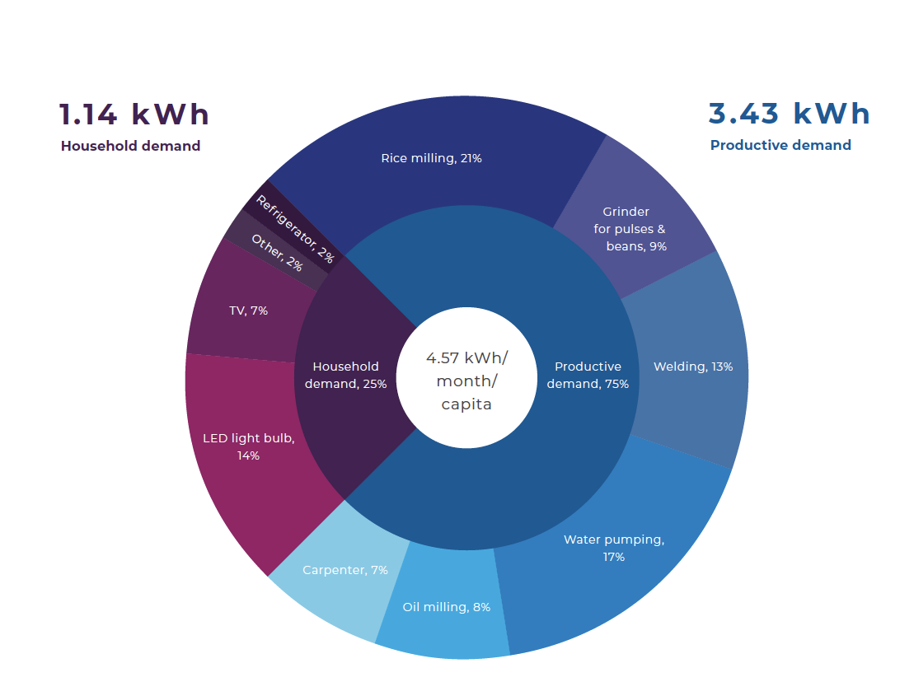
Cumulative productive and consumptive load share and major use types across all non- grid connected (NGC) villages of 44 villages in dry zone. Source: Pact Myanmar (2018).

Livelihood activities
Exhibit 34 Administrative divisions, Tanintharyi

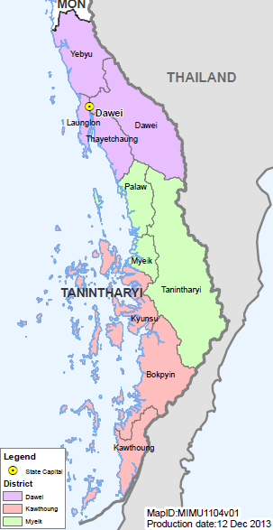
Source map: UNICEF (2013)
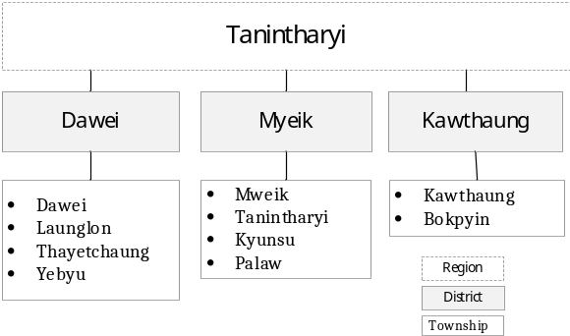

The population in Tanintharyi relies heavily on fishing (80% reported to be involved in some way). Various large companies are responsible for most seafood processing and exports from the region. Aquaculture has the potential to be a significant source of income and employment for people living in the Region. Small businesses, often family or women-owned, use basic technologies (without a freezing process) to produce dried fish, dried shrimps, fish paste, and fish sauce. Although local fishermen acknowledge selling finished products is more profitable than selling raw fish, the high cost of power is cited as a major impediment to food processing. Access to credit is another limiting factor for growth; artisanal fishermen are caught in a cycle of debt as they rely on wholesale buyers who finance their fishing operations by paying for the catch in advance, but if the yield falls short, the fishermen are prevented from selling at a better price to other buyers later in the year.

Regarding agriculture, cash crops such as rubber, oil palm and cashew are important in the lowland south of the Tanintharyi Region. As of 2013, approximately 360,000 acres of oil palm and 300,000 acres of rubber were planted in Tanintharyi, with oil palm plantations concentrated in the southern half of the region (i.e, Kawthoung District) and rubber in the northern half. Oil palm is a large-scale commercial activity, while rubber and cashew are grown at various levels, small up to large, by farmers. The rubber production has found itself into trouble due to the low price of rubber. Betelnut and banana intercropping is common in Tanintharyi. As seasonal crops, paddy rice, corn, sesame, chili pepper, peas and beans, and vegetables are grown. Small-scale livestock rearing is being done for home consumption.

Mining has also emerged as a significant industry, for example, Tanintharyi supplying up to 2/3 of Myanmar’s tin and tungsten. Pearls cultured at Pearl Island creates much budget obtained from foreign countries at the Myanmar Gems Emporia. The current Dawei deep seaport and Special Economic Zone projects are part of the industrial development plan

Beautiful islands and beaches such as Maungmagan (near Dawei) and in the Myeik Archipelago render great opportunities for tourism.

Livelihoods activities by rural women
- Coastal aquacultures, such as shrimp farming and crab farming
- Working at the fishing industry
- Making dried fish
- Agriculture (working as daily labourer or on their own farm)
- Making traditional snacks
- Running a small grocery at home

List of organizations working on livelihoods in Tanintharyi
- Advancing Life And Regenerating Motherland (ALARM), Boatpyin Township
- HELVETAS Myanmar, Dawei Tsp, Myeik Tsp
- Norwegian Refugee Council (NRC), Palaw Tsp, Dawei Tsp, Launglon Tsp
- Swisscontact - Swiss Foundation for Technical Cooperation
- United Nations High Commissioner for Refugees (UNHCR), Palaw Tsp, Dawei Tsp, Yebyu Tsp
- World Vision, Thatyetchaung Tsp, Palaw Tsp

Off-grid electrification

Tanintharyi, in particular, shows the great electrification needs. Compared to Myanmar’s national average (32%) and other states and regions, Tanintharyi has the country’s lowest electrification rate at 8% (in 2014). According to the 2014 Census, the main source of lighting is formed by private diesel generators (47%), kerosene (18%), candles (22%), grid electricity (8%), followed by solar systems (3%). Cooking is done using firewood (52%), and charcoal (44%)

The national grid is slowly being extended from Mon State (Tanintharyi’s northern neighbor) while major town will have local grid systems. Most of the Region’s 18 towns have electricity (provided by gas or diesel generation), but out of a total of 1,236 villages, 256 villages have been electrified by natural gas, diesel generator, and small hydropower. However, the Government plans to reduce the number of unelectrified villages top about 500 by stand-alone solar and solar mini-grid systems,

In the absence of the national grid and government tariff structure, which heavily subsidizes domestic users, private power suppliers in Tanintharyi often charge relatively high electricity rates. Furthermore, rural communities outside the reach of the private power companies can spend a significant share of their income on candles, batteries, and kerosene to light their homes after dark. Electronics shops in purchase solar products and batteries from wholesalers in Yangon who import products mainly from China, however, often warranty or after-sales support with their solar products.
Exhibit 35 Mini-grid systems installed in Thanintharyi
Type | Number  of plants
Minihydro (0-1 MW)  Minihydro (1-10 MW)  Biomass and biogas  Wind turbines | 6  0  11  25
Diesel  Steam / cogeneration / natural gas | 68  0
Source: MEE Net, 2018

The number of stakeholders promoting off-grid renewable energy access in Tanitharyi is relatively small. Myanmar EcoSolutions is developing a 400-kilowatt pilot project in one of Myeik’s islands to use solar for powering commercial facilities (e.g., cold storage, fish processing, shipyard) and local communities. Another example is Techno Hill Engineering, which has set up a 40-63 solar kW mini-grid systems in four villages on Kenti Island (in Palaw Township), visited by the PPG Team

Shan
- Area: 105,801.3 km²
- Total population: 5,824,432 in total (female 2,913,722 - 50.03% , male – 2,910,710- 49.97%), 2014
- Rural: 76%, urban: 24%
- Percentage of female headed households: 21.4%
- Main ethnic groups: Shan, Pa-O, Intha, Lahu, Lisu, Taungyo, Danu, Ta'ang, Ahka, Jinghpaw, Burmese
- Administrative divisions: 14 Districts,
- Capital: Taunggyi
- Main economic activities: Forestry, Mining, Agriculture

Socio-economic characteristics

Livelihood activities
Agriculture is the largest economic sector in Shan State, even in urban areas, followed by mining and (in Shan South) by tourism. However, access restrictions and lack of infrastructure have inhibited the development of tourism outside a few well-known spots, while the local population is not generally involved in mining, even as labourers. Weaving is an additional potential income-generating activity.

Livelihoods activities by rural women
Potential livelihood activities designed for women may include grocery retailing, tailoring, livestock rearing and farming (agriculture and horticulture). On issue regarding gender is land ownership. It is mostly men who end up officially owning land or farms as registered owners. This is because villagers have to go to town in order to register their land, and women rarely travel, since men deal with Registration Office’s officials. Thus, men end up registering land in men’s names.

Organisations working on livelihood in Shan State
Regional CSOs and gender organizations offer capacity-building support to help ensure women’s income generation. The State’s One Village-One Product Programme is of interest to be involved in the Project’s PUE activities. The programme intends to promote local products and markets. Youth entrepreneurship association in Taunggyi (under the Myanmar Entrepreneurship Development Association) offers training designed for value-added products using local produce, e.g., training in fruit processing.

Agriculture

Potential crops include garlic, onion, potatoes, green tea, coffee, and maize in addition to seasonal fruits such as jackfruit, orange, jengkol beans, dog fruit, mango, and sebesten.

The performance of the agriculture sector and its potential for growth have been enhanced by recent progressive agricultural policy reforms such as (i) land law reforms; (ii) abolition of the rice production quota, allowing farmers to choose which crops to cultivate; (iii) liberalization of domestic and international marketing of rice in 2003, and of industrial crops in 2004; (iv) removal of the export tax on key agricultural commodities; (v) a law allowing the establishment of microfinance institutions; (vi) use of crops as loan collateral; and (vii) passage of a plant pest quarantine law in 1990, a pesticide law in 1993, and a fertilizer law in 2000. In spite of this progress, the need remains to adopt a more coherent and comprehensive approach to agriculture and rural development and to make agriculture more commercially oriented, as has been done by the leading ASEAN members that have sizable agriculture sectors. To accomplish this, the government has been adopting a value-chain approach to agriculture since 2011, which will facilitate the job creation and income growth needed to achieve not only rural development but also sustainable inclusive growth.
Exhibit 36 Administrative divisions, Shan State

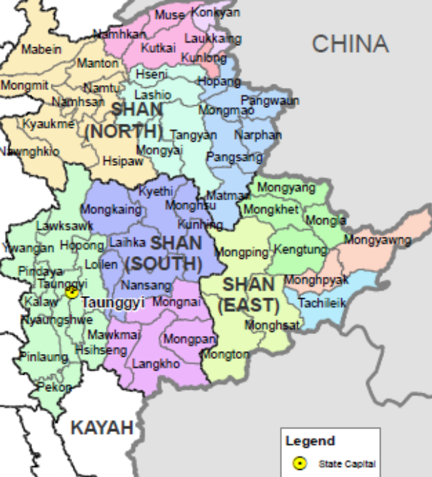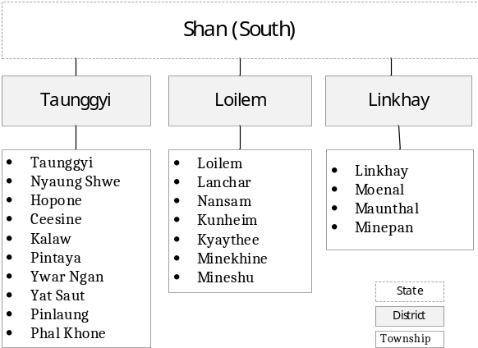
Source mao: UNICEF (2013)

Recently, Myanmar government launched the Myanmar Agricultural Development Strategy and Investment Plan (2018-2023). It responds to the need (1) for the consolidation and integration of various plans, strategies and roadmaps and approaches currently developed by various stakeholders, (2) for systematic approaches to operationalize agricultural policy implementation, (2) to coordinate activities, projects, programme and policies and (4) to build a dialogue with domestic and foreign investors and harmonize foreign aid to the sector. The agricultural sector is estimated to contribute nearly 30% of GDP while industry accounts for about 25% and services about 45%. Agriculture accounts 60-70% of employment and 25-30% of export. Section3.5 of the strategy, it highlights the current condition of agricultural infrastructure and the importance of infrastructure development. Expanded rural electrification will be necessary for the development of both farm and non-farm sectors.

The cost of seeds and other inputs, and reliance on imports from China and Thailand, insecure land tenure, lack of knowledge and lack of infrastructure are barriers to improving farming techniques. While local markets are generally easy to access, farmers often have little access to more distant internal or international markets. The State has a potential for a number of cash crops (coffee, green tea, ginger, avocado, mango, soybean). Maize thrives in the temperate highlands, especially in Shan State.

Off-grid electrification

According to the 2014 Census, main source of lighting is electricity (33%), followed by solar systems (27%), candles (17%) and mini/micro hydropower (10%). Cooking is done using firewood (77%), and electricity (15%). In Southern Shan, most towns have electricity from the main grid or local grid systems (one diesel and one solar-powered). However; out of a total of 4,787 villages, 256 villages have been electrified by natural gas, diesel generator, and small hydropower. In rural areas, 1722 villages out of a total of 4787 have been electrified by the national g
rid, diesel generator, solar, or small hydro systems.
Exhibit 37 Mini-grid systems installed in Shan State
Type | Number  of plants
Minihydro (0-1 MW)  Minihydro (1-10 MW)  Biomass and biogas | 4494  11  62
Diesel  Coal | 4081  1
Source: MEE Net, 2018

In Myanmar, there is significant micro/mini-hydro electrification potential and many existing sites throughout the country, and Shan State can be viewed as the most resourceful and actively developed area. There are several developer-manufacturers of <1MW hydropower in Shan State, who have developed a total of almost 4500 projects below 1MW. These developers are skilled in engineering and developing Crossflow, Francis, Turgo, and Propellor turbines. The majority of these projects have been fully paid for by the benefitting communities, with upfront costs supported by the local developer-manufacturers. Most of these developer-manufacturers are second-generation family-based, social enterprises, building upon the work of their fathers who were raised in villages with micro-hydro projects.

The mini/micro hydropower sectors is expanding, there are at least 20 greenfield projects below 1MW and 50+ brownfield projects that are in need of being upgraded. They are located in southern, central, and eastern Shan State (info provided by HyCEM, 2018).

  - Bibliography

ADB (2014)
Draft, Myanmar Renewable Energy Policy, by Asian Development Bank, National Energy Management Committee (NEMC) and Ministry of Science and Technology (MoST)

ADB (2015b)
Myanmar Energy Master Plan, for Asian Development Bank by Intelligent Energy Systems (IES) and Myanmar International Consultants (MMIC)

ADB (2016)
Myanmar, Energy sector, Strategy, and Roadmap, Asian Development Bank

ADB (2017a)
Off-Grid Renewable Energy Demonstration Project, Project Number: 47128-001, completion report prepared by the consultant, Nexant Asia Ltd. for the Asian Development Bank

ADB (2017b)
ADB Off-grid Renewable Energy, Investment Forum, prepared by Nexant for the Asian Development Bank

ESMAP-WB (2017)
Role of Mini-grids for Electrification in Myanmar, Energy Sector Management Assistance Programme, World Bank

Doberman, J. (2016)
Energy in Myanmar, International Growth Centre (IGC)

PACT (2018) - SPM
Bridging the Energy Gap: Demand Scenarios for Mini-Grids in Myanmar, by PACT/Smart Power Myanmar (SPM), https://www.pactworld.org/library/bridging-energy-gap-demand-scenarios-mini-grids-myanmar

GIZ (2018)
Workshop MOEE Grid-Connected Small Scale Electric Power Enterprise Regulations, Naypyitaw, March 2018. Isolated Small Sccale Electricity Enterprise Regulations (by J. Schmidt-Reindahl). Grid-Connected Small Scale Electricity Enterprise Regulations (C. Graecen)

Numata, M. (2018)
Technoeconomic Assessment of Microgrids in Myanmar, ERIA Discussion Paper Series, ERIA-DP-2018-05

Said, A. (2018)
Myanmar’s Renewable Energy Potential – Open source re-sources mapping for electrification of rural communities, Master’s thesis, Aalto University, Finland

Soe Soe Ohn, Dr. (2016)
Off-grid Electrification in Myanmar, PowerPoint presentation, Department of Rural Development

Soe Soe Ohn, Dr. (2018)
Utilization of Renewable Energy for Off-grid Rural Electrification in National Electrification Project, PowerPoint presentation, Department of Rural Development

Spectrum (2017)
Developing a renewable energy policy for Myanmar: Insights from the 2014 census. Energy Briefing Paper. Spectrum – Sustainable Development Knowledge Network

Ross, R. (2015)
Myanmar’s Path to Electrification; The Role of Distributed Energy Systems, Center of Strategic and International Studies (CSIS)

Tint Lwin Oo (2017)
The Role of Renewable Energy in Myanmar’s Future Energy Mix, Ministry of Electricity and Energy (MoEE)

Vaghela, D. (2017)
Energy Democracy in Myanmar: Scaling up Renewable Energy Social Entrepreneurs, PowerPoint, UK Low Carbon Development Network (LCEDN) Conference

World Bank (2017)
Upscaling Minigrids for Low-cost and Timely Access to Electricity (2017).

Wang, X. (2016) and Maung Win
Myanmar: Towards Universal Access to Electricity by 2030, World Bank-ESMAP and Ministry of Agriculture, Livestock and Irrigation (MoALI)

- Myanmar: de-risking energy investments (DREI)

This Annex sets out the preliminary findings of a “Risk Environment” analysis for private sector models for solar PV-battery mini-grids in Myanmar that was performed using the Derisking Renewable Energy investment (DREI) framwork. More information on the DREI framework can be found at www.undp.org/DREI

The data for the Risk Environment analysis come from two principal sources:
- 10 structured interviews with investors, project developers, donors/international development agencies and ecosystem player in solar PV mini-grid sector in Myanmar - 4 with mini-grid project developers (equity investors), 4 with donors/international development agencies (debt/grant investors) and 2 ecosystem players/enablers.
- A few informational interviews with and inquiries to other public and RE actors

Interviews with local investors were conducted by the UNDP project team via conference calls and in-person in Myanmar between July and September 2018.

The analysis assumes a private sector build-own-operate (BOO) model, with a typical initial system size to serve 100 households, at 95% reliability, for a MTF Tier 2-3 service level (lighting and mobile phone charging and small, energy efficient appliances), together with some productive and community use. It’s assumed that the private sector takes an aggregative approach to solar mini-grids, improving financial viability by creating economies of scale and lowering the transaction costs related to individual solar mini-grids. A modular design approach is also taken, bringing down design costs, and facilitating future adjustments to system sizing, as demand evolves to incorporate further productive use.

Exhibit 38 below shows the financing cost waterfall for solar-battery mini-grids in Myanmar.
Exhibit 38 Impact of risk categories on the cost of equity for solar PV mini-grid investments in Myanmar

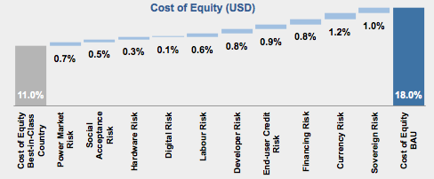

Source: interviews with solar PV mini-grid investors, developers, donor/development agencies; modelling; best-in-class country is assumed to be Azores, Portugal;

- Currently, financing costs are high in Myanmar. Financing for solar mini-grids is limited to equity financing, with no commercial debt available. The analysis estimates that the current commercial cost of equity (USD) for solar mini-grids in Myanmar is 19%. This compares to a best-in-class reference of 11%
- These higher financing costs reflect a range of investment risks solar PV mini-grid developers/investors in Myanmar. These include: 1) “power market risk” that concerns power/energy market regulations and policies for mini-grids, such as the need for government regulations on integrating mini-grids to the national grid when it arrives, and a published national grid extension plan; 2) “financing risk” that concerns the lack of sufficient liquidity in the domestic banking sector and lack of availability of financing from domestic banks to mini-grid developers; and 3) “currency risk” that concerns the depreciation of local currency (MMK) versus USD, given that significant investment into the mini-grid sector has been made by foreign investors, and 4) “sovereign risk” overall stability, peace, and sovereign credit risk.

Exhibit 39 below sets out some preliminary policy derisking and financial derisking instruments to address the various investment risks identified in the Risk Environment analysis.
Exhibit 39 Policy and risks instruments considered

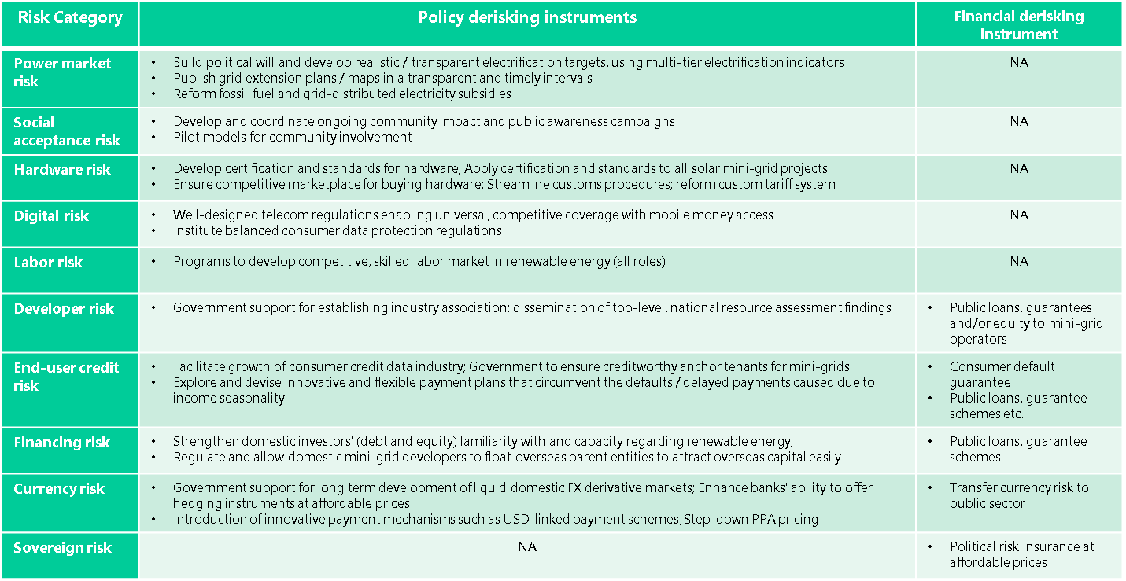

A full quantitative DREI analysis – with levelized cost modelling for solar battery mini-grids - is envisaged during the implementation of the RURED project.

- GEF CORE INDICATORS and GHG emission reduction

  - Calculation of RE energy production and GHG emission avoidance

GEF projects typically focus on facilitating future market development, addressing the causes of the development and environmental problem, and addressing barriers to put the right conditions in place so that emissions and energy needs will not rise or rise less in future. A requirement of any GEF climate change mitigation project proposal is to provide estimates of the emission reductions, “direct” emission reduction (caused by demonstration projects of leveraged investments during the project’s implementation), and “indirect” (also named consequential) emission reduction (as a consequence of RURED’s policy advisory, technical assistance, capacity building and outreach activities).

Direct emission reduction

Direct GHG emission reduction results directly from the investments in the solar PV and hydro mini-grid systems (resulting from implementation of mini-grids benefitting from GEF financing and mini-grids benefitting from co-financing). The analysis is based on a typical rural RE mini-grid system, one powered by micro-hydro and a second by solar PV. We assume the average village has 200 households. The off-grid energy system needs to be able the serve the energy needs of these households, and street lighting, social services (government offices, school, rural health clinic, businesses) and other productive uses.

Exhibit 40 Characteristics and indicators of a typical small hydro and a typical solar mini-grid system
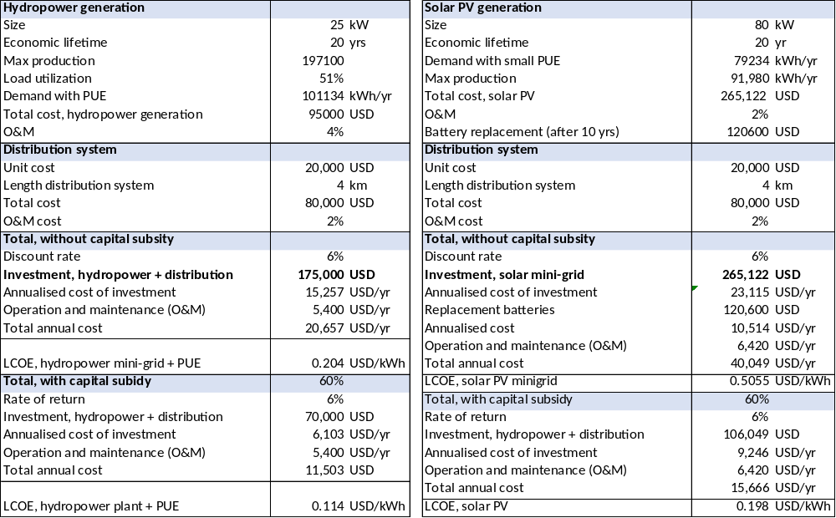

Exhibit 41 Baseline technology: diesel-based mini-grid system

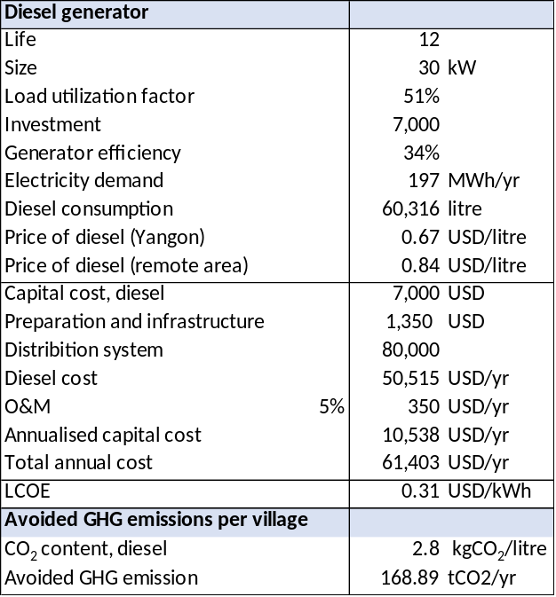

Exhibit 42 Baseline data in estimating energy demand and solar or hydropower supply options

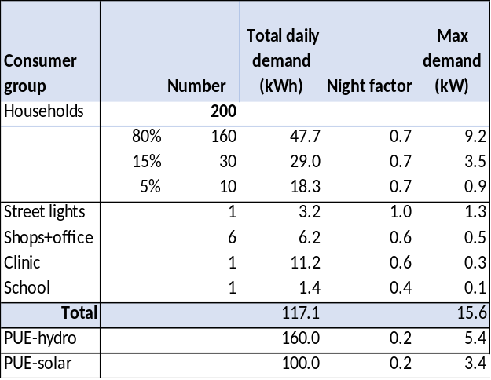
Village energy demand and load profile

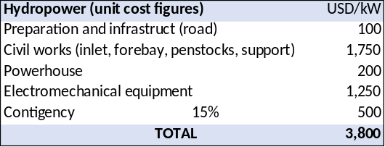
Mini hydropower unit cost figures

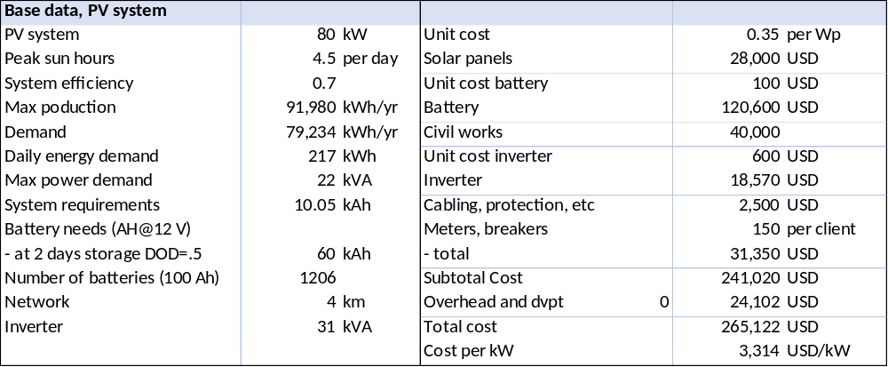
Costs of solar PV mini-grid system and components

The Project alternative technologies consist of the solar or hydro mini-grids. In the absence of RURED (and related co-financed activities) the choice of the village or communities for electrification would be to install a mini-grid powered by a diesel generator set. This is the baseline technology, given the fact that the village cannot be connected to the main grid in the foreseeable future due to its remote location. We estimate the size and fuel use of a diesel system to be able to supply energy for the village demand as sketched above.

The demand of our hypothetical village of 200 households can be met with a 25 kW small hydro or diesel genset and a 80 kW solar PV installation.

In the calculations in this project document, the solar PV grid has been sized according to the demand of households and small businesses, but larger loads for PUE have not been included. One reason is that each village economy has its own unique features, and PUE estimates may not apply to other areas. However, during the actual design of a rural RE project in a village (or cluster) extra attention will be given to the inclusion of PUE with a larger load. These could be small manufacturing loads (e.g., welding, woodworking, tailoring) or agricultural or aquaculture loads (e.g., cooling, drying, irrigation pumping, pressing, grinding, milling, and packaging machinery), as well as larger services load (e.g. tourism facilities).

When designing micro-grids, the specific characteristics of loads, such as timing, magnitude, and seasonality can have a large impact on the financial viability of the overall system. For this reason, the specific power requirements of a business may positively or negatively impact the design, operation and resulting costs of power. This impact may be especially pertinent for smaller solar microgrids where any specific PUE may have an oversized impact. For small hydropower, the role of PUE is beneficial to the system’s economics in a clear way. In solar mini-grid system, the sun only shines during the day and energy needs to be stored during the day in batteries to provide for the evening peak; the system is sized to meet the daily village energy demand (should be higher than the energy the system can be produced during the days with the lowest sunshine in a year). In small hydropower grids, the river flows at day and night, and the system is sized according to the daily peak load (the system should be able to meet the evening peak). Hence, there is a lot of idle power during the day, which can be taken advantage of by incorporating a larger PUE. Thus, including larger PUE loads (outside evening hours) while maintaining the same system size can raise revenues of the mini-hydro system (as indicated in Exhibit 43 ) having a noticeable impact on the system’s levelized cost of energy (LCOE). Including larger PUE does not have the same beneficial effect in solar PV mini-grids, if it implies increasing the system size and battery storage needs. It should be stressed that promoting PUE implies income generation by selling extra products and services and thus increase village income generation. The direct and indirect income increase of villagers mean that these are more able to pay for energy services of the energy system.

Exhibit 43 Summary of villages electrified, annual energy production and GHG emission avoidance

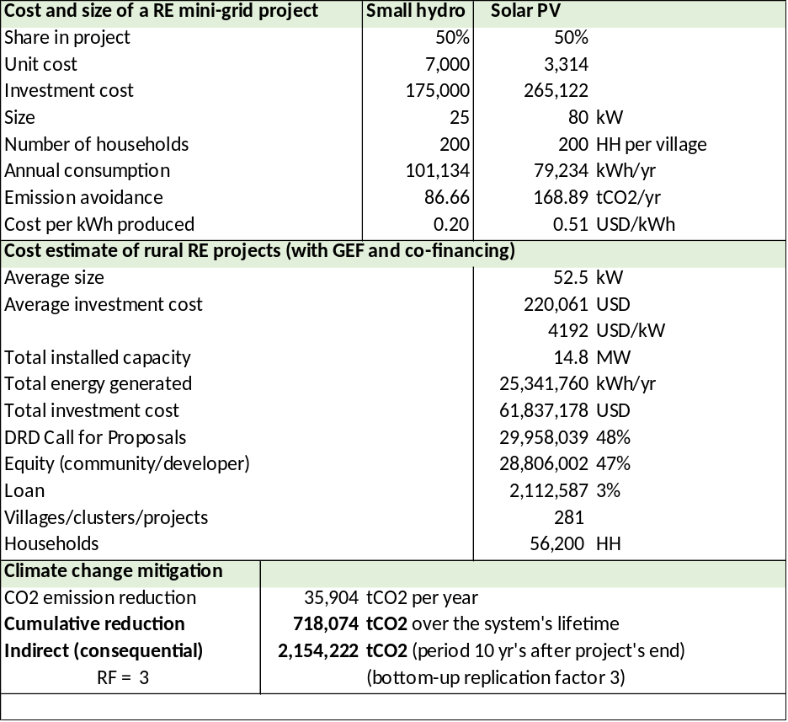

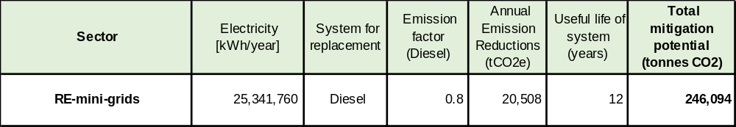

Number of villages supported by RURED and associated renewable energy production (in mini-grids) and greenhouse gas (GHG) reduction

The RURED project will result in 14.8 MW of installed mini-grid capacity in 281 villages, of which 50% is powered by hydro (at 25 kW per village on average) and 50% by solar (at 80 kW per village on average). A village is assumed to have 200 households on average. At an average investment cost of the facility (generation and distribution) of USD 4,192 per kW, the total investment will be USD 61.84 million, of which 48% is covered by DRD-NEP grant support (about USD 30 million.

If these villages would not establish a RE energy system, but one based on diesel generation, the GHG emissions due to the use of diesel fuel would be an estimated 20,508 tCO₂ a year. By employing a RE system instead, the cumulative direct GHG emission avoidance (assuming a 12-year life of the RE mini-grid systems) is 246 kilotons of CO_{2.}

Direct post-project emission reduction is defined as that GHG avoidance resulting from the project’s activities, but for which equipment is installed after project close. In the case of RURED, in addition to support for the village RE systems, which will result in direct GHG avoidance, project activities will result in plans for replicating the project demos and in the obtaining of financing for these plans (e.g. as a consequence of the project’s support to setting up financial and guarantee mechanisms (Output 3.2) Actual installation of these “replications” is expected to occur after project close. Project activities supporting the replication of the incremental off-grid RE power projects are estimated to have a doubling replication effect. Thus, the direct post-project GHG emission avoidance is 246 kilotons of CO_{2.}

Consequential ERs (CERs) are those resulting from indirect replications that are stimulated by the project policy support capacity building and finance strengthening activities. The replications generating CERs are those that do not receive any direct support from the project, either as TA or investment, and thus may be called “indirect replications.” The bottom-up approach used here is based on a simple replication factor (RF) deemed feasible by the project team to estimate amount of systems installed during the ten years influence period. Thus, the consequential GHG emission avoidance is 738 kilotons of CO₂.

  - GEF Core indicators

Core indicator 6: Greenhouse gas emissions mitigated
GHG emission type | Metric tons CO₂-eq (expected at PIF) | Metric tons CO₂-eq (expected at CEO ER) | Metric tons CO₂-eq (expected at MTR) | Metric tons CO₂-eq (expected at TE)
Lifetime direct project GHG emissions mitigated | 224,193 | 246,094
Lifetime direct post-project emissions mitigated | -- | 246,094
Lifetime indirect GHG emissions mitigated | 672,576 | 738,282

Core indicator 11: Number of direct beneficiaries disaggregated by gender (GEF and co-financing)
 | Total number (expected at PIF) | Total number (expected at CEO ER) | Total number (achieved at MTR) | Total number (achieved at TE)
Women | -- | 123,640
Men | -- | 123,640
Total | -- | 247,280
Note: assumes a household size of 4.4 (based on 2014 Census). Number of males and females are equal

- Stakeholder engagement plan

Project preparation
During the project preparation (PIF and PPG stage), a series of consultations were held with a broad range of stakeholders with the objective of informing project design, validating project activities and ensuring interventions are as inclusive as possible, as well as in line with international best practice, the existing relevant national policies, electrification plans and off-grid electrification initiatives.

The following summarizes the stakeholder engagement activities to date:
- Interviews with representatives of RE companies and financial entities as part of the DREI analysis were undertaken between July and September 2018.
- The PPG kick-off meeting, with the participation of a broad range of stakeholders, was held in Yangon on the 20th of September 2018 for wider consultations on project design.
- Stakeholder inputs were further discussed and disseminated through a validation workshop held on the 26th of November 2018 in Yangon
- Field visits to Tanintharyi and Shan State in January 2019 to meet government officials, RE developers, as well as target beneficiaries and users was conducted to understand more on local rural energy demand and off-grid supply options. Interviews with local stakeholders also further elucidated possible productive uses of energy, as well as relevant gender aspects of project interventions (see also the description on Stakeholder Engagement in Section 4.4)
- Bilateral meetings were conducted with the relevant government department, development partners; NGOs and RE project developers in Yangon and Naypyithaw during the project formulation phase.

Project inception and implementation
The table below presents the Stakeholder Engagement plan and summarizes different categories of stakeholders, which are described in Section 4.2 and Annex E.7.

Stakeholder group or organisation | Means of engagement
Ministry of Agriculture, Livestock and Irrigation (MoALI) – Department of Rural Development (DRD) | MoALI-DRD implements the off-grid component of the National Electrification Plan (NEP).  DRD is the main Partner of the Project. DRD staff will work closely with full-time project staff and short-term experts. DRD will also take a leadership role in the Project Board in providing direction to the Project. A few key DOE staff will work side-by-side with the project team on many aspects of implementation, particularly policy-related aspects, institutional aspects, capacity building and off-grid RE implementation and monitoring.
Ministry of Energy and Electricity (MoEE) | Promoting coordination between DRD, MoEE and utilities to achieve a well-planned, mutually complementing, on-grid and off-grid electrification is one activity of RURED
Environmental Conservation Department (ECD) of MoNREC | The GEF operational focal point is the Environmental Conservation Department (ECD). ECD is responsible for climate change and greenhouse gas emission monitoring, reporting, and verification (MRV). ECD is responsible for managing natural resources conservation and sustainable utilisation, pollution control on water, air and land. The Project will work with ECD on improving GHG MRV methodology regarding the contribution of off-grid energy systems. Also, ECD plays a role in ensuring that PV related wastes (lead-acid/lithium batteries) are disposed of nationwide in a way that does not endanger the health of the natural environment. The Project will work with together in natural resources management and watershed protection of the river basins in which the mini/micro hydro activities will be based.
Ministry of Education | The Project will work with technology universities in mainstreaming RE and electrification elements in existing curricula. Further, the Project will provide assistance for the strengthening DRI’s Renewable Energy and Electronic Technology Centre (REETC) and with DTVE to integrate technical training on O&M of small RE systems (solar, hydro) education at the regional Technical and Vocational Education and Training (TVET) centres.
UNDP programmes in Myanmar | RURED will actively seek synergies between the various thematic areas of livelihoods, governance, disaster risk reduction, environmental protection, climate change adaptation and mitigation. These synergies will be pursued through UNDP’s umbrella Governance for Resilience and Sustainability Project (GRSP). Through GRSP, RURED will be coordinated with ongoing projects, such as the UNDP/GEF R2R Integrated Protected Area Land and Seascape Management in Tanintharyi and the UN-REDD+ National Programme, which are providing valuable lesson-learned for navigating interim arrangements in the peace process, and engagement with representatives of both Ethnic Armed Organizations (EAOs) and Civil Society Organization (CSOs) that represent indigenous peoples in the local area.
World Bank, GIZ, New Zealand, Italy and other development partners | The off-grid electrification component of the National Electrification Plan (NEP) is implemented by DRD with financial and technical assistance support from World Bank and TA support from GIZ. The Project will provide further TA to DRD in a concerted effort with WB and GIZ focussing on ‘niche’ areas such the integration of PUE and demand engagement in village-level project design, and sustainable (less subsidy-dependent) financing, as well as capacity development of government entities. The development partners coordinate their activities in an energy sector coordination (with an energy access) working group that includes IFC, GIZ, KfW, and a number of other development agencies working in the energy sector in Myanmar. RURED will actively participate in this energy sector coordination.  Donors will be kept abreast of project activities, as relevant. Particularly, RURED’s village off-grid RE power generation management model of the project will be shared with the donor projects pursing village-scale RE power installations, where the model may also provide a solution to the sustainability problem (subsidy dependence) that highly concerns all donors working in this area
PACT/Smart Power Myanmar | The Smart Power Myanmar facility aims to mobilize financing and provide technical assistance to support the rollout of mini-grids and other rural electrification solutions that are in line with Myanmar’s NEP and with a focus on customer-centred solutions, provided by local energy service providers demand stimulation and PUE, and mobilizing local financial resources. Given the similarity between RURED and SPM’s approach, the Project will cooperate closely with SPM in the selected village off-grid RE, especially on micro-finance and productive uses of energy to mutually complement objectives of both programs.
REAM  HyCEM  UMFCCI Solar Group  RE developers / rural service companies (RESCOs) | REAM works with local inhabitants, professionals, technicians, micro or small enterprises and other like-minded organization on renewable energy Information, education, and communication and supports small development projects in Myanmar. REAM has helped setting up professional associations of RE developers and entrepreneurs, such as HYCEM (mini-/micro hydropower) and the Solar Group (solar PV and mini-grids). The Project will work with these NGOS in Component 2 on information sharing, capturing experiences in off-grid electrification, and knowledge and dissemination, as well as capacity, needs assessment and formulation of capacity building activities, and in Component 3 in the joint implementation of Output 3.1 in the selection of beneficiary villages, consumer engagement design and design and implementation of off-grid RE systems, and work together in organising the financing of the RE systems as well (micro-)finance for energy uses. RE companies will be invited to be involved in the project both as learners and as contracted companies to design and install off-grid RE systems. The project will offer training in both the mini/micro-hydro area and the PV area (technical, business models, socio-economic aspects). The project will be conducting work in identifying the best cost channels for sourcing quality projects and providing expected cost breakdowns for overall systems
Financial service providers | The Project will engage one (or more) local financial service providers, such as A-Bank, in setting a loan programme for small RE and electrification projects. The Project will promote cooperation and exchange with similar banks abroad. The project will invite commercial banks (and equity investors) to attend its capacity building program for the banks on the financing of RE technologies
Engineers / technical persons: | These will be persons with an education in engineering or extensive experience in technical trade. These persons will either already be involved in the RE sector or interested to get involved in PV and/or mini/micro-hydro. The project will invite such person to participate in its training on the design and installation and operations of micro/mini-grids and PV mini-grids
Beneficiaries (rural electricians; operators/ administrators; local villagers)  Indigenous people  Women | Rural electricians will have experience in electrical wiring and repairing electrical equipment. The project will provide training for such persons both through its training programs (in cooperation with TVET centres) so that these persons can become certified and be involved in installation and O&M and basic technical troubleshooting of RE systems in their village. Similarly, the RURED Project will select and train a few operators from each village at which there is a RE project in business development and administration (preparing bills and collecting payment, transferring funds to required account).  The project will put special emphasis on the engagement of local villagers, a significant portion of who are indigenous peoples. The project will during its early stages conduct appropriately scaled environmental and social impact assessments at each of the 40 demo sites as part of its Environmental and Social Management Framework (ESMF) and associated Indigenous Peoples Planning Framework (IPPF). The assessments will include in-depth consultation with local people, with FPIC conducted with affected IPs as required, particularly in any cases where land acquisition may be required, or access to land or resources is affected. The project will further carry out activities to confirm land availability (and consensus thereof) for the local RE projects as needed, and to confirm the continued willingness of local villagers to volunteer labor for demo installation. Lastly, the project will continue to consult local villagers (including, indigenous peoples) regarding productive uses and how the project may assist them in starting or expanding their businesses with productive uses of RE.  The project will put special emphasis on the involvement of women in village community meetings with the project, ensuring that consultations are carried out in a gender-sensitive manner with proportional representation of women(or at least decision-making participants) at such meetings are women. The project will also proactively seek the involvement of women in productive use initiatives, assuring that a part of project funds for productive uses go to initiatives mainly involving women.

The project will effectively engage the stakeholders involved in the project to get their support and guide the project implementation to achieve higher results.
- Project outreach proposed includes project website, media (print/audio visual), workshops, trainings etc.
- The PMU and the Project Board will ensure that the Gender Action Plan recommended by the project is pursued and implemented. The various groups especially women will be engaged during the consultation meetings, prioritized to avail the program and be included in the different capacity building programs. The project will also ensure that it is in line with the National Electrification Plan.
- Meetings, monitoring visits, surveys, and written communications will be used to receive feedback to continue the ongoing dialogue as well as during the course of implementation. Communication materials will be available in the local language as required and conducted in a culturally sensitive manner which accounts for the ethnic diversity in implementation areas.
- The project will follow a participatory approach in decision making by engaging all the relevant stakeholders. The Government agencies, NGOs, CSOs and the private sector actors will be actively involved during the project implementation.

Responsibilities
The PMU is primarily responsible for carrying out the specified stakeholder engagement activities. The stakeholders will be engaged while carrying out various assessments and studies, training and workshop events

Grievance mechanism
People concerned with or potentially affected by the project can express their grievances for consideration and redress. The Project Management Unit will receive grievances, through the community engagement focal point and will try to resolve at the PMU level if possible. If not possible then the issues will be referred to the Project Board that will try to settle the issues amicably. In the event the party does not accept the decision of the Project Board he/she can put the case to Arbitration. Any person or group of persons affected by a UNDP-supported project also has access UNDP’s Stakeholder Response Mechanism (SRM), and alternatively can address grievances to UNDP’s Social and Environmental Complaints Unit (SECU) by accessing https://undp.tnwreports.com and/or by e-mail (https://undp.tnwreports.com).

Monitoring and reporting
The project stakeholders would be engaged at various levels to carry out the monitoring activities. Then the PMU will laisse with relevant Government agencies and other partners and collect data and monitor the activities on a regular basis.
The PMU will report back the results to the stakeholders at the earliest through letters or conduct meetings both individually as well as through engagement of all relevant agencies.

Communications plan
The RURED project will also emphasize strong communications with a broader range of stakeholders. Key elements of the project’s communication strategy are outlined in the table below:

Key element | Relevant group | Means
1. Project governance meetings; Project Board meetings; technical and sub-national working group meetings | All stakeholders that are members of the Board or its Working Groups or are invited to attend | Meetings
2. Seminars/workshops and training events, including the Inception workshop, and End-of-project workshop | National and subnational government officials  Financial and private sector  NGOs and CSOs  Beneficiaries (rural technicians, operators and villagers), including women, indigenous groups | Workshop, meeting, seminar, training  On-the-job training
3. Project documents, thematic reports and publications | Various government departments and decision-makers (DRD at national level and in Tanintharyi/Shan, DRI, ECD) | Direct dissemination (e.g. email or hard copy) to persons.  Access via the Project website
4. Technical reports and off-grid RE toolkit and other tools/software; web-based GIS tool | Local villagers that take initiatives to implement and manage systems  Engineers and persons working or interested in working in off-grid RE  National and subnational energy planners (State/region, townships)  Development partners and NGOs | Direct dissemination (e.g. email or hard copy/ usb-drive)  Access via the Project website to reports and documents as well as the GIS database
5. Project knowledge capturing and info dissemination | Government officials  Financial and private sector  Development partners and NGOs  Stakeholders in other countries | Online access to all project materials and other off-grid RE and PUE information
6. Reports (feasibility assessments; non-confidential parts of business plans; monitoring) of RURED-supported off-grid RE systems, and PUE | Various national and local and regional level officials; CSOs  Financial and private sector  Development partners  Technical professionals; experts/ academics | Direct dissemination to person directly involved  Summaries with non-confidential info access through website

Budget available is part of the various project activities. The budget for seminar/workshops/events and printing of reports. Documents, etc., and Output 2.4 (lessons learned and dissemination) is about USD 480,000

- social and environmental screening

Project Information

Project Information | February 2019
- Project Title | Myanmar Rural Renewable Energy Development Programme (RURED)
- Project Number | 5564
- Location | Myanmar

Part A. Integrating Overarching Principles to Strengthen Social and Environmental Sustainability

QUESTION 1: How Does the Project Integrate the Overarching Principles in order to Strengthen Social and Environmental Sustainability?
Briefly describe in the space below how the Project mainstreams the human-rights-based approach
RURED facilitates and promotes rural renewable energy services and productive applications in Myanmar, providing essential infrastructure to extend electricity to underserved rural populations and supporting livelihoods, thereby allowing beneficiaries to enjoy a fuller range of their social, and economic human rights, in particular, the right to an adequate standard of living.
Notably, Myanmar is one of the most ethnically diverse countries in the Asia Pacific region, with over 135 officially recognized ethnic minorities, known nationally as ethnic nationalities, as well as a diversity of other groups with distinct cultural practices and internationally recognized under the UNDRIP definition of Indigenous People’s (IPs), including a diversity of groups in the states and regions targeted by the project, including, but not limited to Shan (8.5 percent of Myanmar population), Karen or Kayin (7% percent of Myanmar population) Mon (2.4 percent of population), and others for renewable energy mini-grid pilot projects. Although the Government of Myanmar is not signatory to the ILO Convention 169, requiring Free, Prior and Informed Consent (FPIC), the project is subject to UNDP’s Social and Environmental Standards policy which requires FPIC on any matters that may affect rights and interests, lands, territories, resources, and traditional livelihoods, as well as any relocation and appropriation of cultural heritage. A human rights based approach will, therefore, emphasize adequate consultation with stakeholders including FPIC for IPs as required, and in ensuring that benefits are distributed equitably and avoid any restriction of access to resources.
Overall the project is designed to enhance the availability, accessibility, and quality of benefits and services for all relevant target groups including those that are potentially marginalized individuals and groups. The mini-grid pilots in the three region/States, Tanintharyi, Shan (and northern Dry Zone), will be developed including capacity building for marginalized and indigenous people, while creating an enabling environment for full and inclusive participation of all individuals.
Briefly describe in the space below how the Project is likely to improve gender equality and women’s empowerment
The project’s primary goal is one of mainstreaming environmental sustainability into the national energy sector, including through the promotion of low carbon technology applications, including the integration of environmental and social sustainability factors which will be taken into account in the design and site selection, including any potential negative impacts on recipient communities. This consideration includes the gendered use of resources, as well as gendered roles within communities, in order to avoid the reinforcement of negative gender biases, such as the low representation of women in hydropower projects and within Village Electrification Committees (VECs), as identified during initial consultations. By targeting female-headed household as prioritized beneficiaries for electricity generated, as well as ensuring gender balance in training and capacity building activities, the interventions of RURED can be leverages as an opportunity to create gender transformative change in the renewable energy sector in Myanmar. As part of the project design, a Gender Analysis and Action Plan has been prepared and can be found in Annex D of the project document. The Analysis identifies entry points and gender specific actions based on the project’s logical framework, with suggested indicators for monitoring of gender equity outcomes.
Briefly describe in the space below how the Project mainstreams environmental sustainability
The project is geared towards promoting and supporting renewable energy services and productive applications, as among the key elements for the satisfactory achievement of the energy, environment and development agenda of the country. That is, environmental sustainability is at the heart of RURED project design, which acts as an accelerator for the adoption of renewable energy in rural areas, thereby helping to achieve a reduction in GHG emissions nationally, as well promoting the use of a sustainable form of energy for Myanmar’s extensive rural population, that may otherwise depend purely on emission heavy sources such a diesel. In regards to potential adverse impacts, all interventions on the ground will be designed in such a way that proper evaluation of the potential impacts to the natural environment will be carried out, according to national requirements for environmental and social impact assessment, as well accounting for the recommendations outlined in the Environmental and Social Management Framework (ESMF) prepared by the World Bank for the Myanmar National Electrifications Project. In this regard, the Department of Rural Development (DRD), as well as the Department of Environmental Conservation (ECD) under MONREC, as well as the provincial governments will be coordinating closely with the Ministry of Environment on the siting, design, development and implementation of the demo projects that will be carried out directly by the project, and will also coordinate on the replications that are expected to follow towards the end of project implementation and during the influence period. This may involve, for projects such as micro/mini-hydropower facilities carrying out comprehensive environmental and social impact assessments. Finally, given the conflict context in Myanmar, the presence of IPs in the project areas, as well the identification of several other projects risks, which are moderate, a project level Environmental and Social Management Framework has been prepared and can be found in Annex X.

Part B. Identifying and Managing Social and Environmental Risks

QUESTION 2: What are the Potential Social and Environmental Risks?  Note: Describe briefly potential social and environmental risks identified in Attachment 1 – Risk Screening Checklist (based on any “Yes” responses). If no risks have been identified in Attachment 1 then note “No Risks Identified” and skip to Question 4 and Select “Low Risk”. Questions 5 and 6 not required for Low Risk Projects. | QUESTION 3: What is the level of significance of the potential social and environmental risks?  Note: Respond to Questions 4 and 5 below before proceeding to Question 6 |  |  |  | QUESTION 6: What social and environmental assessment and management measures have been conducted and/or are required to address potential risks (for Risks with Moderate and High Significance)?
Risk Description | Impact and Probability (1-5) | Significance  (Low, Moderate, High) | Comments2 |  | Description of assessment and management measures as reflected in the Project design. If ESIA or SESA is required note that the assessment should consider all potential impacts and risks.
Risk 1: The project can potentially have adverse impacts on gender equality and/or the situation of women and girls in case that project activities, such as training and capacity building, as well as those related to the productive use of renewable energy, reinforce or promote occupational gender stereotypes.  (SES Principle 2 Gender, q1, q2) | I = 3  P = 2 | Moderate | In case the activities related to the productive use of renewable energy and reinforce existing gendered dynamics in rural livelihoods. |  | The RURED project envisages prioritizing communities and projects that support productive uses of renewable energy with a parallel focus of advancing gender goals, including promoting women’s voice and participation in gender-specific consultations, achieving gender equity in training and capacity building, and the prioritization of women-owned RE enterprises in the support of productive uses of energy.  The professional capacity development and training interventions of the project will be designed in such a way that equal opportunities exist for men and women, as well as accounting for gendered gaps in capacity, priorities of women for training and gender responsiveness in training delivery and design. By doing this, qualified men and women will benefit and this will contribute to the improvement and promotion of gender equality. This will also improve the number of qualified women in Myanmar in technical sectors such as energy generation and renewables.  The monitoring and evaluation of the project activities will include tracking of a number of human development indicators, among them gender equity in delivery, with targets for the number of trained and employed women in new RE-based power generation facilities.  Recent reviews have shown that women’s participation in existing hydropower projects is significantly low. To promote the meaningful and active participation women in the project design, implementation, in addition to monitoring and management phases, special measures will be implemented following a gender-sensitive capacity needs assessment , such as establishing quotas for VEC membership and capacity-building opportunities according to their roles within the VECs. A separate series of gender-sensitive consultations with women community members, will help achieve more inclusive primary stakeholder engagement, by providing enhanced opportunities for women to join and voice their priorities and concerns about renewable energy, its implementation and end uses.
Risk 2: The construction and operation of the RE technology application projects in the villages may pose potential safety risks to local communities  (SES Principle 3 Health, q1, q4, q7) | I = 2  P = 2 | Low |  |  | The selection of the village RE sites will include safety aspects (occupational and general) as criteria to be considered in the assessment of sites.  The project includes a quality framework including RE standards and protocols in Component 1 and capacity building and testing in Component 2, which reduce the risk of use of poor-quality technology associated with safety hazards. Capacity building will create high-quality technical skills in the sector, covering occupational safety aspects. The RE technologies considered in the project are all technically mature, minimizing the risk of technical failure
Risk 3: The operation of the village RE mini-grids may lead to adverse environmental impacts due to routine or non-routine circumstances with the potential for adverse local and regional impacts, in the form of waste and emissions  (SES Principle 3 Pollution, q1, q2, q3) | I = 3  P =2 | Moderate | Potential adverse impacts may arise in the following circumstances (1) Solar PV power generation does not address battery waste disposal, (2) |  | The RE projects developed and implemented as part of the project are required to adhere to national environmental laws and regulations in regards to environmental and social impact assessment, scoped according to the specifications and siting of pilot projects. Further the RE project developed will also follow standard design practices that involve taking into account environmental impacts of RE resource preparation, utilization, and the recycling of batteries. To minimize the impacts from battery waste disposal lithium-ion batteries will be used rather than the more common but more toxic lead-acid batteries. As the collection and recycling of lithium-ion batteries is significantly underdeveloped in Myanmar, the project will support the creation of community mechanism for used battery collection and work with MONREC to determine an adequate disposal mechanism.  Mitigation of impacts related to possible emissions (e.g. small leaks from diesel generators in hybrid systems), as well as aquatic impacts, will involve following guidelines, as outlined in the ESMF, and further detailed in site specific Environmental and Social Manage Plans (ESMPs).
Risk 4: The construction and operation of the RE technology application projects may pose potential adverse impacts to habitats, including through the diversion of surface water (micro-hydro) and possible small-scale and localized impacts on river hydrology and aquatic biodiversity.  (SES Principle 3 Biodiversity, q3, q8 | I = 2  P = 3 | Moderate | Mini-hydro and PV projects could be sited on areas of habitat that could be adversely affected.. Although hydro will be run-of-river schemes without dam reservoirs,, water quality impacts, or impacts on aquatic habitats. |  | The RE projects that will be developed and implemented will be required to adhere to the standard design practices and the siting, design, development, and implementation of the demo projects will be considered in line with avoidance of any potential impact to habitats, cultural heritage or surface water. For projects such as micro/mini-hydropower facilities, environmental impact assessments will be mandatory and should also include the potential impact of climate change to the output of the hydropower facilities as well as risk mitigation measures of such an impact.  Since no large reservoirs are required, but rather small weirs, the project will not require physical resettlement. Since only part of the stream water will be diverted away from a portion of the river to power the turbine which joins the river downstream again. However, they tend to create small, shallow pools which can cause problems such as sedimentation as well as eutrophication and can thus affect water quality. A water quality monitoring program hence has been included as the project ESMF.
Risk 5: Interventions could be impacted by potential impacts of climate change (micro-hydro), Climate Change, q2) | I = 3  P = 3 | Moderate | Components of hydro systems as well as solar PV systems may be vulnerable to damage in the face of extreme weather events such as flooding and cyclones |  | The RURED project will ensure that siting of installations takes into account climate-linked disasters, such as flooding and droughts with the management of natural resources in the watersheds where off-grid and on-grid hydropower projects are developed.
Risk 6: The project can potentially have adverse impacts on human rights of marginalized and indigenous people, including economic displacement (e.g. if land is used for a mini-grid that was previously used for grazing), in case the project activities will take place on land under indigenous administration or in a contested area, and finally in case the project does not sufficiently include indigenous people in decision making or account for and address indigenous peoples rights and traditional livelihoods. (SES Principle 1 Human Rights, q4, Indigenous Peoples q1, q6) | I = 4  P = 3 | High | There is ongoing conflict in Myanmar between state and non-state actors known as Ethnic Armed Organizations (EAOs), which represent the socio-economic and political interests of IPs. Although a National Ceasefire Agreement (NCA) has been signed with many relevant EAOS, implementations agreements have been violated and interim arrangement remain vague. Regardless, due to the long history of conflict and strong mistrust among IPs (known locally as major national ethnic races) of both state and international actors, there is a high risk that IPs in the states of intervention may not receive the full benefits of the project and/or perceive the project as violating their development priorities. |  | UNDP is engaging in an ongoing strategic dialogue with a varied cross section of IP representation, including EAOs and CSOs, in order to find constructive solutions at the nexus of natural resource management and peace building. The project itself will also take a conflict-sensitive approach, by consulting with potential IP beneficiaries and their representation, to ensure that all project interventions that involve IPs, IP lands and territories or contested areas, are done with consent.  In case mini-grid development will be located on indigenous land or contested territories, FPIC processes will be required and documented during project implementation as a part of the limited, site-specific environmental and social impact assessments to be completed prior to any physical work beginning on the installations. For the FPIC process, extensive consultations, building on initial consultations during the PPG process, will be conducted with local indigenous communities. These more extensive consultations will include consultations with individual households and separate consultation meetings for women and men of the relevant IPs. The FPIC processes and mutually agreed outcomes will be well documented as part of project implementation. The procedure for carrying out consultations with IPs has been described in the ESMF
Risk 7: Economic displacement risk  Principle 3 Displace and Resettlement q2 | I = 2  P = 2 | Low | Although land use is small, land occupied by structures will become unavailable for other uses. There can be some change in land usage due to the installation of PV mini-grid and battery station and the installation of mini-hydro systems |  | Very limited economic displacement may occur as part of the installation of RE systems. Although siting of RE systems will avoid any impacts on land or assets of community members, home-based systems. Mini grid installation and technical feasibility may require removal of vegetation and/or crops as well as installation on plots of land under private ownership or customary land tenure. All economic displacement will occur in close consultations with direct beneficiaries and community structures, and compensated as required. All stakeholders, including direct beneficiaries of the project will also have access to the stakeholder response mechanism and the grievance mechanism, as outlined in the ESMF.
Risk 8: Shortage of local skills for maintenance or repair of the solar mini-grid or micro-hydro.systems may lead to the abandonment of systems (and dumping of of used batteries) | I = 3  P = 3 | Moderate |  |  | Enhancement of local skills and training villages (maintenance, operation, administration) is an integral part of the RURED Project activities in Outcome 1, and this includes awareness creation on environmentally sound management, as well as training in regards to operations and maintenance of installatons.
 | QUESTION 4: What is the overall Project risk categorization?
 | Select one (see SESP for guidance) |  |  |  | Comments
 | Low Risk |  |  | ☐
 | Moderate Risk |  |  | ☐
 | High Risk |  |  |  | Given the highly ethnically diverse context of Myanmar, including marginalization of Shan and Karen ethnic groups, as well as ongoing armed conflict, this project should be considered High Risk. The project team will put special emphasis on the engagement of local villagers, including indigenous peoples, depending on their desire to engage in project activities. The high risk identified in the Social and Environmental Screening for potential adverse impacts on human rights of indigenous people, applies to all projects in Myanmar, implementted in territories where there is ongoing conflict with IPs, locally referred to as Ethnic minorities. Mitigation measures as described above will be applied to address the risks identified.
 | QUESTION 5: Based on the identified risks and risk categorization, what requirements of the SES are relevant?
 | Check all that apply |  |  |  | Comments
 | Principle 1: Human Rights |  |  |  | There is currently an on-going conflict in Myanmar, which includes human rights violations of marginalized groups and IPS. FPIC processes will be required and documented during project planning and implementation.
 | Principle 2: Gender Equality and Women’s Empowerment |  |  |  | The project envisages prioritizing communities and projects that support productive uses of renewable energy and that focus on gender goals including women-owned RE enterprises.
 | 1. Biodiversity Conservation and Natural Resource Management |  |  |  | The RE projects that will be developed and implemented will be required to adhere to the standard design practices and the siting, design, development, and implementation of the demo projects will be subject to the appropriate environmental assessment requirements, in order to avoid any potential impact to sensitive or critical habitats and well as pollution prevention.
 | 2. Climate Change Mitigation and Adaptation |  |  |  | The RE systems themselves constitute a climate change mitigation measure (see Annex G for a quantification). For micro/mini-hydropower facilities, environmental impact assessments will be mandatory and should also include the potential impact of climate change to the output and integrity of the hydropower facilities and solar facilities, as well as risk mitigation measures to such an impact.
 | 3. Community Health, Safety and Working Conditions |  |  |  | Safety requirements and proper engineering design principles and codes/standards shall be emphasized in the design and operation of the low carbon technology installations that will be supported by the project to mitigate potential pollution.
 | 4. Cultural Heritage
 | 5. Displacement and Resettlement |  |  |  | Some limited economic resettlement may be required when installing RE projects, particularly for mini-grid installation.
 | 6. Indigenous Peoples |  |  |  | IPs are highly marginalized in Myanmar, and project interventions will take place in regions with presence of IPs, many of which are currently party to armed conflict with the state. Conflict-sensitive and inclusive FPIC processes will be required and documented during project implementation with affected IPs.
 | 7. Pollution Prevention and Resource Efficiency |  |  |  | Proper engineering design principles and codes/standards shall be emphasized in the design and operation of the low carbon technology installations that will be supported by the project to mitigate potential pollution.

Final Sign Off

Signature | Date | Description
QA Assessor |  | UNDP staff member responsible for the Project, typically a UNDP Programme Officer. Final signature confirms they have “checked” to ensure that the SESP is adequately conducted.
QA Approver |  | UNDP senior manager, typically the UNDP Deputy Country Director (DCD), Country Director (CD), Deputy Resident Representative (DRR), or Resident Representative (RR). The QA Approver cannot also be the QA Assessor. Final signature confirms they have “cleared” the SESP prior to submittal to the PAC.
PAC Chair |  | UNDP chair of the PAC. In some cases, PAC Chair may also be the QA Approver. Final signature confirms that the SESP was considered as part of the project appraisal and considered in recommendations of the PAC.

- Attachment 1. Social and Environmental Risk Screening Checklist

Checklist Potential Social and Environmental Risks
Principles 1: Human Rights | Answer  (Yes/No)
1. Could the Project lead to adverse impacts on the enjoyment of human rights (civil, political, economic, social or cultural) of the affected population and particularly of marginalized groups? | Yes
2. Is there a likelihood that the Project would have inequitable or discriminatory adverse impacts on affected populations, particularly people living in poverty or marginalized or excluded individuals or groups? | Yes
3. Could the Project potentially restrict availability, quality of and access to resources or basic services, in particular to marginalized individuals or groups? | No
4. Is there a likelihood that the Project would exclude any potentially affected stakeholders, in particular, marginalized groups, from fully participating in decisions that may affect them? | Yes
5. Is there a risk that duty-bearers do not have the capacity to meet their obligations in the Project? | Yes
6. Is there a risk that rights-holders do not have the capacity to claim their rights? | Yes
7. Have local communities or individuals, given the opportunity, raised human rights concerns regarding the Project during the stakeholder engagement process? | No
8. Is there a risk that the Project would exacerbate conflicts among and/or the risk of violence to project-affected communities and individuals? | No
Principle 2: Gender Equality and Women’s Empowerment
1. Is there a likelihood that the proposed Project would have adverse impacts on gender equality and/or the situation of women and girls? | No
2. Would the Project potentially reproduce discriminations against women based on gender, especially regarding participation in design and implementation or access to opportunities and benefits? | Yes
3. Have women’s groups/leaders raised gender equality concerns regarding the Project during the stakeholder engagement process and has this been included in the overall Project proposal and in the risk assessment? | No
4. Would the Project potentially limit women’s ability to use, develop and protect natural resources, taking into account different roles and positions of women and men in accessing environmental goods and services?  For example, activities that could lead to natural resources degradation or depletion in communities who depend on these resources for their livelihoods and well being | No
Principle 3: Environmental Sustainability: Screening questions regarding environmental risks are encompassed by the specific Standard-related questions below
Standard 1: Biodiversity Conservation and Sustainable Natural Resource Management
1.1 Would the Project potentially cause adverse impacts to habitats (e.g. modified, natural, and critical habitats) and/or ecosystems and ecosystem services?  For example, through habitat loss, conversion or degradation, fragmentation, hydrological changes | Yes
1.2 Are any Project activities proposed within or adjacent to critical habitats and/or environmentally sensitive areas, including legally protected areas (e.g. nature reserve, national park), areas proposed for protection, or recognized as such by authoritative sources and/or indigenous peoples or local communities? | Yes
1.3 Does the Project involve changes to the use of lands and resources that may have adverse impacts on habitats, ecosystems, and/or livelihoods? (Note: if restrictions and/or limitations of access to lands would apply, refer to Standard 5) | Yes
1.4 Would Project activities pose risks to endangered species? | No
1.5 Would the Project pose a risk of introducing invasive alien species? | No
1.6 Does the Project involve harvesting of natural forests, plantation development, or reforestation? | No
1.7 Does the Project involve the production and/or harvesting of fish populations or other aquatic species? | No
1.8 Does the Project involve significant extraction, diversion or containment of surface or groundwater?  For example, construction of dams, reservoirs, river basin developments, groundwater extraction | Yes
1.9 Does the Project involve utilization of genetic resources? (e.g. collection and/or harvesting, commercial development) | No
1.10 Would the Project generate potential adverse transboundary or global environmental concerns? | No
1.11 Would the Project result in secondary or consequential development activities, which could lead to adverse social and environmental effects, or would it generate cumulative impacts with other known existing or planned activities in the area?  For example, a new road through forested lands will generate direct environmental and social impacts (e.g. felling of trees, earthworks, potential relocation of inhabitants). The new road may also facilitate encroachment on lands by illegal settlers or generate unplanned commercial development along the route, potentially in sensitive areas. These are indirect, secondary, or induced impacts that need to be considered. Also, if similar developments in the same forested area are planned, then cumulative impacts of multiple activities (even if not part of the same Project) need to be considered. | No
Standard 2: Climate Change Mitigation and Adaptation
2.1 Will the proposed Project result in significant greenhouse gas emissions or may exacerbate climate change? | No
2.2 Would the potential outcomes of the Project be sensitive or vulnerable to potential impacts of climate change? | Yes
2.3 Is the proposed Project likely to directly or indirectly increase social and environmental vulnerability to climate change now or in the future (also known as maladaptive practices)?  For example, changes to land use planning may encourage further development of floodplains, potentially increasing the population’s vulnerability to climate change, specifically flooding | No
Standard 3: Community Health, Safety and Working Conditions
3.1 Would elements of Project construction, operation, or decommissioning pose potential safety risks to local communities? | Yes
3.2 Would the Project pose potential risks to community health and safety due to the transport, storage, and use and/or disposal of hazardous or dangerous materials (e.g. explosives, fuel and other chemicals during construction and operation)? | No
3.3 Does the Project involve large-scale infrastructure development (e.g. dams, roads, buildings)? | No
3.4 Would failure of structural elements of the Project pose risks to communities? (e.g. collapse of buildings or infrastructure) | No
3.5 Would the proposed Project be susceptible to or lead to increased vulnerability to earthquakes, subsidence, landslides, erosion, flooding or extreme climatic conditions? | No
3.6 Would the Project result in potential increased health risks (e.g. from water-borne or other vector-borne diseases or communicable infections such as HIV/AIDS)? | No
3.7 Does the Project pose potential risks and vulnerabilities related to occupational health and safety due to physical, chemical, biological, and radiological hazards during Project construction, operation, or decommissioning? | Yes
3.8 Does the Project involve support for employment or livelihoods that may fail to comply with national and international labor standards (i.e. principles and standards of ILO fundamental conventions)? | No
3.9 Does the Project engage security personnel that may pose a potential risk to health and safety of communities and/or individuals (e.g. due to a lack of adequate training or accountability)? | No
Standard 4: Cultural Heritage
4.1 Will the proposed Project result in interventions that would potentially adversely impact sites, structures, or objects with historical, cultural, artistic, traditional or religious values or intangible forms of culture (e.g. knowledge, innovations, practices)? (Note: Projects intended to protect and conserve Cultural Heritage may also have inadvertent adverse impacts) | No
4.2 Does the Project propose utilizing tangible and/or intangible forms of cultural heritage for commercial or other purposes? | No
Standard 5: Displacement and Resettlement
5.1 Would the Project potentially involve temporary or permanent and full or partial physical displacement? | No
5.2 Would the Project possibly result in economic displacement (e.g. loss of assets or access to resources due to land acquisition or access restrictions – even in the absence of physical relocation)? | Yes
5.3 Is there a risk that the Project would lead to forced evictions? | No
5.4 Would the proposed Project possibly affect land tenure arrangements and/or community-based property rights/customary rights to land, territories and/or resources? | No
Standard 6: Indigenous Peoples
6.1 Are indigenous peoples present in the Project area (including Project area of influence)? | Yes
6.2 Is it likely that the Project or portions of the Project will be located on lands and territories claimed by indigenous peoples? | Yes
6.3 Would the proposed Project potentially affect the human rights, lands, natural resources, territories, and traditional livelihoods of indigenous peoples (regardless of whether indigenous peoples possess the legal titles to such areas, whether the Project is located within or outside of the lands and territories inhabited by the affected peoples, or whether the indigenous peoples are recognized as indigenous peoples by the country in question)?  If the answer to the screening question 6.3 is “yes” the potential risk impacts are considered potentially severe and/or critical and the Project would be categorized as either Moderate or High Risk. | Yes
6.4 Has there been an absence of culturally appropriate consultations carried out with the objective of achieving FPIC on matters that may affect the rights and interests, lands, resources, territories and traditional livelihoods of the indigenous peoples concerned? | Yes
6.5 Does the proposed Project involve the utilization and/or commercial development of natural resources on lands and territories claimed by indigenous peoples? | No
6.6 Is there a potential for forced eviction or the whole or partial physical or economic displacement of indigenous peoples, including through access restrictions to lands, territories, and resources? | Yes
6.7 Would the Project adversely affect the development priorities of indigenous peoples as defined by them? | Yes
6.8 Would the Project potentially affect the physical and cultural survival of indigenous peoples? | No
6.9 Would the Project potentially affect the Cultural Heritage of indigenous peoples, including through the commercialization or use of their traditional knowledge and practices? | No
Standard 7: Pollution Prevention and Resource Efficiency
7.1 Would the Project potentially result in the release of pollutants to the environment due to routine or non-routine circumstances with the potential for adverse local, regional, and/or transboundary impacts? | Yes
7.2 Would the proposed Project potentially result in the generation of waste (both hazardous and non-hazardous)? | Yes
7.3 Will the proposed Project potentially involve the manufacture, trade, release, and/or use of hazardous chemicals and/or materials? Does the Project propose the use of chemicals or materials subject to international bans or phase-outs?  For example, DDT, PCBs and other chemicals listed in international conventions such as the Stockholm Conventions on Persistent Organic Pollutants or the Montreal Protocol | No
7.4 Will the proposed Project involve the application of pesticides that may have a negative effect on the environment or human health? | No
7.5 Does the Project include activities that require significant consumption of raw materials, energy, and/or water? | No

- Agreements

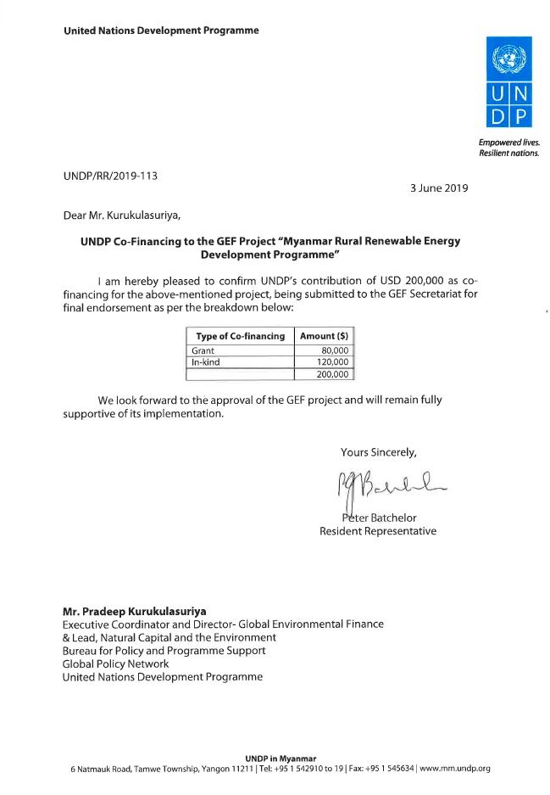

World Bank World Development Indicators (2018); The World Factbook (CIA, 2018)
DAC List of ODA Recipients, effective 2018 for reporting on 2018, 2019 and 2020, http://www.oecd.org/dac/financing-sustainable-development/development-finance-standards/daclist.htm
World Bank World Development Indicators (WDI) 2016, UNDP Human Development Indicators (HDI) 2016, ADB Basic Statistics 2017
Plus 11,600 grid-connected community buildings and on-grid public lighting (132,000 lights). Source: WB Project Appraisal Document for the ‘National Electrification Project’ (2015).
This would cost, at a rate of USD 800 per connection about estimated cost of USD 6 billion. Data taken from Castalia, Myanmar National Electrification Program Roadmap and Investment Prospectus (2014); World bank-ESMAP Role of Mini-Grids in Electrification in Myanmar (2017)
As mentioned in various articles in the media, e.g. www.nytimes.com/2017/03/31, www.rfa.org, www.bangkokpost.com/most-recent/401327
Myanmar Energy Master Plan, National Energy Management Committee (2016)
It should be noted that the project boundary is formed by off-grid electricity using renewable sources of energy (RE). Apart from electricity, energy access also encompasses the use of energy in heat applications, such as cooking (clean cooking fuels in efficient devices for all households) as well as clean fuels for process heat in productive applications. The RURED project will, however, focus on electricity generated in mini-grid systems (powered by solar, small hydro or other sources of renewable energy, RE) that supply energy to households and that can be used for productive applications. Where needed, off-grid power supply may include stand-alone options (individual applications of solar PV or other RE).
In some cases, the power distribution networks just consist of wires strung on wooden or bamboo poles or trees; the thin wires and poor splices have considerable line loss, and can be dangerous and failure-prone
WTP: willingness to pay; ATP: ability to pay; RE: renewable energy
Micro-finance institutions
De-risking Renewable Energy Investment
Regulations need to be put in place that provide opportunities for integration with the grid when it arrives—through transfer of assets or co-existence agreements. Mini grids would benefit from the creation of an independent regulatory authority. However, overregulation can jeopardize the private mini-grid sector during the early development of the market and may frustrate mini-grid investment. More emphasis could be introduced to encourage cooperation between on- and off-grid power. Currently, GIZ supports grid connection standards and regulations of mini-grids, which encourages connection to the national grid down the road.
Research and knowledge sharing is part of the SPM mandate, besides decentralized energy supply efficiency and investments; demand stimulation and data analytics
AFD: Agence Française de Développement (France), Department for International Development (UK). ABC: Anchor, business, community
This will be accompanied by a toolkit with guidelines that support a) least-cost energy planning and RE investment opportunities, b) the mainstreaming of PUE and integration with other rural development strategies and policies (agriculture, natural resources, disaster mitigation); c) practical implementation of quality standards for off-grid systems and requirements and modalities of future grid connection of mini-grid systems (compensation, operation as distributor, generator or electricity retailer); d) gender equality and sustainable livelihood aspects.
International Finance Corporation, World Bank Group
Department of Research and Innovation; Ministry of Education (Science and Technology). Vocational training is under the Ministry of Education’s Department of Technical and Vocational Education (DTVE)
WTP: willingness to pay; ATP: ability to pay; RE: renewable energy
Smart Power Myanmar (SPM). Funded by the Rockefeller Foundation and managed by Pact, SPM is being set-up as a platform to accelerate access to and effective utilization of energy in communities through bringing together key public and private sectors' actors and coordinating strategies and leveraging financing in order to catalyse economic opportunities and transform lives in rural Myanmar: (1) project development support for RE companies and developers and with it associated demand (household and productive loads), (2) investment facilitation and business modelling for last-mile electrification models; and (3) policy support and industry coordination (4) data analytics and knowledge
The DREI methodology was developed by UNDP, see http://www.undp.org/content/undp/en/home/librarypage/environment-energy/low_emission_climateresilientdevelopment/derisking-renewable-energy-investment.html
The baseline market study can include analysis of the experiences obtained in the DRD-NEP programme and ‘home-developed’ mini-grids (without DRD or donor support) and analysis of, among others: - Energy systems (sites, installed capacity, energy demand, connected clients, costs and tariffs); - Actors (private sector and associations, government, relevant CSOs) - Impacts (beneficiaries, social and productive uses, skills enhancement);
Participants are the various government department involved, utilities and development partners
The Nigerian REA has developed a mobile application for a smartphone or tablet that enables rapid and inexpensive sourcing of data on possible sites on the basis of field workers collecting data on the numbers of households and people, schools, churches, and businesses (such as grain mills, welders, or hotels). The data then makes it possible to estimate the existing loads and the potential for additional loads.
Including a user friendly tool (in Excel) for quick demand supply assessment and financial-economic analysis of electrification systems and integration with PUE.
The sustainability of the hydroelectric investment directly depends on adequate upstream watershed management practices. Unsustainable practices lead to problems (such as excessive sedimentation or, lack of regular water flow) that will have a direct effect on the capacity to generate electricity and must therefore be mitigated. This will require actors to be brought together not just within the context of political or administrative boundaries but also based on natural geographic units or river basins.
RE companies, project developers, rural energy service companies (RESCOs), associations; NGOs; practitioners
Main institutes in Myanmar are the Myanmar Technological University (MTU) and the Myanmar Engineering Society (MES), as well as regional Technological Universities
Note that the selection of cluster villages will be primarily based on a range of technical factors, including the biophysical conditions most appropriate for rural renewable energy generation, as described below in Activity 3.1.1. Regardless, given the conflict context in Myanmar, including complex and rapidly changing policy and regulatory environment, and relations between state and non-state actors, including ethnic armed organizations, the approach to the selection of villages will be conflict-sensitive. Site selection will aim for inclusion of marginalized groups, and follow the principles of FPIC for IPs, and no project activities will take place in areas where consent has not been granted.
The DRD-NEP CfP tends to favour solar PV in mini-grids over other technologies (despite the abundance of other renewable energy sources, particularly hydroelectric and agricultural residues in some areas, and despite the experience of Myanmar small companies in setting up mini hydro or biomass-based mini-grids). One reason may be a perceived bias in government and donors towards solar energy systems, as internationally prices of solar panels have been dropping fast. Another reason is that small hydro generally takes much longer to conceptualise (e.g. assessment available resources; design of civil works or biomass conversion system) than solar PV and therefore may not be submitted in the successive CfP rounds. This may change in the forthcoming third round of the CfP, in which developers can present proposals on a rolling basis. Developers in general temd to favour one technology (e.f. or solar or hydro). Where least-cost, RURED will also promote hybrid solutions, e,g. solar-hydro.
Currently, DRD-NEP provides 60% grant with 20% to be provided by the developer/ESCO and 20% mobilized by the community. In the near future the DRD-NEP support is expected to be reduced to 50% grant funding.
The DRD-NEP grant support (about USD 30 million, as referred to in the MoALI-DRD co-financing letter; see Section 9) will be able to cover 50% of the total investment need, in line with DRD-NEP support of 50% grant funding for mini-grids.
During project preparation, members of of the PPG Team visited Tanantharyi and Southern Shan. DRD officials in Tanintharyi suggested to start RURED support in the Region in Bokpyin and Kyunzu Township (see Annex E.8). . Out of 256 villages in Bokpyin, only 95 have access to electricity. In Kyunzu, more than 100 villages are without electricity. The remoteness of these townships is likely to be a critical factor in delaying their connection to the national grid, if at all, connected.
In coordination with the project partners (SPM, REAM) and consultation with RE associations (e.g. HyCEM, Solar Group). SPM has been working on solar mini-grids in Dry Zone and Tanintharyi, while REAM/HyCEM have been working on nini-micro hydropower in Shan State and Tanintharyi
VEC: village electrification committee; VECO: village electrification cooperative
DFI: development finance institution; FSP: financial services provider. A user-friendly tool (in Excel) for quick demand-supply assessment and financial-economic analysis of electrification systems and integration with PUE
Currently, DRD-NEP provides 60% grant with 20% to be provided by the developer/ESCO and 20% mobilized by the community. In the near future the DRD-NEP support is expected to be reduced to 50% grant funding.
Micro-finance in Myanmar is limited to about USD 7,000 and can be used for households to acquire appliances and small businesses to acquire equipment. However, larger investments in the energy system itself and larger productive uses may require loans in the order of USD 100,000 – 3 million
The ‘productive use’ itself is to be financed by non-GEF resources, for instance by the beneficiary itself, a project partner (e.g. SPM), a donor or by means of a loan
The government has proposed to setup a dedicated Credit Guarantee Corporation which would provide credit guarantees to loans from local commercial banks for purposes of national development priority, including SME lending. A Credit Guarantee Corporation Law is currently under development, and the Asian Development Bank has proposed to provide a sovereign loan of USD 60 million to the government to capitalize this proposed Credit Guarantee Corporation. It is unclear when this Law would be approved, but if the existing CGI program of the government for SME lending is discontinued, once the Credit Guarantee Corporation start offering credit guarantees, the RURED Project would have to switch its proposed intervention from absorbing the cost of CGI to absorbing the cost of credit guarantees offered by this proposed Corporation.
DRI: Department of Research and Innovation. REETC: Renewable Energy and Electronic Technology Centre; TVET: Technical and Vocational Education and Training. There are about 60 TVET Centres in Myanmar
HPNet (Hydropower Empowerment Network) is a network of practioners of small-scale (<1MW) hydropower for the advancement and advocacy of resilient hydropower, towards equitable and sustainable development of rural communities in South and Southeast Asia. It organizes workshops, training, webinars; research on technology innovation and sustainability, and practice-to-policy advocacy. More info on www.hpnet.org. MEE Net (Mekong Energy and Ecology Network) together activists, academia, civil society, scientists and local communities from the Mekong countries, including Myanmar, to promote sustainable smaller-scale energy infrastructure
E.g. if land is used for mini-grid structures are built on land owned by indigenous people and in case the project does not sufficiently include indigenous people in decision making or account for and address indigenous people’s rights and traditional livelihoods
Practical Approaches to Ensuring the Full and Effective Participation of Indigenous Peoples in REDD+ (September 2013), BMZ, FPCP, UN-REDD, p.12.
In Shan State and in Taninthary Region, the PPG Team met the Chief Minister, and officials from the Department of Rural Development (DRD), Department of Social Welfare (DSW), and the General Administration Department (GAD). The Team also consulted local NGOs (e.g. Active Youth Grouyp) and some CSOs and VECs.
As an example, DFCC Bank (Sri Lanka) is in discussion with A-Bank (Myanmar) on the best way to support off-grid RE projects that are in need of immediate financing. The RURED project will support this type of technical assistance by foreign banks (with proven experience) to local banks in Myanmar.
Census Gender Report, pages 79-81
See http://www.undp.org/content/undp/en/home/operations/transparency/information_disclosurepolicy/
See https://www.thegef.org/gef/policies_guidelines
see https://info.undp.org/global/popp/ppm/Pages/Closing-a-Project.aspx
Due to investments in solar and hydro mini-grids of about USD 61.84 million. This includes USD 4 million from GEF and USD 30,000,000 from government co-financing (DRD-NEP) and USD 28 million from community and other resources) at an average investment cost of USD 190,000 per village off-grid system (50% small hydro; 50% solar) in 281 villages
As explained in previous footnote. Calculation details are given in Annex G
Number and type of off-grid systems installed (DRD-donors; private, community), business and financing models, community engagement (and role of gender), tariff recovery and system management, role of subsidies and non-financial government support; costs of systems; assessment of RE supplier and project developer sector; role of domestic (micro-)finance, impact of mini-grids on SDG1, SDG3, SDG4 and SDG5.
Planning, demand assessment and beneficiary engagement; hydro: design, installation and O&M; PV mini-grids: design, installation and O&M; use of software (HOMER, PVSYS, other) business models and finance; business plan formulation)
The GIZ co-financing is reflecting their current budget. At the time of formulation of the Project Document continuation is foreseen with additional budget for 2021-2023, yet to be determined
See https://info.undp.org/global/popp/ppm/Pages/Closing-a-Project.aspx
See https://popp.undp.org/_layouts/15/WopiFrame.aspx?sourcedoc=/UNDP_POPP_DOCUMENT_LIBRARY/Public/PPM_Project%20Management_Closing.docx&action=default.
Summary table should include all financing of all kinds: GEF financing, co-financing, cash, in-kind, etc.
UNDP Financial Rules and Regulations: Chapter E, Regulation 16.05: a) The administration by executing entities or, under the harmonized operational modalities, implementing partners, of resources obtained from or through UNDP shall be carried out under their respective financial regulations, rules, practices and procedures only to the extent that they do not contravene the principles of the Financial Regulations and Rules of UNDP. b) Where the financial governance of an executing entity or, under the harmonized operational modalities, implementing partner, does not provide the required guidance to ensure best value for money, fairness, integrity, transparency, and effective international competition, that of UNDP shall apply.
Sources: Asia Foundation; GIWPS, 2018; AGIPP Paper no. 4
2014 Census Gender Report, page 79-81; Gender Situation Analysis; DHS (2017)
Data taken from various sources, ADB (2016, Doberman (2016), Soe Soe Ohn (2016, 2018), World Bank (2017) * The Annex E is based on technical baseline reporting prepared by the PPG Team leader, J. Van den Akker, with contributions from the PPG members M.Nwa Soe, Th..Phyu Htoon, Kh.May.Khyi and M.Thin Aung, with S. Gubbi responsible for drafting Annex F
NEMC’s Order No.(1/2015)
Of which 46.100 MW in 92 projects > 10 MW and 230 MW in 200 projects < 10 MW. Tint Lwin OO (2017)
Of which three projects (470 MW) had reached the stage of PPA (power purchase agreement). Solar power in Myanmar has an estimated levelized cost of electricity between USD 0.16-0.19/kWh (2014 figures; ADB, 2015; Tint Lwin Oo, 2017.
The theoretical wind energy potential is an estimated 80,000 GWh/yr
A waste-to-energy plant was commissioned in 2017 at Shwepyithar Township, Yangon
There are approximately 103 heads of livestock. Around 190 biodisgesters (5-25kW) have been installed. Source: ADB (2015) and Tint Lwin Oo (2017)
World Bank Indicators (2018)
Own estimate, based on MoEE information (website) and Doberman (2016)
Residential prices in Myanmar are K35 per kilowatt-hour for the first 100 units, K40/kWh for the next 100 units, and K50/kWh for all units after that. Prices for commercial and industrial customers are much higher, ranging from K75-K150/kWh, but the financial viability of supplying subsidized power to millions of people cannot entirely paid for by a few thousand businesses. Source: Doberman (2016), Myanmar Times (24 July 2018)
Plus 11,600 grid-connected community buildings and on-grid public lighting (132,000 lights). Source: WB Project Appraisal Document for the ‘National Electrification Project’ (2015).
Other donors contribute as well, KfW, EUR 9 million (2016-19), GIZ (2016-2018, for TA), Italy (EUR 30 million, 2018-21, for Chin State), ADB (USD 2 million, 20150-17) and JICA (JPY 994 million, 2014-17). Source: Soe Soe Ohn (2016a). In parallel to WB’s NEP activities, the International Finance Corporation of the WB Group has setup a Lighting Myanmar program. The Lighting Myanmar program is planned to provide technical assistance and advisory services focused on quality assurance, developing knowledge products aimed at building market and consumer knowledge, and supporting Microfinance Institutions and private sector build technical capabilities and distribution channels for solar home systems in rural and off-grid areas of Myanmar.
The WB Project Appraisal Document for the ‘National Electrification Project’ (2015) mentions 11,400 community buildings connected by mini-grid/off-grid options and 19,000 lights off-grid/mini-grid public lighting. These receive 100% grant funding (since then lowered to 80%).
Kayin: 12,356, Chin: 13,865, Sagaing: 12,059, Tanintharyi: 20,928, Rakhine: 35,403, Shan: 32,767, and Ayeyarwaddy: 33,102. Source: DRD, Soe Soe Ohn (2016a). Wang (2016)
Configuration: 80 W solar module, 12 V 65 Ah battery, controller, inverter, two 3W bulb and one 10 W tube plus 8 m of cabling
Hydro-powered mini-grid or pico-hydropower. Source: End of 2015-2016 FY 70% Rural Electrification Villages. Source of household data: 2014 Myanmar Census.
In rural areas, national grid coverage is much lower, at only 15 percent. About 1 million households (9 percent) receive electricity from private diesel generators, 11% of households use solar home systems, and another 21% use batteries charged in local towns. more than 16,000 of the country’s 64,000 villages get their electricity from diesel generators, micro-hydropower, or biomass. DRD mini-grid developers may be a national or international firm that is a private entity or any combination in the form of a joint venture (JV). data (2015)
Applicants may be the VEC (together with a developer) or a developer (together with a VEC). Prospective developers have two options by which to select a potential mini-grid site: a) Option 1: Developer-identified sites: Prospective developers may choose to identify and propose their own proprietary mini-grid sites, as long as the sites meet the minimum eligibility criteria described in forms NEP-8 and NEP-9, b) Option 2: DRD-identified sites: Prospective developers are encouraged to review a list of potential mini-grid sites which have been pre-screened by DRD to ensure that they meet the minimum eligibility criteria.
International Monetary Fund (IMF) Country Report No 18/91: Myanmar: Selected Issues, March 2018
International Monetary Fund (IMF) Country Report No 18/91: Myanmar: Selected Issues, March 2018
Myanmar Financial Services Monitor and FMR Research & Advisory (in association with British Chamber of Commerce Myanmar and Baker McKenzie): Myanmar Financial Services Report, 2018. There are 24 licensed private banks in Myanmar, according to CBM’s definition, and another five are expected to start operations in 2018
Myanmar Financial Services Monitor and FMR Research & Advisory (in association with British Chamber of Commerce Myanmar and Baker McKenzie): Myanmar Financial Services Report, 2018
ibid
ibid
ibid
ibid
Myanmar Financial Services Monitor and FMR Research & Advisory (in association with British Chamber of Commerce Myanmar and Baker McKenzie): Myanmar Financial Services Report, 2018
Ross (2015; CSIS)., based on REAM interviews with micro-hydropower developers, Micro-Hydropower and Decentralized Renewable Energy for Myanmar Workshop, November 26–27, 2014.
Source: Myanmar Times (12.02.19) and www.myanmargeneva.org (item 29.06.14)
The tariff rate varies depending on source types, e.g., 200MMK/kWh for natural gas; 500 to 600 MMK/kWh for diesel; and 70-80 MMK/kWh for basic lighting with micro/mini-hydro (source: field work by PPG Team, January 2019)
In Kenti village, 310 households are powered with 63 kW installed capacity though there is a plan to extend the capacity by adding another 48 kW due to high demand. Other villages are powered by Techno Hill with 40 kW installed capacity, each with a diesel generator backup system prepared for long cloudy days or rainy days. The PPG field visit report mentions that “Many residents prefer solar mini-grids to diesel power to reduce their expenditure on electricity from MMK 650/kWh to MMK 350/kWh by shifting their power source”
Eastern Shan State suffers from human trafficking. DSW, IOM and Anti- Trafficking Taskforce provide trafficking survivors with financial assistance to help with their reintegration. UNICEF covers travel expenses for survivors to help them return to their homes. DSW provides gender-based violence survivors with services such as financial support, referral to necessary services, and vocation training depending on their needs and consent. DSW has one-stop service center for GBV survivors in Mandalay and Yangon.
The 281 off-grid RE proposals will benefit from RURED’s policy support and capacity strengthening activities. A subset thereof, 30 villages will receive additional GEF grant support which can be a combination of: a) technical support in project design and feasibility assessment, b) additional grant support for innovative project proposals that do not receive DRD grants, for example proposals involving large PUE development or for hybridisation of system (e.g. solar-hydro combinations), and c) to pioneer in Myanmar credit insurance for off-grid RE systems.
See Annex F: 2 structured interviews with investors, project developers, donors/international development agencies.
With participants from government (DRD – national, regional, MOEE, ECD), development partners (GIZ, SPM, JICA, KESAN, Mercy Corps). companies (Yoma Micropower, Sunlabob RE, Huwaei, Infra Capital, Techno-Hill,. New Business-Engie, Solaris, SolRiseSys, Htoo Lin Co., Nay Yaing Eain Co., Talent and Technology, Yi Mon) and associations (REAM)
Meetings with DRD, DRI, ECD, GIZ, UNDP CO, REAM, PACT-Smart Power Myanmar, World Bank, renewable energy companies.
Prohibited grounds of discrimination include race, ethnicity, gender, age, language, disability, sexual orientation, religion, political or other opinion, national or social or geographical origin, property, birth or other status including as an indigenous person or as a member of a minority. References to “women and men” or similar is understood to include women and men, boys and girls, and other groups discriminated against based on their gender identities, such as transgender people and transsexuals.
In regards to CO_{2,} ‘significant emissions’ corresponds generally to more than 25,000 tons per year (from both direct and indirect sources). [The Guidance Note on Climate Change Mitigation and Adaptation provides additional information on GHG emissions.]
Forced evictions include acts and/or omissions involving the coerced or involuntary displacement of individuals, groups, or communities from homes and/or lands and common property resources that were occupied or depended upon, thus eliminating the ability of an individual, group, or community to reside or work in a particular dwelling, residence, or location without the provision of, and access to, appropriate forms of legal or other protections.
Potential pollution from waste solar batteries, if dumped

